William Blake-The little Black Boy
A black boy compares himself to a white English boy, and at first finds himself wanting. He claims his soul is as white as the English boy's, but also sees himself as "black as If _ of light." He then remembers that his loving mother taught him that his black skin is a result of constant exposure to the sun. The mother explains the sun as God's gift to mankind, sharing both His light and his heat, both of which are forms of His love.
His color, she explains, is a temporary "cloud" to be borne until he can fully learn to dwell in the presence of God's love. The speaker ends by saying he will tell the English boy this truth and look forward to the day when both of them have put off this cloud and can love one another truly.
Analysis
"The Little Black Bov" consists of seven heroic stanzas, which are quatrains following the ABAB rhyme scheme. The first two stanzas describe the boy's mother and the influence she has had on his life. The third, fourth, and fifth stanzas recall the mother's exact words in her lessons to her son. The final two stanzas describe how the black boy communicates his lesson to the white English boy for whom he has a great affection.
Stanzas one and two describe the past; stanzas three, four, and five recall the mother's words as if they were being spoken in the present; the sixth and seventh stanzas include the black boy's words, which he "will say" to the English boy in the future. Thus, the poem itself progresses in time from a past (learning), to the present (the lesson itself) and to the future (the implementation or practical outworking of the lesson).
Hints of anti-slavery sentiment and an opposition to racism occur in this poem, but they are not the main message. The equality of human beings is, however, emphasized by the poem in its depiction of God creating the world as an act of divine mercy, giving the sun to shine upon and warm all people everywhere as a preparation for the light and heat of His love.
Form
The poem is in heroic quatrains, which are stanzas of pentameter lines rhyming ABAB. The form is a variation on the ballad stanza, and the slightly longer lines are well suited to the pedagogical tone of this poem.
Commentary
This poem centers on a spiritual awakening to a divine love that transcends race. The speaker is an African child who has to come to terms with his own blackness. Blake builds the poem on dear imagery of light and dark, The contrast in the first stanza between the child's black skin and his belief in the whiteness of his soul lends poignancy to his particular problem of self-understanding.
The child's mother symbolizes a natural and selfless love that becomes the poem's ideal. She shows a tender concern for her child's self-esteem, as well as a strong desire that he knows the comfort of God. She persuades him, according to conventional Christian doctrine, that earthly life is but a preparation for the rewards of heaven. In this context, their dark skin is similarly but a temporary appearance, with no bearing on their eternal essence: skin, which is a factor only in this earthly life, becomes irrelevant from the perspective of heaven.
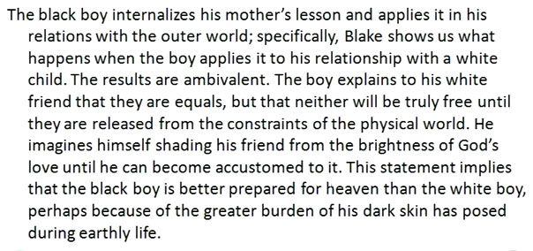

Model Questions
1- The Little Black Boy was written by......................
A- Wordsworth B- Byron
C- Blake D- Shelly
The correct answer is (B) Blake
2- Blake believes that people are........................
A- equal B- unequal
C-lazy D-brave
The correct answer is (a)

تأكدوا من عدم وجود أخطأ
الجزاء الأول من المحاضره الثانيه موجود ضمن محتوى المحاضره الأولى

نسألكم الدعاء
DewDrop

