If the Employees table has the following fields
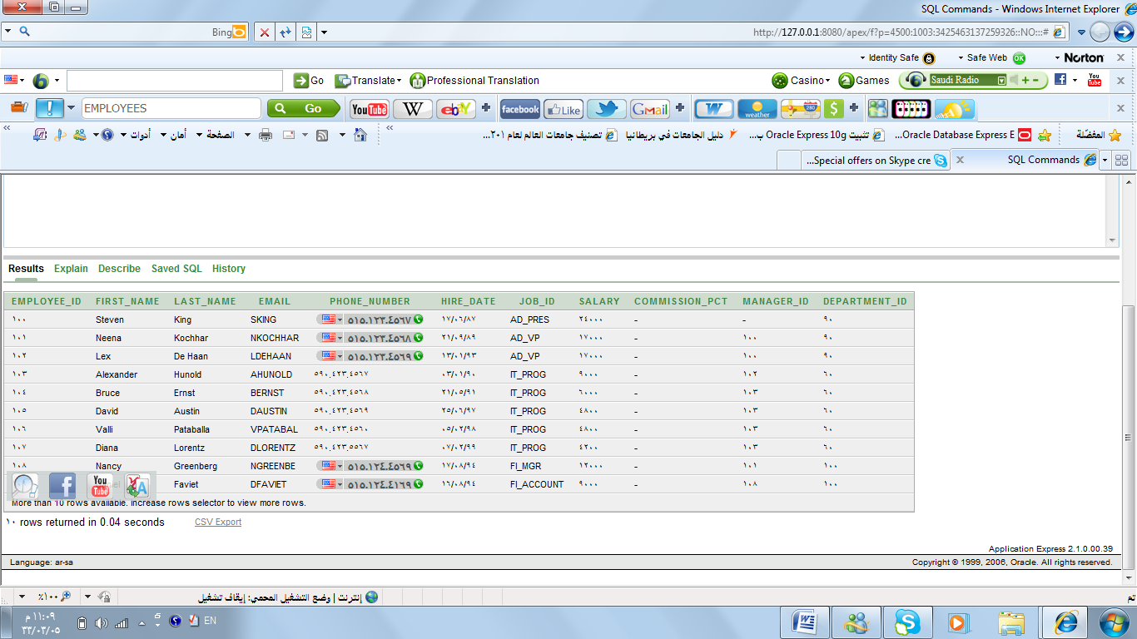
Write the queries required to show these information:
- All information about the employees.
…………………………………………………………………………………………………………………………………………………………………………………………………………………………………………………………………………………………………………………………………………
- The name of the fields and their type.
…………………………………………………………………………………………………………………………………………………………………………………………………………………………………………………………………………………………………………………………………………
- The first name of the employees , their salary and ID.
…………………………………………………………………………………………………………………………………………………………………………………………………………………………………………………………………………………………………………………………………………
- The last name of the employees , their salary and ID and use alias in different way.
…………………………………………………………………………………………………………………………………………………………………………………………………………………………………………………………………………………………………………………………………………
- The first and second name of the employees in one column and use an appropriate alias.
…………………………………………………………………………………………………………………………………………………………………………………………………………………………………………………………………………………………………………………………………………
- The first name of the employees ,their salary and write this sentence (THE SALARY IS ) between them.
…………………………………………………………………………………………………………………………………………………………………………………………………………………………………………………………………………………………………………………………………………
- The last name of the employees , their salary and their annual salary.
…………………………………………………………………………………………………………………………………………………………………………………………………………………………………………………………………………………………………………………………………………
- The departments ID and remove the repeated rows.
…………………………………………………………………………………………………………………………………………………………………………………………………………………………………………………………………………………………………………………………………………
- The first name of the employees , their salary , commission and the sum of the annual salary and the commission.
…………………………………………………………………………………………………………………………………………………………………………………………………………………………………………………………………………………………………………………………………………
- The first name of the employees , their salary , commission and the sum of the annual salary and the commission and remove the null values.

…………………………………………………………………………………………………………………………………………………………………………………………………………………………………………………………………………………………………………………………………………

