المحاضرة الثالثة
Pictograms and ideograms
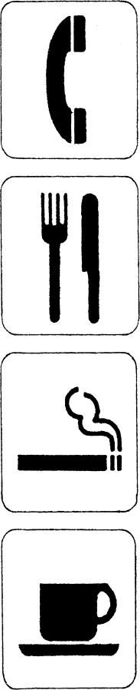
When the relationship between the symbol and the entity or idea becomes sufficiently abstract, we can be more confident that the symbol is probably being used to represent words in a language.
When symbols are used to represent words in a language, they are described as examples of word-writing, or ‘logograms’.

المحاضرة الرابعة
Manner of articulation
The vowel chart (Figure A below) fits into the middle of the mouth as shown in the simple cross-section of the head (Figure B).
الصورة _ _
Below is a chart with a list of the sounds with some examples of familiar words
vowels
[i] eat, key, see | [ʌ] blood, putt, tough
[ɪ] hit, myth, women | [u] move, two, too
[e] great, tail, weight | [ʊ] could, foot, put
[ε] dead, pet, said | [o] no, road, toe
[æ] ban, laugh, sat | [ɔ] ball, caught, raw
[ə] above, sofa, support | [a] bomb, cot, swan

