Lecture 7
Chapter 3
Gender and Relationship
Focus:
In this chapter, you will learn to write about communication style differences between men and women.
The Photos on Page 46:
1. Man: Will you please go to the store for some eggs.
2. Woman: I really need a few things from the store, but I’m so tired.
3. Man: It’s a nice day.
4. Woman: It’s a nice day, isn’t it.
The reading passage on page 48-49:
Read the reading passage on page 48-49 before you continue with this lecture.
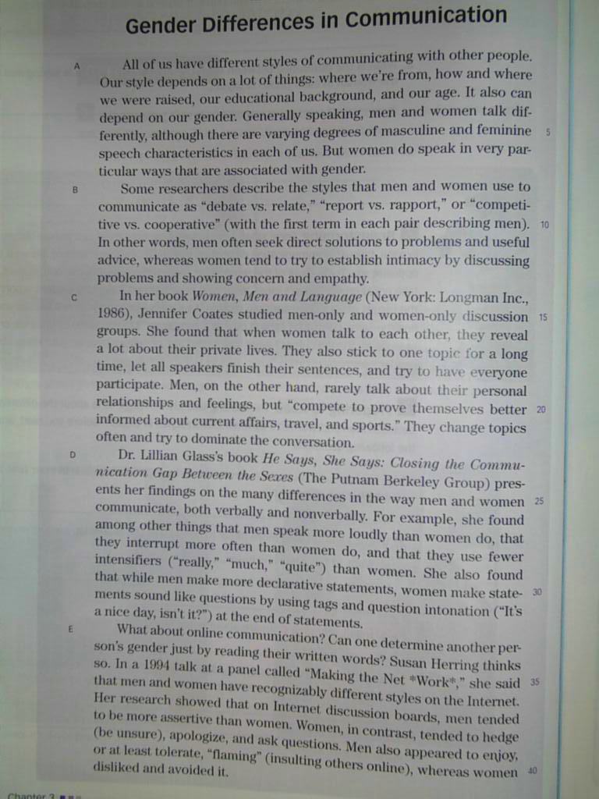
Questions on page 49:
1. According to the reading passage, what are some differences in face-to-face communication styles between men and women?
2. According to the reading passage, what are some differences in the online communication styles of men and women?
3. Give an example from your own experience of each of these communication style differences:
(a) “debate vs. relate,” (b) “report vs. rapport,” and (c) “competitive vs. cooperative.”
4. What does Gladys We mean when she says that online communication “is potentially liberating”? Do you agree?
Task 5:
Try to answer the previous questions on your own. Try to write correct grammatical sentences as best as you can.
Remember to post your response on the course forum. Please do not send it as email.

We will stop here.
Go to the next lecture
THANK YOU

مع تحياتي لكم :
☺ معتزهـ ☺

