المحاضره(14)

Review: Exercises
Verb to be (is, are, am)
Kaka _________ a soccer player. He _________ an attacking midfielder

Angelina Jolie and Brad Pitt _________ both American.

In your opinion, _________ they a perfect couple?
Subject Verb Agreement,
Everyone) going to the park.
Tonight, R(is/arealph and I (is/are) hanging out.
(Is/Are) the jury going to decide on the case tomorrow?

Should we watch the news for three (hour/hours) or not?
Preposition of Place,
The teacher is writing_ on _ the blackboard.

I am a student ___ at __ king Faisal University
Using Have, Has, Had
We ______ a beautiful house.

She _______ a very good English accent.

I ______ a classic car two years ago.
SCANNING & SKIMMING
Skimming refers to the process of reading only main ideas within a passage to get an overall impression of the content of a reading
selection.
Scanning is a reading technique to be used when you want to find specific information quickly. In scanning you have a question in your mind and you read a passage only to find the answer, ignoring unrelated information.
A.Fill in each blank with a word from the box
building

different

neighbors

crowded
front

drugstore

- This store is always _ crowded _______. There are always lots and lots of people.
2. My_ neighbors ______are from Mexico. They're very nice people.
3. There are two big trees in __ front ____of my house.
4. There is a big apartment____ building __ on the corner of the street.
5. People in my neighborhood are from different countries.

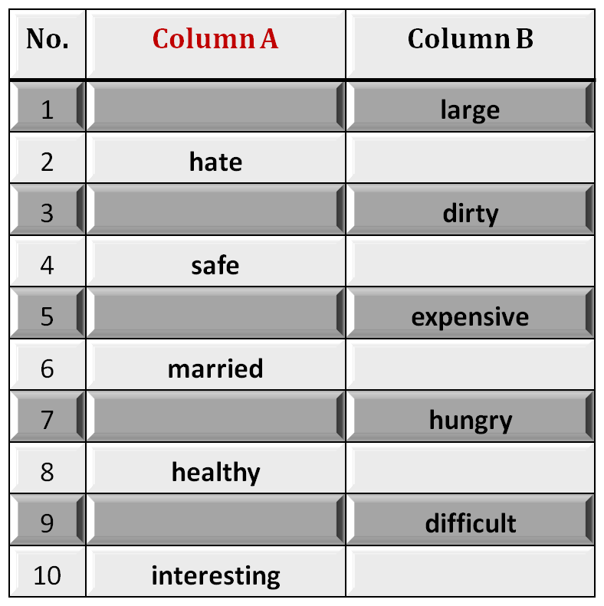
Fill in each blank space with the opposite meaning
small
love
clean
dangerous
cheap
single
full
sick
easy
boring
B. Identifying Opposites

Pronouns
1. The doctor gave__________ a lecture about pronouns.
a. we
b. us
c. our
d. ours
2. ______ friend sent an email to the doctor regarding the homework.
a. I
b. Me
c. Mine
d. My
Vocabulary Previewing ( pages 5+ 18 )
Meaning | Word | No.
Write the same thing | Copy | 1
Very, very good/ fantastic | Wonderful | 2
Number of people in one squire mile | Population | 3
Having lots of people in one place | Crowded | 4
Fearful creature | Monster | 5
Very bad | Terrible | 6
frightened | Afraid | 7
Shopping centre | Mall | 8
Very big or large | Huge | 9
Leave / give up | Quit | 10

Exercise
The phrase “ write the same thing’ means ________________ .
A. cut B. paste
C. copy D. delete
The trip to the sea was very, very good. “ very, very good” means:-
A. wonderful B. dangerous
C. terrible D. easy
at | in | on
PRECISE TIME | MONTHS, YEARS, CENTURIES and LONG PERIODS | DAYS and DATES
at 3 o'clock | in May | on Sunday
at 10.30am | in summer | on Tuesdays
at noon | in the summer | on 6 March
at dinnertime | in 1990 | on 25 Dec. 2010
at bedtime | in the 1990s | on Christmas Day
at sunrise | in the next century | on Independence Day
at sunset | in the Ice Age | on my birthday
at the moment | in the past/future | on New Year's Eve
--------------------------------------------------------------------------------------------------------------------
Do, Does, Did, Doing, Done
- We do the homework every week
- She does the homework every week
- The students did the homework last week
- They are doing the homework now/ at the moment
- Salma has done the homework.
Vocabulary Previewing

Meaning | Word | No.
A place to park your car | garage | 1
People who buy | customers | 2
Money you earn in business / interest | profit | 3
Buy | purchase | 4
Select | choose | 5
Look for | search | 6
A specialist in food | gourmet | 7
Separated from others/ nobody with you | alone | 8
Classifications | categories | 9
Opposite of difficult | easy | 10

Exercise
1. Where is the car? It’s in the___________
A. library B. bog
C. garage D. kitchen
2. If you didn’t find the book, you can look for it in the other room. the underlined
word look for means:
A. buy B. search
C. read D. eat
3. English language is_________________. It is not difficult.
A. beautiful C. boring
C. safe D. easy

Present Simple, form:

Example: to think, present simple

Affirmative

Interrogative

Negative

I think

Do I think?

I do not think

You think

Do you think?

You don't think

he, she, it thinks

Does he, she, it think?

He, she, it doesn't think

We think

Do we think?

We don't think

You think

Do you think?

You don't think

Third-Person Singular (Spelling and Pronunciation)
Put an –s or –es ending on third-person singular (he, she, it).

He needs a shirt.
She wants an apple.

It catches the stick.

Scanning & Skimming Reading paragraph
( Interaction, Page 47)
Families in almost every country are changing. This is true in rich countries and poor ones. It is true in Africa, the Americas, Asia and Europe. All over the world, families are getting smaller.
In North Africa , in the past, many people lived in extended families. Fifty to hundred people lived together in a group of houses.

These were all family members- grandparents, aunts, uncles, cousins, children, and grandchildren. But now this traditional family is breaking into smaller groups.
The traditional family in Mexico was also big. One generation ago, the average Mexican woman had seven children. Today, she has an average of only 2.5 children. Now , without so many children, families don’t need to spend so much money on basics, such as food, clothing and housing.

-------------------------------------------------------------------------------------------------------------------------------- Vocabulary Previewing
( Interaction- pages 65 / 70 )
Adverbs | Adjectives | Verbs | Nouns | No.
often | bilingual | age | beverages | 1
never | chronic | damage | blood pressure | 2
sometimes | healthy | Exercise | brain | 3
 | mental | solve | diseases | 4
 | physical |  | Junk food | 5
 | Sleep- deprived |  | Stress | 6
 | Overweight |  | wrinkles | 7
 |  |  | dentist | 8
 |  |  | toes | 9
 |  |  |  | 10

Present Progressive
Most verbs
Verbs ending in e
Verbs ending in ie
Short verbs ending in a vowel + a consonant
+ ing
-e + ing
-ie + y + ing
Double the consonant + ing
walk
walking
come
coming
lie
lying
run
running
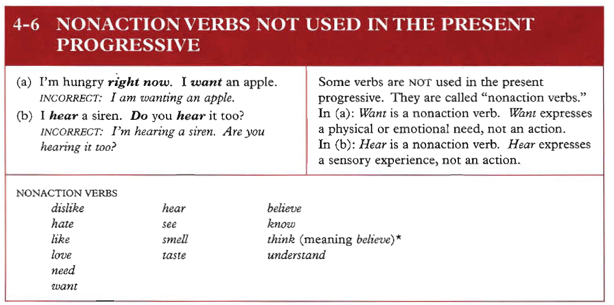

Examples:
1. I hear you now clearly.
2. They understand the lesson now.
3. Be careful! We smell dangerous chemical gas.

“Yes” or “No” questions |  |  | Short Answers  إجابات مختصرة
 |  |  | إثبات Affirmative | نفي Negative
Be | +Subject  فاعل | + Complement  تكملة | Yes + Subject + Be | No + Subject + Be + not
Are | you | a teacher? | Yes, I am. | No, I am not.
Were | the boys | at school? | Yes, they were. | No, they were not.

Making Questions with the verb to HAVE as a main verb
تكوين السؤال مع فعل ”يملك“ كفعل رئيسي
“Yes” or “No” questions  أسئلة إجابتها بـ نعم و لا |  |  |  |  | Short Answers  إجابات مختصرة
 |  |  |  |  | Affirmative  إثبات |  | Negative  نفي
Do/Does/  Did | +Subject  فاعل | +have | + Complement  تكملة | Yes + Subject  +  do/does/did |  | No + Subject +  do/does/did  +not
Do | you | have | a car? | Yes, I do. |  | No, I do not.
Does | he | have | a new watch? | Yes, he does. |  | No, he does not
Did | they | have | Breakfast this morning? | Yes, they did. |  | No, they did not.

الأزمنة TENSES

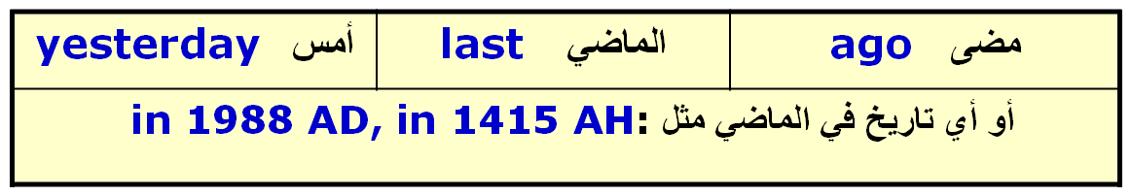
يستخدم هذا الزمن للتعبير عن حدث وقع في الماضي.
يتكون هذا الزمن من التصريف الثاني للفعل أي إضافة مع ملاحظة الأفعال الغير منتظمة Irregular verbs
يأتي هذا الزمن عادة مع كلمات مثل:

Past Simple Tense الماضي البسيط (What happened yesterday?)
ed
Countable & Uncountable Nouns
الأسماء المعدودة و غير المعدودة
Countable Nouns: are things that are counted as one, two, three, and so on.
الأسماء المعدودة: هي الأشياء التي يمكن عدها بـ واحد ، اثنان ، ثلاثة وهكذا.
Uncountable Nouns: cannot be counted.
الأسماء الغير معدودة: هي التي لا يمكن عدها أي لا يمكن وضع رقم قبلها.
Countable Nouns
الأسماء المعدودة
- These nouns have singular and plural forms.
هذه الأسماء لها صيغ مفردة و جمع.
Before singular countable nouns you can use a/an.
قبل الأسماء المفردة المعدودة تستطيع استخدام
(a,an)
You cannot use singular countable nouns alone without words such as:
a, an, one, my, your, his, etc.
لا نستطيع استخدام أسماء مفردة معدودة بمفردها بدون الكلمات السابقة
Uncountable Nouns
الأسماء الغير المعدودة
Uncountable nouns cannot be counted.
هي التي لا جمع لها بإضافة
es , s
أمثلــــــة:
salt, coffee, tea, food, meat, gold, music, blood.
قبل الاسماء الغير المعدودة او لاتستطيع استخدام
حـــــــــالات خاصــــــــــــــة
هناك بعض الأسماء الشاذة:

Singular | Plural
man | men
woman | women
child | children
person | people
foot | feet
tooth | teeth
goose | geese
mouse | mice

Uncountable Nouns
الأسماء الغير المعدودة
flour | دقيق | salt | ملح | meat | لحم
information | معلومات | coffee | قهوة | knowledge | معرفة
butter | زبد | food | طعام | tea | شاي
sugar | سكر | gold | ذهب | blood | دم
news | أخبار | glass | زجاج | cheese | جبن
milk | حليب | paper | ورق | bread | خبز
rice | رز | wood | خشب | furniture | مفروشات
rain | مطر | steel | حديد | grass | عشب
cloth | قماش | music | موسيقى | marble | رخام

Using ( many/much/ a few/ a little, some, several…etc ) page 195
A. Many, a few , few, some, several = Used before countable nouns
( Countable nouns ( nouns that can be singular and plural
e.g [ boy- car – door – page – girl – houses…….etc ]
B. Much, a little, little, some= Used before uncountable nouns
Uncountable nouns ( nouns that don’t have singular or plural forms)
e.g [ water – sugar – snow – money – food – milk, ……etc ]
C. A, An , Each & Every = used before singular nouns
D. Any= used in negative and questions.
E. Some= used when we offer something

Vocabulary Previewing ( pages 107 110/ 113 )
Adverbs | Adjectives | Verbs | Nouns | No.
however | awake | wonder | evidence | 1
 | anxious | Fix | hormone | 2
 | familiar | Happen | psychologist | 3
 | complicated | Wish | emotions | 4
 |  | travel | symbols | 5
 |  | realize | vision | 6
 |  | Make sense | logic | 7
 |  |  | Reason | 8
 |  |  | Opinions | 9
 |  |  |  | 10

Scan and Skim the reading passage( page 108/ 109)القطعة عن الحلم
Many people wonder: Why do we sleep? Why do we dream? They ask themselves the purpose, or reason. There are many theories, or opinions about this , but scientists don’t know if these ideas are correct.
One theory of sleep says that during the day, we need sleep to make new chemicals and repair, or fix, our bodies. This theory is called the “ Repair Theory”. One piece of evidence for this theory is that our bodies produce more of growth hormone while we sleep.
Another theory is that the purpose of sleep is to dream. Dreaming occurs only during one stage , or period, of sleep ( Rapid Eye movement- REM )sleep. REM sleep occurs about 90 minutes and last for about 20 minutes. Some scientists believe that REM sleep helps us to remember things, but others don’t believe and don’t agree.
Scan and Skim the reading passage ( page 89) عن الزواج

Marriage is often not easy. Maybe man and woman love each other, but they argue . They get angry. Later they apologize, but it happens again and again. What’s the problem? Are men and women really very different.
Deborah Tannen says yes, men and women are very different. Tannen teaches at Georgetown University in Washington, D.C. She writes books about the ways people talk. She believes that men and women talk- and think- in different ways. She tells about some differences in her book, You Just Don’t Understand.
The differences, Tannen says, begin when men and women are children. Very young boys and girls are similar to each other. In other words, they like many of the same things and play in the same ways. They aren’t very different. But then there is a change. When children in the United States are five or six years old, boys usually play in large groups. One boy gives orders . For example, he says,” Take this,” ‘ Go over there”. He is the leader. Boys also brag . In other words, they say good thing about themselves. But girls there usually play in small groups or with one other girl. A girl’s best friend is her very good friend and important to her. Girls often don’t give orders; they give suggestions.

Vocabulary Previewing ( pages 127 / 132 / 139 )
meanings | New words | No.
The condition we live in/ everything around | environment N | 1
Problems in life/ pains | hardships N | 2
a person’s age between 13 and 19 | teenager N | 3
A big or strong difference | contrast N | 4
illegal behavior like killing or stealing | Crime N | 5
Love, anxiety, joy / feelings | Emotions N | 6
A picture | Vision N | 7
Work for free | Volunteer V | 8
To let things/ persons free | Release V | 9
To get ready | Prepare V | 10
Take things to destination / hand on | Deliver V | 11

Meanings | New words | No.
Well-known | Famous Adj | 12
Being without any people around | Lonely Adj | 13
Very hard / strong | Tough Adj | 14
Happiness or enjoyment | Fun Adj | 15
quickly | Fast Adj | 16
Look after | Take care of PV | 17

Adverbs of Frequency

Always 100%
Usually 80%
Often 65%
Sometimes 50%
Seldom 30%
Rarely 15%
Never 0%

===========================================================
الظروف [الأحوال] Adverbs
Adverbs of frequency tell how often we do something
: الظروف الدالة على التكرار :التي تخبرنا عن عدد مرات حدوث الشيء. ومن هذه الظروف:
دائماً always | غالباً often
عادة usually | أحياناً sometimes
نادراً seldom | نادراً جداً rarely
أبداً never | من حي لآخر occasionally
فعل يكون: يأتي ظرف التكرار بعد الفعل المساعد Verb to BE:
Ammar is always on time.
الأفعال الأخرى: يأتي ظرف التكرار قبل الفعل العادي Other Verbs:
Ammar sometimes reads a book.
The position of these adverbs is:
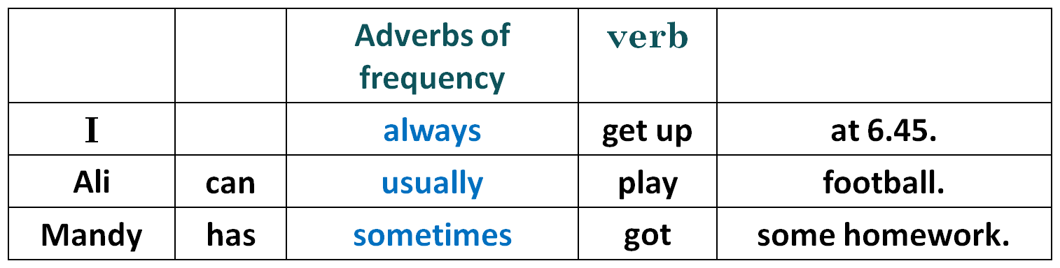
before the main verb
 | verb | Adverbs of frequency
Laila | is | never | late.
- after a form of to be am, are, is (was, were(

Read the following essay ,then answer the questions that follow page 128 عن العمل
Some people go to work each day and then come home. They spend time with their family and friends. Maybe they watch TV or go to a movie. Sometimes they exercise or read. This is their life. But for other people, this is not enough. They look around their neighborhoods and see people with terrible hardships: sickness, loneness, and homelessness. Other people see problems with the environment. Many people want to help. They volunteer. They give some of their time to help others.
Volunteers help in many ways. Some visit sick and lonely people. Some give their friendship to children without parents. Some build houses for homeless people .

يستخدم هذا الزمن للتعبير عن فعل وقع في الماضي أثناء وقوع فعل أخر .
يتكون هذا الزمن من :

يأتي هذا الزمن عادة مع كلمات مثل :

عندما when
بينما while
حيث أن as
لأن because

Past Continuous Tense الماضي المستمر
(What was happening?…)
was / were فعل+ + ing

ملحوظة:
هذا الزمن عادة ما يأتي معه زمن الماضي البسيط و الذي تخلل الماضي المستمر أي الذي وقع أثناء حدوثه.

أمثلــــــــــــــــــــــة
ملاحظة: يمكن وضع أداة الربط وسط الجملة دون أن يتغير المعنى فتصبح الجملتان السابقة كما يلي :

A thief entered while I was sleeping .

دخل لص غرفتي بينما كنت نائماً

My father came when we were eating .

جاء والدي بينما كنا نأكل
ماضي مستمر
ماضي بسيط
ماضي بسيط
ماضي مستمر
Past Continuous Tense الماضي المستمر

Vocabulary Previewing ( pages 147/ 50/ 152 /160) )
meanings | New words | No.
Very beautiful | Attractive ( Adj ) | 1
Special food for sick or for slimming | Diet ( N ) | 2
Not cooked | Raw (Adj ) | 3
thin in an attractive way | Slim ( Adj ) | 4
Win or get something | Gain ( V) | 5
Meet or unite | join ( V ) | 6
Fat – the opposite of slim or thin | Overweight ( Adj) | 7
during | While ( conj) | 8
Do / succeed/ have a job | Work ( V) | 9
a small or light meal between main meals | Snack ( N) | 10
meanings | New words | No.
Heat with fire | Bake ( V) | 11
Heat in water | Boil ( V) | 12
Heat in oil | Fry ( V) | 13
Old, smelly and bad | Disgusting ( adj) | 14
Very pleasant taste | Delicious ( adj) | 15
Apart from | Except ( Conj) | 16

 | تعريف | مثال
Noun  اسم |  | Ahmed, book
Pronoun ضمير | هو ما يدل على اسم أو يحل محله | I, he, she, it, etc. ……..
Verb  فعل | هو ما يدل على حدوث شيء في وقت ما | Play, played, will play
Adjective صفة | هو عبارة عن كلمة تصف الاسم  وتكون قبله | rich man رجل غني  لاحظ أن الصفة هنا سبقت الاسم الموصوف بعكس اللغة العربية التي تكون فيها الصفة بعد الاسم لموصوف
Adverb  حال | هو عبارة عن كلمة تصف الفعل أو تزيد الصفة وضوحاً | Ahmed writes quickly.  أحمد يكتب بسرعة.

Parts of Speech

--------------------------------------------------------------------------------------------------------------------------------
Parts of Speech
 | تعريف | مثال
Preposition حرف الجر | هو كلمة تأتي مع الاسم أو الضمير لتبين علاقته بكلمة أخرى | Ahmed goes to school.  أحمد يذهب إلى المدرسة  They traveled by plane.  هم سافروا بالطائرة
Conjunction حرف العطف | هو كلمة تصل ما بين كلمة و كلمة أو جملة وجملة . | Ali and Ahmad visited us yesterday.  علي و أحمد زارونا أمس
Interjection حرف تعجب | هو عبارة عن أصوات أو صيحات تعبر عن التعجب | Alas! She died.  يا للأسف ! لقد ماتت.

Exercise

Circle the most suitable answer a, b, c or d for each of the following
- The final test will be similar to the questions in the lectures exercises.
1. The part speech of “ final” is __________________________________
A. a verb B. an adverb
C. a noun D. an adjective
2. The part speech of “ questions ” is _____________________________
A. a verb B. an adverb
C. a noun D. an adjective
3. The part speech of “ will” is __________________________________
A. a main verb B. a verb to be
C. a modal D. a preposition
4. The part speech of “ in” is ___________________________________
A. a verb B. a preposition
C. a noun D. an adjective
Summary comparison

long
est
iest
funn
modern
most
best
long
er
iest
funn
modern
more
better
long
modern
good
comparative
superlative

PAY ATTENTION
What is the comparative of "hot"?
- hoter
- hotter
- hotest
- hottest (incorrect)
What is the superlative of "unpleasant"?
- unpleasant
- most unpleasant
- more unpleasant (Incorrect)
- unpleasantest
Al has the…… clothes. (colorful) -- The most colorful (if we compare three of more(
Or (the more colorful) if we compare between two persons or things

Using Articles
What is an article? Basically, an article is an adjective. Like adjectives, articles modify nouns.
English has two articles: the and a/an. The is used to refer to specific or particular nouns; a/an is used to modify non-specific or non-particular nouns. We call the the definite article and a/an the indefinite article.
the = definite article
a/an = indefinite article
For example, if I say, "Let's read the book," I mean a specific book. If I say, "Let's read a book," I mean any book rather than a specific book.

