Introduction to biostatistics :
– Some basic Concepts:
بعض المفاهيم الأساسية :
1 – Variable:
Is any characteristic of a person or an object that can be measured and can take different values.
أي صفة من شخص أو كائن أو مادة التي يمكن قياسها ويمكن أن تأخذ قيم مختلفة
متغير كمية A - Quantitative variables
Are variables that can be measured in the usual sense
Examples :
(blood pressure , Weight , height heart , age ,…)
هي المتغيرات التي يمكن قياسها بالمعنى الاعتيادية
الأمثلة :
(ضغط الدم ، والوزن ، وارتفاع في القلب، والعمر ،...)
1 – Discrete :
A variable is called discrete if it has only accountable number of values
2 – Continuous :
Does not possess any gaps .

متغير نوعية b - Qualitative variables
Are variables that cannot be measured that is if the values of the variable are words for Examples ( sex (male or female ), color ( red , blue …)
من المتغيرات التي لا يمكن قياسها، هذا إذا وقيم المتغير هي الكلمات. الأمثلة : (الجنس (ذكر أو أنثى)، لون (أحمر ، أزرق...)

2 – Measurement scales :
Measurement:
Assignments of numbers to objects or events according to asset of rules.

List Types of Measurements?
المقياس الاسمي 1 - Nominal scale
Measurements in which " name " is assigned to each observation the study belongs to the nominal scale of measurement
المقياس الترتيبي 2 - Ordinal scale
Beside classifying the individuals according to specified categories , it ranks the categories in certain order.
The distance between the categories is not equal .
3 - Interval scale
What we lack interval scale is stable starting point ( zero point

المقياس النسبي 4 - Ratio scale

:المجتمع أو السكانPopulation
Is an entire set of individuals or objects , which we are interested at a particular time
مجموع من الإفراد أو الأشياء أو المواد تقوم بعمل دراسة عليهم في زمن معين
:العينة Sample
Subset of the population
العينة هي جزء من المجتمع

?أسباب اخذ العينة List Reasons for sampling
1 – population is very large
2 – less expensive to obtain information from the sample
3 – Save time and labor
4 – permit more data to be collected
- حجم المجتمع كبير جدا
- الحصول على معلومات من العينة اقل تكلفة
- توفير الوقت والمجهود
- تسمح بجمع معلومات أكثر
Simple random sampling :
1 – sampling units
Collection of individuals or objects from the population .
2 – frame
The list of sampling units

:نسبة والمعدلاتRatio and Rates

100×Ratio = (a/b)
100×percentage = Proportion
K×Rate = (a/(a+b))
Data Collection , analysis and presentation :
تجميع المعلومات وتحليلها وعرضها :
The following examples will explain that:
والأمثلة التالية توضح ذلك :
: المعلومات المنفصلة 1 - Discrete Data
A set of data is said to be discrete if the values /observations belonging to it are distinct and separate
:المعلومات الوصفية 2 - Categorical Data
A set of data is said to be categorical if the
Values or observation belonging to it can be sorted according to category

3 – Nominal Data :
A set of data is said to be nominal if the values / observations belonging to it can be assigned a code in the form of a number where the numbers are simply labels
You can count but not order or measure nominal data
البيانات الرتيبة 4 - Ordinal data
A set of data is said to be ordinal if the values / observations belonging to it can be ranked (put in order ) or have a rating scale attached .
You can count and order , but not measure , ordinal data
5 – Interval scale :
An interval scale is a scale of measurement where the distance between any two adjacent units of measurement ( or intervals ) is the same but the zero point is arbitrary
:معلومات مستمرة 6 - continuous data
A set of data is said to be continuous if the values / observations belonging to it may take on an y value within a finite or infinite interval
You can count , order and measure continuous data .

:الجدول التكراري7 - Frequency Table
Is a way of summarizing a set of data . it is a record of how often each value (or set of values ) of the variable in question occurs
A frequency table is used to summaries :
1 - Categorical data
2 - Nominal data
3 - Ordinal data
أنواع الرسم البياني :
1 – pie chart
2 – bar chart
3- dot plot
4 – histogram

: الرسم البياني الدائري او التخطيط الدائري 1 - pie chart
A pie chart is a way of summarizing a set of categorical data .it is circle which is divided into segments . each segment represents a particular category
رسم بياني دائري هو وسيلة لتلخيص مجموعة من البيانات أو معلومات(الوصفية) على شكل دائرة مقسمة إلى أجزاء كل جزء يمثل فئة معينة
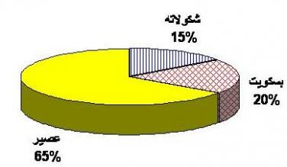

: الرسم البياني بالأعمدة 2 - Bar chart

A bar chart is a way of summarizing a set of categorical data . It is often used in exploratory data analysis to illustrate the major features of the distribution of the data in a convenient form .
Bar charts are used to summaries nominal or ordinal data
الرسم البياني بالأعمدة هو وسيلة لتلخيص البيانات أو المعلومات (الوصفية).
وفي اغلب الأحيان تستخدم في تحليل البيانات الاستكشافية أو الاستطلاعية لتوضيح المميزات الرئيسية وتوزيع البيانات أو المعلومات بشكل مناسب أو ملائم
ويستخدم الرسم البياني بالأعمدة لتلخيص البيانات أو المعلومات الاسمية والترتيبية
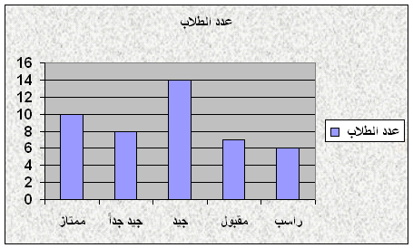

: الرسم البياني النقطي Dot plot
A dot plot is a way of summarizing data , often used in exploratory data analysis to illustrate the major features of the distribution of the data in a convenient form .
For nominal or ordinal data , a dot plot is similar to bar chart , with the bars replaced by a series of dots
الرسم البياني النقطي وسيلة لتلخيص البيانات وغالبا ما يستخدم في تحليل البيانات الاستكشافية لتوضيح الصفات الرئيسية وتوزيعها
بشكل مناسب
ويستخدم لتلخيص البيانات الاسمية والترتيبية , الرسم البياني النقطي يشبه الرسم البياني بالأعمدة لكن تستبدل الأعمدة بسلسة من النقاط
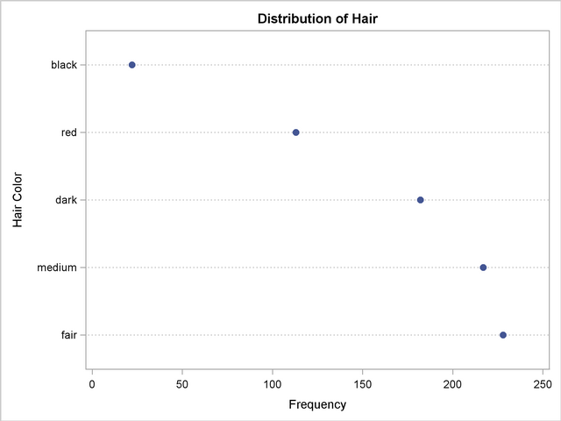

: المدرج التكراري 4 - histogram
A histogram is a way of summarizing data that are measured on an interval scale ( either discrete or continuous )
It is generally used when dealing with large data sets (>100 observations)

المدرج التكراري وسيلة لتلخيص البيانات التي يتم قياسها باستخدام مقياس الفترة (سواء كانت بيانات منفصلة أو مستمرة )
يستخدم عادة عند التعامل مع مجموع كبير من البيانات (اكثر من 100 ملاحظة )
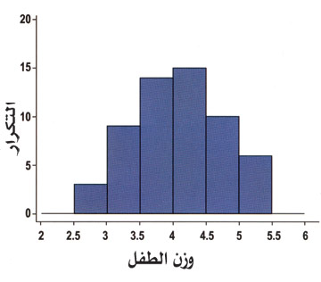

1 – Measures of central tendency :
The purpose of the measures :
1 – summarize the data in one number that best represent the data
2 – can be used for comparison between groups for certain characteristics
Measures of central tendency can be computed from the population or from sample .
Measures of dispersion :
It give just information on where the center of the date is
1 – Range :
Range is not good measure of variability as it ignores most of the observations by using only two observations
2 – variance :
Define the center of the data obtained from the sample or population
Tertiary prevention
Rehabilitation as component of tertiary prevention comprises
1 – medical Rehabilitation or the restoration of Skeletal function by means of physical therapy
2 – Vocational Rehabilitation or the restoration the capability to earn a living by means of occupational therapy .
3 – Social and psychological Rehabilitation or the restoration of personal confidence , family and social relationship by means of counseling
Chronic diseases
1 – Ischemic Heart disease
Areas soft water supply
Diets rich in satur
screening in order to identify people with one or more risk factors is the starting point in the control a
2 – Diabetes Mellitus
The problem with diabetes is to determine which people who are found to have a moderately raised blood sugar are eventually going to develop the disease .
3 – Coronary heart disease
4 –hypertension
The Screening test :
Is the basic tool of the screening program
1 – simplicity and cheapness
2 – safety
3 – meeting established standards
4- the test must be easily acceptable to both the investigator
6 – screening should be a continuous process
Reliability:
Is degree to which the results of repeated test are close to one another .
Validity:
is the degree to which the results of test correspond to the true value . it is a measure of accuracy .

