Lecture # 8
Tell a Story
(cont.)
Lecture Components
Personal Narrative (story)
First person pronouns
Transition Words
Organization: a beginning, a middle, and an end
The topic sentence
The supporting sentences
The concluding sentence

Tell a Story: Personal Narrative
- A personal narrative tells a story from the writer’s point of view.
It uses the first person (I, my, me, we, our, us).
- It also has a beginning, a middle, and an end.
- In a narrative, the topic sentence introduces the story.
- The supporting sentences tell about the setting, characters, and action.
- The concluding sentence ends the story and tells what it means.

First Person Pronouns
Pronoun
I (subject pronoun) | I had an interesting trip last July.
Me (Object pronoun) | The zookeeper gave me a snake.
My (Adjective pronoun) | My brother held the snake, too.
We (subject pronoun) | We watched an animal show.
Us (Object pronoun) | My father drove us to the zoo.
Our (Adjective pronoun) | It was very close to our home.

A Trip to the Zoo
First Person Pronouns
I had an interesting trip last July. My father, mother, brother, and I went to a new zoo downtown. My father drove us to the zoo. It was very close to our home. We walked around the zoo after we arrived. We saw many animals. Some animals were beautiful. Some animals were funny. I really liked the snakes. I thought they were fascinating. My brother didn’t like them. He thought they were scary. Later on, we watched an animal show. During the show, the zookeeper gave me a snake! I held it for five minutes. It was really heavy, but it was beautiful. Later on, my brother held the snake, too. Now, he doesn’t think they are scary. They are his new favorite animal. In the end, we all had a good time at the zoo.

Time Transition Words
Transition words help to connect ideas. Time transition words tell the reader the order of events in a story.
Examples:
Ahmad studied after he ate lunch. / Ahmad studied before he ate lunch.
Dad and I went fishing. Meanwhile, Mom made our lunch.
After Dad and I went fishing, Mom made our lunch.
Before Dad and I went fishing, Mom made our lunch.
Dad and I went fishing after Mom made our lunch.
While Dad and I went fishing, Mom made our lunch.

Remember from lecture 7 (Time Transition Words)
My family took a trip to New York City. We visited my father’s friends, Mr. and Mrs. Vega. We were very excited before we left. It was our first trip to New York. We flew to New York on Sunday morning. The weather was clear and sunny. The airplane was very comfortable. We arrived at about 3:00 p.m. Mr. and Mrs. Vega met us at the airport. We stayed with Mr. and Mrs. Vega for one week.
We didn’t have much free time during our visit to New York. On Monday, we took the train to Long Beach. We swam and ate watermelon. The next day, we took a ferry and saw the Statue of Liberty. The view was amazing. We had an exciting time. However, one day was especially exciting for Maria. On Friday, we went sightseeing. First, we took a subway into the city. Later on, we took a bus to Central Park. The bus was very crowded. We got off the bus at the park. However, something was strange. Maria wasn’t with us. We looked around and finally we saw her. Maria was on the bus! She didn’t get off. There were too many people. My father ran after the bus. At last, the bus driver stopped and Maria got off. In the end, Maria was safe. She was careful on buses and trains after that.
Time Transition Words
A Trip to the Zoo
I had an interesting trip last July. My father, mother, brother, and I went to a new zoo downtown. My father drove us to the zoo. It was very close to our home. We walked around the zoo after we arrived. We saw many animals. Some animals were beautiful. Some animals were funny. I really liked the snakes. I thought they were fascinating. My brother didn’t like them. He thought they were scary. Later on, we watched an animal show. During the show, the zookeeper gave me a snake! I held it for five minutes. It was really heavy, but it was beautiful. Later on, my brother held the snake, too. Now, he doesn’t think they are scary. They are his new favorite animal. In the end, we all had a good time at the zoo.

Time Transition Words
Look the following words up in an English-English dictionary and use them in examples of your own
after afterwards before
during earlier eventually
First until later
meanwhile next now
once second soon
when then today
The Topic Sentence
The first sentence in a paragraph is a sentence that
names the topic and tells what the paragraph will
explain about the topic. In a narrative essay, the
topic sentence introduces the story
Example: see next slide.
The Topic Sentence
I had an interesting trip last July. My father, mother, brother, and I went to a new zoo downtown. My father drove us to the zoo. It was very close to our home. We walked around the zoo after we arrived. We saw many animals. Some animals were beautiful. Some animals were funny. I really liked the snakes. I thought they were fascinating. My brother didn’t like them. He thought they were scary. Later on, we watched an animal show. During the show, the zookeeper gave me a snake! I held it for five minutes. It was really heavy, but it was beautiful. Later on, my brother held the snake, too. Now, he doesn’t think they are scary. They are his new favorite animal. In the end, we all had a good time at the zoo.
Supporting Sentences
The middle sentences in a paragraph are called the supporting sentences. They give examples or other details about the topic.
In a personal narrative, the supporting sentences tell about the setting, characters, and action.
Example: see next slide.

I had an interesting trip last July. My father, mother, brother, and I went to a new zoo downtown. My father drove us to the zoo. It was very close to our home. We walked around the zoo after we arrived. We saw many animals. Some animals were beautiful. Some animals were funny. I really liked the snakes. I thought they were fascinating. My brother didn’t like them. He thought they were scary. Later on, we watched an animal show. During the show, the zookeeper gave me a snake! I held it for five minutes. It was really heavy, but it was beautiful. Later on, my brother held the snake, too. Now, he doesn’t think they are scary. They are his new favorite animal. In the end, we all had a good time at the zoo.

The Concluding Sentence
The last sentence in a paragraph is called the concluding sentence. It often repeats the topic sentence in different words or summarizes the main points.
In a personal narrative, the concluding sentence ends the story and tells what it means.
Example: see next slide.
The Concluding Sentence
I had an interesting trip last July. My father, mother, brother, and I went to a new zoo downtown. My father drove us to the zoo. It was very close to our home. We walked around the zoo after we arrived. We saw many animals. Some animals were beautiful. Some animals were funny. I really liked the snakes. I thought they were fascinating. My brother didn’t like them. He thought they were scary. Later on, we watched an animal show. During the show, the zookeeper gave me a snake! I held it for five minutes. It was really heavy, but it was beautiful. Later on, my brother held the snake, too. Now, he doesn’t think they are scary. They are his new favorite animal. In the end, we all had a good time at the zoo.

((Personal narrative example)) online

Tell a Story
Tell a story about a trip you took.
Describe the setting and the characters.
Describe the action.
Use transition words
Be sure your story has a beginning (topic sentence), a middle (supporting sentences), and an end (concluding sentence).
See next slide:
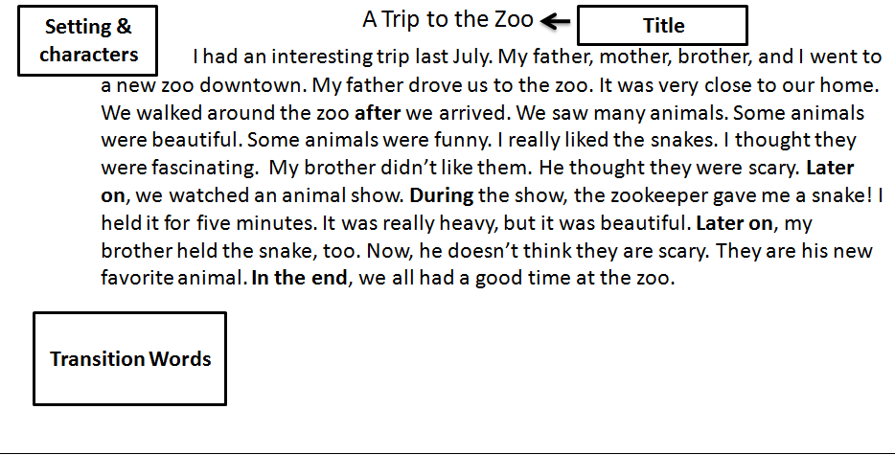
My Trip
Setting:
Where did you go?
When did you go?
Characters:
Who did you go with?
Action:
What happened?

Practice
- My family took a train to Chicago last summer.
- took train
- drove a train
- flew a train
- Make no change ✓
- The scary movie was bright.
- cloudy
- Frightening ✓
- careful
- Make no change
- Later on, we eat lunch at a new café.
- eats
- did ate
- Ate ✓
- Make no change
- We didn’t swam on our trip.
- doesn’t swam
- didn’t swim ✓
- doesn’t swim
- Make no change
- Where do you go last weekend?
- Where do go
- Where did you go ✓
- Where you go
- Make no change
- We were on the train all day. It was very nice.
- It was terrible.
- It was amazing.
- It was OK.
- It was exhausting. ✓
- My family took last July a trip to Abha.
- My family took a trip to Abha last July. ✓
- My family to Abha took a trip last July.
- Make no change.
- We took a train Damman to Riyadh.
- We took a trip from to Dammam Riyadh.
- We took a trip from Dammam to Riyadh. ✓
- Make no change

------------------------------------------------

