Lecture 2 --- part 2
SOUNDS OF ENGLISH: Consonants

الحروف الساكنة في اللغة الإنجليزية تصدر عن طريق مرور الهواء عبر الأوتار الصوتية مروراً بمخارج الحروف (الاسنان العلوية ، اللسان، الحنك ... إلخ) وتختلف طبيعة مرورها حسب انغلاق مرور الهواء إما يكون غلق كامل
أو جزئي يسمح بمروره عبر المخارج مع التثقيل أو التخفيف ( غنة أو بغير غنة ) وهكذا

- In English there is a MANNER OF ARTICULATION – PLOSIVES to make the consonants. What are they in general?

- Stop (p, b, t, d, k , g )
- Fricative (f, v, th, dh, s, z, sh, zh, h )
- Affricates ( / ʧ / , / ʤ /)
- Nasals (/ m / , / n / , / ŋ /)
- LIQUIDS ( /l/, /r/ )
- APPROXIMANTS - GLIDES

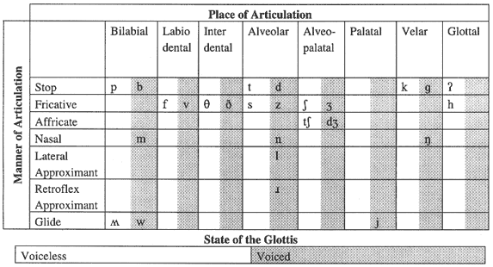

- ……………:The air is blocked for a moment, then released. In English, they are p, b, t, d, k, and g? ( choose the true manner of articulation)
- Stop
- Fricative
- Affricates

- ……………: involve a slightly resisted flow of air. In English, these include f, v, th, dh, s, z, sh, zh, and h.g? ( choose the true manner of articulation)
- Affricates
- Fricative
- Nasals

- ……………: total closure of speech organs and air is released with friction? ( choose the true manner of articulation)
- Affricates
- Fricative
- Nasals

- ……………: Sounds are produced when air flow through the mouth is completely blocked and released through the nose. ( choose the true manner of articulation)
- Affricates
- Fricative
- Nasals

- There are no …………… nasals
- Voiced
- Voiceless
- All of above.

- ……………: are sounds with very little air resistance. ( choose the true manner of articulation)
- Affricates
- Nasals
- Liquids

- We touch the tip to the ridge of the teeth and let the air go around both sides. To say the ……… consonant:
- / r/
- / l/
- None of above.

- We almost block the air on both sides and let it through at the top. To say the ……… consonant:
- / r/
- / l/
- None of above.
- Both / l / and / r / are :
- Voiced.
- Voiceless.
- All of above.

- Semivowels are sounds that are, as the name implies, very nearly vowels, They are also called …….:
- Stop
- Glides
- Fricative

- Phoneme: smallest significant unit of sound. (Choose the correct answer)
- True
- False
- None of above

- ……….: two different words which are identical in every way except for one sound segment that occurs in the same place in the string.
- Minimal sets
- Minimal pairs
- None of above

- ………..: more than two words in a string
- Minimal sets
- Minimal pairs
- None of above

- mat & met , ray & lay , is:
- Minimal sets
- Minimal pairs
- None of above

- sue & shoe & chew , bib & bit & bid , is:
- Minimal sets
- Minimal pairs
- None of above

- Allophone: a variant of a phoneme

- Free variation: When a word is pronounced in two different ways – using two different phonemes but has no effect on the meaning

بدويه – ملتقى جامعة الملك فيصل – المستوى الخامس
2011 - 2012

