Lecture 1
Simple Present Tense: Uses
Everyday activities: What do you do every day?
Routines, habits
General truths
Bake Cut / style hair
Build deliver draw / design drive
fix / repair plumbing, appliances
fly garden guard
manage / supervise
paint use a computer / program
answer telephone, type, file, take messages
sell serve, help customers teach research, do experiments wash dishes clean, wax weld
Third Person
He / She / It
Singular subject (my friend, the boss, a co-worker)
Verb + s
Goes, works, talks, does, speaks
Spelling rules: Third person verbs in simple present tense
- teach research wash push
Third Person Spelling Rules
Pass fix wax
Rule 1: verbs ending in –ch, -sh, -ss, and –x + es
Third Person Spelling Rules
fly dry try study
Rule 2: final consonant + y ->
- y + ies
Third Person Spelling Rules
do go have
Find and correct the mistakes:
- I’m work for a very good company, and I also student at MiraCosta College.
- I’m work for a very good company, and I also student at MiraCosta College.
- The manager tas with all employees once a week.

- The manager and I has a meeting today.
- The company’s profits looks good.
- The technician fixxes any computer problems we have.
- Everybody working hard every day, and company morale is high.
- The people in this company really likes working here.
Negatives in Simple Present Tense
Change these to negative:
- I work.
- I like my job.
- They have benefits.
- We have a nice boss.
Negatives in Simple Present Tense
Change these to negative:
- She has a lot of experience.
- He drives to his work.
- The new employee comes early.
- My co-worker talks to me.
Negatives in simple present tense
- I / you / we / they
Plural subject (the workers, the people)
+ do not (don’t) + verb
- He / she / it
Singular subject
+ does not (doesn’t) + verb (no –s)
Questions in Simple Present Tense
Change these statements to questions:
I work.
I like my job.
They have benefits.
We have a nice boss.
Questions in Simple Present Tense
Change these statements to questions:
She has a lot of experience.
He drives to his work.
The new employee comes early.
Your co-worker talks to you.
Questions in Simple Present Tense
Do + I / you / we / they + verb + ?
Does he / she / it + verb + ?
Lecture 2
The Present Simple
Lecture Summary
Present Simple - summary
Negative
Questions
Practices
And again
+ +

We don’t visit the moon
SNOB…
Don’t forget the snobs. He She It. They are very tricky. They also take the verb DO it becomes DOES
But the verb looses
s
It snows in the winter.
It snow in the summer
LET’S PRACTISE
Write in negative
My cat has a swimsuit.
- Dan and Dana catch frogs.
- Robots eat hot dogs

Write in negative
My cat has a swimsuit.
My cat doesn’t have a swimsuit.
- Dan and Dana catch frogs.
2) Dan and Dana don’t catch frogs
3) Robots eat hot dogs.
3) Robots don’t eat hot dogs.
Simple Present Tense- Negative
Change these statements to questions:
- I work.
- I like my job.
- They have benefits.
- We have a nice boss.
Simple Present Tense- Negative
Change these statements to questions:
- She has a lot of experience.
- He drives to his work.
- The new employee comes early.
- Your co-worker talks to you.
Yes/ No Questions in Simple Present Tense
- Do + (I – you – we – they) + verb + rest of sentence ?
- Does (he- she- it) + verb + rest of sentence ?
3. IS (he-she-it)+ rest of sentence?
4. Are (you-we-they)+ rest of sentence?
5. AM (I) + rest of sentence?
Simple Present Tense- Questions
Change these statements to questions and then answer them
- I work.
DO I work?
2. You like my job.
DO you like my Job?
3. He has cats.
Does he have cats.
Lecture 3
The Present Simple Lecture Summary Using the textbook to answer the exercises
Lecture 4

When you see verb to be you have to think of ing
Noun (pronoun) + Verb to be (is- am –are) + (verb) = verb ing
Majid is playing tennis
Sara is sleeping
Present Continuous Afirmative
I | am | eating
You | are | eating
He  She  It | is | eating
We  You  They | are | eating

Present Continuous Interrogative
I | am | eating
You | are | eating
He  She  It | is | eating
We  You  They | are | eating

Present Continuous Negative
I | am not | eating
You | aren´t | eating
He  She  It | isn´t | eating
We  You  They | aren´t | eating

Present Continuous- Signal words
Now- right now
Look!
Listen!
At the moment
I am reading
What are they doing?
They are boxing He is cooking He is doing judo He is driving He is falling down
He´s playing golf They are playing hockey He´s looking He´s riding a bike It is eating
They are shaking hands He is skateboarding He is weightlifting He´s playing rugby
He´s working on the computer He´s windsurfing He´s surfing They are singing
Test-Taking Strategies
The boys _GO_ to the gym everyday
لم نختار قونق لان افريدي مضارع بسيط ليس مستمر
- going b) go c) goes
Sary is _____ to the radio right now.
- listening b) listens c) listen
Mubarak and Huda usually ______ their parents
a) Visits b) visiting c) visit
Test-Taking Strategies
Salim ____ a lexus car
- drives b) driving c) drive
Reem _____ to a new house.
- moving b) is moving c) move
Jamal ______ at 9.30pm
a) sleeping b) sleep c) sleeps
Test-Taking Strategies
We____ a new house
- buy b) are buying c) buys
Maha _____ as a manager.
- working b) works c) work
I ______ drinking milkshakes
a) Like b) liking c) likes
Lecture 5
The Simple Future Lecture Summary Simple Future- Uses Questions Negative Practices
Pre-Test (Affirmative Sentences)
Select the best answer.
__ 1. The stores ____ at noon today.
(A) is going to close (B) are going to close (C) am going to close
__ 2. The secretary ___ the documents tomorrow morning.
(A) is going to fax (B) am going to fax (C) are going to fax
__ 3. Esteban ___ us at the Mall tonight at 8:30.
(A) am going to meet (B) are going to meet (C) is going to meet
__ 4. I ___ a health club next month.
(A) am going to join (B) is going to join (C) are going to join
__ 5. The meeting ___ in 15 minutes.
(A) are going to begin (B) is going to begin (C) am going to begin
Pre-Test (Negative Sentences)
__ 6. Mr. and Mrs. Cardona ____ their home near the beach.
(A) am not going to build (B) isn’t going to build (C) aren’t going to build
__ 7. Some friends ___ to our welcome party next Friday.
(A) isn’t going to come (B) aren’t going to come (C) am not going to come
__ 8. I ___ at any fast food restaurant this week.
(A) aren’t going to eat (B) isn’t going to eat (C) am not going to eat
__ 9. Elizabeth ___ cards to her friends this Christmas. She’s going to visit them
(A) isn’t going to send (B) aren’t going to send (C) am not going to send
__10. Luis fractured his ankle. He ___ basketball this basketball season.
(A) aren’t going to play (B) am not going to play (C) isn’t going to play
Pre-Test (Yes/No Questions)
__ 11. __ George ___ from California to Mexico next summer ?
(A) Is, going to drive (B) Am, going to drive (C) Are, going to drive
__ 12. __ you ___ casual clothes to the get together activity next Saturday ?
(A) Are, going to wear (B) Is, going to wear (C) Am, going to wear
__ 13. __ the students ___ their e-mails this afternoon ?
(A) Is, going to read (B) Am, going to read (C) Are, going to read
__ 14. __ the train ___ in twenty minutes ?
(A) Am, going to leave (B) Is, going to leave (C) Are, going to leave
__ 15. __ I ___ my reimbursement check next Friday ?
(A) Are, going g to receive (B) Is, going to receive (C) Am, going to receive
Pre-Test (Information Questions)
__ 16. Where __ Anita ___ her job interview tomorrow morning ?
(A) am, going to have (B) is, going to have (C) are, going to have
__ 17. When __ Paul ___ the yard ?
(A) are, going to clean (B) is, going to clean (C) am, going to clean
__ 18. Who _______ Nancy to the airport next Sunday ?
(A) are going to take (B) am going to take (C) is going to take
__ 19. What __ you ___ next weekend ?
(A) are, going to do (B) is, going to do (C) am, going to do
__ 20. Why __ the manatees probably ___ in the future ?
(A) is, going to disappear (B) are, going to disappear (C) am, going to disappear

Simple Future Tense
You use the Simple Future Tense when you talk about future events or plans.
You also use the Simple Future Tense when you want to make a prediction or make a promise. ☺

Simple Future Tense
There are two (2) ways to make the Simple Future Tense. In this module we will present Pattern # 1. In the module Simple Future Tense Part II, we will present Pattern # 2.
Pattern # 1:
SUBJECT + BE + GOING TO + VERB (BASE FORM)
Pattern # 2:
SUBJECT + WILL + VERB (بدون أي اضافاتBASE FORM)
Simple Future Tense
Pattern # 1
Subject + BE (am, is, are) + going to + Verb (base form)…
Example:
I am going to graduate next May. OR I will graduate next May
Future Time Expressions
tomorrow
tomorrow ► morning
► afternoon
► evening
► night
the day after tomorrow
next ► Monday
► week
► weekend
► month
► year
► semester
► summer
► Eid

today
this ► afternoon
► Friday
► week
► month
► year
► Thanksgiving…
in ► ten minutes
► three days
► two weeks
► nine months
► a few years
► a little while…

soon
tonight

Affirmative Sentences
SUBJECT + BE | GOING TO | VERB  (BASE FORM) | Time
I’m | going to | study | tomorrow.
you’re | going to | study | tomorrow.
he’s  she’s | going to | study | tomorrow.
we’re  you’re  they’re | going to | study | tomorrow.
it’s | going to | rain | tomorrow.

Affirmative Sentences Examples:
1. I’m going to watch a movie tonight.
2. You’re going to see the doctor tomorrow.
3. Miguel is going to fix his car later today.
4. Sarah and Daniel are going to buy a laptop next month.
5. The dog is going to eat its food soon.
6. We’re going to move to Florida next year.
7. The game is going to begin in 10 minutes.
8. Mrs. Medina is going to sign the house contract next Monday.

Negative Sentences
Negative Sentences
SUBJECT + BE | NOT | GOING TO | VERB (BASE FORM) | TIME
I’m | not | going to | study | tomorrow.
You’re
He’s
She’s
We’re
You’re
They’re
It’s | not | going to | rain | tomorrow.
Negative Sentences Examples:
1. I’m not going to watch a movie tonight.
2. You’re not going to see the doctor tomorrow.
3. Miguel is not going to fix his car later today.
4. Sarah and Daniel are not going to buy a laptop next month.
5. The dog is not going to eat its food soon.
6. We’re not going to move to Florida next year.
7. The game is not going to begin in 10 minutes.
8. Mrs. Medina is not going to sign the house contract next Monday.
Use of Contractions
Contractions: A contraction is the combination of two words into
one. In contractions, letters are replaced with an apostrophe (’).
Examples:
I am not = I’m not
you are not = you’re not / you aren’t
he is not = he’s not / he isn’t
she is not = she’s not / she isn’t
it is not = it’s not / it isn’t
we are not = we’re not / we aren’t
they are not = they’re not / they aren’t

Examples of Contractions in Negative Sentences
- I am not going to watch a movie tonight.
- You’re not going to see the doctor tomorrow.
- We’re not going to move to Florida next year.
- The game is not going to begin in 10 minutes.
- I’m not going to watch a movie tonight.
- You aren’t going to see the doctor tomorrow.
- We aren’t going to move to Florida next year.
- The game isn’t going to begin in 10 minutes.
Yes/No Questions and Short Answers
YES/NO Questions
BE | SUBJECT | GOING TO | VERB  (BASE FORM) | TIME | ?
Am | I | going to | study | tomorrow | ?
Are | you
Is | he  she
Are | you  we  they
Is | it | going to | rain | tomorrow | ?

Yes/No Questions and Short Answer
SHORT ANSWERS
AFFIRMATIVE | NEGATIVE
Yes, you are. | No, you’re not. / No, you aren’t.
Yes, I am. | No, I’m not.
Yes, he is.  Yes, she is. | No, he’s not. / No, he isn’t.  No, she’s not. / No, she isn’t.
Yes, you are.  Yes, we are.  Yes, they are. | No, you’re not. / No, you aren’t.  No, we’re not. / No, we aren’t.  No, they’re not. / No, they aren’t.
Yes, it is. | No, it’s not. / No, it isn’t.

Yes/No Questions and Short Answers
Examples:
1. Are you going to watch a movie tonight?
Yes, I am. / No, I am not. / No, I’m not.
2. Are you going to see the doctor tomorrow?
Yes, I am. / No, I am not. / No, I’m not.
3. Is Mike going to fix his car later today?
Yes, he is. / No, he’s not. / No, he isn’t.
4. Are Sarah and Daniel going to buy a laptop next month?
Yes, they are. / No, they’re not. / No, they aren’t.
Yes/No Questions and Short Answers
5. Is the dog going to eat its food soon?
Yes, it is. / No, it’s not. / No, it isn’t.
6. Are you going to move to Florida next year?
Yes, we are. / No, we’re not. / No, we aren’t.
7. Is the game going to begin in 10 minutes?
Yes, it is. / No, it’s not. / No, it isn’t.
8. Is Mrs. Medina going to sign the house contract next Monday?
Yes, she is. / No, she’s not. / No, she isn’t.

Wh-Questions (Information Questions)
WH-QUESTIONS ABOUT THE SUBJECT
WH-WORD | BE | GOING TO | VERB  (Base Form) | TIME | ? | SHORT ANSWERS
Who | is | going to | come | tomorrow | ? | Robert and his family.
What | is | going to | happen | tomorrow | ? | There is going to be a cancer detection clinic.

OTHER WH-QUESTIONS
WH-WORD | BE | SUBJECT | GOING TO | VERB (BASE FORM) | TIME | ?
1. What | is | she | going to | do | tomorrow | ?
2. Where | is | the plane | going to | land | tomorrow | ?
3. When | are | you | going to | arrive | tomorrow | ?
4. Why | are | we | going to | shop | tomorrow | ?
5. Who | are | they | going to | visit | tomorrow | ?
6. How | am | I | going to | finish | tomorrow | ?

Wh-Questions (Information Questions)
More Examples:
1. (Q) What are you going to watch tonight?
(A) A terror movie.
2. (Q) When are you going to take a test?
(A) Tomorrow at 9:30 am.
3. (Q) What is Mike going to fix today?
(A) His car.
4. (Q) Where are you going to move to next year?
(A) To Florida

.
5.(Q) Who is going to sign the house contract next Monday?
(A) Mrs. Medina.
Practice Exercises (Affirmative Sentences)
Select the best answer.
__ 1. I ____ the laundry this afternoon.
(A) is going to do (B) am going to do (C) are going to do
__ 2. Eliezer ____ to a pool party next Saturday.
(A) is going to go (B) are going to go (C) am going to go
__ 3. We ____ at the new Italian restaurant tomorrow night.
(A) am going to eat (B) is going to eat (C) are going to eat
__ 4. The tutors ____ the students in the English class next week.
(A) is going to help (B) are going to help (C) am going to help
__ 5. Carolyn ____ her baby next month.
(A) is going to have (B) am going to have (C) are going to have
Practice Exercises (Negative Sentences)
__ 6. My mother ____ dinner tonight.
(A) am not going to cook (B) isn’t going to cook (C) aren’t going to cook
__ 7. The temperature ____ in the 90s tomorrow.
(A) isn’t going to be (B) am not going to be (C) aren’t going to be
__ 8. Bob and his family ____ at the lake next weekend.
(A) aren’t going to fish (B) isn’t going to fish (C) am not going to fish
__ 9. I ____ new decorations for the house this Christmas.
(A) aren’t going to buy (B) am not going to buy (C) isn’t going to buy
__10. The meeting ____ at three o’clock. It’s going to end later.
(A) am not going to end (B) isn’t going to end (C) aren’t going to end
Practice Exercises (Yes/No Questions)
__ 11. __ you and your family __ your house before you sell it?
(A) Is, going to remodel (B) Am, going to remodel (C) Are, going to remodel
__ 12. __ Henry __ in the university next semester?
(A) Is, going to register (B) Am, going to register (C) Are, going to register

__ 13. __ your parents __ their wedding anniversary next July?
(A) Am, going to celebrate (B) Are, going to celebrate (C) Is, going to celebrate
__ 14. __ Julian and Carol __ a business next year?
(A) Is, going to own (B) Am, going to own (C) Are, going to own
__ 15. __ Wal-Mart __ until 10:00 pm next Sunday?
(A) Am, going to open (B) Are, going to open (C) Is, going to open
Practice Exercises (Information Questions)
__ 16. Who ___ your sister ___ to her wedding?
(A) are, going to invite (B) is, going to invite (C) am going to bring
__ 17. When ___ the students ___ their science projects?
(A) are, going to finish (B) am, going to finish (C) is, going to finish
__18. What trick __ the dolphin __ next?
(A) am, going to do (B) is, going to do (C) are, going to do
__ 19. Why ___ Peter ___ his sports car next month?
(A) am, going to sell (B) are, going to sell (C) is, going to sell
__ 20. How ___ the engineers ___ houses in the future?
(A) are, going to design (B) am, going to design (C) is, going to design
Lecture 6
The Past Lecture Summary Simple Past- Uses Past Perfect Present Perfect Questions Negative Rule
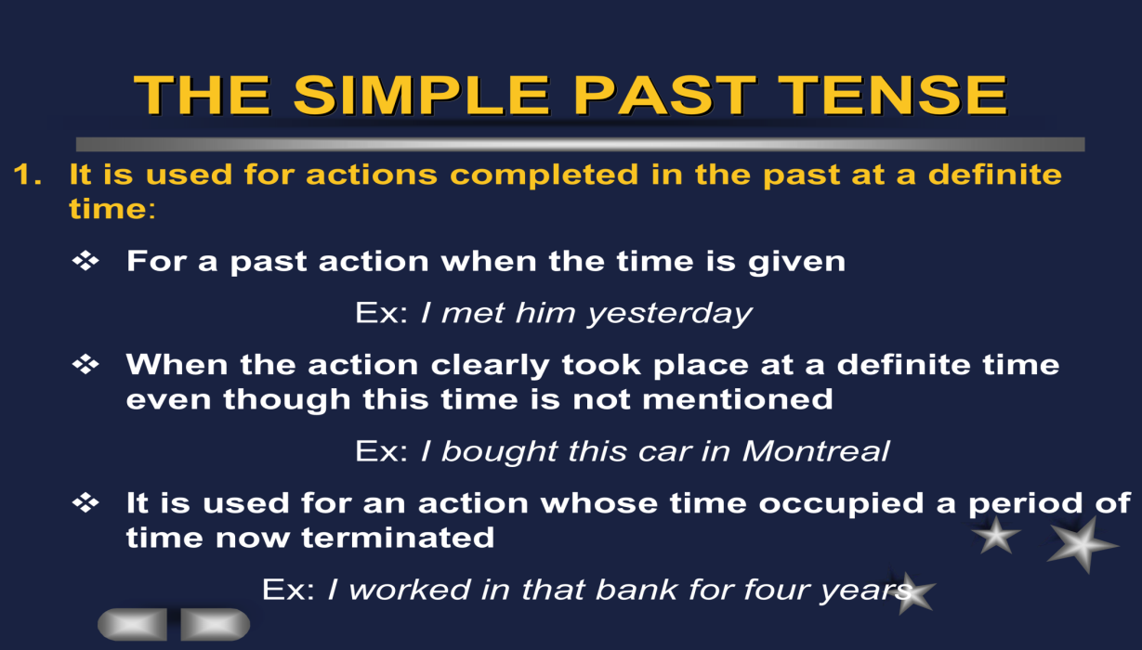
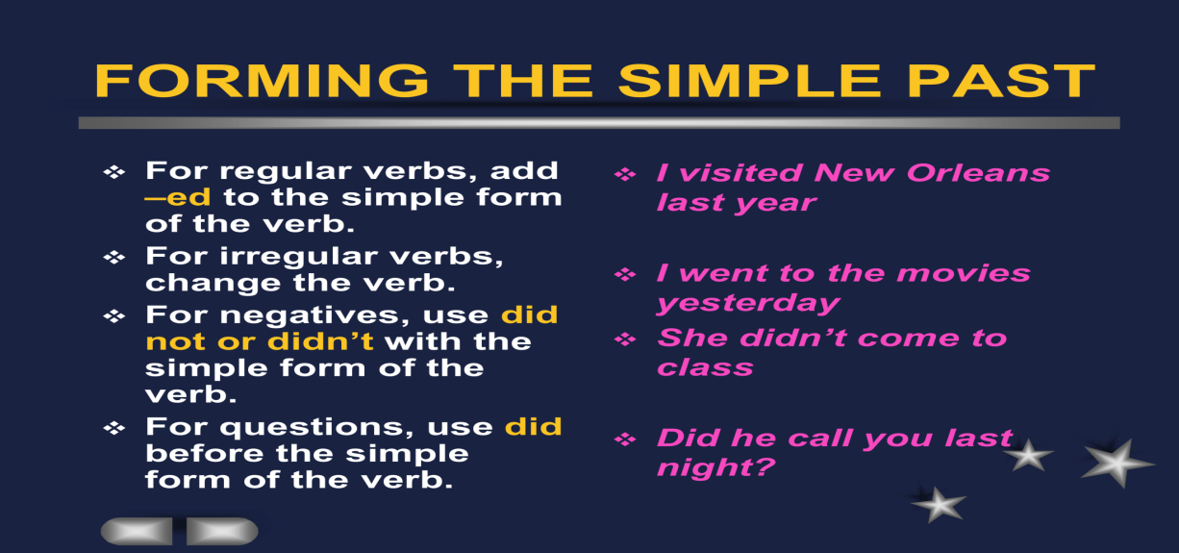

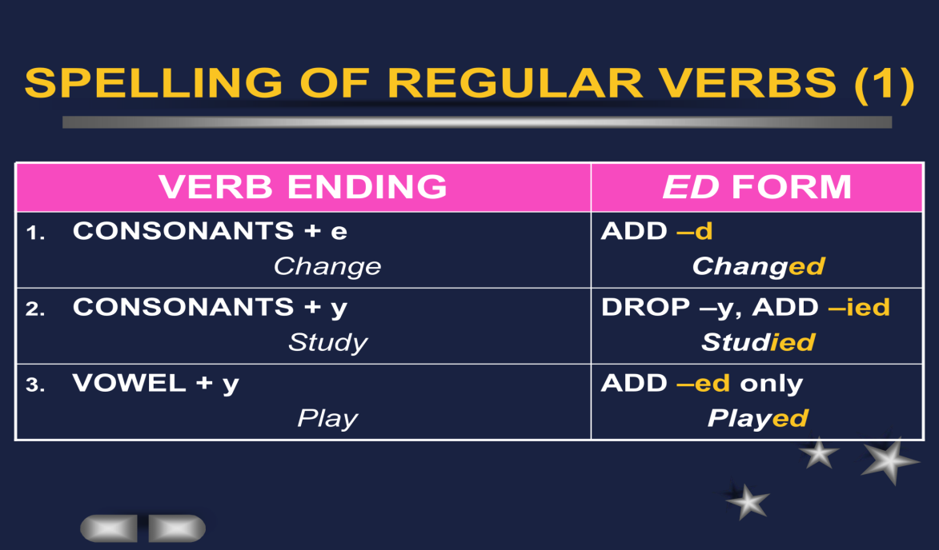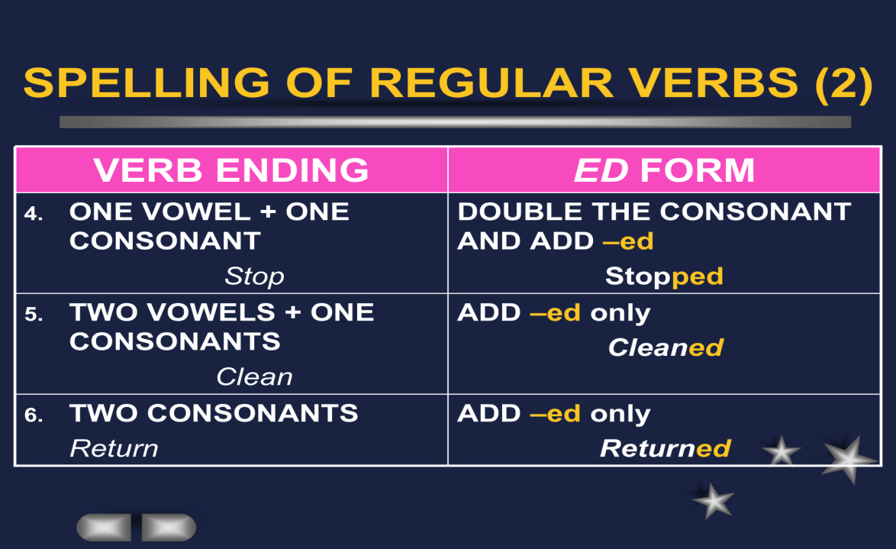
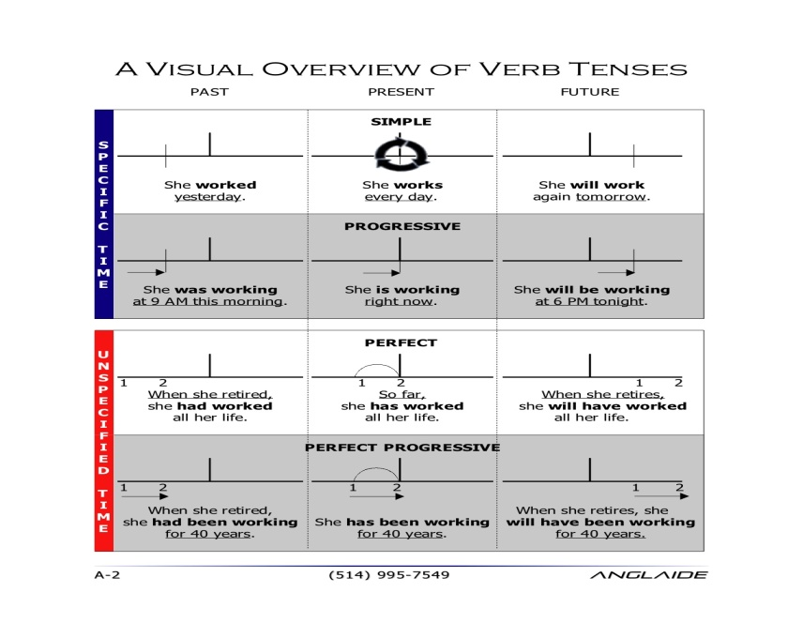
Lecture 7
Practices
Unit 1
Lecture Summary
Referring to the book Unit 1
Pages 13-34
Lecture 8
Practices
Unit 1
Lecture Summary
Referring to the book Unit 1
Pages 34-46

Lecture 9
Count and Noncount nouns
NONCOUNT NOUNS
Whole groups or whole masses.
Furniture, coffee and sugar.
Abstract concepts.
Love, wisdom, spirituality.
Phenomenon of Nature
Sunshine, rain, snow.
SOME COMMON NONCOUNT NOUNS
Whole groups made up of similar items
Fluids
Solids Gases Particles Abstractions Languages Fields of Study Recreation
- Activities Natural Phenomena Generic Nouns
Articles are used to make generalizations .A is used for singular nouns
A banana is yellow. An umbrella An egg
0 is used for plural nouns and non count nouns
0 Bananas are yellow.
0 Fruit is good for you.

Indefinite Nouns
Singular | I ate a banana.
Plural count noun  (two, a few, several) | I ate some bananas.
Noncount noun  (a little, a lot of) | I ate some fruit.

Definite Nouns
The banana I ate this morning was delicious. | Singular  اقصد موزه معين
I got the apples from the tree. | Plural
The fruit from that market is inexpensive. | Noncount  نستخدم the
Expressions of Quantity for Count nouns
One Each Every Two,three, etc. A couple of A few
Many Several A number of
Expressions of quantity for non count nouns
A little Much A great deal of
Expressions of quantity for both count and noncount nouns
No(there is no book) Some/any I have some fruits A lot of/lots of
Plenty of Most all
Negative vs. Positive
She has few friends.  تستخدم مع count N | She made a few friends.
I have little money.  تستخدم مع non count  Memorize | I saved a little money.
Go to the book pp. 57
Page 96 important

Lecture 10
Modal Auxiliary What do they mean? Can- Could will- Would Shall - Should Must- Have to – Ought to
May- Might
Modals Giving permission
Would you please help me?لاتعرفه ابد فتطلب منه المساعدة
Could you help me? تعرفه لكنه ليس صديقك
Can you help me? تسال عن شي معين
Will you help me?
Modals Giving permission
Would you please help me?
Could you help me
Can you help me?
Will you help me?
May I ….?
Modals Expressing ability
I can speak English (present ability)
Last year I could speak English (past ability)
I am able to …. (present)
I was able to …. (past)
I will be able to ….. (future)
Modals Expressing expectation
The train should arrive now
Ought to seldom used! (negative or questions only!)
Should – ought to – had better (express advice)
You are sick. You should see a doctor!
You ‘d better not stay home.
Modals Expressing preferences
I would like …… to some sope
I would rather to go to Costa rather than Blockbuster
Modals Expressing Need or obligation
Must (You must have a driving license to drive)
Must not to ( you must not bother your parents)
Have to
You have to study for the exam.
Not have to
You do not have to come with us.
Modals Expressing possibility and impossibility
May --- may not
Might …. Might not

Could … could not
…..have enough money
It can’t be five!
That couldn’t be my uncle!
Borrow & Lend
Borrow = you take from some one
May I borrow your pen?
Borrowing a book from a library
Lend= you ask some one to give you something
Can you lend me your car?
Lending someone money
Modals Expressing preferences
Go to the book pp. 135 (important)
Lecture 11
Phrasal Verbs
What do they mean?
Verb + preposition (particles)
separable- inseparable
Inseparable Phrasal Verbs
agree with
belong to
talk to
wait for
look for
Remind – of
Ask ----- about
Inseparable verbs
Check into (register)
Come across ( find/ met)
Drop by (visit)
Keep up with (stay on the same level)
Go over (review)

Go through (experience/ have)
Take care of (supervise)
Stay up ( remain awake)
Separable Phrasal verbs
Bring up (raise)
Look over (review, read quickly)
Try out (test)
Work out (find a solution)
Separable phrasal verbs
Academic:
Add up fill in
Finish up fill out
Write up hand in
Check in hand out
Check out hand back
Do over
Look over
Go to the book page 220
Lecture 12
Global Connections
What do they mean?
They connect two sentences
And But Nor Or So
Adverb clauses (condition/ contrast/ reason/ time)
If after/before
Unless until
Although when/ since
Even though
So that
Because

Transitions
For example
In addition/ furthermore
In fact/ as a mater of fact
However/ in contrast
Therefore/ as a result/ consequently
First/ second/ third etc..
Go to the book page 259
Lecture 14
The Passive voice
Active sentence
Noha made a cake
Passive voice
The cake was made by Noha
Structure of the passive voice
Present
Is/am/are + verb ed + by
Past
Was/ were + verb ed + by
The cake was made of strawberry
The cake was made for the guests
Passive voice with it
People believe that the Earth is round. (active present)
It is believed that the Earth is round. (passive present)
People thought that English was a difficult language (active past)
It was thought that English was a difficult language. (passive past)
Go to the book page 293

Lecture 14
SUDI GIRL :) دعواتكم لي
