Research methods and Design
Dr Muneer Alqahtani

Coordination : Skon al jro7

Lecture 1
Research Methods & Design

Definitions
What is Research?
The systematic investigation into and study of materials and sources in order to establish facts and reach new conclusions.

What are methods?
A particular procedure for accomplishing or approaching something, esp. a systematic or established one.

What is design?
It is a logical structure of the inquiry (research)

Types Of Research
Descriptive
Explanatory
Ethnographic
Experimental
Action research
Case study
Longitudinal vs. cross-sectional

Quantitative vs. Qualitative

Quantitative: you collect data through some tools and you quantify them
Qualitative: you collect data through some tools and you explain and discuss, argue, hypothesis and philosophy them.

Classical Report of Research
Abstract
Introduction
Literature Review
Methods
Data Analysis
Results
Discussion
Conclusion
Bibliography
Appendices

Lecture 2
Classical Report of Research

Classical Report of Research
Abstract
Introduction
Literature Review
Methods
Data Analysis
Results
Discussion
Conclusion
Bibliography
Appendices

Abstract
The abstract is a short (about 100-500 word) summary of the entire paper. It should include: goals and objectives, results, and conclusions. It is usually one of the last parts of the paper to be written.

Introduction
The introduction describes the focus and purpose of the paper you are writing. It gives an overview of what is contained in the paper's various sections.

Literature Review
A literature review is a search and evaluation of the available literature in your given subject or chosen topic area. It documents the state of the art with respect to the subject or topic you are writing about. It also shows your readers that you have an in-depth grasp of your subject; and that you understand where your own research fits into and adds to an existing body of agreed knowledge.

Methodology
This section describes what you did, how you did it, gives strategies, sample calculations, diagrams and circuits, and descriptions of equipment. The goal here is to give the reader sufficient information to be able to repeat your work if desired.

Data Analysis
Data analysis is the most crucial part of any research. It summarizes collected data. It involves the interpretation of data gathered through the use of analytical and logical reasoning to determine patterns, relationships or trends.

Results
This section is where you prove your point with the data. Give graphs and tables of costs, profits, whatever your data is. Also give some description or guide to help the reader recognize your important points.

Discussion
The purpose of the discussion is to interpret and describe the significance of your findings in light of what was already known about the research problem being investigated, and to explain any new understanding or insights about the problem after you've taken the findings into consideration.

Conclusion
Here you state what your learned or proved. What are the "take home messages" or major accomplishments of this work? You may also describe interesting observations, new questions, and future work here.

Bibliography
A list of the references you used in the work & writing the paper.

Appendices
An appendix contains supplementary material that is not an essential part of the text itself but which may be helpful in providing a more comprehensive understanding of the research problem or it is information that is too cumbersome to be included in the body of the paper. A separate appendix should be used for each distinct topic or set of data and always have a title descriptive of its contents.

Lecture 3
Quantitative Research I

Quantitative research methods are research methods dealing with numbers and anything that is measurable in a systematic way of investigation of phenomena and their relationships. It is used to answer questions on relationships within measurable variables with an intention to explain, predict and control a phenomena.

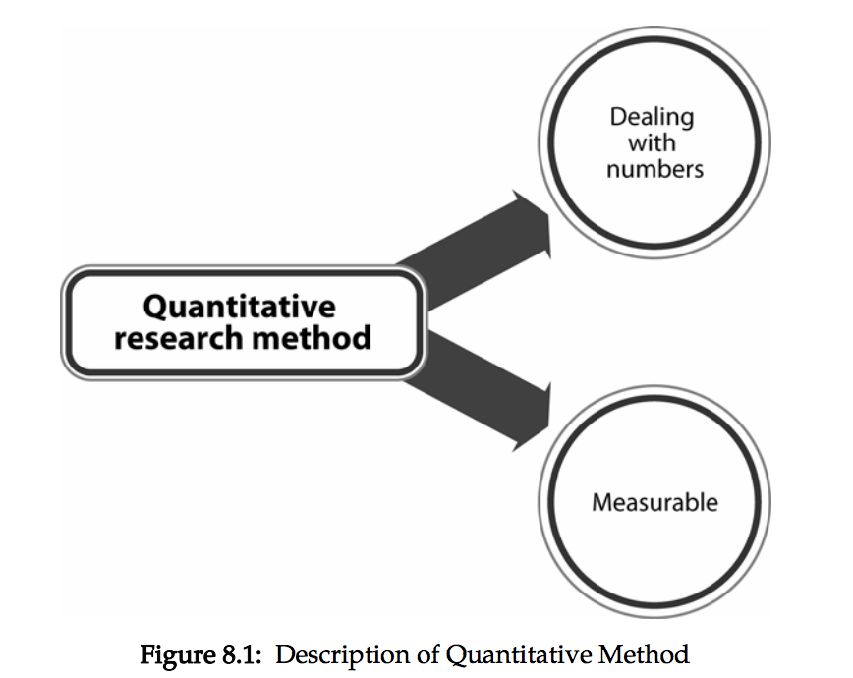

Quantitative method typically begins with data collection based on a hypothesis or theory and it is followed with application of descriptive or inferential statistics. Surveys and observations are some examples that are widely used with statistical association.

Descriptive Research
Quantitative research methods fall under the broad heading of descriptive research. This type of research corresponds to identifying the characteristics of an observed phenomenon, or exploring correlations between two or more entities.

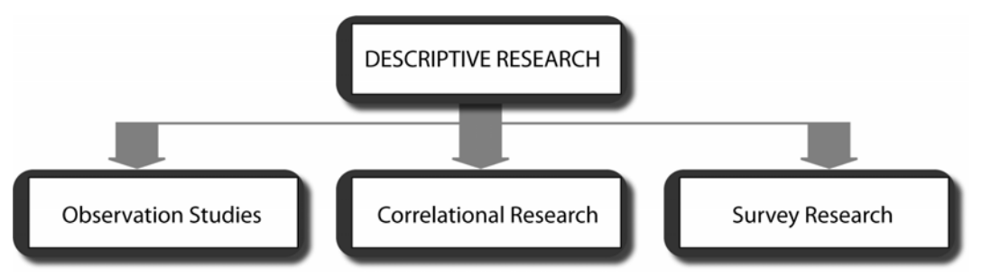

Observation Studies
Observation studies are involved in both quantitative and qualitative research methods. However, in quantitative methods, the focus of observation studies is on a particular factor of behaviour and it is quantified. In this type of design, a researcher will try to maintain objectivity in assessing the behaviour being studied.

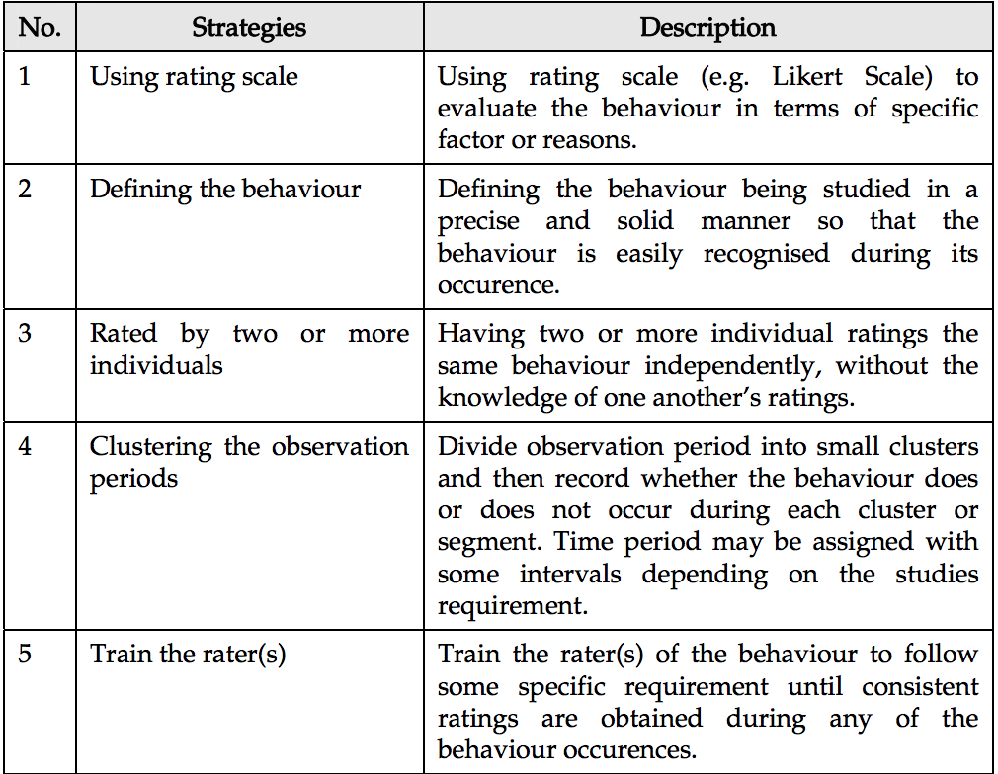

Lecture 4
Quantitative Research II

Correlational Research
Correlational research or studies examine differences of characteristics or variables of two or more entities. A correlation exists when one variable increases or decreases correspondingly with the other variable. A researcher will gather data about two or more variables in a particular group.
These data are numbers that reflect measurement of the characteristics of research questions such as test scores, baud rate, device jitter or network performance using 2 different transmission mediums. For example, as storage becomes larger, it is easier to manage databases. In other words, there is a correlation between storage size and database capacity. Correlational results can be represented using various means of visualisation.

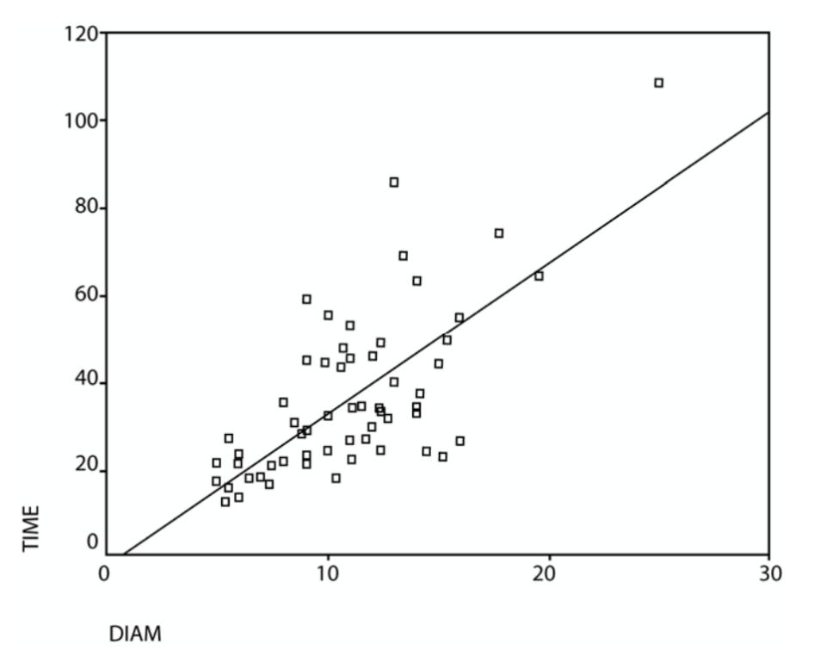

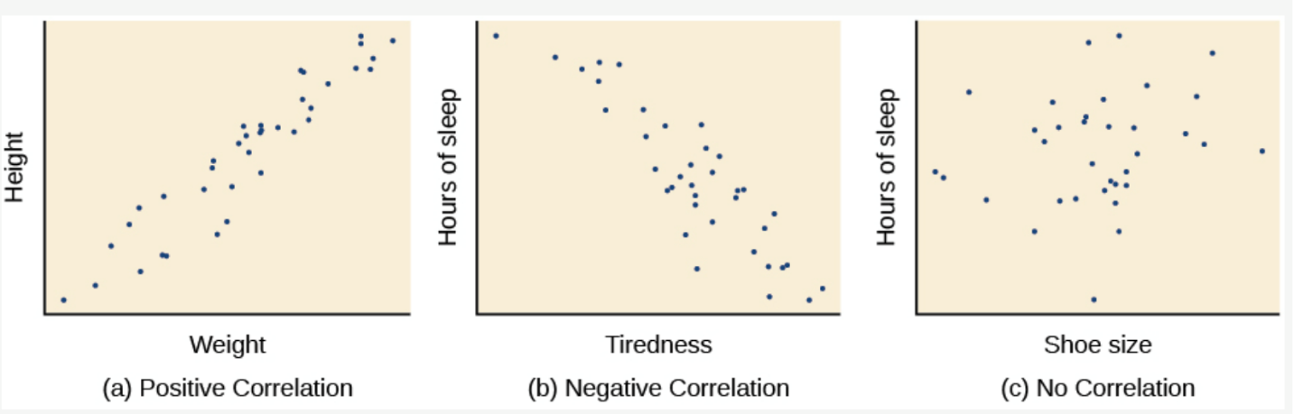

Lecture 5
Quantitative Research III

Survey Research
Survey research is as a study on large and small populations by selecting samples chosen from the desired population and to discover relative incidence, distribution and interrelations.
The ultimate goal of survey research is to learn about a large population by surveying a sample of the population; thus we may also call it descriptive survey or normative survey. In this method, a researcher poses a series of questions to the respondents, summarises their responses in percentages, frequency distribution and some other statistical approaches.
Survey research typically employs face-to-face interviews, telephone interviews or the common approach using questionnaires. Basically, information is acquired by asking respondents questions related to the phenomenon that is studied.
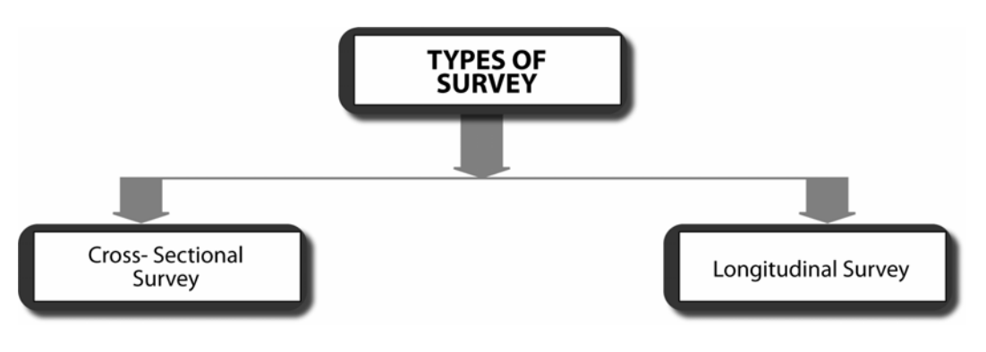

Normally, the type of survey method used depends on the scope of the research work. If the research needs a pool of opinions and practices, a cross-sectional survey would be appropriate. On the other hand, if a researcher specifies the objective as to compare differences in opinion and practices over time, a longitudinal survey would be the ideal method.
In cross-sectional survey, a researcher collects information from a sample drawn from a population. It involves collecting data at one point of time. The period of data collection can vary and it depends on the study weightage. For example: You administer a questionnaire on broadband usage among 500 university students for information dissemination using research network.
The university students may comprise 20-23 year old students. The students could be males and females from different course backgrounds in a particular university. In this case, the data you obtain is derived from a cross-section of the population at one point of time.
In longitudinal surveys, data collection is done at different points of time to observe the changes. Two common types of longitudinal surveys are Cohort Studies and Panel Studies.

(a) Cohort Studies
In Cohort Studies, a researcher specifies population (e.g. IT subordinates in an organisation dealing with security audit and penetration tests) and lists the names of all members of this population. At each data collection point, a researcher will select a sample of respondents from the population of IT subordinates doing security audit and penetration testing and administer a questionnaire.

This is then repeated at another point of time. Although the population remains the same, different respondents are sampled each time. The researchers’ aim here is to see if there are changes in perceptions or trends that occur in the study.

(b) Panel Studies
In Panel Studies, a researcher can identify a sample from the beginning and follow the respondents over a specified period of time to observe changes in specific respondents and highlight the reasons why these respondents have changed.

Lecture 6
Quantitative Research IV

Data collection instruments
Quantitative data collection instruments rely on random sampling and structured data collection instruments that fit diverse experiences into predetermined response categories. They produce results that are easy to summarize, compare, and generalize.

In a broad sense, there are two main instruments for collecting quantitative data:
1- Interviews
2- Questionnaires

1- Interviews
Interviews are more structured than in Qualitative research. The researcher asks a standard set of questions and nothing more. Most researchers use telephone interviews, face-to-face interviews, and Computer Assisted Personal Interviewing (CAPI).

Face-to-face interviews
Advantages:
1- Enables the researcher to establish rapport with potential participants and therefore gain their cooperation.
2- Yields the highest response rates in survey research.
3- Allows the researcher to clarify ambiguous answers and when appropriate, seek follow‐ up information.

Disadvantages:
1- Impractical when large samples are involved
2- Can be time consuming and expensive.

Telephone interviews
Advantages:
1- Less time consuming
2- Less expensive
3- Researcher has ready access to anyone who has a telephone.
4- Higher response rate than the mail questionnaire.
5- Can be fully automated using CATI (Computer Assisted Telephone Interviewing) saving data processing time.

Disadvantages:
1- The response rate is not as high as the face‐to‐face interview.
2- The sample may be biased as only those people who have phones are contacted.
Computer Assisted Personal Interviewing (CAPI):
It is a form of personal interviewing, but instead of completing a questionnaire, the interviewer brings along a laptop or hand‐held computer to enter the information directly into the database.
Advantages:
1- Saves time involved in processing the data.
2- Saves the interviewer from carrying around hundreds of questionnaires.

Disadvantages:
1- Can be expensive to set up.
2- Requires that interviewers have computer and typing skills.

Lecture 7
Quantitative Research V

2- Questionnaire
Questionnaires often make use of checklist and rating scales. These devices help simplify and quantify people's behaviours and attitudes.
A checklist is a list of behaviours, characteristics, or other entities the researcher is looking for. Either the researcher or survey participant simply checks whether each item on the list is observed, present or true or vice versa.
A rating scale is more useful when a behaviour needs to be evaluated on a continuum. They are also known as Likert scales.

Mail questionnaires
Advantages:
1- Can be sent to a large number of people.
2- Save the researcher time and money compared to interviewing.
3- People are more truthful while responding to the questionnaires regarding controversial issues in particular due to the fact that their responses are anonymous.
4- Allow the respondent to answer at their leisure.

Disadvantages
1- In most cases, the majority of people who receive questionnaires don't return them. Therefore:
- Over‐sampling may be necessary if doing a one‐time mail out in order to get enough completed questionnaires to be generalizable to the population.
- Follow‐up reminders to participants encouraging them to complete the questionnaire may be necessary, thereby increasing the time and cost to conduct the study.
- May need to offer incentives to increase response rate.
2- Time – mail surveys take longer than other types of surveys.

Web-based questionnaires
Advantages:
1- This type of research is often quicker and less detailed.
2- Very cost effective.
Disadvantages:
1- Excludes people who do not have a computer or are unable to access a computer.
2- Need to have access to email addresses.
3- Many worksites have screening mechanisms in place blocking access to employee emails.
4- The validity of such surveys may be in question as people might be in a hurry to complete it and so might not give accurate responses.
Remember!
Quantitative researchers must ensure Validity and Reliability when conducting their research.
Validity
Validity refers to the degree to which a study accurately reflects or assesses the specific concept that the researcher is attempting to measure. It is is concerned with the study's success at measuring what the researchers set out to measure.
Reliability
Reliability is the extent to which an experiment, test, or any measuring procedure yields the same result on repeated trials. Without the agreement of independent observers able to replicate research procedures, or the ability to use research tools and procedures that yield consistent measurements, researchers would be unable to satisfactorily draw conclusions, formulate theories, or make claims about the generalizability of their research.

