This is an optional quiz. No marks are given
الفصل: | الاسم:

COMPSITION | - Write a paragraph about Fire.  Fire is dangerous for tow reasons .first ,it can start anywhere .for example it can start in cities, in villages, in shop and in factories.second it can spread extremely fast.
DIALOGE | - Complete this dialogue: (A driver is calling an operator to help him)  Driver: Excuse me, there is an accident?  Operator: Where …are you………………………………….?  Driver: On the 70th street near Banda Supermarket?  Operator: What emergency do you need?  Driver: ………I need……….. a police car and the ambulance.
COMPREHENSION | - A- Read the following lines, then answer the questions:  Henry Ford was the first person to build cars which were cheap, strong, and fast. Ford's father hoped that his son would become a farmer, but the young man did not like the idea and he went to Detroit where he worked as a mechanic. By the age of 29, in 1892, he had built his first car. However, the first 'mass-produced' car in the world, the famous 'model T', did not appear until 1908-five years after Ford had started his great Motor Company.  - Where did Ford worked? ………he worked as a mechanic……………………………………………..  - What was the first car in the world? the first 'mass- produced' car in the world, the famous 'model T..  B- Choose the correct answer:
   | 1. The opposite of young is old…..
   | a- same | b- small | c- old | d- big
   | 2. However means.…
   | a- also | b- forever | c- quickly | d- very
GRAMMAR | IV. - A-_Do as wanted between brackets:  - Majed wrote a story. {Change into passive}  …the story was wrote by majed…………………………………..  - Do you like football? {Report}  ………he ask me if I like football………………………………….  - The book describes accidents. {Ask about the underlined word}  ……what the book describes?……………………………………….  B- Choose the correct answer.
   | 1- ………….. waste any time | a- never | b- always | c- if | d- can
   | 2- …………...sport does you good. | a- play | b- played | c- playing | d- plays
VOCABULARY | V. A-Use the correct words: {develop –rank- scald}  - What is his ……rank….. in the army? He's major.  - It is easy to ……………………. Colds in winter.  B. What is the English meaning and the part of speech for the following word :  1. Death:…………………………………………  2. Ocean:……………………………………………  3. Extremely:……………………………………………
READER | - Write the correct word under the picture. {{ outlet – ink- plugs}}
  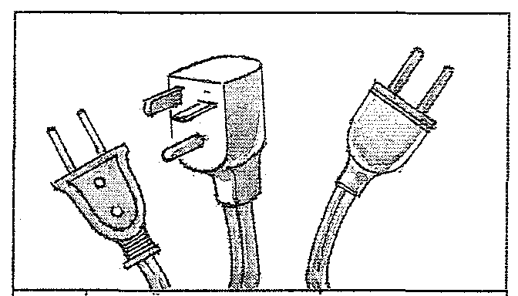 | 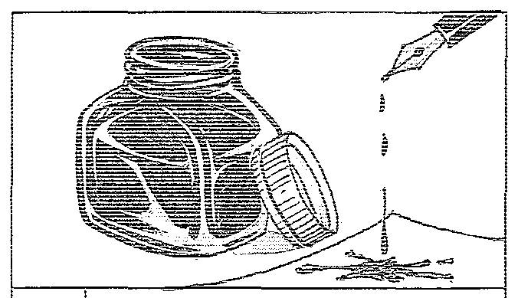
  1-plugs | 2-ink

