Accomplish | Needy
Gratify | Postage
Heroine | Respected
Vocabulary Definitions
The Peace Corps is a volunteer organization created by U.S. President John F. Kennedy. Peace Corps volunteers go to developing countries to do volunteer work in the fields of education, health, agriculture, and technology.
………………………………………………………………………………………………………..
The People of Malawi Were Kind to Her Son
1 One of the most respected persons in the Beacon Hill community of Boston is Dorothy. She was born on December 3, 1908, in Province, Rhode Island, and moved to the old West End in 1941, then to Beacon Hill in 1953. By then; Dorothy had a husband and three sons.
2 Each year, Dorothy sends from 38 to 40 packages full of clothing to a small country in Africa called Malawi. It all began 23 years ago when her youngest son, Jordan, was in Malawi in the Peace Corps. There Jordan met a family that came to be known as his “[…] parents.”
3 Dorothy had been renting out some of her rooms in her house. A man left a suitcase there and she wrote him about it. After waiting a year for a reply from him, she opened it and decided that those clothes could be used by some of the needy people in Malawi. So she sent them to her sons “{…} parents.” That was just the beginning.
4 Dorothy spends about $2,000 a year on postage and sends away clothes collected from neighbors and family. The number of families she is providing for has grown to 70. In a small book, Dorothy keeps track of all 70 families. She sorts the clothing according to size and packs them based on each family's needs. Dorothy brings the package to the post office and off it goes.
5 One of the high points of her project was for her to send 76 boxes the year she turned 76. She accomplished this task, and it shows just how much difference one person can make.
6 “It is so gratifying to me when a neighbor comes by with an armful of clothes. I would rather have that than a thousand dollars.” These are words of an 88-year-old woman; a heroine. She is a woman who places importance on doing for others, even those she never met. The people of Malawi were kind to her son when he was in the Peace Corps, and she has returned the favor many times more.
- What are some important events and dates from Dorothy’s life?
- How did Dorothy begin sending packages to Malawi?
- What is the greatest number of packages Dorothy has ever sent to Malawi? Why was that number special to her?

Brave | Crumple
Spears | Tomb

Vocabulary Definitions
Abuelito = grandfather for Spanish
Esta muerto = Spanish for “He is dead”
Spears = The author is probably referring to calla lilies. These long, white, slender flowers are often used in death ceremonies in Mexico.
……………………………………………………………………………………………………………………………………..
Papa Who Wakes Up Tired in the Dark
1 "Your abuelito is dead" papa says early one morning in my room. Esta muerto, and then as if he just heard the news himself, crumples like a coat and cries, my brave papa cries. I have never seen my papa cry and don't know what to do.
2 I know he will have to go away, that he will take a plane to Mexico, all the uncles and aunts will be there, and they will have a black and white photo taken in front of the tomb with flowers shaped like spears in a white vase because this is how they send the dead away in that country.
3 Because I am the oldest, my father has told me first, and now it is my turn to tell others. I will have to explain why we can't play. I will have to tell them to be quiet today.
4 My papa, his thick hands and thick shoes, who wakes up tired in the dark, who combs his hair with water, drinks his coffee, and is gone before we awake, today is sitting on my bed.
5 And I think if my own papa died what would I do. I hold my papa in my arms. I hold and hold and hold him.
- How does the narrator of this story find out that her grandfather is dead?
- What preparation must be made for the grandfather's death ceremony?
- The narrator of this selection is the oldest child in her family. What are her responsibilities now that her grandfather has died?
- What details does the girl give that show she cares deeply about her father and knows him very well?

arrest (verb) | criminal | murderer
burglar | dedicated | professional
career | disabled | sacrifice (verb)
client | division | sensitive
cop | liaison

Police Officer
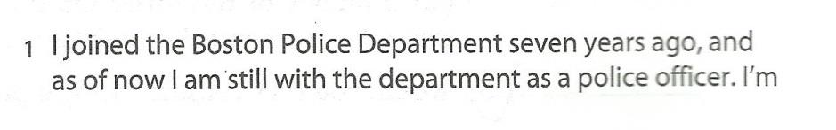
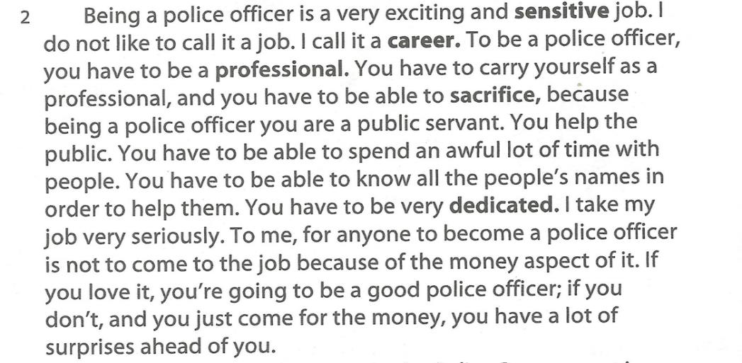

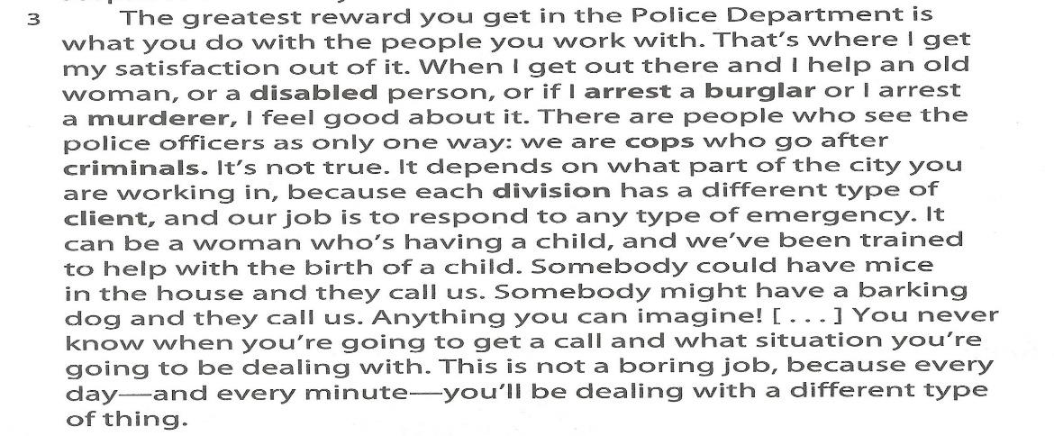
- How does this police officer feel about his job?
- What are some of his duties?
- According to this police officer, how do many people see police officers?

rural | embroidery | barrier
sew | medical | clinic
 | recall | determination

Vocabulary Definitions
in the long run: over a long period of time
primary care: general, or non-specialized medical care
to stick to: persist or commit to doing something for a long period of time
……………………………………………………………………………………………………………………………
Physician
1 Dr. Marie Louise Baptiste decided to become a doctor when she was about to graduate from college in Haiti 10 years ago. Her medical training there lasted another six years. While she was a medical student, she also taught math and science in the high school. She recalls that her own studying “took a lot of energy. There was a lot of material to cover. Sometimes it took hours and hours, sometimes nights and nights.”
2 As a young girl, she loved to read, to dance, to go to the movies, and to sew. She did embroidery and she made her own dresses. She remembers her childhood as a happy time because she was living with her family. Someday she will go back to Haiti to live.
3 In 1982, Dr. Baptiste left Haiti to come to the U.S. to receive more advanced medical training. She lived in New York for two years, and then came to Cambridge City Hospital.
4 “In the beginning it was difficult, because of the language barrier, and because it is a different society. But in the long run, it was a very good experience, for myself and for the people around me. And for the Haitian community also”.
5 Her field is primary care medicine. When she sees patients, she listen to the chest, looks at the skin, and examines the belly and the legs. Next year she will be helping to start a clinic for Haitian patients two days a week. In five years or so, after her training is complete, Dr. Baptiste would like to return to Haiti to practice medicine in the rural areas, to help people and to help the community.
6 When we asked her if she had advice for us, she said, “Yes, I do have advice for you. The advice I will leave you with is for you to have a lot of determination, and to know what you want to do, and to stick to what you want to do.”
- How long did Dr. Baptiste’s training last while she was in Haiti? Where else did she study, and for how long? How many more years of training must she complete?
- What were Dr. Baptiste’s hobbies as a young girl?
- What kind of medicine does Dr. Baptiste practice? Where does she work?
- What are Dr. Baptiste’s plan for the future?

1- Dr. Baptiste decided to become a doctor ……….
- 8 years ago c. 20 years ago
- 11 years ago d. 10 years ago
2- In 1982, Dr. Baptiste left Haiti to go to the ……….
- US c. UK
- Mexico d. Haiti
3- “in the long run” means:
- general c. over a long period of time
- to be committed d. over a short period of time

Read the list of games and sports. Then, connect the names of these activities to the appropriate label.
Basketball Board Games
Chess
Jogging Team Sports
Checkers
Gymnastics Individual Sports
Soccer

sprain | medal | beloved
swelling | qualifying | brace (noun)
triumph | remarkable | glorious
victorious | severely | hardship

Vocabulary Definitions
The 100 meter event: A foot race of a short distance
To top of: To a accomplish a goal in a way that exceed minimum requirement
The anchor leg: A position on a relay race
A relay race: A race in which runners pass a baton to another runner who the continues the race
……………………………………………………………………………………………………….
The World’s Fastest Woman
1 Perhaps no Olympic champion had greater childhood hardships than Wilma Rudolph. When she was very young, Wilma had to walk with a brace on her left leg until she was 11 years old. Nine years later, she would win three gold medals at the 1960 Rome Olympics becoming one of America's most beloved athletes.
2 But Wilma’s triumph in Rome did not begin well. The day before her qualifying race in the 100 meter event, she tripped over a water pipe and severely sprained her ankle. But that night, the swelling went down. Wilma would make it to the starting line, but she had to keep her ankle taped throughout the Olympics.
3 Despite the injury, Rudolph won the gold medal in the 100-meter race. Even more remarkable, she won another in the 200 meters. Then to top off her glorious day, Wilma ran the anchor leg on the victorious 4 x 10 relay team. Rudolph became the star of the 1960 Olympic Games as newspapers all over the world called her "the fastest woman in the world".
- What was one of the hardships Rudolph had to deal with as a child?
- What happened the day before Rudolph’s first event at the Olympics?
- For which three events did Rudolph win gold medals at the 1960 Olympics?
1- The first race that Wilma participated in the 1960 Olympics is the …….
- 100-meter race c. 200-meter race
- 150-meter race d. Relay team race.
2- The 1960 Olympic games happened in ……….
- Barcelona c. New York
- Rome d. Milan
3- Wilma won …………… in the 1960 Olympics.
- Two gold medals c. Three silver medals
- Three gold medals d. Four gold medals

atmosphere | corporate | marvelous
benefit (noun) | depth | mount
billboard | dreaded | perspiration
champ | drill (verb) | scholarship
championship | eliminate | trophy
coach (noun) | illusion | via
congratulate | graduate school | workshop
Twelve-Year-Old Spelling Champ
1 It was the end of the second day of competition at the Scripps Howard national Spelling Bee. All the other spellers had been eliminated. Jody-Anne Maxwell, age twelve, was the last one left. But the championship was not hers yet. She still had to spell one more word. The spelling bee official read the word, and then the definition: “An artist who uses the treatment of light and shade in a painting or drawing to produce the illusion of depth”.
2 Jody-Anne repeated the word and spelled, “c-h-i-a-r-o-s-c-u-r-i-s-t.” No dreaded bell for misspelled words rang after she was done. She had won! And it was the first time she had ever entered the contest.
3 And that's not the only first- Jody-Anne, an eighth-grader from Kingston, Jamaica, is also the first speller from her country and the first speller from outside the U.S. to win the contest. She competed against 248 spellers, aged nine to fifteen, from the U.S., Mexico, the U.S. virgin Islands, the Bahamas, American Samoa, Guam, and Europe.
4 Jody-Anne began preparing for her big day in late 1996.she and her spelling coach, […] Glen O.J. Archer, studied using an entire dictionary, the root words, and their original meanings. The long hours of studying paid off. She won the spelling bee in her school [district] (similar to a country spelling bee). About 3,000 to 4,000 kids competed in the Jamaican national spelling bee in August 1997. And Jody-Ann won!
5 After a two-month break, Coach Archer started drilling her and the other two girls who also went to the 71st Scripps Howard bee in Washington, D.C. they had to meet together every two to three weeks in special workshops because they lived far apart. Haydee (pronounced Heidi) Lindo, 11, traveled from Montego Bay, and Bettina Mclean, 11, came from Ocho Rios .For eight months they studied Webster's Third New International Dictionary and the Official word list for the spelling bee.
6 Then came the big trip in May to the bee in D.C. not only did Jody-Anne win the bee, but Bettina came in sixth place and won $750. Two of the ten spellers came from Jamaica! For her spelling perfection , Jody-Anne won $10,000 in cash, a beautiful trophy , a spelling bee watch, a set of encyclopedias ,and a trip for two from U.S Airways to any destination in the U.S.
7 When interviewed afterwards Jody-Anne said that there were several words in the bee that she did not know how to spell, but that “God gave me the words that I knew.” Her advice to other spellers? “Trust God, work hard, and never lose sight of your goal.” Coach Archer agrees, “We believe that inspiration plus perspiration is a marvelous formula,” he says.
8 One of her four sisters, Janice, was also an inspiration .She was the 1990 All-Island Spelling champ of Jamaica. “She was the one who encouraged me to enter and helped me, too” says Jody-Anne. Her favorite part about the spelling bee was “the sitting down part” she says. “Because at the national finals in Jamaica, we had to stand for 7 hours.” She also liked the fun, relaxed atmosphere at the spelling bee.
9 When Jody-Anne came home, she got a royal welcome. The government of Jamaica congratulated her via a billboard mounted on the grounds of the prime minister's home. It also promised to pay for the rest of her schooling At Ardenne High school in Kingston. The University of Jamaica gave her a full college scholarship to study anything she likes. Other universities in the U.S. have talked about giving her a scholarship to study corporate law in graduate school, too. She has been thinking about becoming a lawyer for a couple of years now, she says, and her aunt is also a corporate lawyer. The Caribbean Hotel Association and another group were so proud of her, said Coach Archer, that they gave her a combined award of $11,000.
10 Jody-Anne did get one other benefit from being a spelling champion. Because she was busy after the spelling bee, her school excused the straight -A student from her final exams. It doesn't get much better than that!
- What was the word which Jody-Anne won the spelling bee? What does it mean?
- How did Jody-Anne prepare for the spelling bee?
- What are the prizes that Jody-Anne won?
- What are Jody-Anne’s future plans?
1- The closest meaning to the word Drill is …………….
- win c. coach
- train d. play
2- The closest synonym to the word marvelous is ……… .
a. ugly c. wonderful
b. good d. pretty
3- To eliminate someone is to………..him.
- train c. defeat
- play with d. win

admirer | graciously | opponent
avoid | grin (verb) | retort
benevolently | hiss | rustle
bound | humility | slit
defeat | hurl | tablet
desperately | jade | tournament
detour (verb) | leap | vanity
diminish | lest | well-tended
distract | murmur
etiquette | observe

Vocabulary Definitions
Vincent: The narrator's brother
Life Savers: A kind of candy
Captured men: In chess, when a player takes the opponent’s piece, that piece is called a “captured man”
Check: When a person wins a game of chess, he say “check”
Exhibition games: Practice games before the real tournament
To bite back one’s tongue: to keep quiet when one wants to speak
…………………………………………………………………………………………………………………………………………………
Rules of the Game
1 On a cold spring afternoon, while walking home from school, I detoured through the playground at the end of our alley. I saw a group of old men, two seated across a folding table playing a game of chess, other smoking pipes, eating peanuts, and watching. I ran home and grabbed Vincent’s chess set, which was bound in a cardboard box with rubber bands. I also carefully selected two prized rolls of Life Savers. I came back to the park and approached a man who was observing the game.
2 “Want to play?” I asked him. His face widened with surprise and he grinned as he looked at the box under my arm.
3 “Little sister, been a long time since I play with dolls,” he said, smiling benevolently. I quickly put the box down next to him on the bench and displayed my retort.
4 Lau Po, as he allowed me to call him, turned out to be a much better player than my brother’s. I lost many games and many life Savers. But over the weeks, with each diminishing roll of candies, I added new secrets. Lau Po gave me the names. The Double Attack from the East and the West Shores. Throwing stones on the Drowning Man. The sudden Meeting of the Clan. The surprise from the Sleeping Guard. The Humble Servant Who kills the King. Sand in the Eyes of Advancing Forces. A Double killing Without Blood.
5 There were also the fine points of chess etiquette. Keep captured men in neat rows, as well-tended prisoners. Never announce “check” with vanity, lest someone with an unseen sword slit your throat. Never hurl pieces into the sandbox after you have lost a game, because then you must find them again, by yourself, after apologizing to all around you. By the end of the summer, Lau Po had taught me all he knew, and I had become a better chess player.
6 A small weekend crowd of Chinese people and tourists would gather as I played and defeated my opponents one by one. My mother would join crowds during these outdoor exhibition games. She sat proudly on the bench telling my admirers with proper Chinese humility, “Is luck.”
7 A man who watched me play in the park suggested that my mother allow me to play in local chess tournaments. My mother smiled graciously, an answer that meant nothing. I desperately wanted to go, but I bit back my tongue. I knew she would not let me play among strangers. So as we walked home I said in a small voice that I didn't want to play in the local tournament. They would have American rules. If I lost, I would bring shame on my family.
8 “Is shame you fall down nobody push you,” said my mother.
9 During my first tournament, my mother sat with me in the front row as I waited for my turn. I frequently bounced my legs to unstick them from the cold metal seat of the folding chair. When my name was called, I leapt up. My mother unwrapped something in her lap. It was her chang, a small tablet of red jade, which held the sun’s fire. “Is luck,” she whispered, and tucked it into my dress pocket. I turned to my opponent, a fifteen-year-old boy from Oakland. He looked at me, wrinkling his nose.
10 As I began to play, the boy disappeared, the color ran out of the room, and I saw only my white pieces and his black ones waiting on the other side. A light wind began blowing past my ears. It whispered secrets only I could hear.
11 “Blow from the South,” it murmured. “The wind leaves no trail.” I saw a clear path, the traps to avoid. The crowd rustled. “shh! shh!” Said the corners of the room. The wind blew stronger. “Throw sand from the East to distract him.” The knight came forward ready for the sacrifice. The wind hissed, louder and louder. “Blow, Blow, Blow. He cannot see. He is blind now. Make him lean away from the wind so he is easier to knock down.”
12 “Check,” I said, as the wind roared with laughter. The wind died down to little puffs, my own breath.

- Who was the narrator’s chess teacher?
- What are some of the rules of “chess etiquette” that the young narrator learns?
- How did the narrator’s mother convince her to enter the tournament?

a. pride b. shame  c. fear | Humility
a. cry b. whisper  c. Shout | Murmur
a. soften b. increase  c. distract | Diminish
a. frown b. smile  c. hiss | Grin
a. connect b. confront  c. arrange | Avoid

1- To bite back one’s tongue means to …………… .
a. talk b. keep quiet c. argue d. leave
2- The boy didn’t want to play in the local tournament because they have ……… .
a. American rules b. Spanish rules c. Asian rules d. Chinese rules
3- The boy played in the park against a man called ………… .
a. Vincent b. Lau Po c. Paul d. Jack
4- When a person wins a game of chess, he or she says :
a. Captured men b. check c. lose d. die
5- The opposite of the word Avoid is ………. .
a. connect b. arrange c. confront d. get away
6- The word Slit means …………. .
a. burn b. Cut c. cheat d. fry
7- The opposite of the word Humility is ….
a. Pride b. Modesty c. challenge d. Shame

apprehension | faint | reverse (verb)
cab | frustrated | roommate
considerable | pickup truck
dim (verb) | recount

A Close Encounter with a UFO
1 Tom Page and his two college roommates were on their way to Canada in a pickup truck. Page was driving; his two friends were asleep in the back of the truck.
2 Alone, he had seen a white light ahead of him which suddenly shot straight up into the night sky. It could not have been an automobile. Somewhat later, he stopped and pulled over because the light (or a similar one) had reappeared and he wanted his friends to see it. One of his friends, Bob, got up and sat in the cab with Tom. He turned all of his lights off and then attempted to roll slowly down the hill toward the UFO ahead of them. “But as the truck moved forward, the light backed up, keeping the same distance from us,” Page said. Then Jim, the third roommate, knocked on the window and Tom stopped again to let him into the cab.
3 The white light dimmed and then they could see a faint object in its place as wide as the roadway and shaped like an “upside-down cereal bowl.” A separate, tiny red light was seen above the object. All three witnesses felt “a considerable amount of apprehension.” Once again, Page let the truck roll toward the object and it became much brighter again, moving slowly away from their truck. Then, Page noticed another white light about 50 yards behind them, so he stopped and all three got out of the cab. No sound could be heard of any kind. Page recounts what happened next.
4 “I was frightened , but also frustrated at not understanding what was going on. I started running toward the light [in front of the truck] to get closer to see what it was. As I started running towards the light, it started moving toward me…. The light was still moving towards me so I raised my hands, not knowing what else to do. The light dimmed reversed direction and went back up and over the hill out of sight.”

- Why were Page and his friends driving at night?
- What did Page see and why was he sure that is wasn’t an automobile?
- What did the light do as the car rolled forward?
- What did the three men see when the light dimmed? Why do you think they felt “considerable apprehension”? How would you have felt?
- What happened when Page ran toward the light? What happened after that?
- Do you believe that this was a UFO? If it wasn’t a UFO, what else could it have been?
The SETI (search for extraterrestrial intelligence) program
at Ohio State University in Columbus, Ohio,
has searched the universe for radio signals from other planets
since 1973.
None have been detected yet.

