Licture 10

- Introduction

Semantics is the study of the meaning of words, phrases and sentences. Linguistic semantics deals with the conventional meaning conveyed by the use of words, phrases and sentences of a language.
E.g. Fire Department (not Extinguishing Department) or
pain pills (not relief pills).

- Conceptual and associative meaning

Conceptual meaning is the basic components of meaning conveyed by the literal use of words.
Associative meaning is the type of meaning that people might connect with the use of words (e.g. needle = “painful”) that is not part of conceptual meaning. Poets, novelists, advertisers and lovers may be very interested in using words in such a way that certain associative meanings are evoked and literary critics often write about this aspect of language use.

- Semantic features

NP V NP
The hamburger ate the boy
This sentence is syntactically good, but semantically odd. The components of the conceptual meaning of the noun hamburger must be significantly different from those of the noun boy, thereby preventing one, and not the other, from being used as the subject of the verb ate. The kind of noun that can be the subject of the verb ate must denote an entity that is capable of ‘eating’. The noun hamburger does not have this property and the noun boy does.

Semantic features
This simple example is an illustration of a procedure for analyzing meaning in terms of semantic features. Features such as ‘+animate,−animate’; ‘+human, −human’, ‘+female, −female’, for example, can be treated as the basic elements involved in differentiating the meaning of each word in a language from every other word.

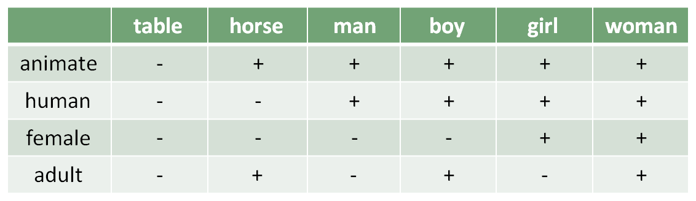

Semantic features
It may not be as easy to come up with neat components of meaning. If we try to think of the components or features we would use to differentiate the nouns advice, threat and warning, for example, we may not be very successful.
Part of the problem seems to be that the approach involves a view of words in a language as some sort of ‘containers’ that carry meaning components

- Semantic roles

Instead of thinking of words as ‘containers’ of meaning, we can look at the ‘roles’ they fulfill within the situation described by a sentence. If the situation is a simple event, as in The boy kicked the ball, then the verb describes an action (kick). The noun phrases in the sentence describe the roles of entities, such as people and things, involved in the action. We can identify a small number of semantic roles (also called ‘thematic roles’) for these noun phrases.

- Agent and theme

Agent is the semantic role of the noun phrase identifying the one who performs the action of the verb in an event (The boy kicked the ball)
Theme is the semantic role of the noun phrase used to identify the entity involved in or affected by the action of the verb in an event (e.g. The boy kicked the ball)

- Instrument and experiencer

Instrument is the semantic role of the noun phrase identifying the entity that is used to perform the action of the verb (e.g. The boy cut the rope with a razor)
Experiencer is the semantic role of the noun phrase identifying the entity that has the feeling, perception or state described by the verb (e.g. The boy feels sad)

- Location, source and goal

Location is the semantic role of the noun phrase identifying where an entity is (e.g. The boy is sitting in the classroom)
Source is the semantic role of the noun phrase identifying where an entity moves from (e.g. The boy ran from the house)
Goal is the semantic role of the noun phrase identifying where an entity moves to (e.g. The boy walked to the window)

- Lexical relations

Not only can words be treated as ‘containers’ of meaning, or as fulfilling ‘roles’ in events, they can also have ‘relationships’ with each other. If we give the meaning of “shallow” as “the opposite of deep”, or the meaning of “daffodil” as “a kind of flower”, or the meaning of “big” as “the same as huge”, we are characterizing the meaning of each word in terms of its relationship to other words.

- Synonymy

Synonymy is the lexical relation in which two or more words have very closely related meanings (e.g. “Conceal” is a synonym of “hide”). We should keep in mind that the idea of ‘sameness’ of meaning used in discussing synonymy is not necessarily ‘total sameness’. (purchase: formal / buy informal)
- Antonymy

Antonymy is the lexical relation in which words have opposite meanings (“Shallow” is an antonym of “deep”).
Antonyms are usually divided into two main types, ‘gradable’ (opposites along a scale) and ‘non-gradable’ (direct opposites). Gradable antonyms, such as the pair big/small, can be used in comparative constructions like I’m bigger than you. Also, the negative of one member of a gradable pair does not necessarily imply the other. For example, the sentence My car isn’t old, doesn’t necessarily mean My car is new.

Antonymy
With non-gradable antonyms (also called ‘complementary pairs’), comparative constructions are not normally used. We don’t typically describe someone as ‘deader’ or ‘more dead’ than another. Also, the negative of one member of a non-gradable pair does imply the other member. That is, “My grandparents aren’t alive does indeed mean My grandparents are dead”.
Reversives are antonyms in which the meaning of one is the reverse action of the other(e.g. dress/undress, enter/exit, pack/unpack, lengthen/shorten, raise/lower, tie/untie)

- Hyponymy

Hyponymy is the lexical relation in which the meaning of one word is included in the meaning of another (e.g. “Daffodil” is a hyponym of “flower”).
When we consider hyponymous connections, we are essentially looking at the meaning of words in some type of hierarchical relationship.

Hyponymy
living thing

creature plant

Animal insect vegetable flower tree

dog horse snake ant cockroach carrot rose banyan pine

poodle asp

Hyponymy
Looking at the diagram, we can say that “horse is a hyponym of animal” or “cockroach is a hyponym of insect”. In these two examples, animal and insect are called the superordinate (= higher level) terms. We can also say that two or more words that share the same superordinate term are co-hyponyms. So, dog and horse are co-hyponyms and the superordinate term is animal.

- Prototypes

Prototype is the most characteristic instance of a category (e.g. “Robin” is the prototype of “bird”).
While the words canary, cormorant, dove, duck, flamingo, parrot, pelican and robin are all equally co-hyponyms of the superordinate bird, they are not all considered to be equally good examples of the category ‘bird’. According to some researchers, the most characteristic instance of the category ‘bird’ is robin. The idea of ‘the characteristic instance’ of a category is known as the prototype.

Prototypes
The concept of a prototype helps explain the meaning of certain words, like bird, not in terms of component features (e.g. ‘has feathers’, ‘has wings’), but in terms of resemblance to the clearest example. Thus, even native speakers of English might wonder if ostrich or penguin should be hyponyms of bird (technically they are), but have no trouble deciding about sparrow or pigeon. These last two are much closer to the prototype.
- Homophones and homonyms

Homophones are two or more words with different forms and the same pronunciation (e.g. to–too–two).
Homonyms are two words with the same form that are unrelated in meaning (e.g. bank (of a river) – bank (financial institution)).

- Polysemy

Polysemy is a word having two or more related meanings (e.g. foot, of person, of bed, of mountain).
If we aren’t sure whether different uses of a single word are examples of homonymy or polysemy, we can check in a dictionary. If the word has multiple meanings (i.e. it’s polysemous), then there will be a single entry, with a numbered list of the different meanings of that word. If two words are treated as homonyms, they will typically have two separate entries.

- Metonymy

Metonymy is a word used in place of another with which it is closely connected in everyday experience (e.g. He drank the whole bottle (= the liquid)).
That close connection can be based on a container–contents relation (bottle/water, can/juice), a whole–part relation (car/wheels, house/roof) or a representative–symbol relationship (king/crown, the President/the White House). Using one of these words to refer to the other is an example of metonymy.

- Collocation
- Collocation is a relationship between words that frequently occur together (e.g. salt and pepper). One way we seem to organize our knowledge of words is simply on the basis of collocation, or frequently occurring together.

