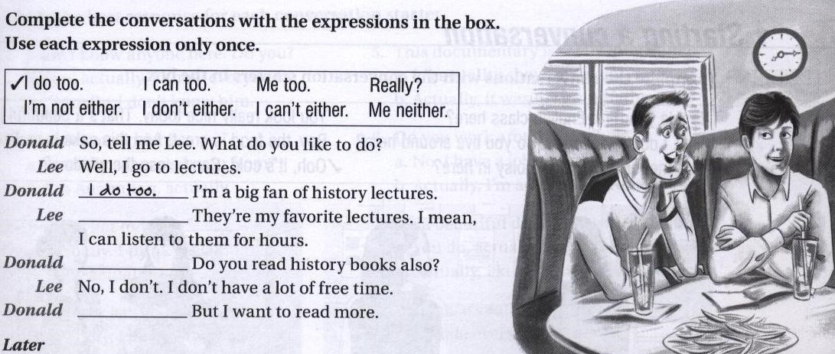
me too

I can too

Me neither

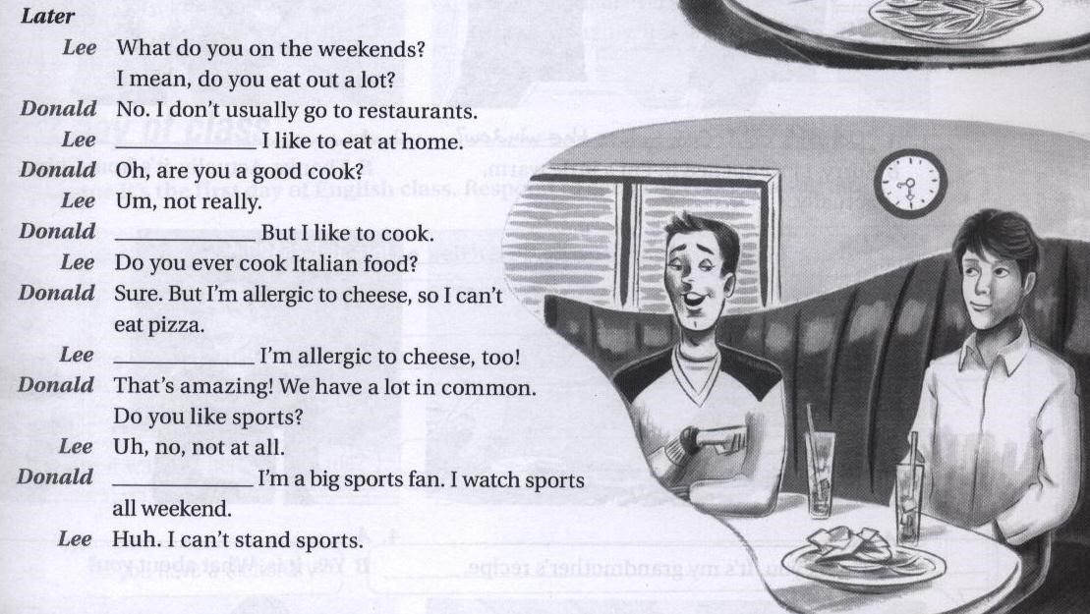
I don’t either

I am not either

Me neither

really

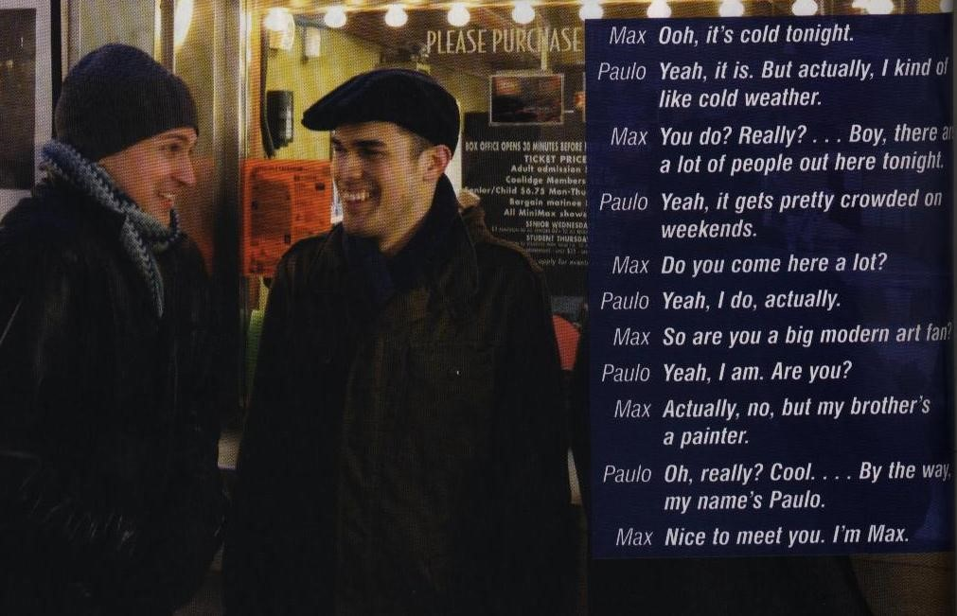
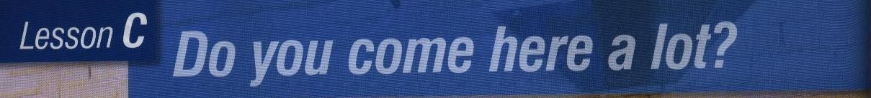

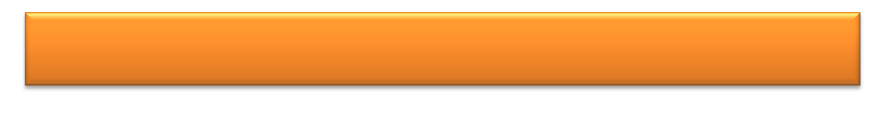
Think of a Way to Start a Conversation

1. ) You met someone new at a family party. The food is really good. This food is delicious!
2.) It’s a very windy day. You’re just arriving at a new class. It’s really windy today. / Is this room B? this room is B 3.) You’re in a long line in a museum. It’s a cold day.
It’s freezing out here. / This exhibit got a great audience.
4.) You’re working out at a new gym. The room is very hot.
Do you think this room is too hot?
5.) You’re in a new English class. You meet someone during the break. Do you want to get some coffee?
6.) You’re at the bus stop on a beautiful day. Someone arrives and smiles at you.
How often does this bus come?
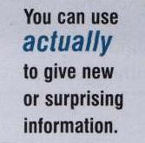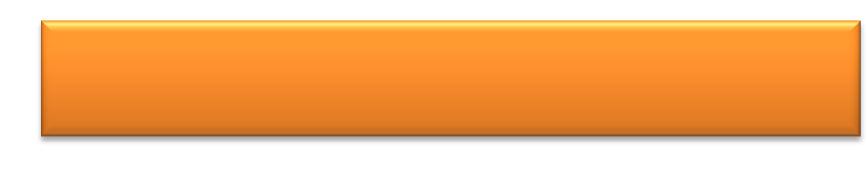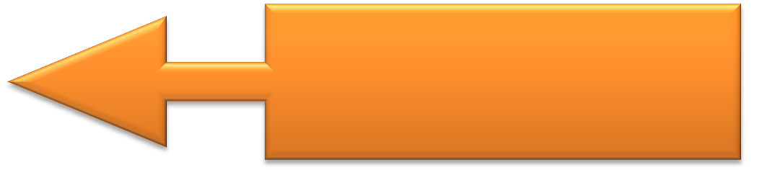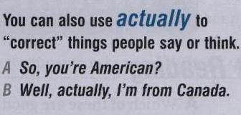
Actually

A: Do you come here a lot?

B: yeah, I do, actually

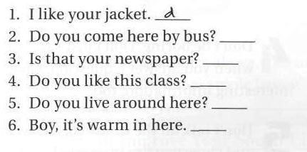
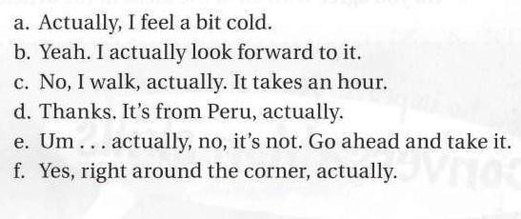
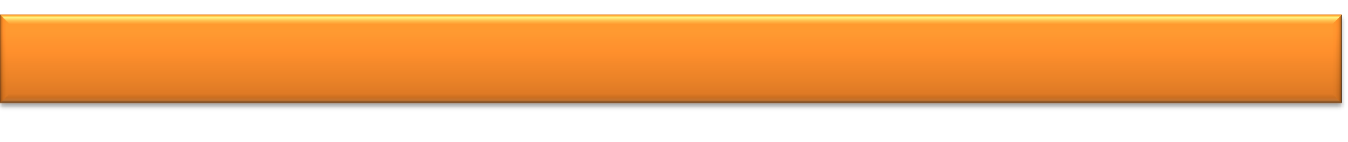
Match each conversation starter with a response

c

e

B

f

a


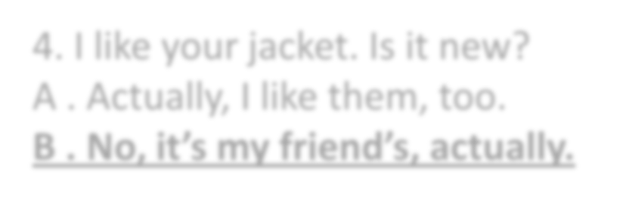


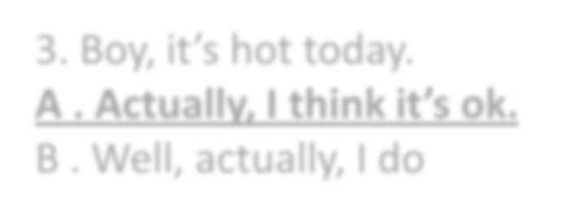

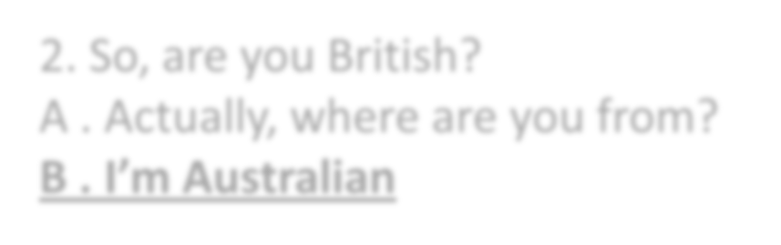

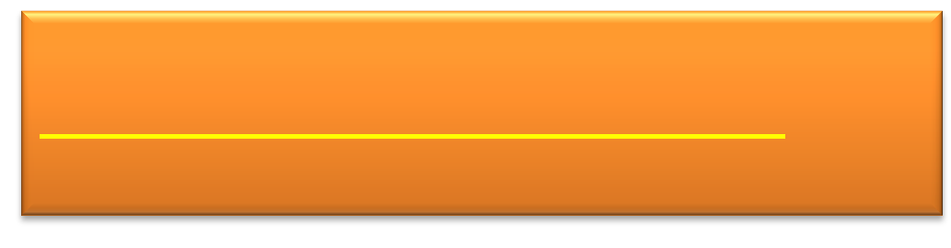
Choose the best response for each conversation starters:

4
. I like your jacket. Is it new?

A . Actually, I like them, too.

B . No, it’s my friend’s, actually.

3
. Boy, it’s hot today.

A . Actually, I think it’s ok.

B . Well, actually, I do

2
. So, are you British?

A . Actually, where are you from?

B . I’m Australian

1
. I don’t know anyone here. Do you?

A . Um, actually, I know everybody.

B . Actually, I don’t know him.

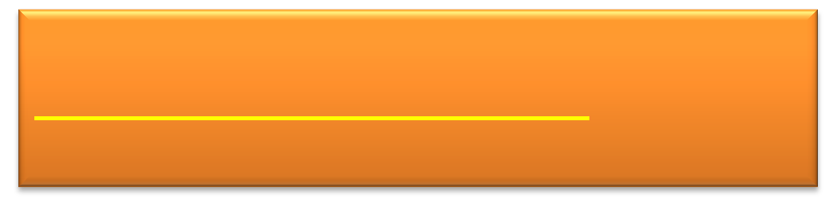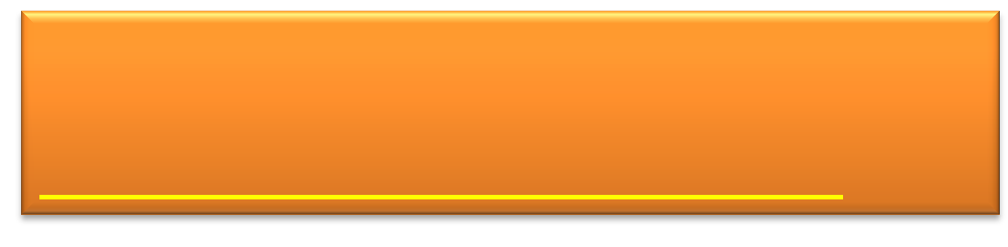
5
. This documentary is really interesting.

A . It’s a reality show, actually.

B . Actually, it was my grandfather’s.

6
. Do you work around here?

A . No, I have a job, actually.

B . Actually, I’m a full
-
time student.

7
. It’s a beautiful day. I love warm weather.

A . You do, actually.

B . Actually, I kind of like cold weather

8. The bus is really late today.
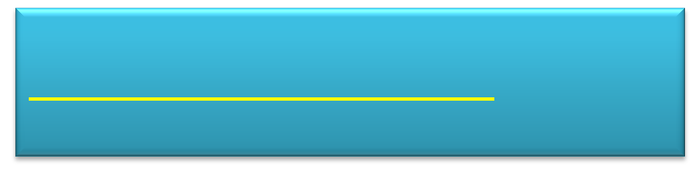
- . It’s late every day, actually.
- . Actually, it is late.
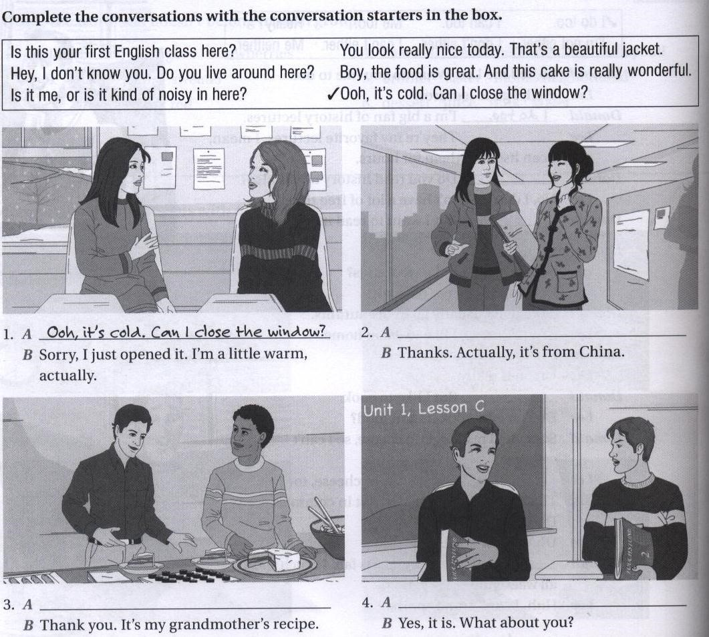
You look really nice today. That’s a
beautiful jacket.

Boy, the food is great. And this cake
is really wonderful.

Is this your first English class here?

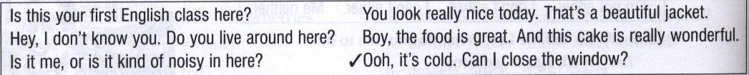
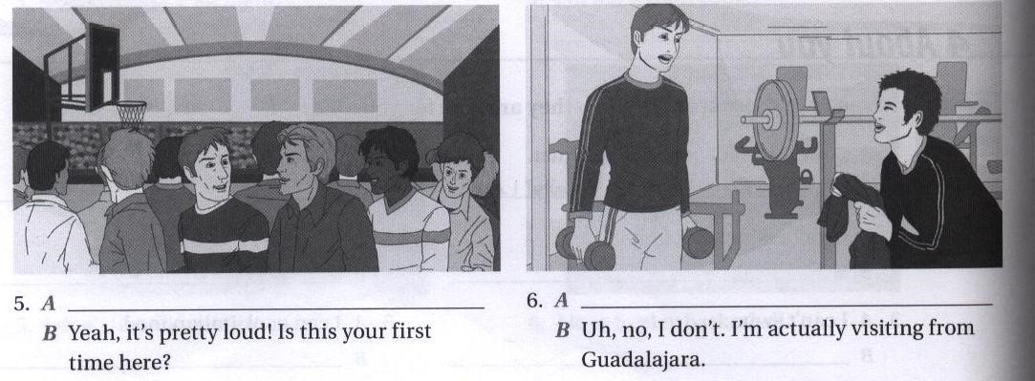
Is it me, or is it kind of noisy in here?

Hey, I don’t know you. Do you live
around here?

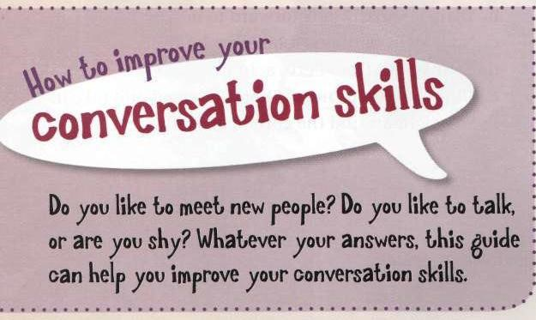

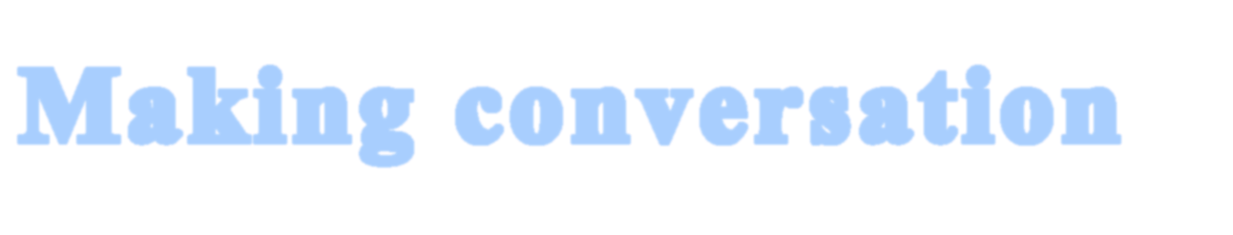




Lesson ( D )

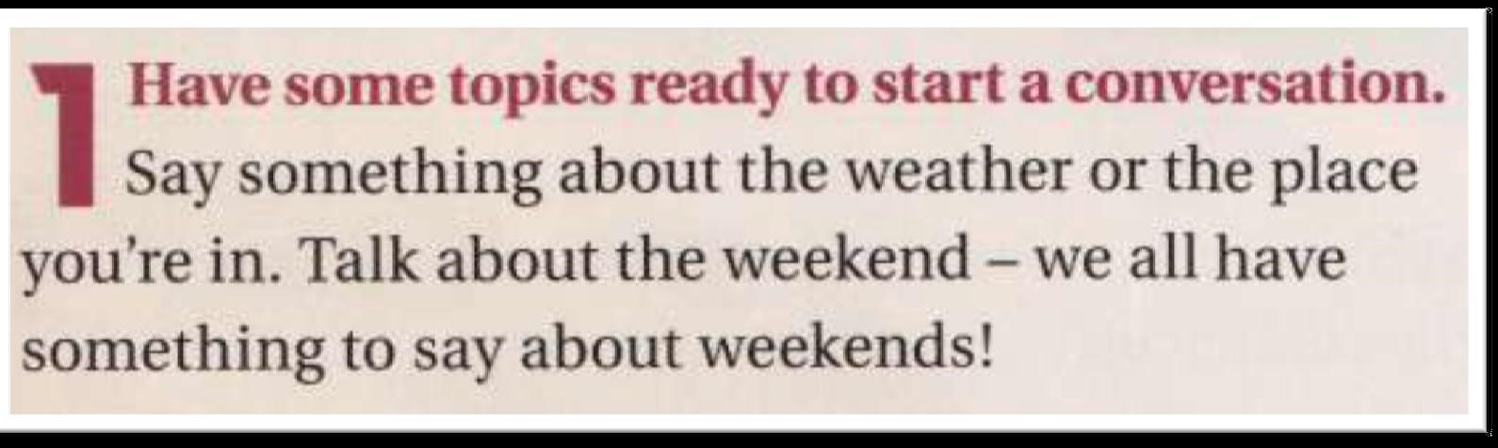
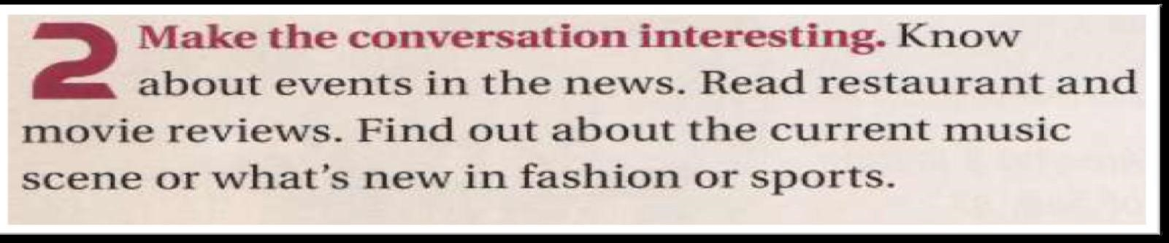
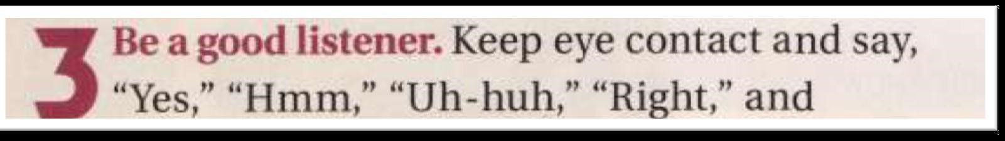
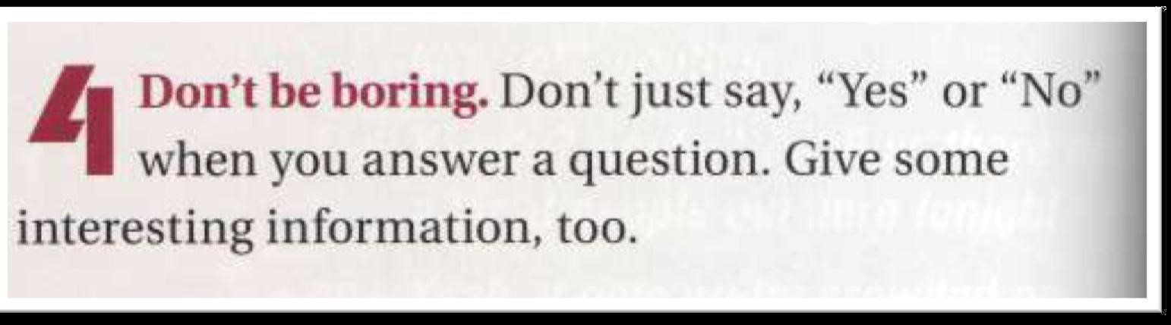
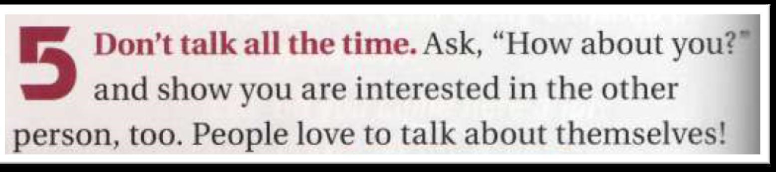
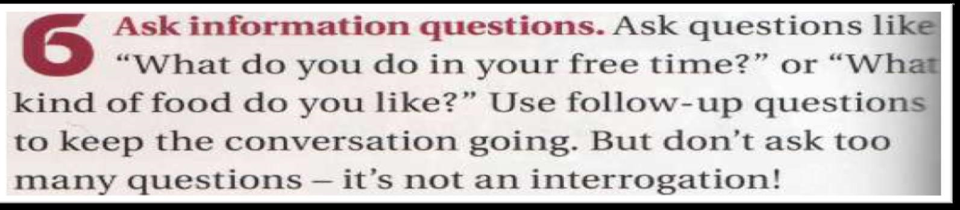
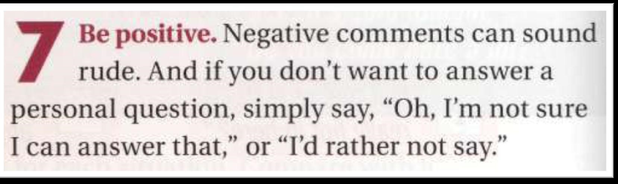
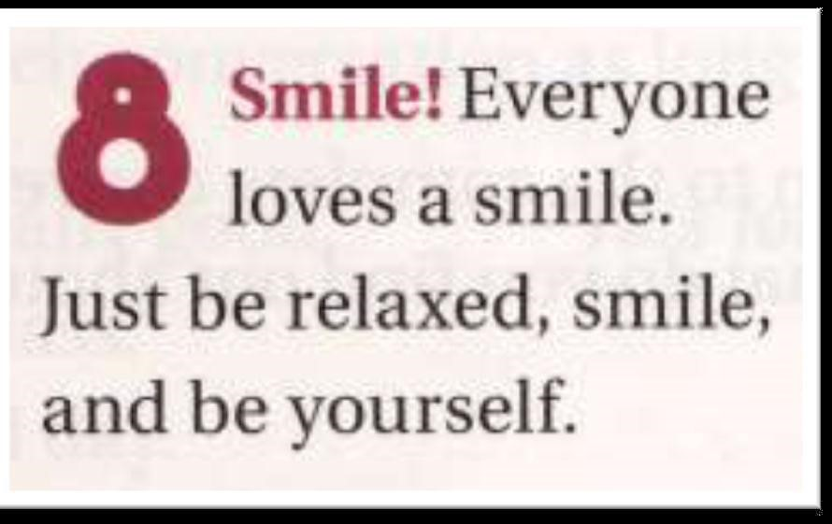
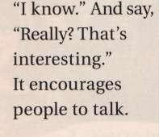
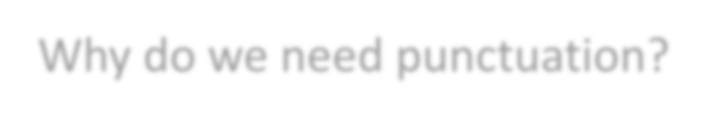
Punctuation

Why do we need punctuation?


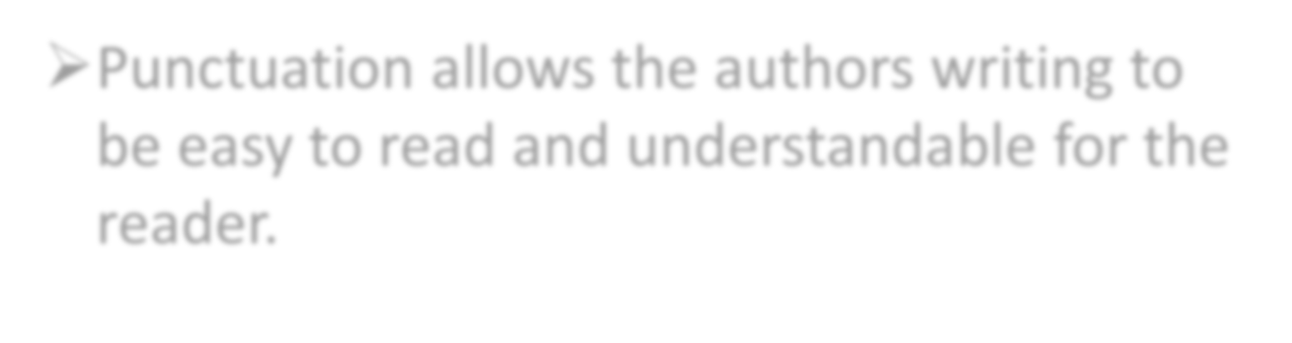

➢Punctuation allows the authors writing to be easy to read and understandable for the reader.

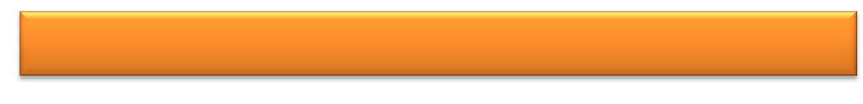
Types of Punctuation

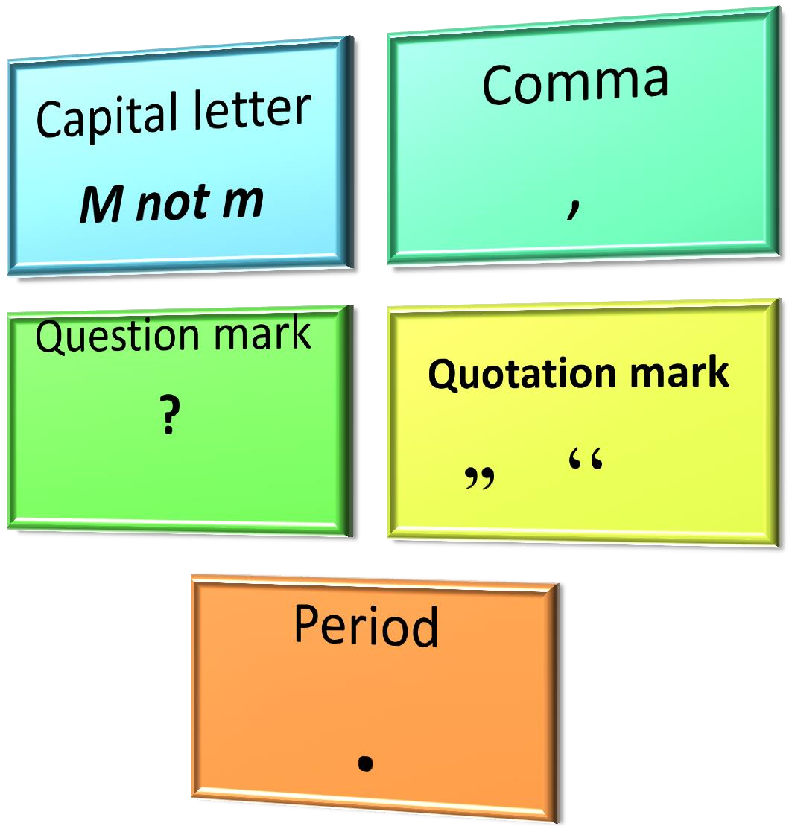



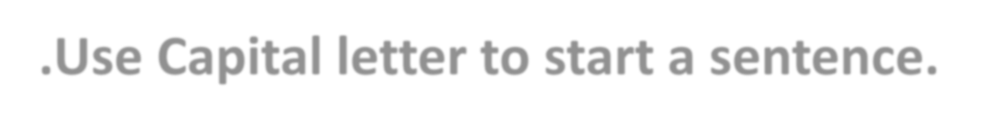

- 1.Use Capital letter to start a sentence. I am a good student.
He was born on August 4th, 1990.


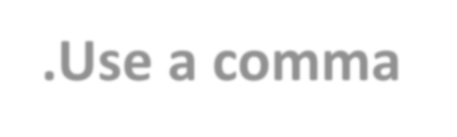


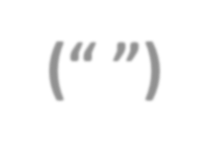

- 2.Use a comma (,) before quotation marks (“ ”) and lists. The teacher says, “study hard to pass the exam”.
She has two dogs, three cats, one bird, and five fish in her house.


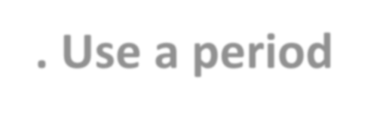









- 3. Use a period (.) at the end of a statement and a question mark (?) at the end of a question.
I went to the store for groceries.
Will you come over after school?

