Lecture 11
(WHAT’S IN THE NEWS?)
Vocabulary Check:

Communication satellites | Fax machine | Electronic mail | technology
Cultural environment | inform | videotape | entertain

- The ___fax machine__ and __electronic mail_ are two recent inventions that help in communication.
- If you see an important event happening and you have a camera, you can make a __videotape_ recording.
- The physical world is part of our environment, but other things create our ___cultural environment___ such as the way we live and work, our system of beliefs, and the art and music we have.
- Technology like ___communication satellites___ makes it possible to send messages instantly around the world.
- Some people say that many TV news programs __entertain__ more than they __inform__ .

Understanding Weather Reports:
- It’s sunny/warm/dry/fair.
- It’s cloudy/partly cloudy/overcast.
- It’s rainy. There are thunderstorms/scattered showers.
- There’s snow/ice. It’s freezing/icy.
- It’s cool/chilly/foggy.
- It’s windy/breezy.

Comparative and Superlative Adjectives:
LET’S START J
Adjectives and adverbs are words the modify other words. The comparative form of an adjective or adverb compares two things. The superlative form of an adjective or adverb compares three of more things.

Adjective | Comparative | Superlative
cold | colder | the coldest
dry | drier | the driest
sunny | sunnier (more sunny) | the sunniest (the most sunny)
humid | more humid | the most humid

What’s the weather like in……………?

What is a “comparative form”?
Comaprative form expresses the idea of ‘more’
Fast-er
My car is fast.
But his car is faster.

How is a ‘comparative’ form built?
one syllable adjectives * long -er
two syllable adjectives ending in –y * funny -ier
other two and three syllable adjectives * more modern
irregular adjectives for example ‘good’ * better

Change of ‘y’ into ‘i’:
We want the comparative form of the adjective ‘funny’
Funny +er
Yèi
Funnier.

What is a “superlative form”?
Comaprative form expresses the idea of ‘most’
Fast-est
My car is fast.
Your car is fast.
But his car is the fastest.

“Superlative form”?
How is a ‘superlative’ form built?
one syllable adjectives * long -est
two syllable adjectives ending * funny -iest
other two and three syllable adjectives * most modern
irregular adjectives for example ‘good’ * best

Summary comparison:

 | Comparative | Superlative
long | longer | longest
funny | funnier | funniest
modern | more modern | most modern
good | better | best

Identify Items of Clothing:
- Scarf
- Snow boots
- Rain boots
- Heavy gloves
- Umbrella
- Raincoat
- Overcoat

CD 2, TR 32-35
Understanding Weather Reports:
For each report, write what you would probably wear or take with you for the day.
Weather Report 1: __________
Weather Report 2: __________
Weather Report 3: __________
Weather Report 4: __________

Listen again. For each report, tell the high and low temperatures the reporter give.

 | High | Low
Weather Report 1 | 50s
Weather Report 2
Weather Report 3
Weather Report 4

Language you can use: Expressing Agreement:
- Of course! Certainly! Sure! Naturally!
- That’s true. True.
- That’s right. Right.
- That’s a good point. Good point.
- I agree (completely).
- I think so too.
- You said it!
- You’re absolutely right.

Language you can use: Expressing Disagreement:
- I disagree (completely). I don’t agree (at all).
- That’s not true. That’s not right.
- That’s ridiculous! (not polite)
- What nonsense! (not polite)
- I’m sorry to disagree, but…
- I see your point of view, but…

Vocabulary Match:

Word | mean
To cope | To deal with (a problem)
Somewhere else | Another place
To play catch | To throw and catch a ball (with another person)
Best buddies | Very good friends
Mean | No nice, unkind
To shatter | To break, destroy

At home CD 2, TR 36-39
Understanding numbers

13 | 30 | 13th
4 | 14 | 4th

Done…

Lecture 12
(Planthood)

Labeling a World Map:

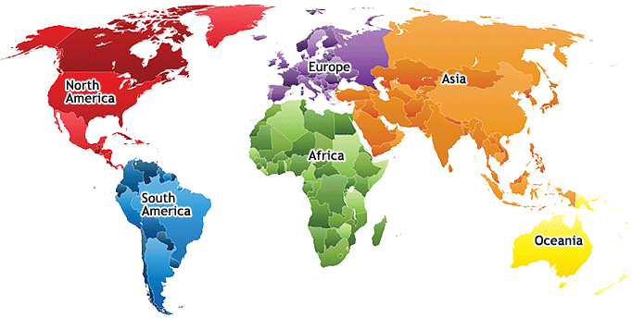
- Japan
- Jordan
- Spain
- Egypt
- Algeria
- India
- China
- Germany
- Saudi Arabia

Language you can use: Asking for clarification:
If you simply didn’t hear a word or phrase, you can ask the speaker:
- Pardon? Excuse me? Could you repeat that?
If you didn’t understand the meaning, you can ask the speaker:
- What does that mean? Could you explain that?

Language Learning Strategy:
If you understand parts of words –prefixes (at the beginning of words), roots (the main parts), and suffixes (at the end), you can guess the meaning of words more easily. To do this, divide words into parts and analyze each part.

Prefixes | re- | back; again
 | dis- | away; apart
Suffixes | -able | with ability; possible to
 | -al | having property of

Complete the sentences:

a. Breathable | b. Drinkable | c. Changeable
d. Livable | e. Disposable | f. Recyclable

- We need to clean up the water so that it will be __b__.
- The air pollution is so bad that sometimes the air isn’t __a__.
- There are a lot of toxic chemicals in that area, so everyone had to move out of the neighborhood. The area isn’t __d__.
- The weather is very __c__ these days. One minute it’s warm, and then suddenly it’s cold.
- Don’t throw away that bottle. It’s __f__.
- New parents like to use __e__ diapers for their babies.

What Are Prefixes?
Prefixes are first syllables like “non-” and “re-” that have their own meaning.
Prefixes combine with words to create new meanings.
  - Pre + View = Preview (first look)
  - Super + Star = Superstar (top player)

Most Common Prefixes:
- Anti = against : anti-war
- De = opposite : destroy
- Dis = not, opposite of : disagree
- En(m) = cause to : encode, embrace
- Fore = before : forecast
- In(m) = in : intake, implant
- Inter = between : interact
- Mid = Middle : Midway
- Mis = Wrongly : Mistake
- Non = Not : Nonsense
- Over = Over : Overlook
- Pre = Before : Preview
- Re = Again : Return
- Semi = Half : Semicircle
- Sub = Under : Submarine
- Super = Above: Superstar
- Trans = Across : Transport
- Un = Not : Unfriendly
- Under = Under : Undersea
- In, Im, Il, Ir = Not : Injustice, Impossible, Illiterate, Irreligious.

What Are Suffixes?
Suffixes are last syllables like “ed” and “ly” that have function and add meaning to the root.
Suffixes combine with words to change word function.
  - Turn + ed = Turned (in the past)
  - Quick + ly = Quickly (adj-adverb)
  - Accept+able= acceptable (verb-adj)
  - boy+ish=boyish (noun-adj)

Most Common Suffixes:
- -able = can be done : doable
- -al = has property of : personal
- -ed = past verb : turned
- -en = made of : golden
- -er = comparative : higher
- -er = one who : doer, actor
- -est = superlative : best, biggest
- –ful = full of : careful, joyful
- –ic = having property of : linguistic
- –ing = present participle : running
- –(t)ion = act, process : action
- –(i)ty = state of : infinity, sanity
- –(t)ive = adjective : motive, votive
- –less = without : fearless, careless
- –ly = having : quickly, quietly
- –ment = action, process : enjoyment
- –ness = state of : kindness
- –ous = having : joyous, religious
- –s = more than one : books
- –y = having : happy, windy

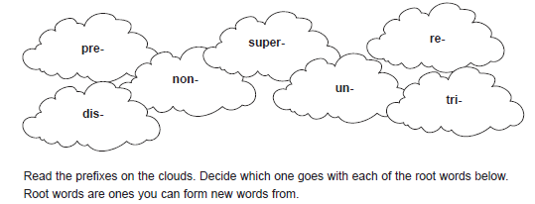
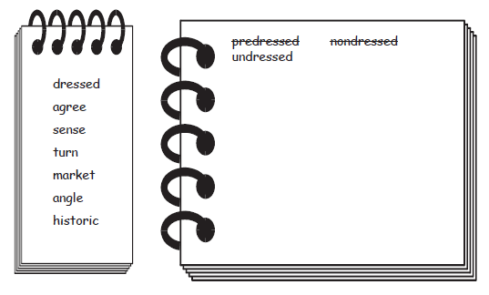

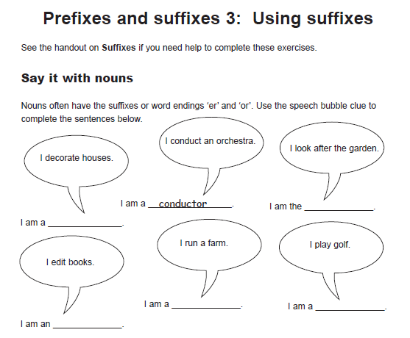

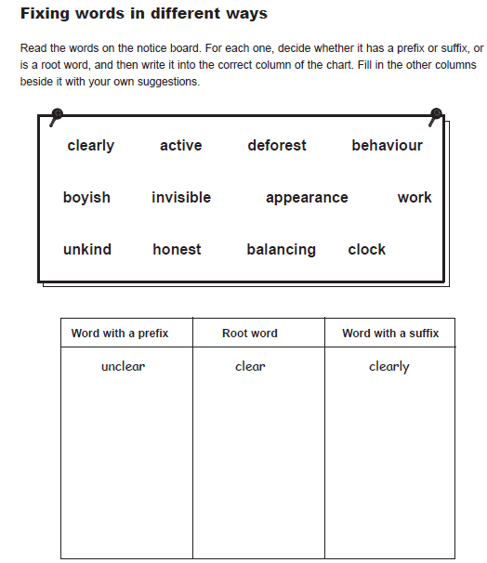

Can you use common affixes?
- I have a different idea; I __agree. dis-
- That can’t be; it’s just __possible. im-
- Say that again; please __peat it. re-
- Aliens look bad; they are __friendly. un-
- Tina took the car since she want__ it. -ed
- Now the car is run__ down the road. -ing
- Tina is in a hurry; she’s driving quick__. -ly
- Do you think that she has any ticket__? -s

Done…

Lecture 14
(review)

NOTE: Like adjectives some adverbs can take comparative and superlative forms,
with -er and -est:

- Sally works hard.
- Steve works harder than Sally
- Kathy and Sue work the hardest of all.

Let’s Start Exercising:

1. The weather in winter is _____________ than it is in summer.
A. colder B. cold
C. coldest D. the coldest
2. I have ___________ money than you do.
A. much B. more
C. most D. least
3. Abdullah is ______________ of all boys.
A. the fastest B. the most fastest
C. fast D. faster

- ملاحظة: محاضرة ٧ , ٨ , ١٣ , ١٤ كلهـآ مراجعة .. لكن في المحاضرة ١٤ لقيت هالتمارين زيادة واضفتهـآ لكم .

أدعو الله للجميع بالتوفيق والنجاح .
اللهم اغفر لي ولوالدي وللمسلمين جميعاً.
دمتم بخير .

