Lecture 9
(what do you mean? Thought and communication)

Vocabulary Match:

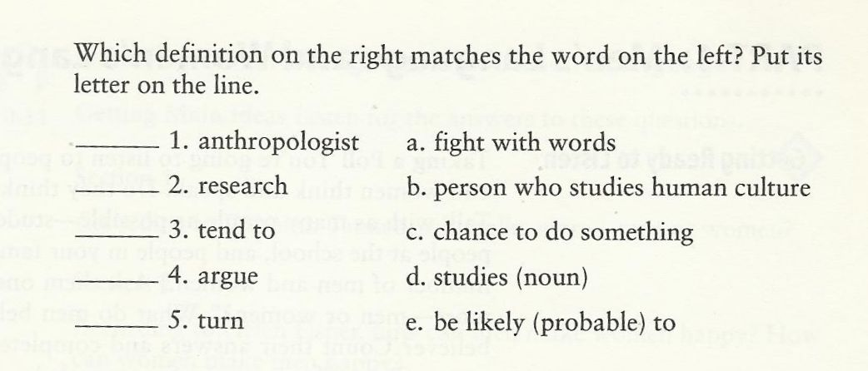

CD 2, TR 10-11:
Getting main ideas:
- According to Deborah Tannen, who talks more –men or women?
- According to Helen Fisher, how can men make women happy? How can women make men happy?

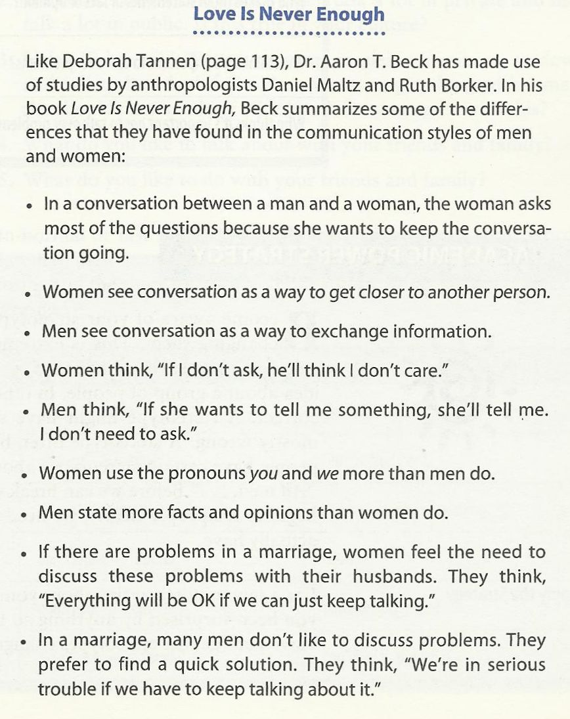
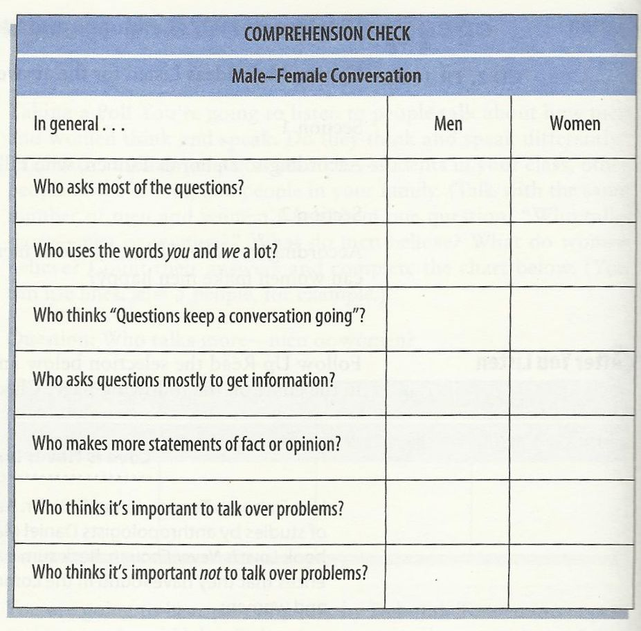
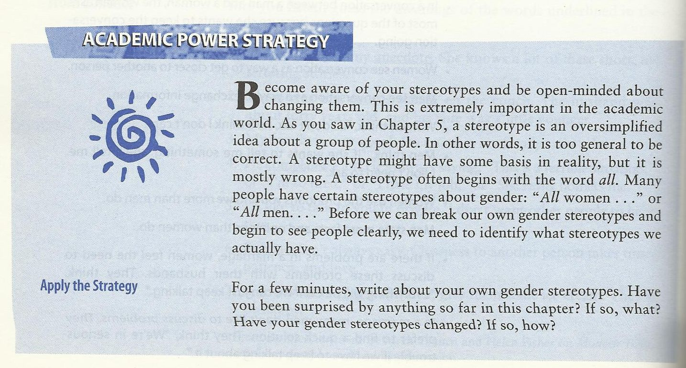
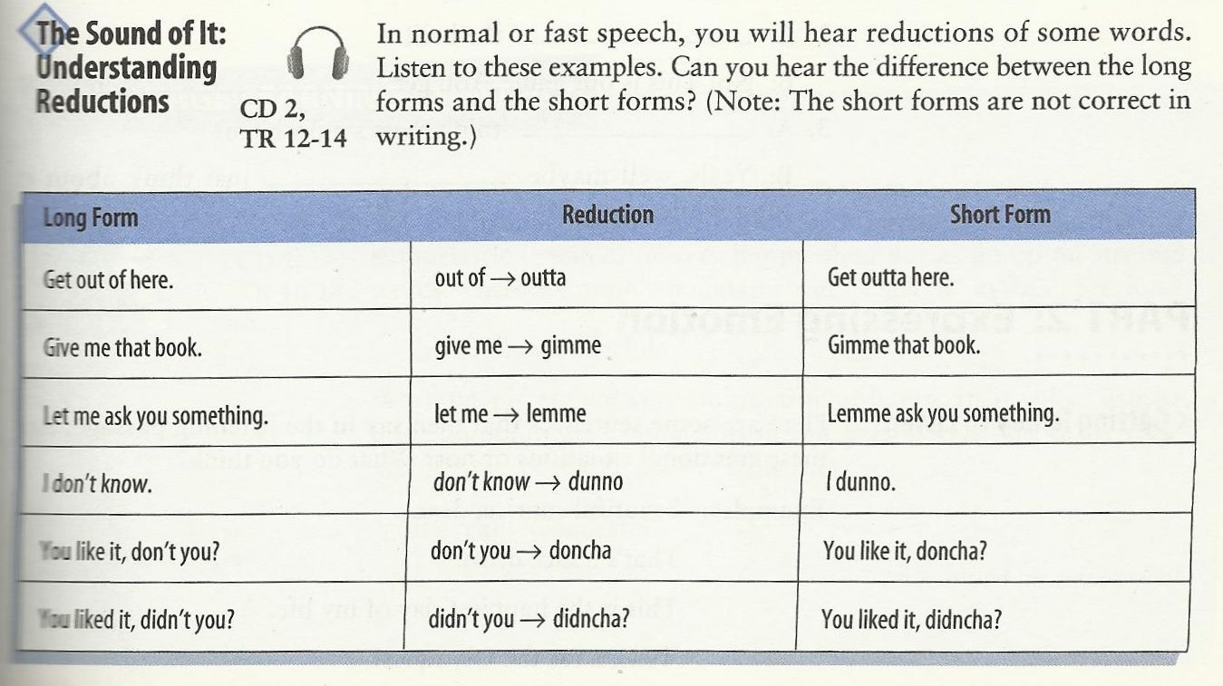
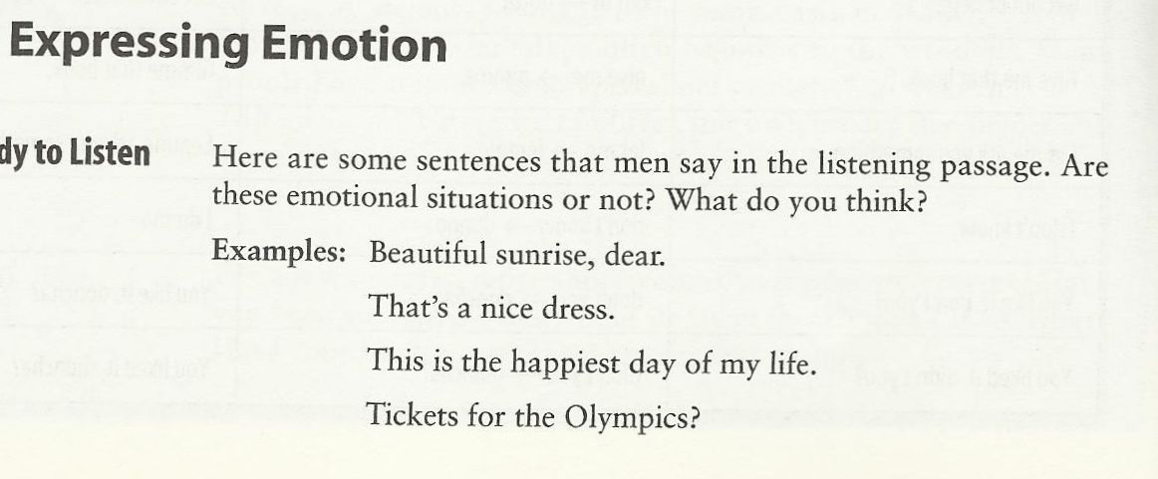
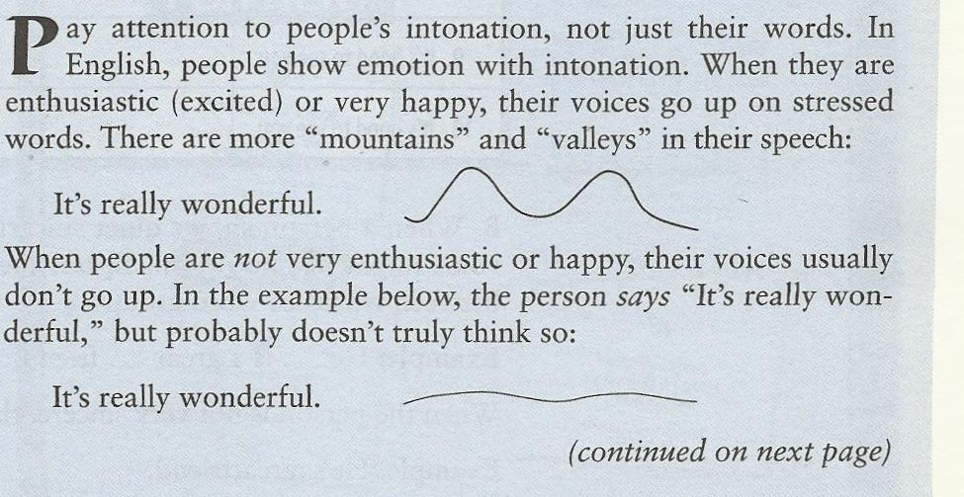
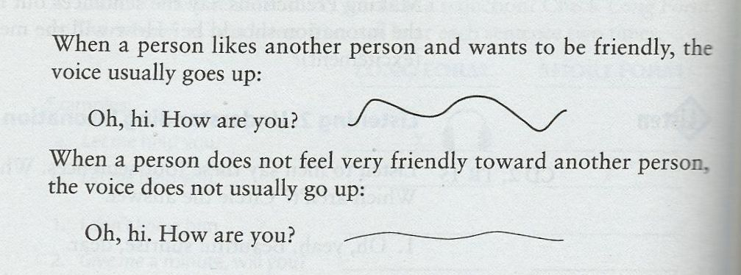
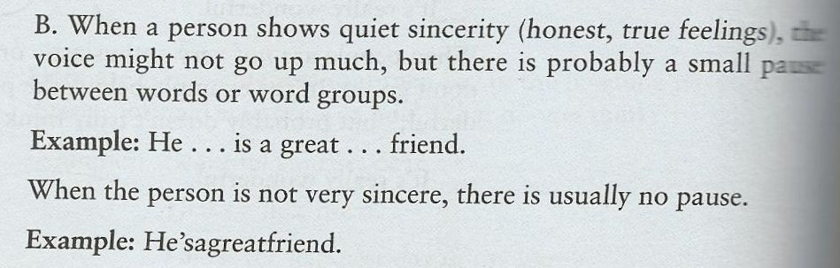
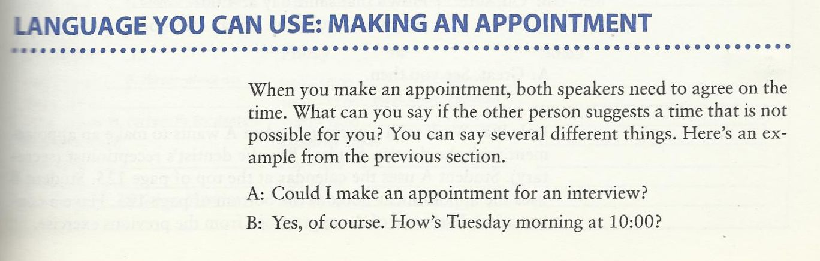
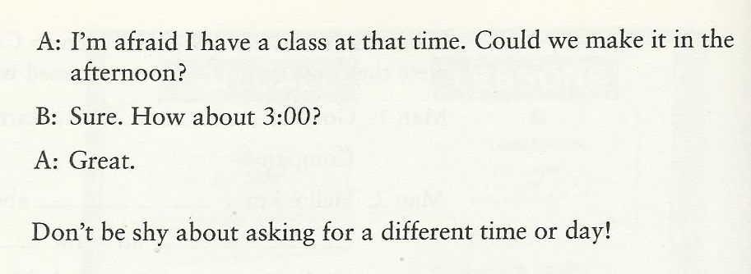
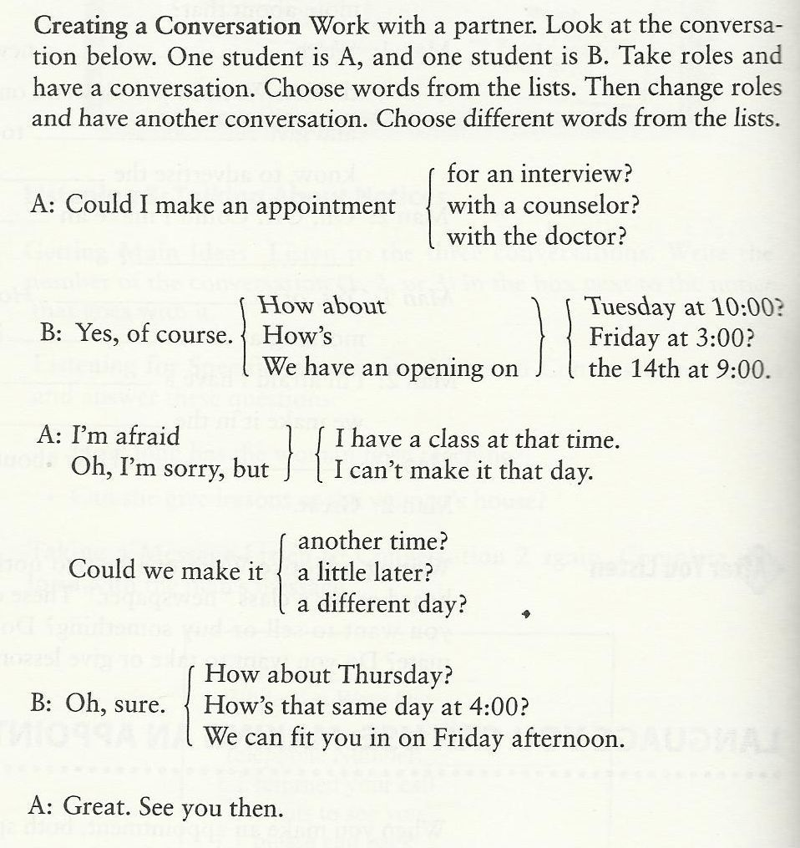
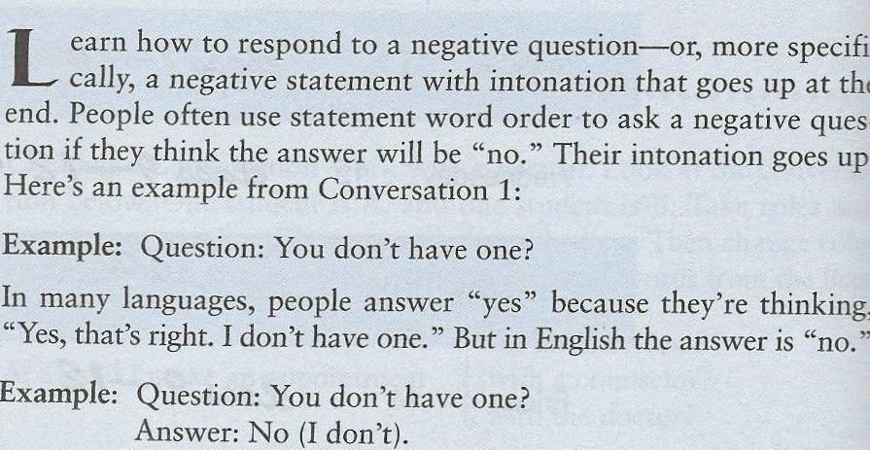
CD2, TR 22-24:

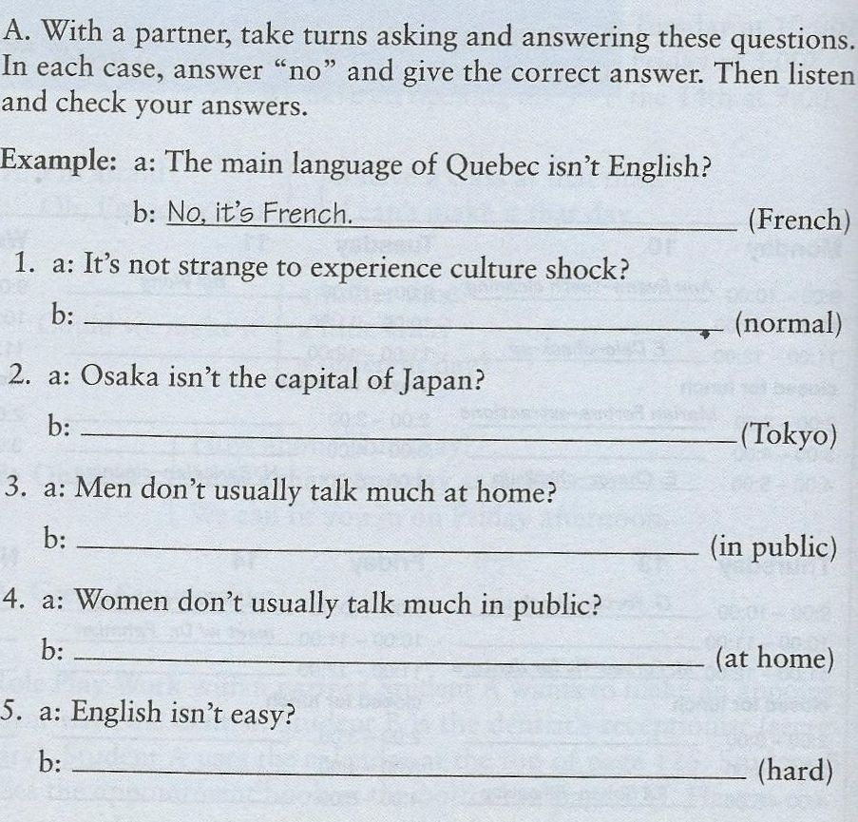
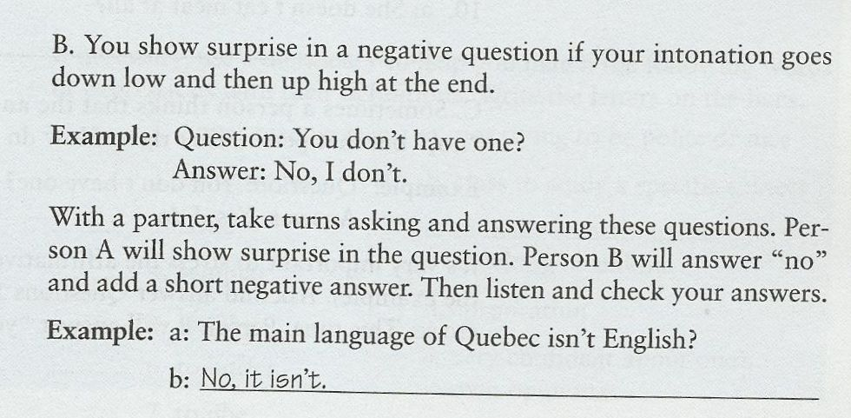

Practice:

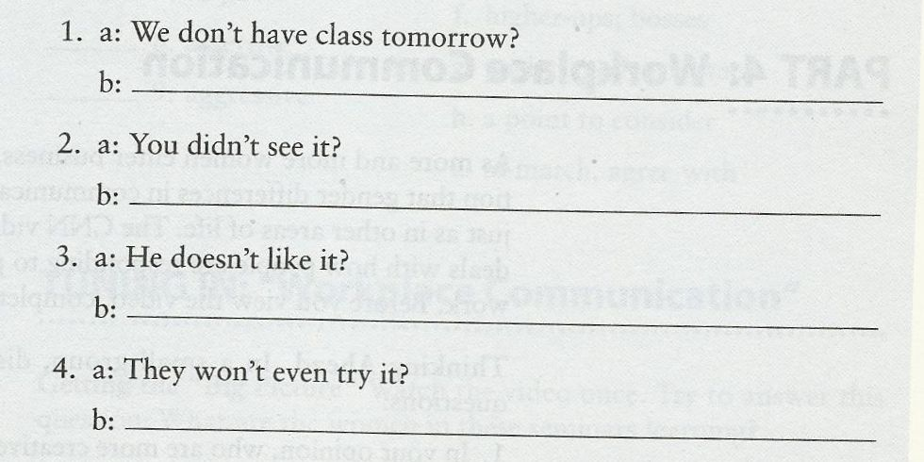
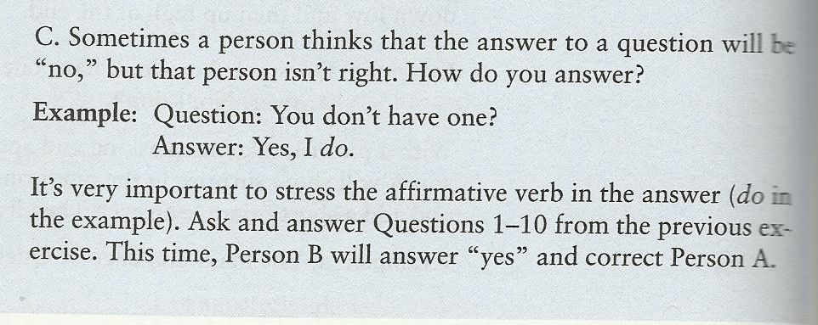
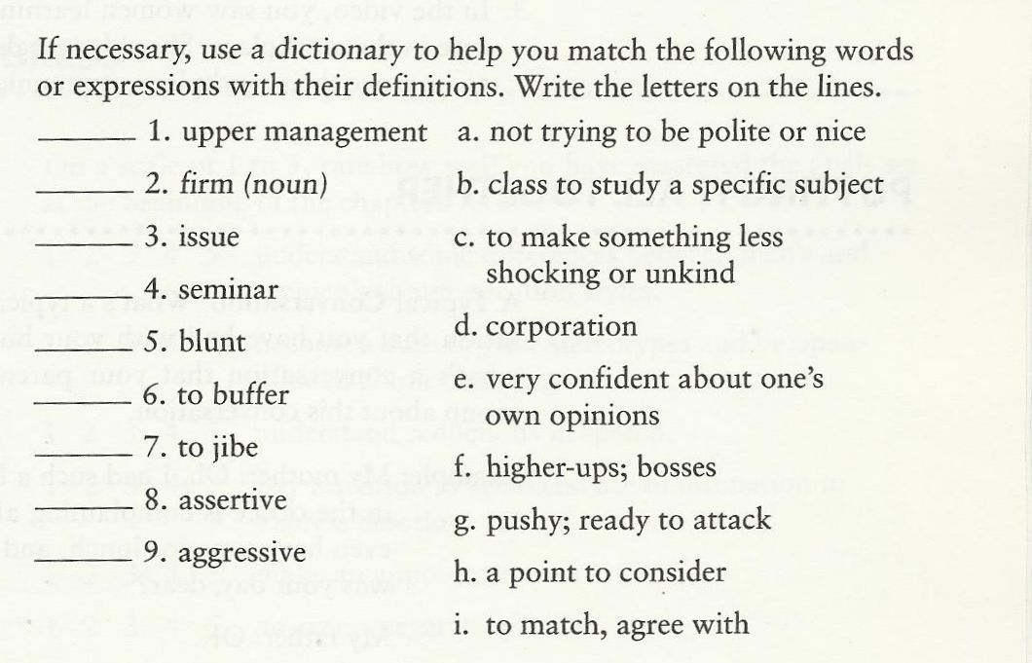

Done…

Lecture 10
(Tell me what I want: Advertising… and shopping)

Vocabulary Match:

advertisement, ad | Commercial.
to cheer up | To make happy.
fashion | Style.
like a kid in a candy store | Like a child in a place with lots of goods or appealing things.
window shopping | Shopping without spending any money.

Guessing meaning from context:
- I recommend that you buy a new computer –your old one is not working very well, so it would be a good idea to get another one.
- There’s a sale at the shopping center –let’s go buy a new desk while the price is low.
- They have other office equipment on sale too –like laser printers and fax machines.
- I don’t know how to use a computer. I hope my new computer comes with an instructional manual that is easy to read.
- Do you pay cash for things you buy? Or do you charge them on your credit card?
- I always write checks to pay for things so that I have a record of what I spend.

Returning things to a store:
Vocabulary building:
___ 1. reliable a. warranty
___ 2. to switch b. dependable
___ 3. guarantee c. money that you get back
___ 4. refund d. safe, no danger
___ 5. no-risk e. to change

CD 2, TR 29 Understanding an ad:
Getting the main idea: Listen to the ad for AT&T Communications and answer the questions.
- Who is Emerson?
- What idea does he give the boss (the head of the company)?

Language you can use: Returning things to a store:
- I’d like to return this.
- I’d like to make an exchange.
- I have the receipt (sales slip) right here.
- I’d like a refund.
- This _____ is broken (too large, the wrong size).

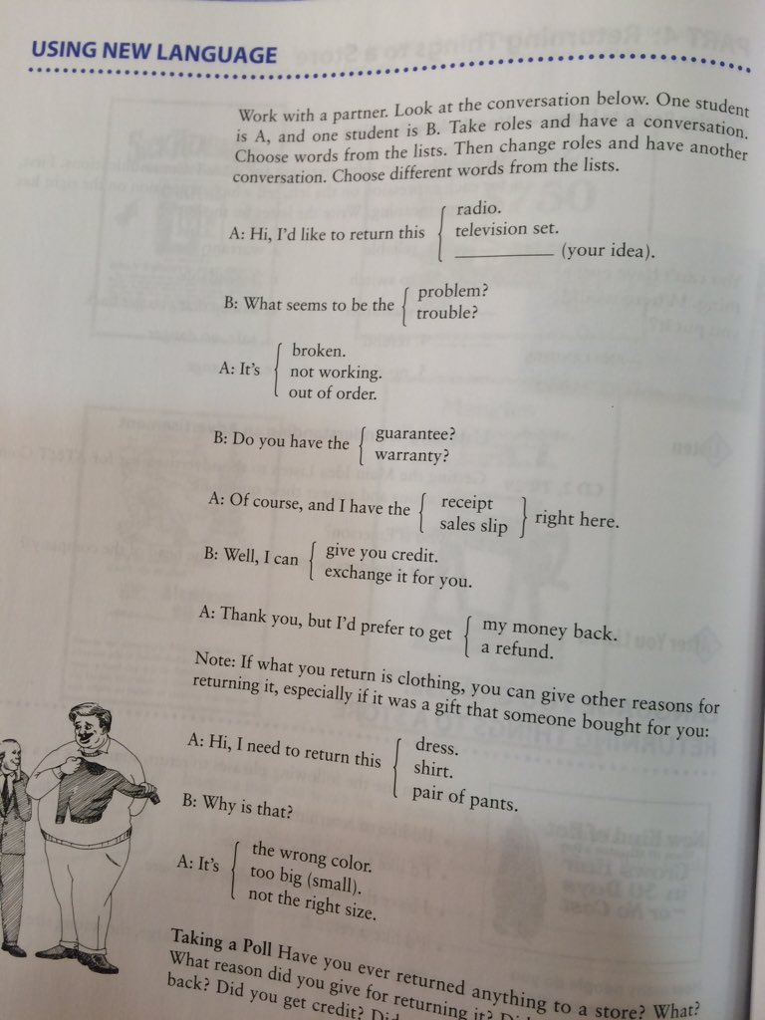

Agreement and Disagreement:
Before that, we should learn about 3 levels of discussion:
- Dialogue
- Discussion
- Debate
But what is the difference between them?

(Dialogue):
- The goal is primarily to try and understand where each person is coming from and what makes them think the way they do.
- People spend as much effort on really listening and probing to understand others as they do trying to explain what they think and why they think that way.
(Discussion):
- The goal is primarily to get to “say your piece”.
- People are more interested in getting a chance to speak than listening to other’s perspectives and trying to understand where they are coming from.
(Debate):
- The goal is to prove that you’re right and the other person is wrong.
- Things are presented as very black and white/ right or wrong.

Some ways of expressing agreement are:
- That’s just what I was thinking.
- You know, that’s exactly what I think.
- That’s a good point.
Agreement (and continuing the dialogue):
- The point you made about “…..” is excellent. I’d like to add that…
- I agree with your comment “…”. What do you think about…?
- I’m with you on that point. What I still wonder about is….
- I think what you’re saying about…. is so right. What would happen though if…?
- Yes, and in fact….
- Yes, and what is more…
- Absolutely. Actually, I would go further, and say…

Partial Agreement:
- I agree with……, but what about …….?
- That’s a good point, but in my opinion….
- That could apply in some situations, but what about when….?
- I understand your point about…, but I don’t understand…..
- It’s certainly true that…, but on the other hand….
- I can see that…., but I think it’s also important to consider….
- That makes sense, but could it also be true that….
- I’d agree with you if…., but not if…
- I see what you mean with…, but I also think we need to consider….

Constructive Disagreement:
- I can appreciate your point about…, but I would disagree because….
- That’s interesting, however, from my point of view….
- That may be the case, but in my experience…..
- I’m afraid I can’t agree with… because …..
- I disagree. What about the situations where…?
- I don’t think that’s the case because ….
- I’m not so sure about that because…
- I don’t think your point about…necessarily follows because…
- I don’t really see it that way because….

Things to Avoid:
1. Avoid using words like never and always.
This type of language can easily lead to arguments about the wrong thing, and take a discussion completely off track.

2. Avoid expressing disagreement without explaining why or supporting your point.
In a discussion, if you are going to disagree, it is only fair to explain why you disagree.

3. Avoid criticizing the person who made the comment.
Everyone is entitled to their opinion. Just because someone thinks differently doesn’t make them better or worse than you. Sticking to comments about ideas keeps the dialogue interesting and avoids making it personal.

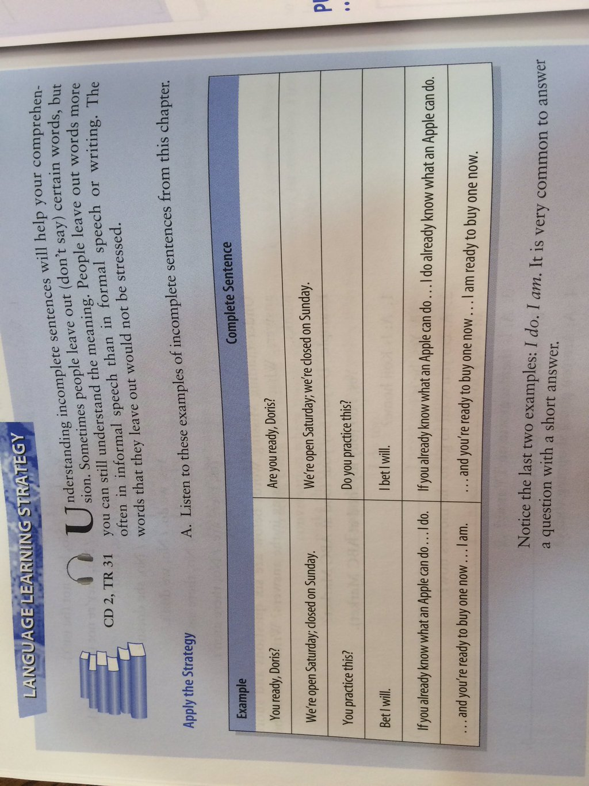

Done…

