Varieties of English
From around 1600, the English colonization of North America resulted in the creation of a distinct American variety of English. Some English pronunciations and words "froze" when they reached America. In some ways, American English is more like the English of Shakespeare than modern British English is. Some expressions that the British call "Americanisms" are in fact original British expressions that were preserved in the colonies while lost for a time in Britain (for example trash for rubbish, loan as a verb instead of lend, and fall for autumn; another example, frame-up, was re-imported into Britain through Hollywood gangster movies). Spanish also had an influence on American English (and subsequently British English), with words like canyon, ranch, stampede and vigilante being examples of Spanish words that entered English through the settlement of the American West. French words (through Louisiana) and West African words (through the slave trade) also influenced American English (and so, to an extent, British English).
Today, American English is particularly influential, due to the USA's dominance of cinema, television, popular music, trade and technology (including the Internet). But there are many other varieties of English around the world, including for example Australian English, New Zealand English, Canadian English, South African English, Indian English and Caribbean English.
The Germanic Family of Languages
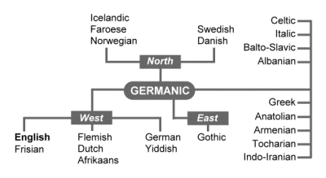
English is a member of the Germanic family of languages.
Germanic is a branch of the Indo-European language family.
