المملكة العربية السعودية  وزارة التعليم العالي  جامعة الملك فيصل  عمادة التعليم الكتروني |  | نظام التعليم المطور للانساب  قسم اللغة الانجليزية  الفصل الداراسي الاول  الدكتور غسان نايفه

Orientation Lecture
Introduction
Why should students learn English ?!!
- We all know that English language is considered as the first international language in the world. It is the language of all science and economics ………etc.
- People all over the world , with different nationalities and languages, realize that English language is very important in their life to communicate among themselves.
- University students need English language to help them in their academic studies & higher education
Elements of the Lecture
- Course Description
- Course Objectives
- Course Content
- Evaluation
- References
- Contact

Course Description
This course is a beginning level ESL/EFL developmental skills text in which grammar serves to expand learners’ abilities in speaking , writing, listening and reading . It uses a grammar- based approach integrated with communicative methodologies. Starting from a foundation of understanding form and meaning, students engage in meaningful
communication about real actions, real things and their own real lives .
This course is very helpful for the learners , especially, distance learning students to revise the basic grammar of English that is greatly required in their different specializations and at the same time meet, at minimum , their needs in their academic studies.

Course Objectives

1. Revising some important English language skills that students have
already learned before.
2. Providing students with basic English structures that help them
understand sentence formation.
3. Helping students to communicate with others using simplified English
grammar.
4. Improving students’ English language skills in reading and writing
5. Training students to scan and skim reading texts for specific & general
information.

Contents of the Course.

a- Verbs to BE ( is , am , are, was and were)
b.- Pronouns ( I , you, he , we , them……etc )
c- Verb Tenses ( past, present, future…. etc
d. Negative Forms
e. Types of Questions( Yes/No & Wh- Questions
f. Prepositions ( time & place )
g. Countable & Uncountable Nouns
h. Spelling & pronunciation of final –es and final –ed
i. Irregular verbs
j. Expressions of frequency
k. Using Articles ( a, an , the and no articles)
l. Comparative & Superlative forms
m. Using many, much, few , little , a few , a little, one, none , all and some
n. Reading texts with different topics and some relevant vocabulary
Students’ Performance Evaluation
Total mark is out of 100
1. 30% of the total mark is for students’ participation ,interaction & activities.
2. 70% of the total mark is for the FINAL TEST
- The final test is ( about 100 multiple choice questions with different forms )
The exact date and time of the final test will be announced later

Textbooks & Recommended References
The main textbook is:
1. Basic English Grammar
Third edition
Azar & Stacy A. Hagen Authors: Betty Schrampfer
( NOTE: Color of the book cover is red . It is available at Jareer & Al-obeikan bookshops )
Recommended reference:-
2. Interactions access
Reading and Writing
Authors : Pamela Hartmann, James Mentel & Ahmed Mototal
NOTE: Color of the book cover is yellow. It is available at Jareer & Al-obeikan bookshops
NOTE:
- In case the textbooks are unavailable students can choose any relevant references that contain the required topics or subjects in addition to focusing mainly on lectures that will be demonstrated, explained and then registered in the website.

Contact
For more information or details, you can contact me through :
King Faisal University
e-Learning Deanship
Building Number: 50
email: ghnayfi@kfu.edu.sa
Office telephone: 035802278-234
Mobile:
Wish you all success
Dr. Ghassan M Nayfi

Chapter ONE
Using Be
English Language
Basic English Grammar

Present Verbs to Be
There are 3 present verbs to be;
- Am
- Is
- Are
How to use each on of them
Am (used with I only) :-
Iam a student.
Iam happy.
Iam in the library now.
Iam from Saudi Arabia.

Is ( used with singular subjects)
He is a boy.
She is a girl.
It is an insect.
The car is new.
My friend is from Jordan.
Summer is hot now in Saudi Arabia.
Your pen is on the table.
Contractions with Be
Am (used with I only) :-
Iam / I’m a student.
Iam / I’m happy.
Iam / I’m in the library now.
Iam / I’m Saudi Arabia.
________________
Is ( used with singular subjects)
He is / H’s a boy.
She is / She’s a girl.
It is / It’s an insect.
The car is / The car’s new.
My friend is / My friend’s from Jordan.
Summer is hot now in Saudi Arabia.
Your pen is on the table.

Are ( used with plural subjects )
We are / We’re students
They are / They’re girls
You are / You’re boys/ a boy
The books are in the bag now
Samia and Reem are sisters
Our friends are very kind
His brothers are Fahd and Rami

Negative with BE
Am (used with I only) :-
Iam not/ I’m not a student.
Iam happy.
Iam at work now.
Iam from Saudi Arabia.

________________
Is ( used with singular subjects)
He is not/ He’s not / He isn’t a boy.
She is a girl.
It is an insect.
The car is new.
My friend is from Jordan.
Summer is hot now in Saudi Arabia.
Your pen is on the table.

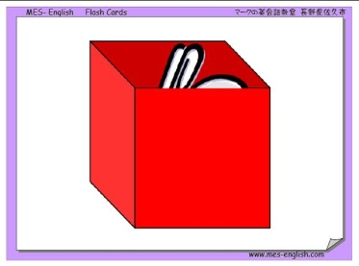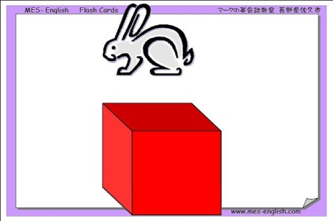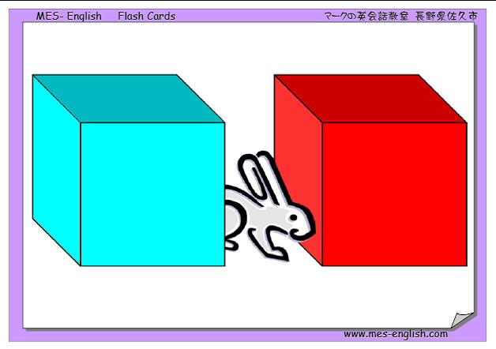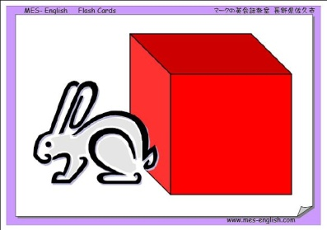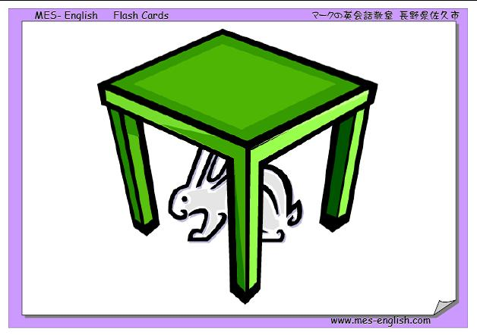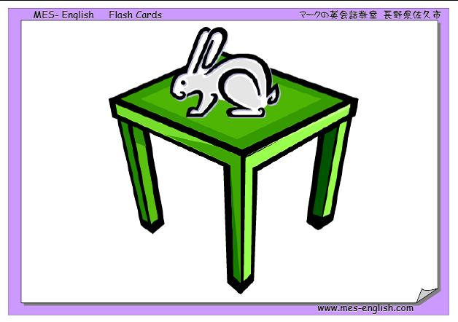
Prepositions ( place )
in
over
between
Next to
under
On

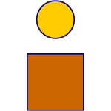
ON
IN
ABOVE
UNDER
BEHIND
IN FRONT OF
BETWEEN
NEXT TO
NEAR

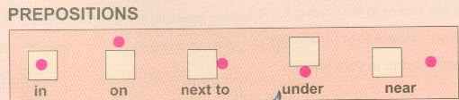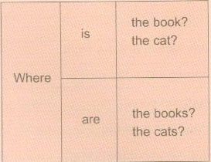
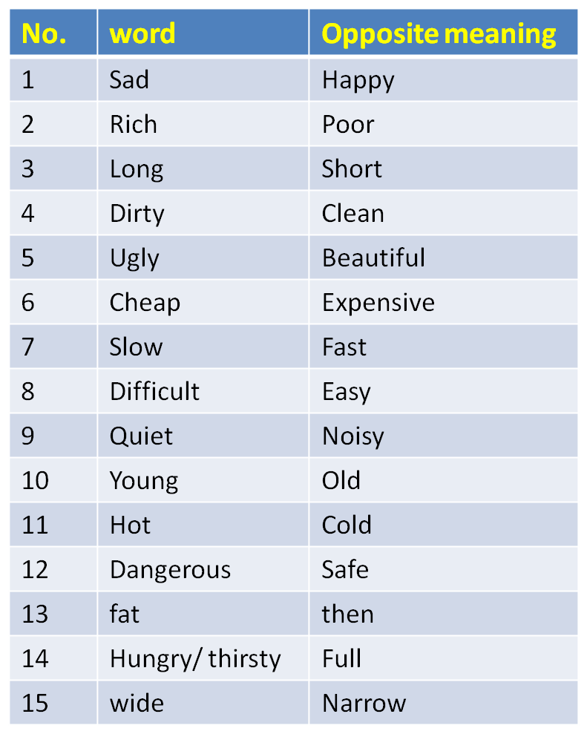
The Opposite Meaning

Yes/No Question with BE
1. He is a mechanic.
Is he a mechanic? – Yes, he is
- No, he isn’t
2. They are at home.
Are they at home ? – Yes, they are.
- No, they aren’t
3. Iam a student.
Are you a student? – Yes, Iam
_ No, Iam not
4. The car is expensive.
Is the car expensive? - Yes, it is
- No, it isn’t
Exercise 1
- English language _______ easy to learn.
- it is
- are
- is
- am
2. Ahmed and I _________ free today.
- am
- aren’t
- is
- am n’t
3. ______ is my sister.
- She
- He
- They
- We

4. You are _____ man.
- a
- an
- not
- nothing
5. Airplanes aren’t slow. ___________ very fast.
- He’s
- They aren’t
- It isn’t
- They’re
6. ______ my uncle. He is my father.
- He is
- He’sn’t
- He isn’t
- It is not

7. The food _____ very delicious.
- are
- am
- aren’t
- is
8 ______ cat is________ animal.
- An / a
- A / a
- An / an
- A / an
9. Ibrahim is a doctor. ____ ____ a doctor?
- He is
- He isn’t
- Is he
- Isn’t she

- ___ your father at home?
- Are
- Is
- Aren’t
- Am
11. Flowers aren’t ugly. They are very _____________.
- hot
- rich
- beautiful
- Safe
12. English language is _____________ to learn. It isn’t difficult.
- slow
- easy
- noisy
- Cheap

13. Look! The bird is flying ____________ our heads.
- in
- under
- over
- On
14. You should keep your money ________ your pocket.
- on
- over
- under
- in

15. My friend is_________. He can’t come to work.
- healthy
- sick
- Rich
- beautiful

End of the first lecture
Good Luck For All

Lecture 2
Reading Skill
- Scanning
- Skimming
- Previewing Vocabulary
- Revising some structures
- Writing : Jumbled sentences
IV. Writing: Jumbled sentences

Reading Skill
- Scanning
- Skimming
- Previewing Vocabulary
- Revising some structures
- Writing : Jumbled sentences

My name is Elena Sanchez. I am from Mexico, but now I live in California. I'm a student here in English language classes at a small college.

I live in an apartment building. It's on the corner of Olive Street and Sycamore Avenue. My address is 2201 Olive Street. There's a big olive tree in front of the building. There's a park across the street. There are a lot of oak trees in the park. The trees are beautiful in the summer.
A lot of my neighbors are from different countries. The people next to me are from Indonesia. The family across from the Indonesian family is from Colombia.

I. Read the following essay ,then answer the questions that follow
The stores in this neighborhood are always busy. There's a Korean drugstore and an Armenian flower shop.
There are three restaurants on Olive Street: One Mexican, one Japanese, and one Moroccan-Italian-American.
I like my neighborhood, but I ask myself one question. Where are the Americans?!!!
Now, Answer the following questions
Part one
1. Where is Elena from?
2. Why does she live now in California?
3. What kinds of trees are in California? [ Mention TWO kinds]
4. When are the trees beautiful?
5. Which country are the people who live next to Elena from?
Part one
6. What does a Korean store sell?
7. Who is from Colombia?
8. How many restaurants are there in Olive Street?
9. What is in front of the building?
10. Where does Elena go if she wants to buy flowers?

Part Two
Complete each the following statements with correct information based on the passage content.
The underlined word " here" LINE 2 refers to: ------------------------------------------------------------
The underlined word " one" LINE 11 refers to:-------------------------------------------------------------
The underlined pronoun “ me” refers to: --------------------------------------------------------------------
A word in the passage which has the same meaning as " shops" is --------------------------------
A word in the passage which has the same meaning as " flat" is ------------------------------------
A word in the passage which has the same meaning as " road" is ----------------------------------
A word in the passage which has the opposite meaning of "behind" is---------------------------
A word in the passage which has the opposite meaning of "ugly" is-------------------------------
A word in the passage which has the opposite meaning of " free" is-------------------------------
The simple past form of the verb "am" is ----------------------
The simple past form of the verb " are" is ---------------------

II:

Structure

1.Salma and Fatima -----------------from Riyadh.

a. is
b. was
c. has
d. are

2. ___________ your car new?

a. Are
b. Is
c. Aren't
d. Has
Part One : Circle the correct response
II.
Structure
3. London ------------------ a country. It is a city.

is
aren't
isn't
are
4. ----------- ant is ---------------- insect.

An / an
An / a
A / an
A / a
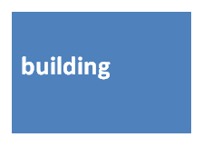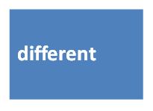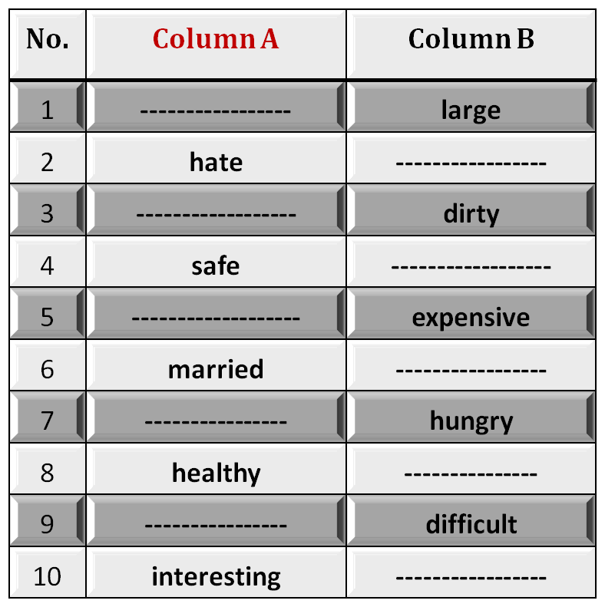
Part One:
Structure
5. Are you a doctor? No, ---------------------.

I'mn't
amn't
Iamn't
I'm not
6. Where is the water? ------------------- inside the refrigerator.

They're
It
It's
He's
Part Two:
Structure
7. A teacher usually starts a lesson by writing the date------------------the board.

in
under
over
on
8. My friend is from America.---------- lives in New York city.

I
We
He
It

Part Two:
Structure
9. ------------ in the house now.

We're
Wer'e
Were
We re

10. Are you ready? - -------------------------------.
No, I'm not
Yes, I'm
No, Iamn't
Yes, You're

A.Fill in each blank with a word from the box
This store is always ____________. There are always lots and lots of people.

2. My________________ are from Mexico. They're very nice people.

3. There are two big trees in ______________ of my house.

4. There is a big apartment ________________ on the corner of the street.

5. People in my neighborhood are from ________________ countries.

III. Vocabulary
B. Identifying Opposites
Fill in each blank space with the opposite meaning
IV. Writing: Jumbled sentences
Rewrite the words in the correct order to make meaningful sentences
weather / very / in / Saudi Arabia / hot / in / The / summer / is.

------------------------------------------------------------------------------------------------------------

2. speak / at / The / this / English / university / lecturers.
-------------------------------------------------------------------------------------------------------------
3. fast / is / Driving / very / your / dangerous / car.
-------------------------------------------------------------------------------------------------------------

4. red / the / is / book / the / color / of
-------------------------------------------------------------------------------------------------------------

5. homework / I / my / myself / do / always.
---------------------------------------------------------------------------------------------------------------

Good **** Luck
End of Lecture 2
Lecture Three
Eng 121
Grammar – Vocabulary - Reading
Chapter Three
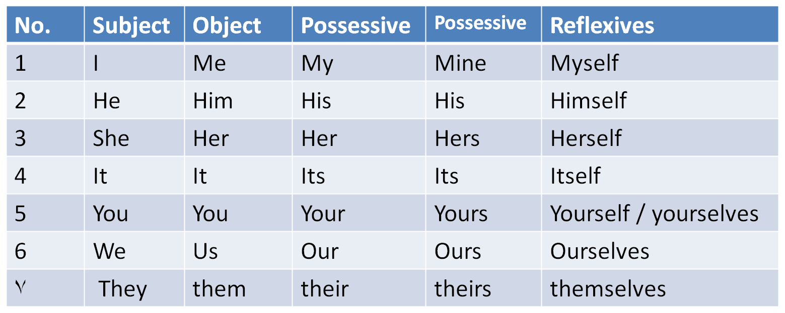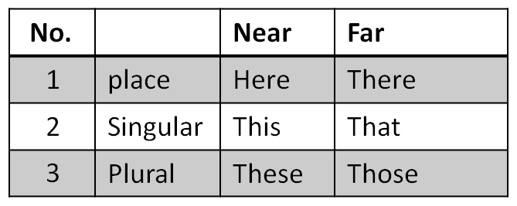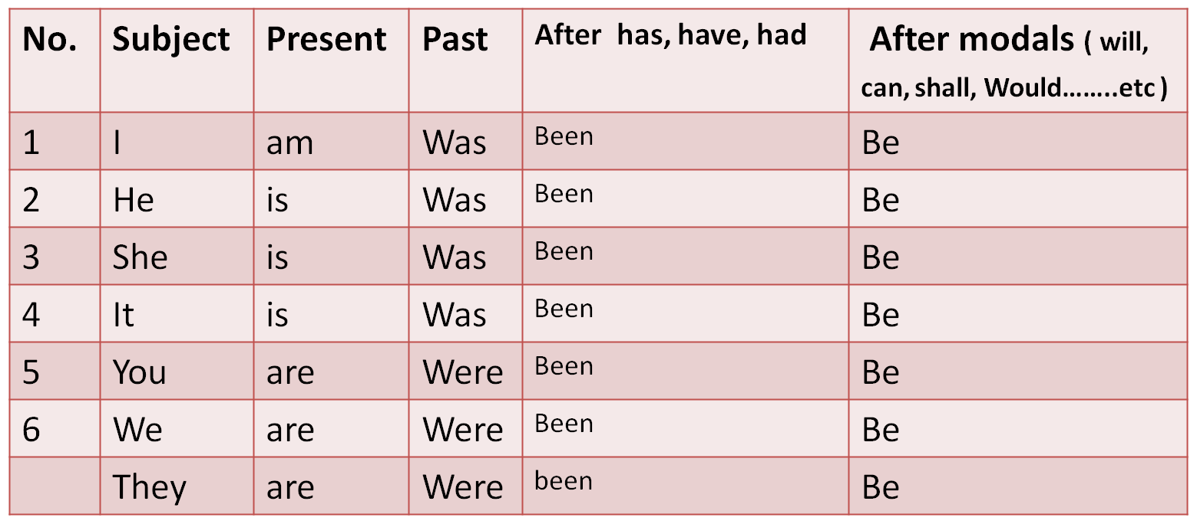
Elements of the Lecture
Scanning and Skimming reading text
1-Articles ( A , An )
2- Pronouns
3- Verbs to Be
4. Have / Has / Had
5. Previewing Vocabulary

Scan & Skim the following reading paragraph
Fifty years ago, many people said, “ Online shopping is crazy. Nobody can make money in online company.” They were wrong. Today, jeff Bezos is a billionaire. More and more people are shopping online, and online companies are making a profit. It is a huge business. But some people predict, “ Online business isn’t going to grow any more.” They said, “ customers are afraid of online crime, and they will stop shopping on the internet.

Scan & Skim the following reading paragraph
“They “ Line 2 refers to____________________________
“ They” Line 8 refers to____________________________
“Make money” means_____________________________
“Huge means”___________________________________
“Profit means”___________________________________
“Predict means”__________________________________
Why do some people predict that online shopping will not going to grow?
_________________________________________________
8. “Grow” means ____________________________________

1. Articles- Indefinite
There are 2 indefinite articles in English:
A= used before singular nouns that begin with consonants.
An= used before singular nouns that begin with vowels
Consonants= all letters in English except ( a , e , i, o , u )
Vowels= ( a, e , i ,o , u )
Examples.
__book __orange __ car __story __ egg __lecture
__ man __umbrella __apple __ pencil __table __ email
Note: 1.Remember that all the above words are Singular
2. We can’t use ( A or An ) before proper nouns, cities, days, months, etc

I. Exercise ( an & a )
1. Could you please give me _____ piece of cake?
a. an b. two c. a d. many

2. ___ dog is ____ animal.
a. An/a b. An/an c. A/an d. A/a
3. I visited ____Ahmed last week.
a. an b. the c. a d. Nothing
4. The capital of Saudi Arabia is ____ Riyadh.
a. Nothing b. an c. a d. the
5. I finished ____ unit in English language course.
a. an b. a c. three d. few
6. I take___ umbrella when it rains.
a. a b. an c. two d. several

2. Word & Pronoun Reference
A. Personal Pronouns

2. Word & Pronoun Reference
B. Demonstrative Pronouns

II. Exercise
1. The doctor gave__________ a lecture about pronouns.
a. we
b. us
c. our
d. ours
2. ______ friend sent an email to the doctor regarding the homework.
a. I
b. Me
c. Mine
d. My

II. Exercise
3. Hani visits _______ every week.
a. them
b. they
c. theirs
d. their
4. _______ are the books you told me about.
a. That
b. These
c. You
d. Their

II. Exercise
5. The building you asked me about is ___________.
a. these
b. those
c. there
d. her
6. That car over there is __________.
a. mine
b. me
c. my
d. I

3. Verbs to Be

III. Exercise ( verbs to be )
1. She______ at home now.
a. be b. was c. is d. been

2. My friends will_____________ here after 15 minutes.
a. are b. were c. been d. be
3. I ____in Riyadh two weeks ago.
a. was b. am c. be d. were
4. We _________ ready to start now.
a. were b. aren’t c. weren’t d. isn’t
5. ____ Hiba at university yesterday?
a. Is b. Are c. Were d. Was
6. Will Rashed___ at university tomorrow?
a. be b. is c. was d. been

4. Verbs to Have
There are THREE forms of HAVE
A. Have= Present comes after ( I , You, They, We or after plural nouns)
B. Has = Present comes after ( He, she , it or after singular nouns )
C. Had= Past comes after all kinds of nouns plural or singular
******************************************************
Exercise:
1. We _______ a lecture in English yesterday. ( has, have , had, having )
2. My friend________ a new car nowadays. ( has, having, had, have)
3. The students _____ studied English for a month.( has, have, had, having)
4. He has a car. He doesn’t have a car. Does he have a car?
5. He has got a car. He hasn’t got a car. Has he got a car?
Note: 1. ( has, have, had) can be used as main verbs like 1 & 2 & 4 in the
exercise or as helping verbs as 3 & 5.

IV. Exercise ( verbs have )
1. She______ a new car nowadays.
a. had b. have c. has d. hasn’t

2. My friends ___________been here for 15 minutes.
a. has b. have c. hasn’t d. aren’t
3. I ____an English lecture yesterday .
a. had b. have c. has d. haven’t
4. Hind _________ a dictionary now.
a. hasn’t b. doesn’t have c. haven’t d. didn’t have
5. Ahmed and Abdullah _________a mathematics test now?
a. has b. have c. doesn’t have d. had
6. _______ she been here before ?
a. Have b. Has c. Is d. Was

Lecture Four
Eng 121
Grammar – Vocabulary - Reading
Chapter Four
Elements of the Lecture
* Jumbled sentences
1- Do / Did / Done
2- Prepositions with Time ( at – on – in )
3-Vocabulary Previewing
4-Reading
A. Word & Pronoun reference
B. Scanning & Skimming
Jumbled sentences (page 20)
Write the words in the correct order to make meaningful sentences
1. / in / I / an / nowadays/ live / apartment /
-------------------------------------------------------------
2. busy / in / malls/ are / The / the / weekends
--------------------------------------------------------------
3. English / at / all / university / students / language / study
-----------------------------------------------------------------------------
4. Neighbors / from / My / are / my / country.
----------------------------------------------------------------------------
5. this / at / speak / lecturers / English / The / university
----------------------------------------------------------------------------

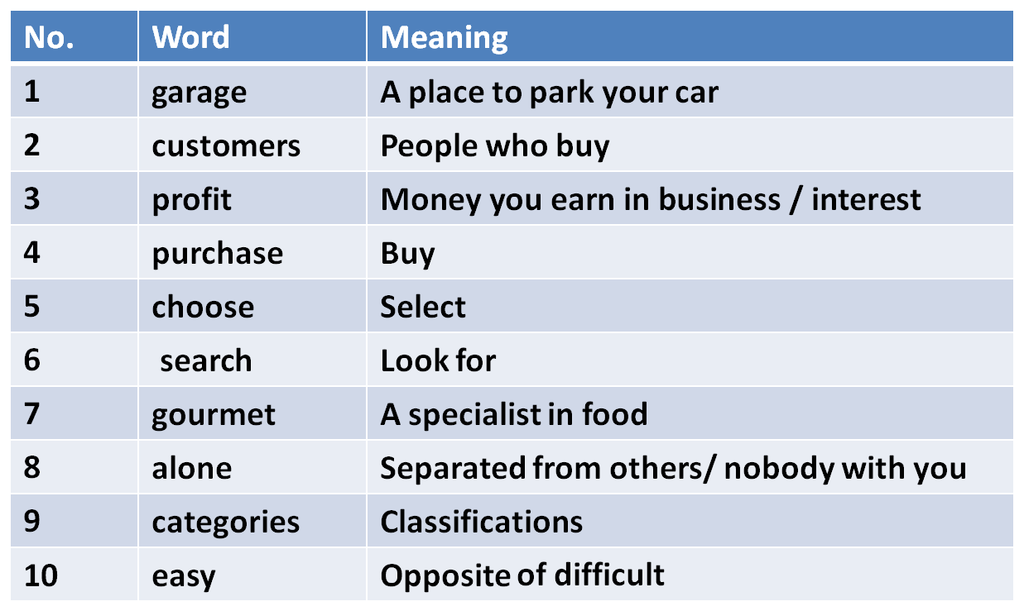
1. Do- Does- Did- Done- doing
They are used as helping verbs in order to form Questions & Negative OR used as
main verbs.
- I, We, They, You or any plural subjects + do ( Present )
- He, She, It + does ( present)
did - Plural OR singular subjects+
- After (has, have, had) + done
- After ( is, am, are, was, were) + doing ( active progressive)
________________________________________________________________
e.g:- - We do the homework every week
- She does the homework every week
- The students did the homework last week
- They are doing the homework now/ at the moment
- Salma has done the homework.
1. Exercise
1. Sultan __________ his best to get full mark in the last homework.
a. do b. does c. did d. done
2. Fatin has _________ the homework perfectly.
a. done b. did c. do d. does
3. You will _______ me favor if you tell me the answer
a. doing b. do c. doing d. did
4. He always __________ the right thing.
a. do b. doing c. does d. done
5. The students are _________ the exercises now.
a. do b. doing c. done d. did
6. _______________ the homework yesterday?
a. Have you do b. Can you doing c. Do you d. Did you do
2.Prepositions with time ( at- on – in)
At = used before o’clock / night
On =before days / following morning
In = before years and months/ morning/ evening / seasons
======================================================================
Exercise:
1. He goes to work____________ seven o’clock
a. in b. on c. at d. for
2. She was born_______ October.
a. at b. in c. on d. with
3. The weather is hot______ summer.
a. in b. on c. At d. From
4. Students don’t go to university_______ Friday.
a. in b. At c. Over d. on

3.Vocabulary Previewing

Exercise
1. Where is the car? It’s in the___________
A. library B. bog
C. garage D. kitchen
2. If you didn’t find the book, you can look for it in the other room. the underlined word look for means:
A. buy B. search
C. read D. eat
3. English language is_________________. It is not difficult.
A. beautiful C. boring
C. safe D. easy

Exercise
4. The word “ classifications’ means ________________ .
A. entertainments B. eatables
C. categories D. customers
5. The word “gourmet means__________________.
A. a policeman B. Food specialist
C. mechanic D. who works at hospital
6. “separated from others” . The underlined phrase means:
A. happy C. sick
C. alone D. busy

4. Reading :
A. Word & Pronoun Reference
Ahmed and his sister are from Riyadh. They study English at university. She is older than him. He speaks English better than her. They always go there by bus. It is a very suitable place for practicing English. They always speak English with each other to improve their language.
1. She refers to : ___________
2. him refers to : ___________
3. They refers to: __________
4. There refers to : __________
5. He refers to:_____________
6. It refers to: ______________
7. Their refers to:____________

Scanning & Skimming
8. Where are Ahmed and his sister from? They’re from __________.
A. university B. Riyadh
C. English D. the bus
9. Who is better in English? _______________
A. Ahmed’s sister B. English language
C. Ahmed D. English
10. How do they go to university? _______________________
A. On foot B. In a taxi
C. By plane D. By bus

English Language
English 121
Lecture 5
Vocabulary– Grammar- Reading
Chapter 3-4
Elements of Lecture 5
I- Previewing Vocabulary
2- Present Simple Tense
3- Negative Forms
4. Forming Questions
3- 5- Spelling & Pronunciation Of Final – es
6- Scanning & Skimming Reading Text

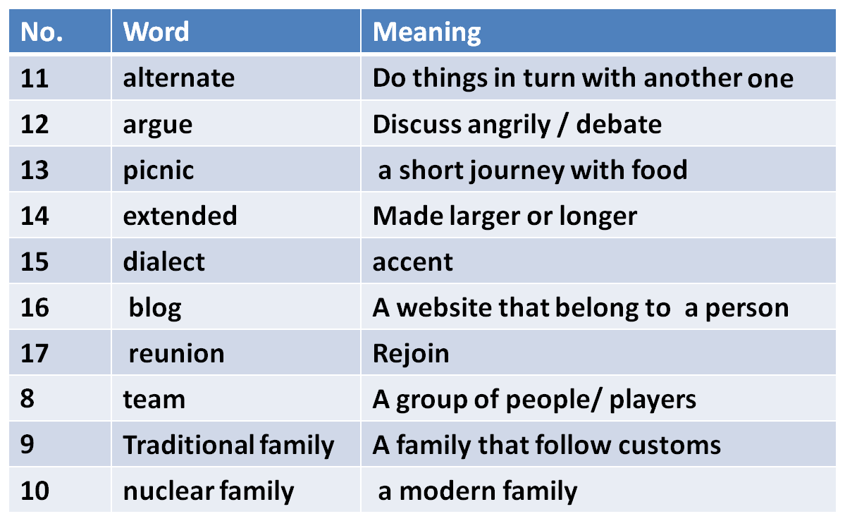
5.Vocabulary Previewing ( pages 45, 50, 56,57, 61)

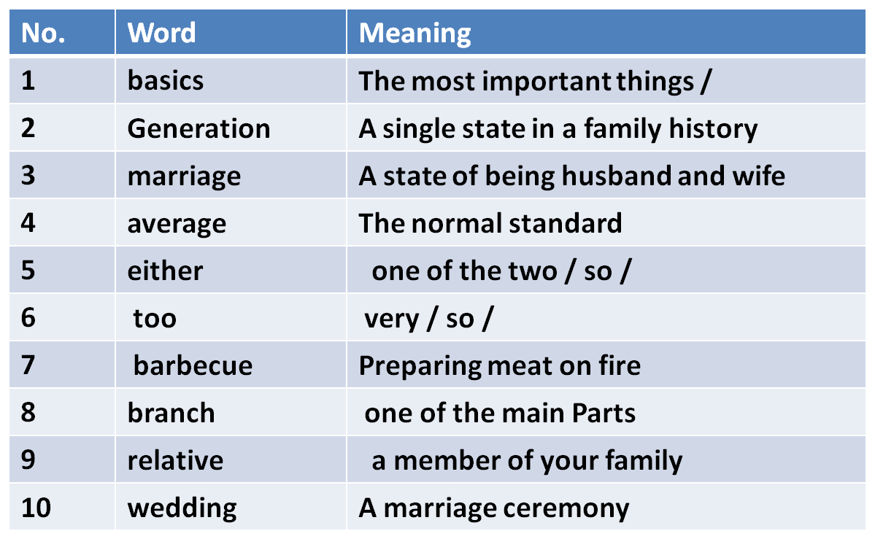
5.Vocabulary Previewing ( pages 45, 50, 56,57, 61)

I. Exercise
1. I speaks speak English fluently and Reem does, ___________
a. either b. too c. so d. neither

2. My ________ in this term is 84.3 %.
a. marriage b. package c. garage d. average
3. All members in __________ families were living in one house.
a. traditional b. nuclear c. rich d. bad
4. We went for a picnic by the sea and had a ___________.It was a very
delicious meal.
a. problem b. barbecue c. test d. camera
5. My uncle and my aunt are called my _______________.
a. relatives b. brothers c. friends d. neighbors
6. Group of people/ playing a sport is called a ________________.
a. family b. friend c. team d. match

2. Simple Present Tense
Present simple is used to describe an action which happens repeatedly
The verb in this tense has 2 forms:-
A . Ends with – s = When the subject is 3rd person : [ He , She & It ]
- He/ She drinks coffee every morning.
- Noura usually sleeps at 11 p.m every night.
- The sun rises from the east.
B. without any ending ( infinitive without to)= When the subject is
plural, I & You.
- I sometimes drink coffee.
- We take a quiz in English language from time to time.
- The students take lessons through the internet once a week

Exercise
1. My uncle _________ us every week.
a. visit b. visits c. visiting d. has visited

2. Water __________ at 100 degree centigrade.
a. boiled b. boiling c. boil d. boils
3. They _______________ the work at 7 every morning.
a. begins b. have begun c. begin d. beginning
4. ____ drinks milk before sleeping.
a. The child b. The children c. The boys d. You
5. I usually ____ carefully when it rains.
a. drove b. drives c. driving d. drive
6. My mother cooks rice and meat _____________________.
a. now b. yesterday c. once a week d. last month

3. Simple Present -Negative forms

We have two negative forms:-
A. Doesn’t When the verb ends with s:-
Kamal Lives in an apartment.
Kamal doesn’t live in an apartment.
B. Don’t when the verb is infinitive without to
We live in an apartment
We don’t live in an apartment

3. Simple Present –Forming Questions
We have two forms forms:-
A. Doesn’t When the verb ends with s:-
Kamal Lives in an apartment.
Does Kamal live in an apartment ?
Where does Kamal live? – In an apartment
B. Don’t when the verb is infinitive without to
We live in an apartment
Do you live in an apartment ?
Where do you live? We live in ----

Exercise 3 & 4

1. She _______________ her mother in the house.
a. help b. doesn’t help c. don’t help d. doesn’t helps

2. The men __________ their work in the best way.
a. don’t do b. does c. doesn’t do d. don’t
3. _______________ doesn’t smoke nowadays .
a. My brothers b. You c. My father d. I
4. ____ they play football every week?
a. Do b. Does c. Are d. Done
5. Why ____ he always come late?
a. is b. do c. does d. was

5. Spelling & Pronunciation of Final -s
We have pronunciation forms of final -s:-
A. / s / when the final letter of the word is [ p, t, k , q, c, ..]
speaks / sits / picnics …….. Etc
B. / z / when the final letter of the word is [b, d, g, r, m, n, l, o, v, y ]
reads, bags, leaves, listens, boys...etc
C. / IZ / when the final letter is [ ch, sh, z, s, x ]
teaches, buses, bushes, axes....etc
V. Exercise
1. The underlined letter /s/ in the word ‘ leaks” has the same
pronunciation of the letter /s/ in the word: ____________ .
a. hats b. toys c. windows d. rains

2. The underlined letter /es/ in the word ‘ fixes” has the same
pronunciation of the letter /s/ in the word: ____________ .
a. employs b. rooms c. matches d. helps

3. The underlined letter /s/ in the word ‘ goes” has the same
pronunciation of the letter /s/ in the word: ____________ .
a. heats b. repairs c. breaks d. catches

VI. Scanning & Skimming Reading paragraph ( Page 47)
Families in almost every country are changing. This is true in rich countries and poor ones. It is true in Africa, the Americas, Asia and Europe. All over the world, families are getting smaller.
In North Africa , in the past, many people lived in extended families. Fifty to hundred people lived together in a group of houses. These were all family members- grandparents, aunts, uncles, cousins, children, and grandchildren. But now this traditional family is breaking into smaller groups.
The traditional family in Mexico was also big. One generation ago, the average Mexican woman had seven children. Today, she has an average of only 2.5 children. Now , without so many children, families don’t need to spend so much money on basics, such as food, clothing and housing.

Scan and skim the previous paragraph

1. The underlined word “ ones” refers to _______________.
a. families b. countries c. children d. Americas

2. Food and clothing are __________ .
a. grandchildren b. families c. members d. basics
3. The underlined pronoun “ she” refers to_______________ .
a. a brother b. an aunt c. a Mexican women d. a family
4. How many children did a Mexican woman have?
a. 2.5 b. 7 c. 4 d. 3
5. What happened to the traditional family?________________
a. getting larger b. breaking into smaller groups
c. became rich d. had no children

Lecture Six
Eng 121
Vocabulary– Grammar- Reading
Chapter 4-5
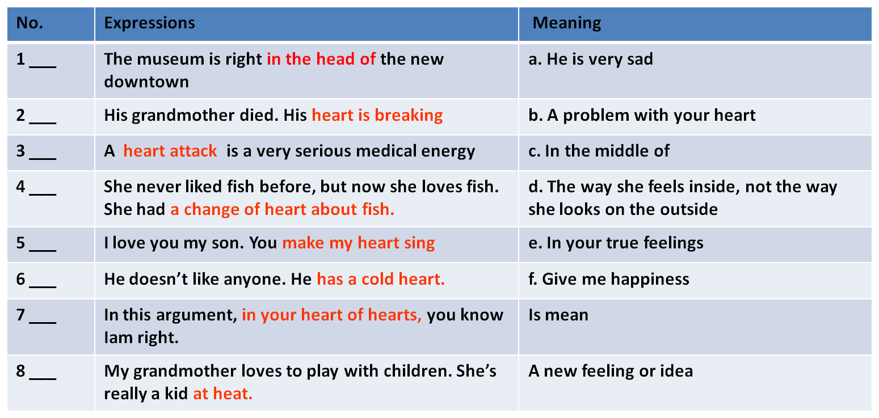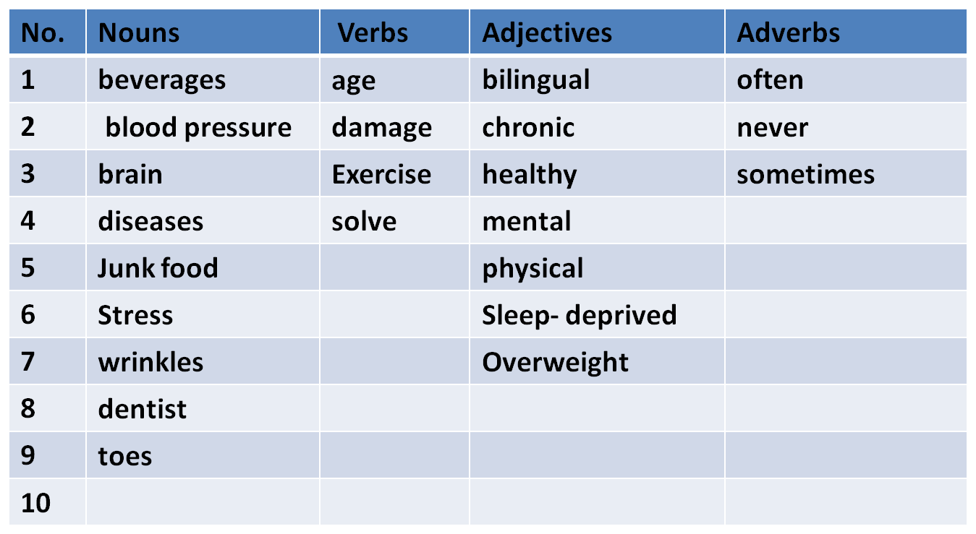
Elements of Lecture 6

I- A. Different meanings of Heart
B. Previewing Vocabulary
2- Present Progressive Tense
3- Non-Action Verbs
4. Negative Form of Present Progressive
5- Forming Questions with Present Progressive

I. A. Different Meaning of Heart( pages 78)

I. B. Vocabulary Previewing ( pages 65 / 70 )

I. Vocabulary Exercise
1. The word ‘ ___________” means lines on one’s skin
a. stress b. wrinkles c. beverages d. toes

2. “________” means that a person is unable to sleep.
a. sleep- deprived b. sleep too much
c. relaxed d. healthy
3. The word that has the same meaning as sickness is __________ .
a. wealth b. disease c. health d. earth
4. My friend suffers from ___________.He has become too fat.
a. overweight b. poorness c. English d. hard work
5. “ __________________” means worry.
a. Relaxation b. Stress c. Health d. highness
6. The opposite meaning of sick is ________________.
a. rich b. happy c. healthy d. tired

I. Vocabulary Exercise

7. The phrase “ get older” means ___________.
a. age b. to be young c. fat d. strong

8. “________” means not even once.
a. Always b. never c. sometimes d. rarely
9. The word that has the same meaning as “ drinks of all kinds” is___ .
a. water b. food c. vegetables d. beverages
10. “ Unhealthy things to eat” means__________________.
a. overweight b. junk food c. honey d. milk
11. “ __________________” means find an answer.
a. solve b. shake c. draw d. watch
12. The opposite meaning of “Physical” is ________________.
a. successful b. happy c. healthy d. mental
13. He doesn’t like anyone. He has a cold hear . A cold heart means___________
a. very sad b. mean c. in the middle of d. a new feeling

II. Present Progressive Tense page 92
Present Progressive is used to describe an action which is happening at the moment / now.
The main verb ends with -ing:-
A . When the subject is 3rd person : [ He , She & It ] we put is before the verb.
- He/ She is drinking coffee now.
- Noura is sleeping at the moment.
- Look! It is raining outside.
- Listen! Someone is knocking at the door.
B. When the subject is [ I ] we put am before the verb
- I am drinking coffee now.
C. When the subject is one of [ we, they or you , plural] we put are before the verb
- We are watching the lecture on TV .
- The children are playing outside now.

III. Non-Action Verbs
page 111

Non-Action Verbs are the verbs that have no –ing forms in Present continuous.
- see - hear – believe- understand - like – hate – love – dislike –taste
– smell –want – need
Examples:
1. I hear you now clearly.
2. They understand the lesson now.
3. Be careful! We smell dangerous chemical gas.

IV. Negative Form of Present Progressive Page 99

In case we are asked to negate the verb in present progressive we just add not after ( is, are or am )
- He/ She is drinking coffee now.
He’s not / is not / isn’t drinking coffee now
- Reena is sleeping at the moment.
Reena is not / isn’t sleeping at the moment.
- I am drinking coffee now.
I am not / m not drinking coffee now.
- We are watching the lecture on TV .
We’re not/ are not / aren’t watching the lecture on TV.
- The children are playing outside now.
The children are not/ aren’t playing outside now.

V. Forming Questions on Present Progressive Tense
page 102

In case we want to form a question we just exchange the
subject with ( is, am & are ).
A. Yes/ No Question
- He is drinking coffee now.
Is he drinking coffee now? – Yes, he is OR No, he isn’t/ is not.
- Noura is sleeping at the moment.
Is Noura sleeping at the moment? – Yes, she is OR No, she is not/ isn’t.
- I am drinking coffee now.
Are you drinking coffee now? – Yes, Iam OR No, Iam not.
- The children are playing outside now.
Are the children playing outside now? – Yes, they are OR No, they are not/ aren’t

V. Forming Questions on Present Progressive Tense
page 102

In case we want to form a question we just exchange the
subject with ( is, am & are ).
B. Information Questions
- He is drinking coffee now.
What is he drinking now? – Coffee.
- Salim is sleeping in his room at the moment.
Where Is Salim sleeping at the moment? – In his room.
- I am going to the bookstore to buy some books now.
Why Are you going to the bookstore now? – To buy some books.
- The children are playing outside now.
Who is playing outside now? – The children
Be careful [ Who is knocking at the door? - It is Ahmed ]

VI. Sample Questions
1. The men ____________ in the building now.
a. worked b. works c. are working d. working

2. ___________________ waiting me at the moment? – near the pharmacy.
a. Where he is b. Where does he
c. Where did he d. Where is he
3. The boys __________________________ football now .
a. are play b. play
c. is playing d. aren’t playing
4. Listen! The baby ________________ in the next room.
a. will cry b. crying
b. are crying d. is crying
5. I can’t go with you. I ______________ my homework now.
a. did b. have don c. am doing d. do

VI. Sample Questions
6. She ____________ meat with rice now.
a. isn’t liking b. doesn’t like c. is liking d. like

7. She___________________ meat with rice at the moment.
a. eats b. doesn’t eats c. is eating d. eat
8. The boys __________________________ football now .
a. are play b. play
c. is playing d. aren’t playing
9. look! The car________________ coming toward us.
a. will come b. coming
b. are coming d. is coming
10. My mother is in the kitchen. She ______________ now.
a. cooked b. have cooked c. is cooking d. cook

