بسم الله الرحمن الرحيم
بالتوفيق للجميع
[IMG]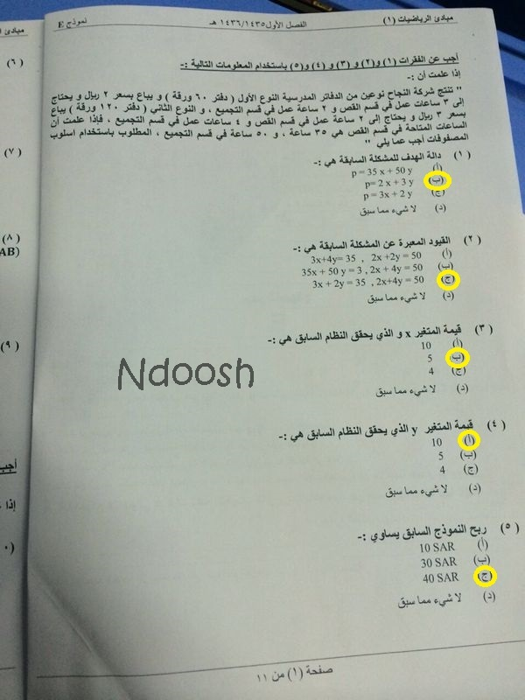 العاب[/IMG]
[IMG]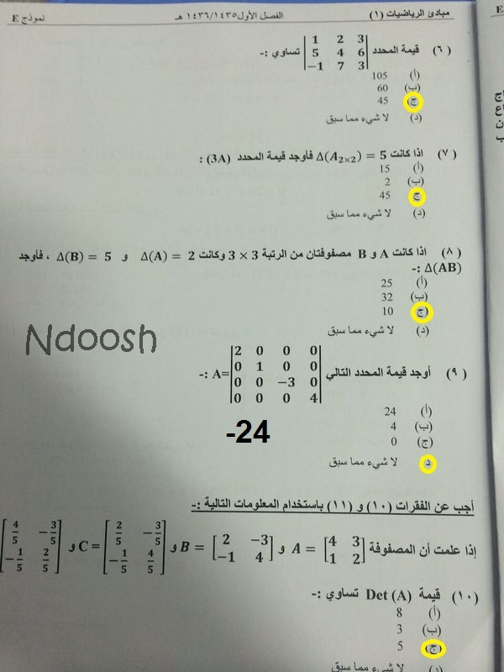 العاب[/IMG]
[IMG]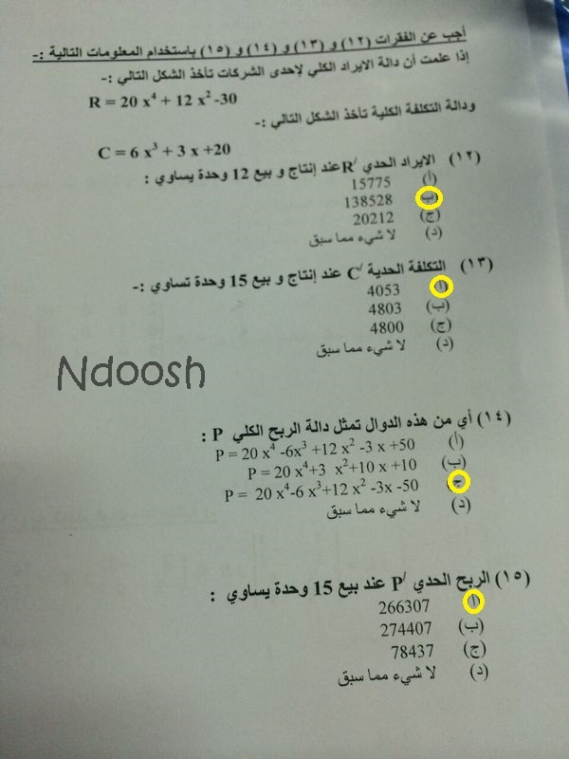 العاب[/IMG]
[IMG]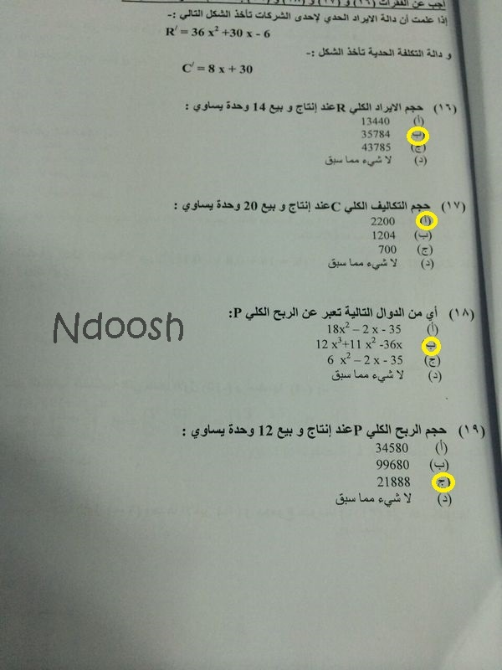 العاب[/IMG]
[IMG]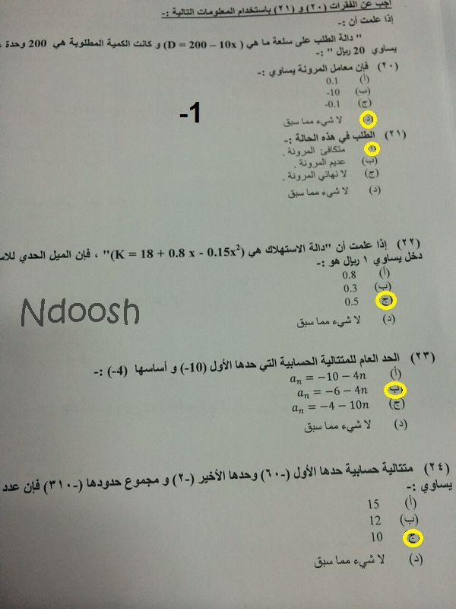 العاب[/IMG]
[IMG]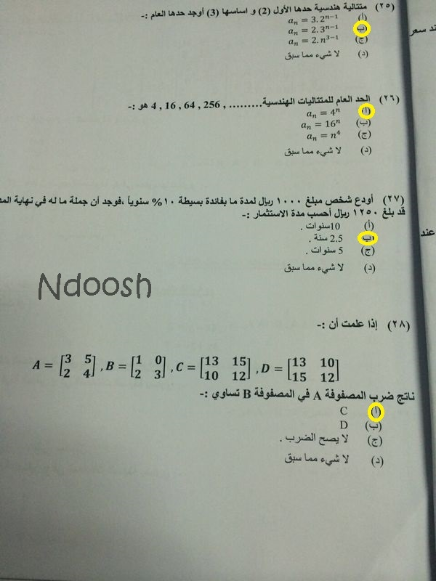 العاب[/IMG]
[IMG]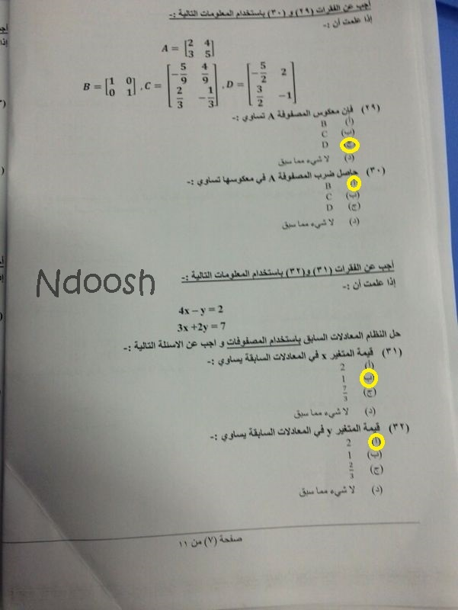 العاب[/IMG]
[IMG]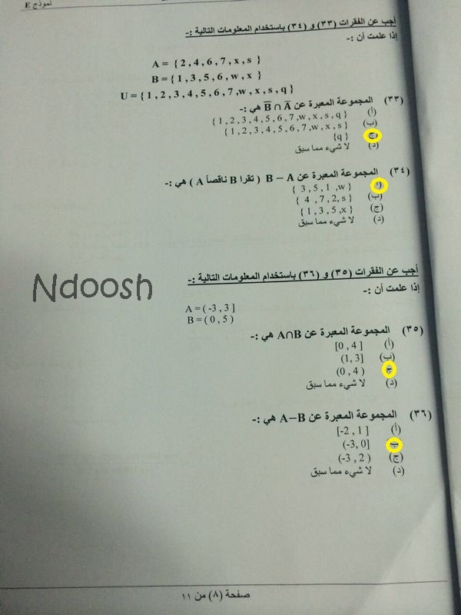 العاب[/IMG]
[IMG]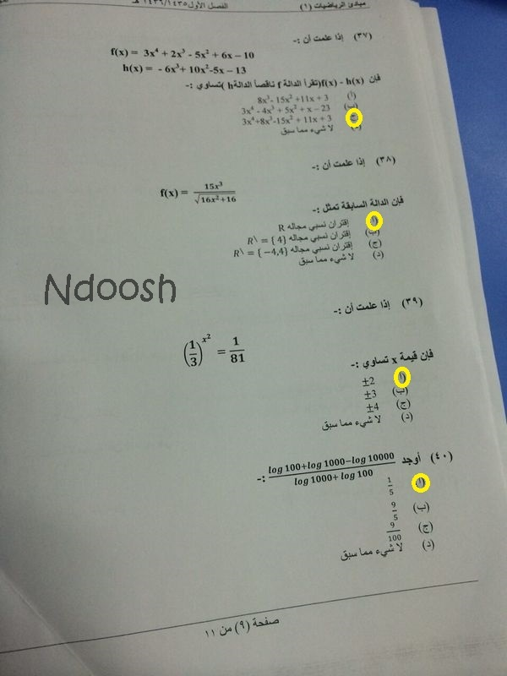 العاب[/IMG]
[IMG]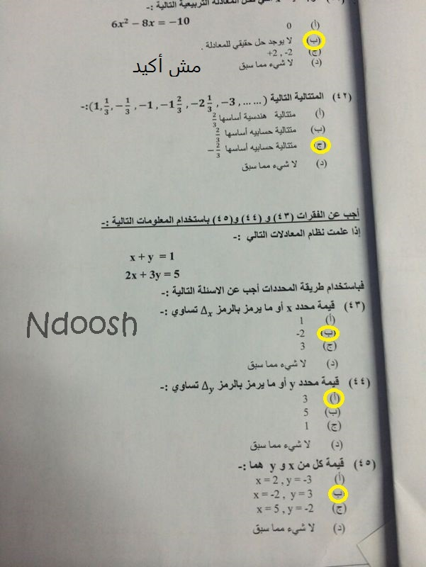 العاب[/IMG]
[IMG]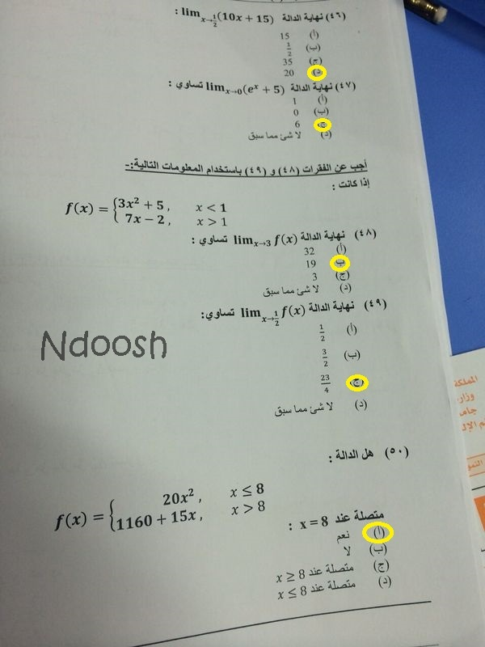 العاب[/IMG]

