8th Lecture
- Lecture Elements

Phrases and sentences: grammar
- Introduction
- Grammar
- Traditional grammar
- The parts of speech
- Agreement
- Grammatical gender
- Traditional analysis
- The prescriptive approach
- Captain Kirk’s infinitive
- The descriptive approach
- Structural analysis
- Immediate constituent analysis
- Labeled and bracketed sentences

Introduction
We have already considered two levels of description used in the study of language. We have described linguistic expressions as sequences of sounds that can be represented in the phonetic alphabet and described in terms of their features.
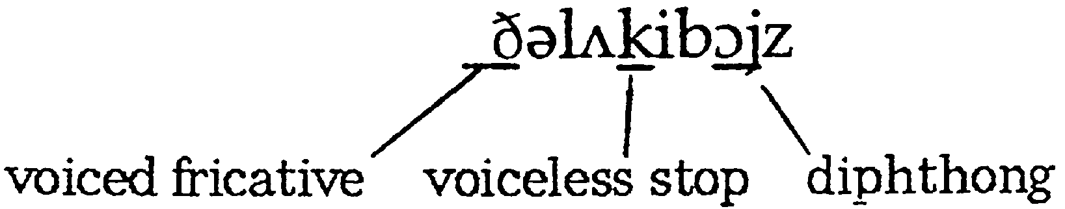

We can take the same expression and describe it as a sequence of morphemes.
The luck -y boy -s
functional lexical derivational lexical inflectional
With these descriptions, we could characterize all the words and phrases of a language in terms of their phonology and morphology.
- Grammar
However, we have not accounted for the fact that these words can only be combined in a limited number of patterns.
The English phrase the lucky boys is well-formed, while the two following phrases ∗boys the lucky ∗lucky boys the are not.
(We use an asterisk ∗ to indicate that a form is unacceptable or ungrammatical)

The process of describing the structure of phrases and sentences in such away that we account for all the grammatical sequences in a language and rule out all the ungrammatical sequences is one way of defining grammar.

- Traditional grammar

Traditional grammar is the description of the structure of phrases and sentences based on established categories used in the analysis of Latin and Greek. Since there were well-established grammatical descriptions of these languages, it seemed appropriate to adopt the existing categories from these descriptions and apply them in the analysis of ‘newer’ languages such as English.

- The parts of speech

The technical terms used to describe each part of speech are illustrated in the following sentence and simple definitions of each term are listed below.
The | lucky | boys | found | a | Bac`kpack | in
Article | adjective | noun | verb | article | noun | preposition
The | park | and | they | opened | it | carefully.
Article | noun | conjunction | pronoun | verb | pronoun | adverb

Noun (N): a word such as boy, bicycle or freedom used to describe a person, thing or idea.
Article (Art): a word such as a, an or the used with a noun.
Adjective (Adj): a word such as happy or strange used with a noun to provide more information.
Verb (V): a word such as go, drown or know used to describe an action, event or state.
Adverb (Adv): a word such as slowly or really used with a verb or adjective to provide more information
Preposition (Prep): a word such as in or with used with a noun phrase.
Pronoun (Pro): a word such as it or them used in place of a noun or noun phrase.
Conjunction: a word such as and or because used to make connections between words, phrases and sentences
Interjections are words that show emotion. They are not grammatically related to the rest of the sentence (Wow/Oh/Uh-oh)

- Agreement
Agreement: the grammatical connection between two parts of a sentence, as in the connection between a subject (Cathy) and the form of a verb (loves chocolate).
Agreement can be dealt with in terms of number (singular or plural), person (1st, 2nd, or 3rd person), tense, active or passive voice, or gender (male, female, or neuter)
- Grammatical gender
The type of biological distinction used in English is quite different from the more common distinction found in languages that use grammatical gender. Whereas natural gender is based on sex (male and female), grammatical gender is based on the type of noun (masculine and feminine) and is not tied to sex. In this latter sense, nouns are classified according to their gender class and, typically, articles and adjectives have different forms to ‘agree with’ the gender of the noun.

- Traditional analysis
Traditional analysis / grammar: the description of the structure of phrases and sentences based on established categories used in the analysis of Latin and Greek. Such is the case of describing the way to conjugate the verb love comparing Latin and English languages (p. 77).

- The prescriptive approach
Prescriptive approach: an approach to grammar that has rules for the proper use of the language, traditionally based on Latin grammar, in contrast to the descriptive approach. It is one thing to adopt the grammatical labels (e.g. ‘noun’, ‘verb’) to categorize words in English sentences; it is quite another thing to go on to claim that the structure of English sentences should be like the structure of sentences in Latin.

This view of grammar as a set of rules for the ‘proper’ use of a language is still to be found today and may be best characterized as the prescriptive approach. Some familiar examples of prescriptive rules for English sentences are:
- You must not split an infinitive.
- You must not end a sentence with a preposition.

- Captain Kirk’s infinitive
The infinitive in English has the form to + the base form of the verb, as in to go, and can be used with an adverb such as boldly. At the beginning of each televised Star Trek episode, one of the main characters, Captain Kirk, always used the expression To boldly go. . . . This is an example of a split infinitive. Captain Kirk’s teacher might have expected him to say To go boldly or Boldly to go, so that the adverb didn’t split the infinitive.

- The descriptive approach

Descriptive approach: an approach to grammar that is based on a description of the structures actually used in a language, not what should be used, in contrast to the prescriptive approach. Two famous approaches are:
      - structural analysis
      - immediate constituent analysis = labeled and bracketed sentences

- Structural analysis
Structural analysis: the investigation of the distribution of grammatical forms in a language. The method involves the use of ‘test-frames’ that can be sentences with empty slots in them. For example:
The ----------------- makes a lot of noise.
I heard a ----------------- yesterday.
There are a lot of forms that can fit into these slots to produce good grammatical sentences of English (e.g. car, child, donkey, dog, radio).

As a result, we can propose that because all these forms fit in the same test-frame, they are likely to be examples of the same grammatical category. The label we give to this grammatical category is, of course, ‘noun’.

- Immediate constituent analysis

Constituent analysis: a grammatical analysis of how small constituents (or components) go together to form larger constituents in sentences. One basic step is determining how words go together to form phrases. In the following sentence, we can identify eight constituents at the word level: Her father brought a shotgun to the wedding.
her father / a shotgun / the wedding = noun phrases.
to the wedding = a prepositional phrase.
brought a shotgun = a verb phrase.
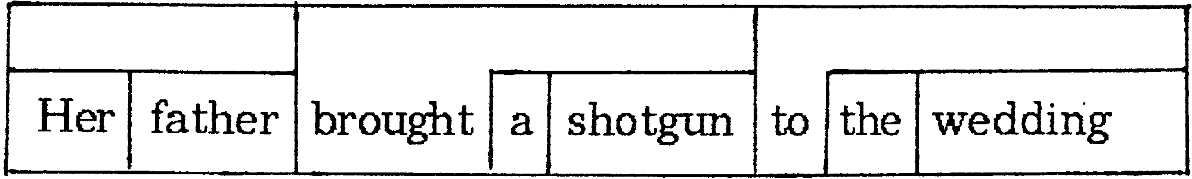

- Labeled and bracketed sentences

Labeled and bracketed sentences: a type of analysis in which constituents in a sentence are marked off by brackets with labels describing each type of constituent

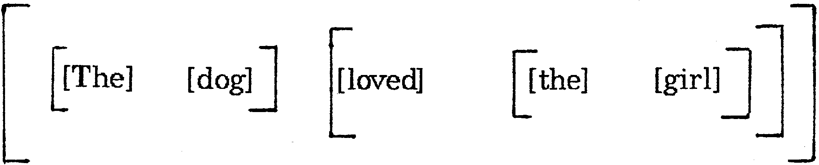

We can then label each constituent using abbreviated grammatical terms such as ‘Art’ (= article), ‘N’ (= noun), ‘NP’ (= noun phrase), ‘V’ (= verb), ‘VP’ (= verb phrase) and ‘S’ (= sentence).

