| P a g e 1

Heart story

In The Name Of Allah Most Gracious Most Mercifvl
King Faisal University
Deanship of E-Learning and Distance Education



Research Methods & Design Instructor : Dr. Abdullah Al Fraidan The content of material


By Heart story

| P a g e 2

Heart story

Introductory & Orientation

Course Content

“Research Methodology and Design” is a basic course which prepares students for designing and carrying small-scale research projects in the areas of language studies and Linguistics. It deals with methodological problems in humanities ranging from empiricism to Ethnomethodology and hermeneutics. In addition, it covers experimental design, sampling and data collection in various types of corpora. The course also covers research techniques and styles such as the APS style.
Why is this course?

This course has been suggested because:

- It provides students with a theoretical background needed for research in humanities.
- It develops the skill and knowledge needed for research in humanities.

- It is needed for carrying out a small-scale research project.

Course Objectives

By the end of the course, students should be able to:

Demonstrate knowledge of the theoretical dimensions of research in language studies.
Identify and solve problems in a given area of language studies.

Design a small-scale investigation of a given topic.

Apply standard procedures and styles in writing up research reports and investigations.

Course Assessment

- Homework 10%

- Attendance of Lectures 10%

- Forum Discussions 10%

- Final Exam 70%

References and teaching materials

- Main Textbook:
| P a g e 3

Heart story

Brown, James Dean, Rodgers, Theodore S. (2003). Doing Second Language Research. Oxford, Oxford University Press.
- Slides & Lectures

| P a g e 4

Heart story

Lecture 1
Research Methods & Design

Definitions

What is Research?

The systematic investigation into and study of materials and sources in order to establish facts and reach new conclusions.
What are methods?

A particular procedure for accomplishing or approaching something, esp. a systematic or established one.
What is design?

It is a logical structure of the inquiry (research)

Types Of Research Descriptive Explanatory Ethnographic Experimental
Action research Case study
Longitudinal vs. cross-sectional

Quantitative vs. Qualitative

Quantitative: you collect data through some tools and you quantify them
| P a g e 5

Heart story

Qualitative: you collect data through some tools and you explain and discuss, argue, hypothesis and philosophy them.

Classical Report of Research

Abstract Introduction Literature Review Methods
Data Analysis Results Discussion Conclusion Bibliography Appendices
http://privatewww.essex.ac.uk/~scholp/report.htm

Lecture 2
Classical Report of Research
| P a g e 6

Heart story

Classical Report of Research

Abstract Introduction Literature Review Methods
Data Analysis Results Discussion Conclusion Bibliography Appendices
http://privatewww.essex.ac.uk/~scholp/report.htm

| P a g e 7

Heart story

Lecture 3 What is an Abstract?
What is an Abstract

a summary of the whole thing

An abstract is a short summary of your completed research. If done well, it makes the reader want to learn more about your research.
It is important to note that the weight accorded to the different components can vary by discipline. For models, try to find abstracts of research that is similar to your research.

Components of an Abstract

- Motivation/problem statement: Why do we care about the problem? What practical, scientific, theoretical or artistic gap is your research filling?
- Methods/procedure/approach: What did you actually do to get your results? (e.g. analyzed 3 novels, completed a series of 5 oil paintings, interviewed 17 students)
- Results/findings/product: As a result of completing the above procedure, what did you learn/invent/create?
- Conclusion/implications: What are the larger implications of your findings, especially for the problem/gap identified in step 1?
| P a g e 8

Heart story
! You give what is really an introduction, missing out what the results were

! You tell us what each section of the writeup is going to talk about (e.g. 'In the third section we will describe the method'), not briefly what you did (e.g. 'The method we used was...')

! You include wording that refers forward like ‘… as we shall see…’. Again it is not an introduction. It should read as referring back to the whole completed project

Example of an Abstract

The Factors Accounting for the Egyptian EFL University Students’ Negative Writing Affect
This study attempts to identify the factors that account for the Egyptian English majors’ negative writing affect, i.e. their high English writing apprehension and low English writing self-efficacy. The subjects were administered two scales measuring their writing apprehension and writing self-efficacy, then those students with scores falling into the extremes of the two scales were interviewed about their writing experience and background.

To supplement the qualitative data obtained from the interviews, the subjects’ scores on three linguistic tests used for measuring their English grammar and vocabulary knowledge were compared to their scores on the two scales. Analysing both types of

data showed that there are six causes of the subjects’ high English writing
| P a g e 9

Heart story

apprehension and four causes of their low English writing self-efficacy. Based on the results reached, the study presents some recommendations for writing instruction and suggestions for further research.

Example of a Poor Abstract

Friends of Children helps underprivileged elementary school children.

There currently is a need for after-school programs in Anywhere Parish, like the one Friends of Children would like to provide.

Such a program will help at-risk children do better in school, learn important interpersonal skills, and become better citizens.

The after-school program will target kids in Anywhere Parish and will operate after- school on Monday through Friday in the local community center.

Trained adults will provide homework assistance in all classroom topics, as well as provide games and fun activities.

The objectives of the program are to make students better learners and improve their social skills and personal well-being.

| P a g e 10

Heart story

The impact of the after-school program will be evaluated by looking at student grades and satisfaction with the program.
Friends of Children is requesting $137,790 for this project.

The poor example is incomplete – it does not provide the same level of detail found in the good example. This (poor) example does not grab the attention of the reader. There is no good description of the need, the rganization and its mission is not well defined, and no basic details of the program are provided.
| P a g e 11

Heart story

Lecture 4
Introduction

How to choose a topic?

Research to demonstrate not only research expertise in the relevant field but an appropriate level of originality. One way to achieve this is by a piece of work which applies existing ideas (e.g. previous findings, theories, research methods) to a new domain (e.g. provides a competent analysis of new data in terms of an existing theory or approach). Another way is by a piece of work which proposes a new and interesting account (maybe a new theory) of existing data. Clearly, the highest attainable level of originality would be to propose a novel theoretical account of novel data (a goal all academics strive for but few attain!).

Clearly, your chosen topic should be one which excites and stimulates your intellectual curiosity, and which is going to retain your interest throughout the period you work on it.
It may also be a topic which has some direct relevance to your future career aspirations, or special importance in the context where you normally work (esp. if you are a teacher)
It should be a topic which you personally feel confident that you are able to master within the time available for your research. For this reason, it is important not to be too wide-ranging in your choice of topic. On the contrary, there are a number of reasons for focusing your research as narrowly as possible on a topic which is highly
| P a g e 12
Heart story circumscribed and specific. One reason for this is that the existing research literature is growing at such a rapid pace that it is no longer possible to keep up with the whole of the literature in a broad field, so that narrowing down your research topic reduces your background reading to much more manageable proportions. Secondly, the broader the topic you choose, the more open-ended your research becomes - and the less likely it is that you will complete it on time (so putting yourself under unnecessary financial, emotional and intellectual pressure). From this point of view, ‘Language Acquisition by Bilinguals' is far too broad to be viable as a research topic; by contrast ‘A case study of the development of personal pronouns in the grammar of a two-year old bilingual child' is a much more restricted, and hence more manageable research topic.o note that the weight accorded to the different components can vary by discipline. For models, try to find abstracts of research that is similar to your research.

Introduction chapter

what the topic is, in brief

! You start telling us a lot of detail about the method and your results at this point

! Detailed research questions and hypotheses… premature to give them here

- reasons for doing the work, e.g.

importance as a research topic in itself, in the context of current knowledge in the relevant field. This entails saying a bit about what general areas of ELT, linguistics or whatever the study relates to importance for local situation of researcher (esp. if teacher). This entails possibly a detailed description of what that situation or context

is (e.g. if your study is on writing, then how that is taught throughout the educational system etc.)
| P a g e 13

Heart story

! The research is presented as having interest only for the researcher's school/country. Classical research needs to be presented as having wider implications
! Long account of 'problems of teaching in my country'...none of which turn out to be the subject of your research
! Unfounded generalisations with no sources like ‘standards of English have become poor in recent years’
! Multiple sections with titles like Importance of the study, Significance of the study, which are really not differentiatedin content
- outline of what will come in the chapters/sections that follow

- maybe brief definitions of some key terms to be used later

Components of an Abstract

! You give what is really an introduction, missing out what the results were

! You tell us what each section of the writeup is going to talk about (e.g. 'In the third section we will describe the method'), not briefly what you did (e.g. 'The method we used was...')
! You include wording that refers forward like ‘… as we shall see…’. Again it is not an introduction. It should read as referring back to the whole completed project

Example of an Abstract
| P a g e 14

Heart story

The Factors Accounting for the Egyptian EFL University Students’ Negative Writing Affect

This study attempts to identify the factors that account for the Egyptian English majors’ negative writing affect, i.e. their high English writing apprehension and low English writing self-efficacy. The subjects were administered two scales measuring their writing apprehension and writing self-efficacy, then those students with scores falling into the extremes of the two scales were interviewed about their writing experience and background.
To supplement the qualitative data obtained from the interviews, the subjects’ scores on three linguistic tests used for measuring their English grammar and vocabulary knowledge were compared to their scores on the two scales. Analysing both types of data showed that there are six causes of the subjects’ high English writing apprehension and four causes of their low English writing self-efficacy. Based on the results reached, the study presents some recommendations for writing instruction and suggestions for further research.

| P a g e 15

Heart story

Lecture 5
Plagiarism

What Plagiarism is

http://www.essex.ac.uk/plagiarism/index.html
| P a g e 16

Heart story

Lecture 6
Literature review

Literature review

REVIEW OF LITERATURE covering these things but not necessarily in this order
review and critique of previous research in the same general area (shortcomings of methods or argumentation previously used, new areas to look at suggested by previous results). Their findings, esp. with respect to variables you are interested in. This should at every point be explicitly connected to your specific project.

! The background review reads like an MA survey essay on some area of investigation, cataloguing other people's studies, with no comparison of them with each other, or critique, and no use explicitly made of them to connect to your own work by showing what they suggested for it.

! Too broad… need to focus rapidly on just what bits of articles and books are relevant to your study

! You report previous work as ‘important’ when actually it has no relevance to your own research (though it may be highly regarded in the field generally).
| P a g e 17

Heart story
! You retail other people’s criticisms of each other’s research but do not resolve opposing views, argue your own view, or draw implications for your research.
! Review feels like the literature got on top of you, rather than that you are on top of the literature, and is too long (more than a third of the writeup)

! You mention the results of your own later research in your review

! see also http://privatewww.essex.ac.uk/~scholp/litrevsarc.htm

theoretical background(s) or 'models' from which the ideas come (both pure and applied linguistic, and maybe in psychology, sociology...), or which you hope to shed light on
! Ostrich: you stick with one model you have learnt about and don't cover the rival theories or look in other disciplines that have something to say.
Discussion of definitions of key terms… esp, vague ones (e.g. in ELT ‘communicative’, ‘function’, ‘strategy’, ‘task’ etc….) where you disentangle different opinions of scholars
! You catalogue a lot of people’s definitions of X but fail to show where they agree/differ or which one you are adopting for your work and why.
a review of methods used previously to gather relevant data, justifying yours (e.g. merits of interviews versus questionnaires etc.). Better here than in Method chapter/section if it is substantial.
| P a g e 18

Heart story

Lecture 7

Refining Research Ideas and Beginning to Design your Study

Agenda

So I have a good idea….now what? Research design elements:
Sample selection Comparison/control groups One time versus Many times Reducing Confounds and Bias
Variables and Operational Definitions
Turning your research question into a research hypothesis

Recap
So….you have a good idea
You realize that you could gather information to test that idea in some way You did a literature search to confirm it is a good idea (i.e., that it hasn’t been done well before)
Now what should I do to make it scientifically rigorous?..........
Research Design & Methods is what makes a good idea into a great research study

Elements of Research Design: Sample
| P a g e 19

Heart story

“Sample” versus “Population” Sample determination
What group (population) is your research idea about?
If it is about people in general – then it doesn’t matter who you sample
-Is it about a particular type of person, age group, culture, sex/gender, clinical group, occupation?
Inclusion and Exclusion Criteria specified

Elements of Research Design: Sample/Recruitment

Where will you get the data from that group? Own organization versus other organization
Do they have enough people there? (i.e., sample size)
Will the people be interested or motivated to participate in your research? How long will it take? Are you willing to wait that long?
Will you need to compensate them?

Elements of Research Design: Data Format
What format will the data be in? Questionnaire? Standardized versus survey? Interview? (individual versus focus group) Interviewer/observer rating scale?
Retrospective chart reviews?
Continuous versus categorical data (means versus frequencies)
Data format affects statistics/interpretive methods you use (e.g., qualitative versus quantitative methods)

| P a g e 20

Heart story

Lecture 8
Refining Research Ideas and Beginning to Design your Study

Elements of Research Design: Comparison/Control Groups

Selecting a comparison group:

Between Groups Designs
Compare it to another group (that is similar to research group except with respect to the treatment/construct you are measuring)

Within Group Designs
Can compare one group to itself over time (i.e., before treatment and after treatment)
Note: qualitative/descriptive studies do not use comparison groups – they just describe…really well

Elements of Research Design: Between Groups Design

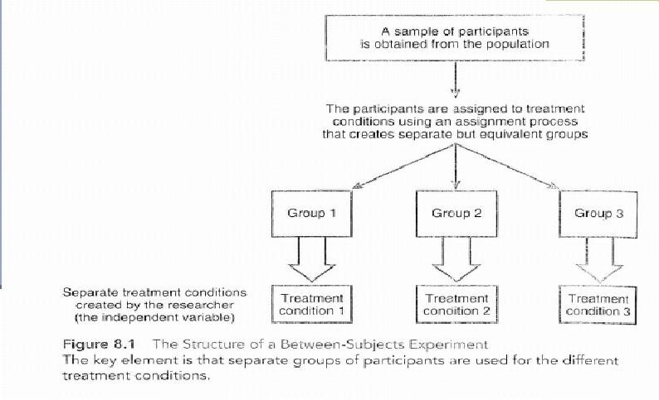
Source: Gravetter, F.J., & Forzano, L. B. (2006). Research Methods for the Behavioral Sciences
(2nd ed.). United States of America: Thomson Wadsworth.
| P a g e 21

Heart story

Elements of Research Design: Within Group Design

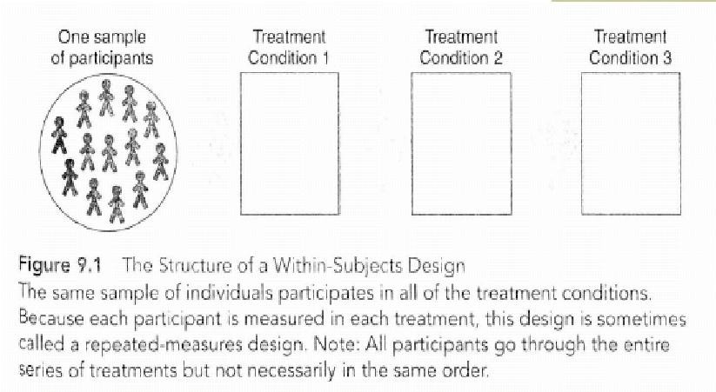

Source: Gravetter, F.J., & Forzano, L. B. (2006). Research Methods for the Behavioral Sciences
(2nd ed.). United States of America: Thomson Wadsworth.

Elements of Research Design: One time vs. over time research Cross-sectional method
- Same group of people are observed at one point in time

Longitudinal method

- Same group of people are observed at different points in time as they grow older
| P a g e 22

Heart story

Elements of Research Design: Longitudinal Method

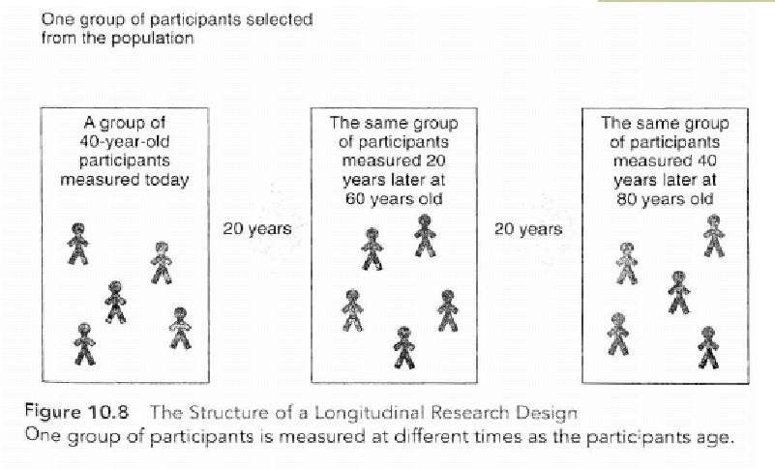
Source: Gravetter, F.J., & Forzano, L. B. (2006). Research Methods for the Behavioral Sciences
(2nd ed.). United States of America: Thomson Wadsworth.
| P a g e 23

Heart story

Lecture 9
Elements of Research Design: Defining your terms

Elements of Research Design: Defining your terms

Independent variable – variable that is manipulated by the researcher (or the variable that is thought to affect the outcome/dependent variable)
Dependent variable – variable that is measured to assess the effects of the independent variable
“Operational definition” – procedure for measuring and defining a construct (i.e., what measures will you be using)

Turning your research question into a Research Hypothesis

It is the test of your idea or theory

A hypothesis is a statement that describes or explains a relationship among variables

It is a prediction that is derived from your research question
-e.g. “Shared Journey staff education will improve patient satisfaction as compared to units whose staff did not receive SJ training”

-e.g. “internalized stigma is related to increased depression”

RH & RQ

http://privatewww.essex.ac.uk/~scholp/Hypotheses05.htm
| P a g e 24

Heart story

Summary

Start thinking about who you want to participate in your study, how you will recruit them, how you will collect the data etc.

Decide if you want a single or multiple groups of participants and if you want to collect data at one time or over time

Start thinking about how you can minimize/eliminate confounds and bias

Formulate a research hypothesis

| P a g e 25

Heart story

Lecture 10
Data Collection Defining your terms

Defining your terms

Task 1. Words:
Counting things in spoken or written products can be harder than you think. Even 'What is a word?' can be complicated (and caused a disaster to one of my PhD students when asked this in a viva once!...). Yet one cannot count words without a definition!
In this text, how many words are there?

What problems arise in deciding on the answer?

How would you prefer to resolve them in your definition of a word?

How do you think a computer would resolve them if asked to count words?

At long last I decided that I couldn't put up with the food any longer. But having taken that decision I next had to decide where else to go to eat. I long for take-away fast food. Indecisive, I first went to McDonalds then KFC.

Task 2. T units:
| P a g e 26

Heart story

Often one wants to quantify the length of text or spoken utterances. One can do this in words or in sentences, but quite popular in child and learner research are also T- units. A T-unit ('terminable unit') is essentially a main clause with a non-elliptical subject, including any dependent clauses. Thus When I got home, the new TV I ordered yesterday was on the doorstep, is one T-unit, as is John got up and left the room. However, John got up and Mary left the room is two T-units because each coordinated clause has its own subject expressed, and could stand alone as a sentence.
How many T-units in each of the following fragments of child writing? Hence what is the average length of T-unit in words of each?
And what do you think are the supposed merits of measuring length of utterances or text in T-units rather than sentences?

I like branded because they always win and it is fun and I like it because sometimes he gets killed. <Note: Branded is an old TV programme set in the Wild West>
  - I like to come to school and my mummy like school and my bearther we was so happe wane I come home I eat cake and daere my tea I halp my mummy. One day I wanet in m sister house The end.

| P a g e 27

Heart story

Task 4. Errors:
Categorising and then counting errors in more or less naturally produced written or spoken material used to be common. But in order to constitute a proper variable a good categorisation/classification system should: be exhaustive, have mutually exclusive categories, not mix categories of different types in one set, have unambiguously defined categories, etc.
A student came up with these categories for classifying errors: do you see any problems?
How to improve the classification system? Grammar errors
Vocab errors

L1-induced errors
| P a g e 28

Heart story

Lecture 11

Data Collection

Questionnaires

Data elicited in the form of people's reports about language or something related
Data of this sort is most used in ELT, applied linguistics and sociolinguistics: essentially subjects report about what they or others do, or on beliefs about or attitudes to language, language learning etc., or on non-linguistic variables you need to record (e.g. their age, years of learning English...).
One type, the grammaticality judgment task, is popular in acquisition research. Reporting ranges from (a) ‘think aloud’ reporting, immediate retrospective reporting after a task, open interviews, or diary type of reports to (b) structured interviews, closed questionnaires or attitude rating inventories and judgment tests.
The former are heavy on Data Analysis transcribing them (if spoken) and categorising what people say, and often contain material suitable for purely qualitative analysis. The latter involve more work in constructing the Materials beforehand, and the Data Analysis may be fairly automatic (and computerisable).
The more open instruments of this sort are typical of ethnographic research. All might be involved in action research, or classical research usually of the nonexperimental type.
| P a g e 29

Heart story

Conventional closed questionnaires

    - Spot as many unsatisfactory features as you can in the following start of a sociolinguistic research questionnaire given to people in Wales:
Name? ........

What age category do you belong to? Under 18 years

18-21 years

21-25 years

Over 25 years

Have you ever learnt any other languages? If so, which languages?

How much do you speak Welsh at home? Often, Sometimes, Never

Do you agree that Welsh should be obligatory in schools in Wales and on official documents (e.g. income tax forms)? Yes/No
There are not enough Welsh language programs on TV. Yes/No

How many variables are being measured there? Think of more than one hypothesis one might formulate about them. How would you represent people's responses on each as a number for computer entry?

Lecture 12

Your research variables
| P a g e 30

Heart story

Your research Variables

- How many variables are centrally involved?

We are not counting here the variables you might want to exclude the effects of… see later, just those that are central to a RQ or RH. So is this a one variable design, two variable, three variable etc. design? In the jargon: univariate, bivariate or beyond two variables it may be either factorial or multivariate (As a rough guide, it would be called factorial only where there are two or more explanatory variables in categories, see below for explanation, otherwise it would be called multivariate).
In this course we stick to two-variable designs, since understanding them properly is the key to understanding more complicated ones. In fact often a study with many variables can be broken down into a whole lot of RQs each dealt with as a two variable design. E.g. in a questionnaire you ask Taiwan senior high school learners of English their gender and also how often they use 20 different reading strategies; you also give them Nation’s Levels test to check their vocab proficiency. You then potentially have a whole lot of two variable analyses (each with its own research Q or H!), involving gender in relation to each of the 20 strategies and vocab prof in relation to each of the 20 strategies (so 40 two-variable designs are analysed).

What roles do the central variables each play?
| P a g e 31

Heart story

Often we think of one or more variables as potentially 'explaining' or 'causing' or 'affecting' or 'predicting' one or more of the others. For instance gender would be regarded as 'explaining' any differences in use of strategies we find. It would be odd to regard strategy use as somehow affecting people's gender! In the jargon, the 'explaining' variable (or variables) is perhaps most neutrally labelled the 'explanatory variable' (EV, as I prefer), but many call it the 'independent variable' (IV), or in some special design circumstances 'factor' or 'predictor'. The other variables are then 'dependent variables' (DV) or sometimes called 'response variables' etc. Sometimes there is no obvious EV - DV distinction among variables, e.g. if you are interested in the relationship between learners' grammatical proficiency and vocabulary size it is not obvious that either one is potentially affecting the other. Then regard the design as having DVs only.
There is a reason for talking in weaker terms and saying that one variable ‘explains’ another, or just ‘is related to’ it, rather than more strongly saying it ‘causes’ it or ‘affects’ it. Much language research is not experimental in the true sense, and the conventional wisdom is that it is only in a proper experiment that cause and effect can definitely be demonstrated.

Is this an experiment, in the strict sense?

| P a g e 32

Heart story

5) What variables are or should be considered additionally to the central EVs and DVs?
These are variables that you might need to control, in the sense of 'exclude the effects of' (which I call CVs!). They may well not be mentioned in the research question/hypothesis, but are nevertheless crucial. They are things that may otherwise interfere with the results and make it hard to interpret what you discover about the central variables in the design.
You can 'control' or eliminate such variables in various ways. One is by making them constant. E.g. you choose only people in their twenties for a study comparing men and women, thus eliminating the age variation factor; for an experiment where people read two types of text (narrative and argumentative) you make all the texts at the same level of vocabulary difficulty. Another way is to randomise the variable (or, more often, claim it is as good as random, even though you have not strictly randomised it…): to eliminate age you pick men and women randomly of all ages, so hopefully you will not get a lot more older people in one group than in the other.
We have already seen also the 'stratified sampling' solution to this sort of problem, where you would pick equal numbers of people of different age groups in each gender, and the use of the 'matched subjects design' which also eliminates this, if age is chosen as one of the variables to be used for matching.
If you fail to make sure relevant variables are controlled, then you may have what is called a 'confounded' design. E.g. you want to compare people's strategies depending on the rhetorical type of the text they read (narrative vs argumentative), but you use texts where the difficulty of language and unfamiliarity of topic is greater in the latter texts than the former. Then if you find a difference between text types in the
| P a g e 33
Heart story strategies readers use, a critic afterwards will say 'maybe your result really shows a difference between easy and hard texts, not narrative and argumentative ones'. You will have failed to 'control' language and topic difficulty and have 'confounded' these variables with your targeted EV
In much language research ideal control is not possible. In theory, it is only in experiments that it could be fully achieved. E.g. suppose you study learner behaviour going on in classes in a school taught by two different means (which could be either naturally occurring means or ones you experimentally impose). You will typically have to use existing classes ('intact groups') rather than take students and randomly assign them to the two method groups. Hence you cannot control whether, say, more proficient students get into one group than another. The best you can do here is to at least record as much as you can about the subjects in the two classes with a little background questionnaire. Then you can afterwards use the information about proficiency, for example, to help interpret the findings, and maybe analyse the data with the effects of prof statistically taken into account and discounted (by treating the offending variable as a ‘covariate’ in the analysis, but that is an advanced topic).
Obviously the 'alternative' research paradigms do not lend themselves to control and rely heavily on delicate interpretation by the researcher of how all the uncontrolled factors might have affected what is observed.
| P a g e 34

Heart story

Lecture 13
Results

RESULTS IN GENERAL: THREE STATISTICAL THINGS TO DO WITH RESULTS

- Presentation. Mainly presentation consists of making easy to understand tables, and especially graphs of various sorts, to go in the main text and show the key features of the results (e.g. histograms, bar charts, scatterplots, line graphs of various sorts). For these tables and/or graphs, frequencies of people falling in a category may be converted to %, etc., for easy understanding, and often what will be presented are descriptive statistics derived from the data (see b), rather than scores or whatever of each case separately.
- Descriptive statistics. These are figures you (get the computer to) calculate from a lot of specific figures which arise from data. Essentially they summarise certain facts just about the specific cases you studied. Hence they are referred to as 'statistical measures' based on 'observed' data, sometimes referred to as O (=observed) figures for short (cf. 'statistical tests' in c which go beyond just what has been observed about samples). Mainly they are of one of the following types, depending on what kind of thing about your people/words/etc. they measure:
-- (b1) Measures of centrality. These in some way indicate the one score or category that you might choose to represent a whole set of scores or categorisations for one group of cases on one variable. These are mostly familiar measures from everyday life. One example is the "average" score of a set of interval scores
| P a g e 35
Heart story (technically the Mean). Another, where you have cases that have been put in categories, is the category that the greatest proportion of people chose or fell in
-- (b2) Measures of variation. These summarise how far the individual scores were closely spread round some central measure, how far they were widely spread. In a way they measure how closely the scores (or people who scored the scores) "agreed" within a group, on a scale running upwards from 0. The higher the figure, the greater the variation. Examples of such measures are the Standard Deviation (and related notions Variance and Error) for scores, Index of Commonality for categories.
b3) Measures of difference. These summarise the amount of difference between pairs of samples or groups measured, or between scores the same group obtained in different conditions, usually by a figure that is the 'difference between two means', or the 'difference between two percentages' (percentage difference). Again such figures normally run upwards from 0 (= no difference) to any size.
(b4) Measures of relationship. These quantify the amount of relationship between two (or more) variables as measured in the same group of people or whatever. They are usually on a scale 0-1 (in some instances they run from -1 through 0 to +1). I.e. if such a measure comes out near 1 (or -1 where relevant), that indicates that those cases that scored a particular value on one variable also tended to score a particular value on the other. E.g. those who scored high on motivation also scored high on proficiency. If it comes out near 0, that indicates that cases that scored a particular way on one variable scored all over the other variable, and vice versa. Examples are the Pearson 'r' Correlation Coefficient, the Spearman 'rho' Correlation Coefficient, Kendall's W, the 'phi' Correlation Coefficient, Kruskal's 'gamma'. (Remember that relationship and difference are really the same thing looked at from different points
of view. If there is a difference between men and women - the two values of the
| P a g e 36
Heart story gender variable - in attitude to RP accent, then there is a relationship between the variables gender and attitude to RP accent. It is just that for technical reasons sometimes statistics approaches the matter more via measuring difference, sometimes via measuring relationship).
If you are only interested in the particular cases or groups of cases you measured in themselves (e.g. because they are the whole population of interest), then (a) and (b) probably provide the answer to any questions or hypotheses you had about them. But usually in research you have not measured everyone/thing of interest directly, but only samples, and wish to generalise, hence inferential statistics are also needed.
- Inferential statistics. These in some way enable you to generalise from the specific sample(s) you measured, and the descriptive measures of them (O's), to a wider 'population' that you sampled (if that is of interest to you, of course). Most descriptive statistical measures have associated inferential statistics.
In effect then, the input to inferential

- the level of certainty is about what inferential stats tells you that you will be satisfied with. No inferential stats give you 100% certainty of anything. I.e. statistics can never tell you that, based on the difference between 3rd graders and 4th graders you found in your samples, it is 100% certain that there is a difference between 3rd and 4th graders in the populations your samples represent. You have to choose to be satisfied with something less than 100%. 95% is commonly taken as adequate in language research: this is the same as choosing the .05 (or 5%) level of significance as the one you will be satisfied with. (Statistics actually works with the chances of being wrong about a difference rather than being correct, hence 5% not 95%). If you adopt that level, then if a statistical test comes up with a significance of less than .05 for some difference or relationship you are interested in, then that is the same as saying

that there is a 95% or more certainty that there is a population
| P a g e 37

Heart story

difference/relationship, not just one in the sample. So you will take it that a difference or relationship is proved to be real in the population(s) as well as the sample(s). If you adopted .01 as the threshold then you would only be satisfied if the test came out with a significance smaller than that (You would be demanding 99% or more certainty).
Significance tests. These deal with hypotheses about 'differences' or 'relationships', which is why it was a good idea to think in these terms when formulating hypotheses and planning what to do in the first place - before actually starting gathering data.
They tell us if a difference or relationship we have observed in samples is strong enough to indicate a 'real' difference/ relationship in the populations sampled or not.
Suppose you are comparing the attitudes of men and women to RP. You find an observed difference between the results for two samples (one of men and one of women) - i.e. the sample difference between the two average scores for attitude to RP English is not zero. So clearly the samples are, descriptively, different, but what can you say about the hypothesis about the populations of men and women that you sampled (since it is this "large-scale" hypothesis that you are really interested in)?
Common sense says that you could get small differences between samples of men and women without there being any real population difference between men and women, just because samples from populations don't exactly reflect those populations in microcosm. Something called 'sampling error' always comes in. What you want (though you may not realise it!) is to be told a probability: you need to know the probability that you would get a difference the size of your observed one between samples if there were no population difference. If the probability is remote (say 5% or less (p<.05) - the common threshold chosen), then you will conclude that your samples are evidence for a population difference and will say that the difference is,

| P a g e 38
Heart story technically, 'significant'. But if the probability is reasonably large (bigger than 5%, p>.05 say), then it is not safe to regard the "no difference" hypothesis as rejectable.
The main bit of information you get from any significance test is therefore a probability, which may be referred to as p or sig.

http://privatewww.essex.ac.uk/~scholp/onevardesc.htm
| P a g e 39

Heart story

Lecture 14
Revision & Final Exam

A hypothesis is:

- A hypothesis is a statement that describes or explains a relationship among variables

- A hypothesis is a statement about your research

- A hypothesis is a statement about the problems in your research

- A hypothesis is a statement about the outcome of your research

The independent variable is:

- the variable that is thought to affect the dependent variable

- the variable that is thought to affect the hypothesis

- the variable that is thought to affect the results

- the variable that is thought to affect the abstract

Research is:

Looking for knowledge only Looking for data only
Looking for new ideas and findings Looking for previous studies
| P a g e 40

Heart story

An Abstract is:

A summary of the whole thing A summary of the whole results
A summary of the whole literature review A summary of the whole methodology

A good classical report will consist of: Abstract- methodology- results-introduction Abstract-literature review- results-introduction
Abstract-introduction-literature review-methodology-results Abstract-results-introduction-literature review

In the introduction:

You introduce the results

You introduce the study and its significance

You introduce all previous studies and a critique for them You introduce all the methods and instruments you used

In the literature review:

You talk about the results

You talk about the study and its significance

You talk about all previous studies and a critique for them You talk about all the procedures used

Plagiarism is:

Representing other authors’ language and ideas as your own original work Representing your own language and ideas as your own original work Representing other authors’ language and ideas as their own original work Representing other authors’ language and ideas as a plagiarised work.

The dependent variable is

The variable that is affected by the independent variable The variable that is dependent on the hypothesis
The variable that is affected by the abstract The variable that is affected by the results
| P a g e 41

Heart story

| P a g e 42

Heart story

The significant difference has to be at the level of:

P= 50 P=.05 P=.50 P=0.50

If you have one variable in your research, then it is:

Multivariate Univariate Bivariate factorial

We use questionnaires in research as a:

tool to collect data tool to analyse data tool to generate results tool to design research

