المحاضره الاولى 1
In this lesson…
let’s make sentences with verb “be” (am, are, is).
Sentences = SUBJECT + VERB.
Subjects = nouns and pronouns (I, you, he, she, it , we, they ,this, these.

Subject + form of verb “be”

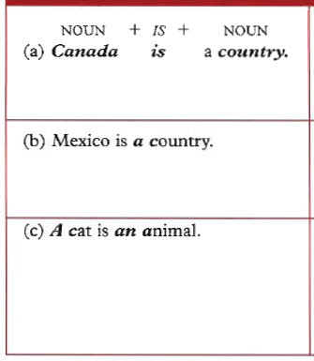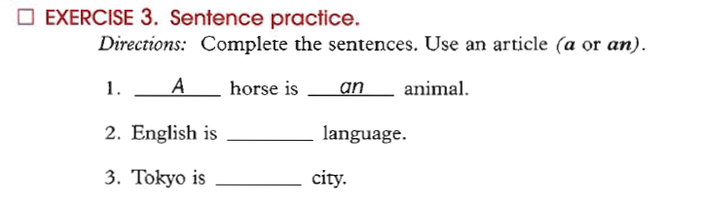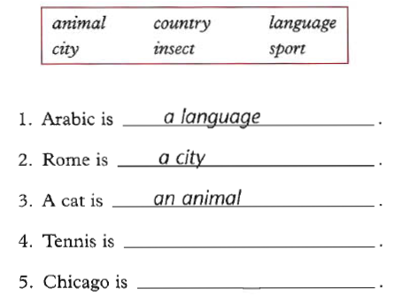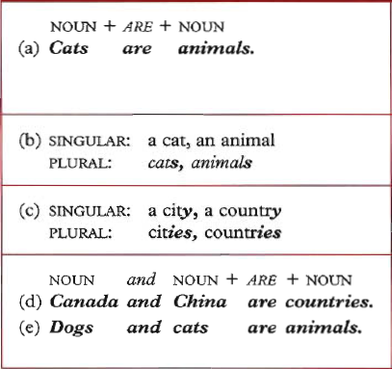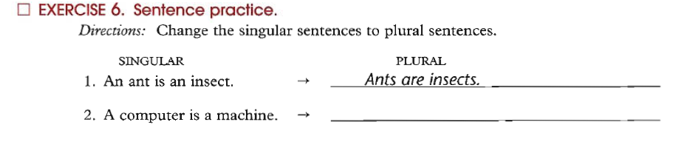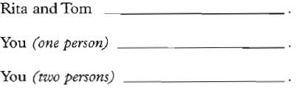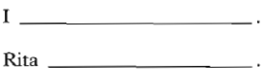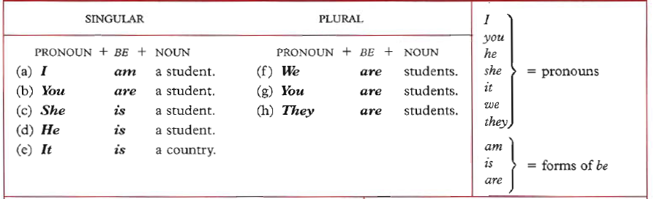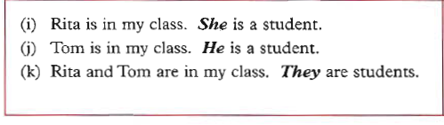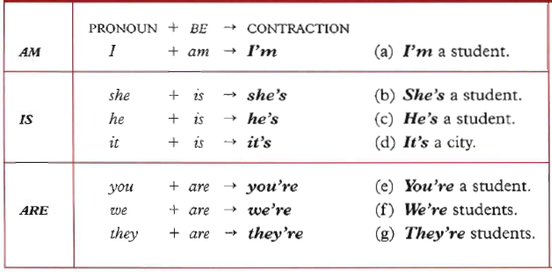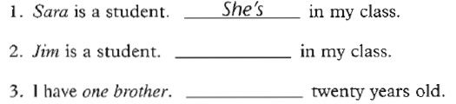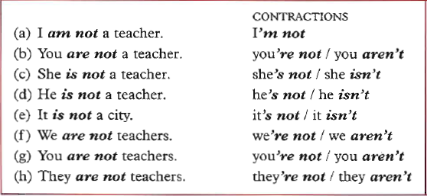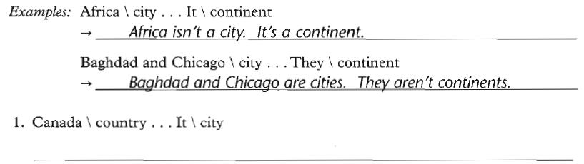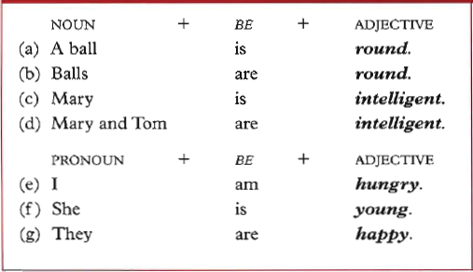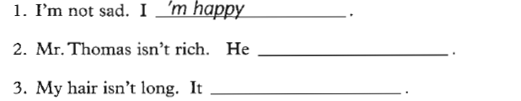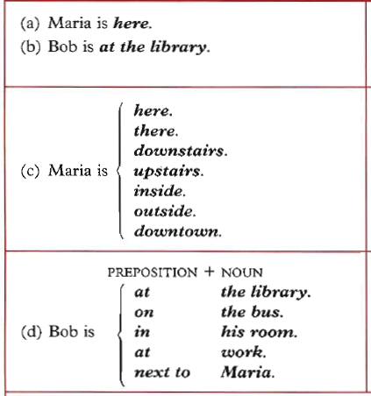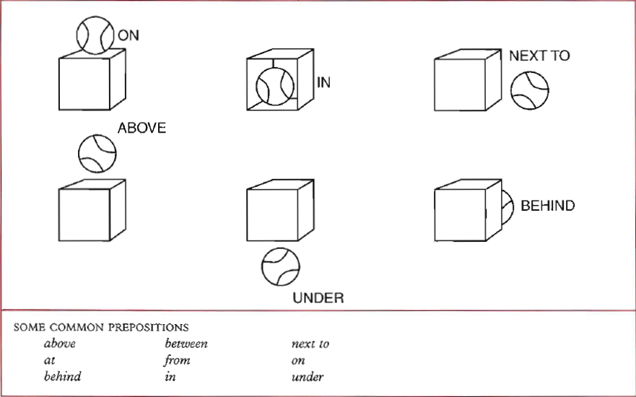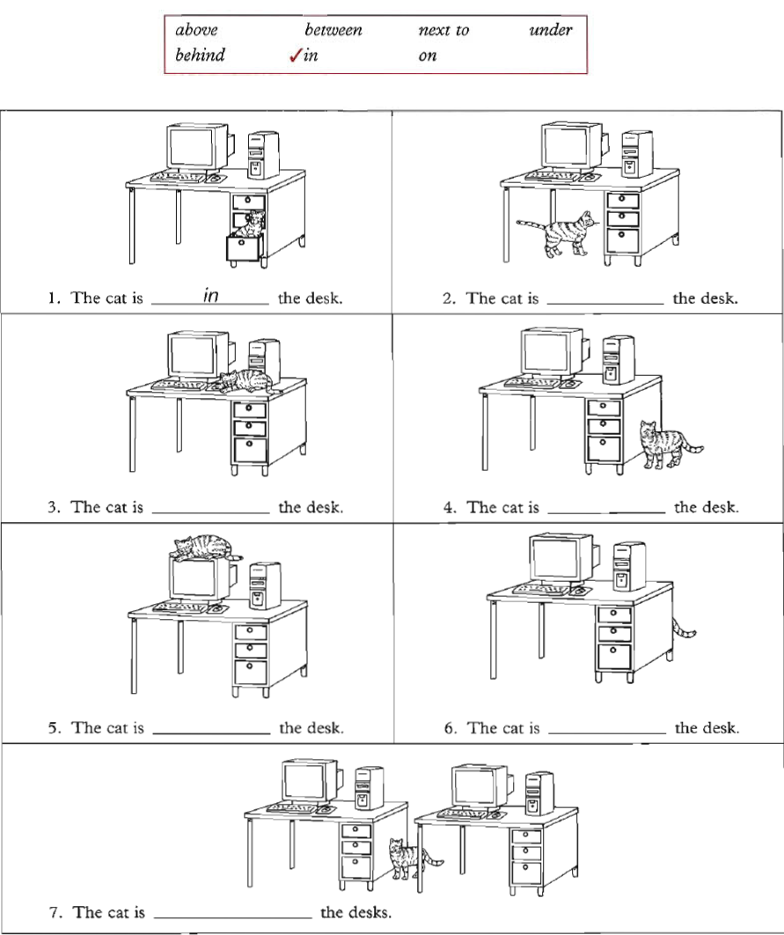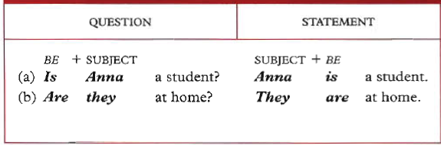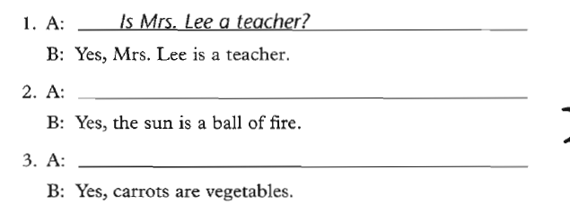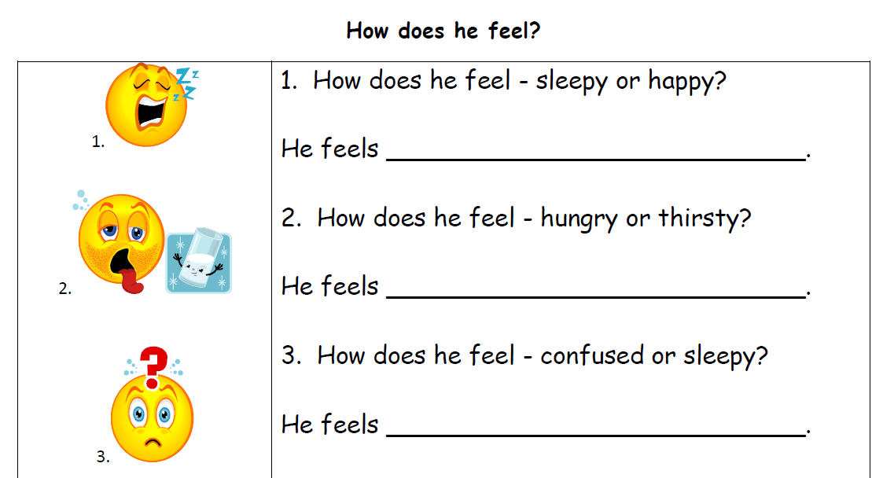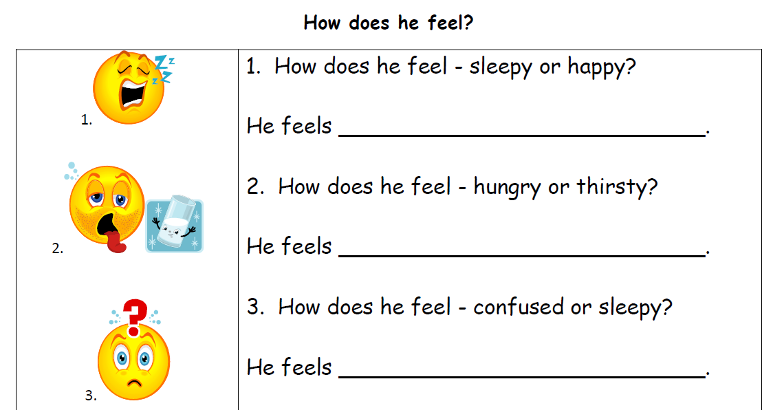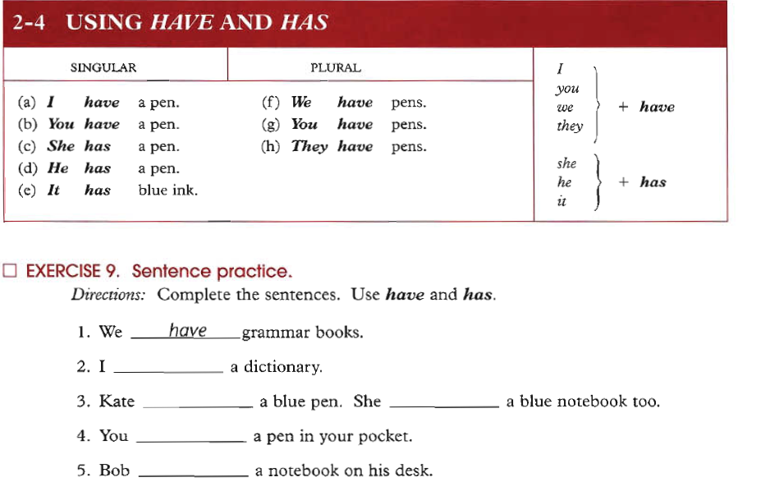
المحاضره الثانيه
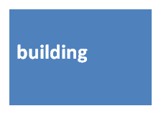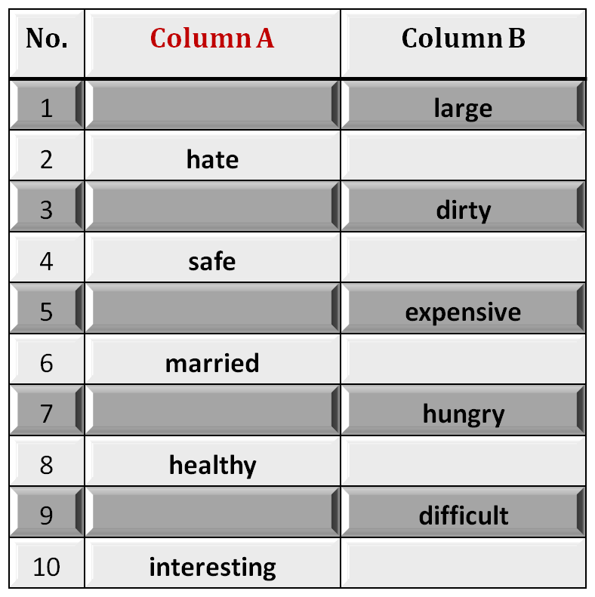
II:

Structure

1.Salma and Fatima -----------------from Riyadh.

a. is
b. was
c. has
d. are

2. ___________ your car new?

a. Are
b. Is
c. Aren't
d. Has
Part One : Circle the correct response
II.
Structure
3. London ------------------ a country. It is a city.

is
aren't
isn't
are
4. ----------- ant is ---------------- insect.

An / an
An / a
A / an
A / a
Part One:
Structure
5. Are you a doctor? No, ---------------------.

I'mn't
amn't
Iamn't
I'm not
6. Where is the water? ------------------- inside the refrigerator.

They're
It
It's
He's
Part Two:
Structure
9. ------------ in the house now.

We're
Wer'e
Were
We re

10. Are you ready? - -------------------------------.
No, I'm not
Yes, Im
No, Iamn't
Yes, You're

Part Two:
Structure
7. A teacher usually starts a lesson by writing the date------------------the board.

in
under
over
on
8. My friend is from America.---------- lives in New York city.

I
We
He
It

A.Fill in each blank with a word from the box
This store is always ________. There are always lots and lots of people.

2. My_______are from Mexico. They're very nice people.

3. There are two big trees in ________of my house.

4. There is a big apartment_________ on the corner of the street.

5. People in my neighborhood are from ________ countries.

III. Vocabulary
B. Identifying Opposites
Fill in each blank space with the opposite meaning
small
love
clean
dangerous
cheap
single
full
sick
easy
boring
IV. Writing: Jumbled sentences
Rewrite the words in the correct order to make meaningful sentences
weather / very / in / Saudi Arabia / hot / in / The / summer / is.

The weather in Saudi Arabia is very hot in Summer

2. speak / at / The / this / English / university / lecturers.

3. fast / is / Driving / very / your / dangerous / car.

4. red / the / is / book / the / color / of

5. homework / I / my / myself / do / always.

Good **** Luck
End of Lecture 2

