Lecture 14

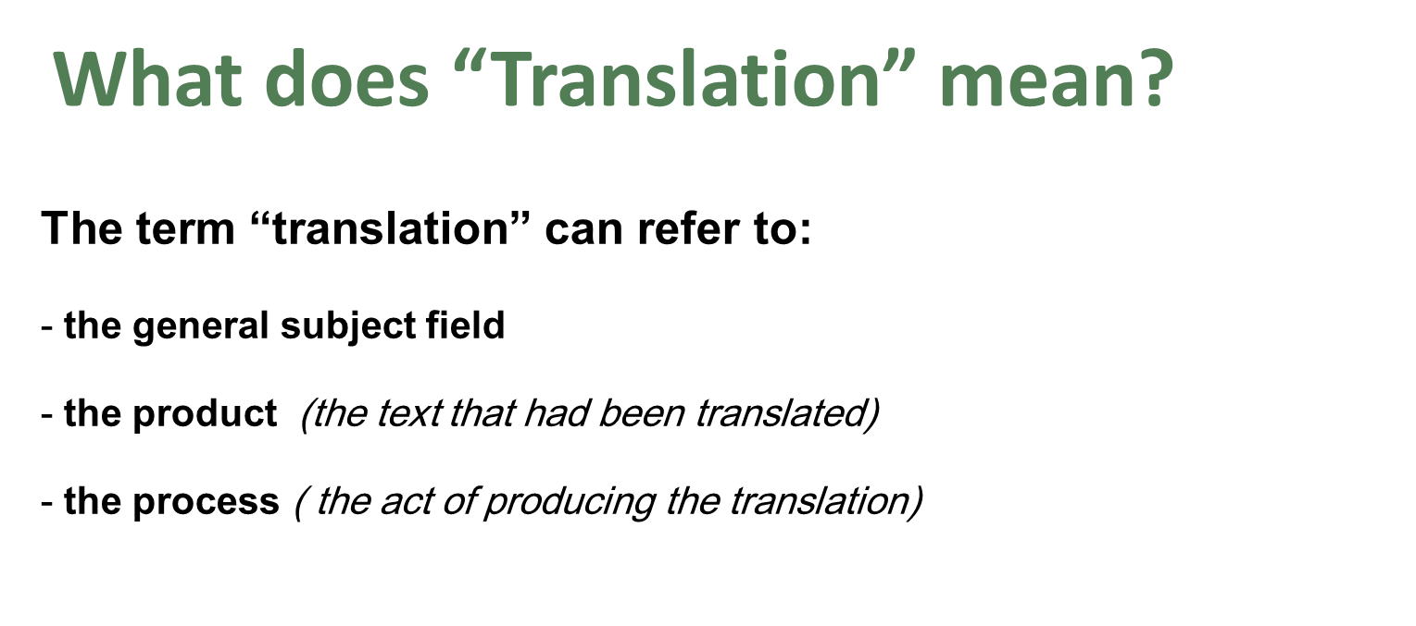
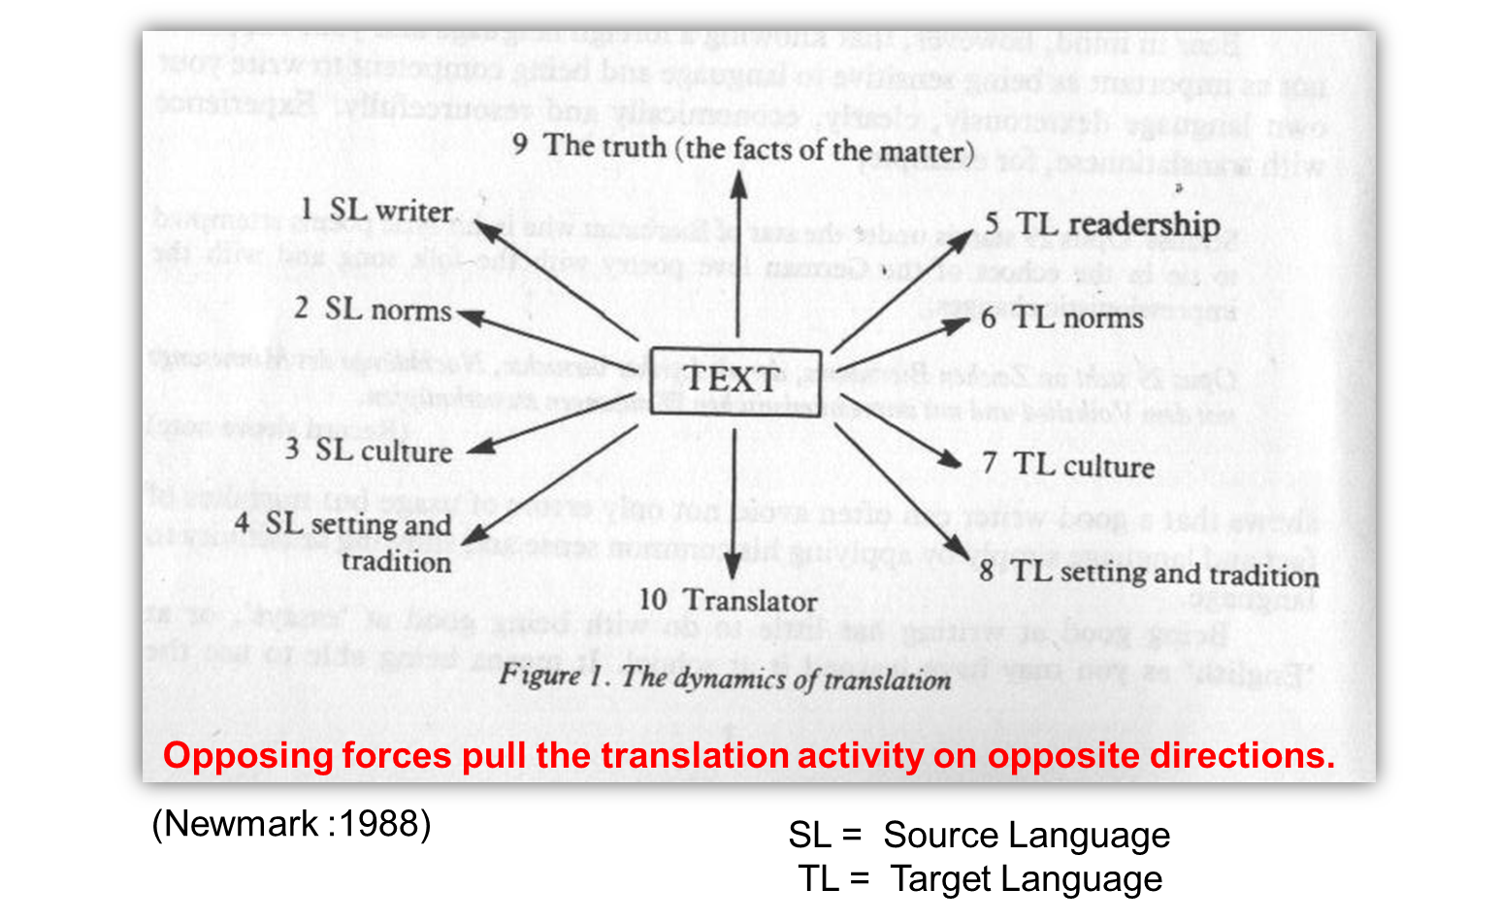

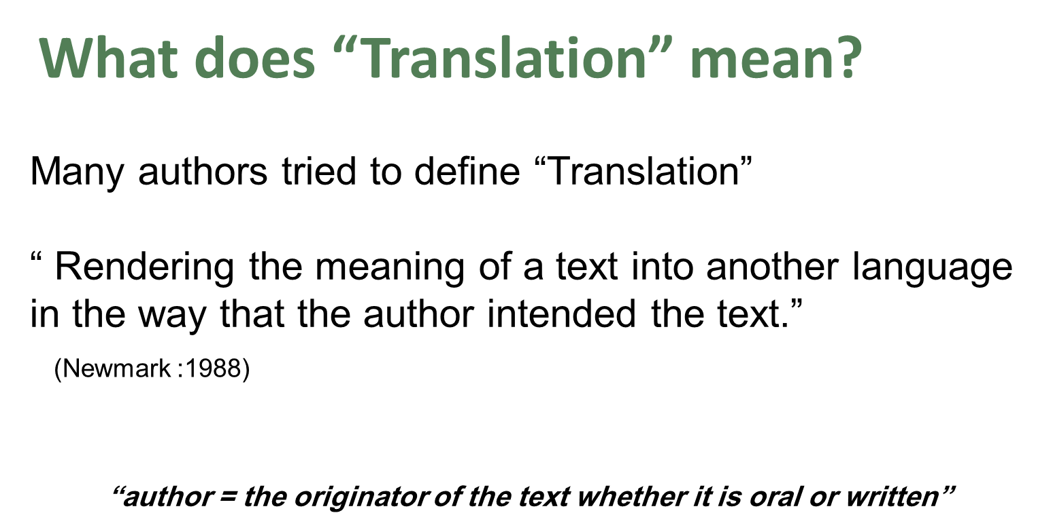

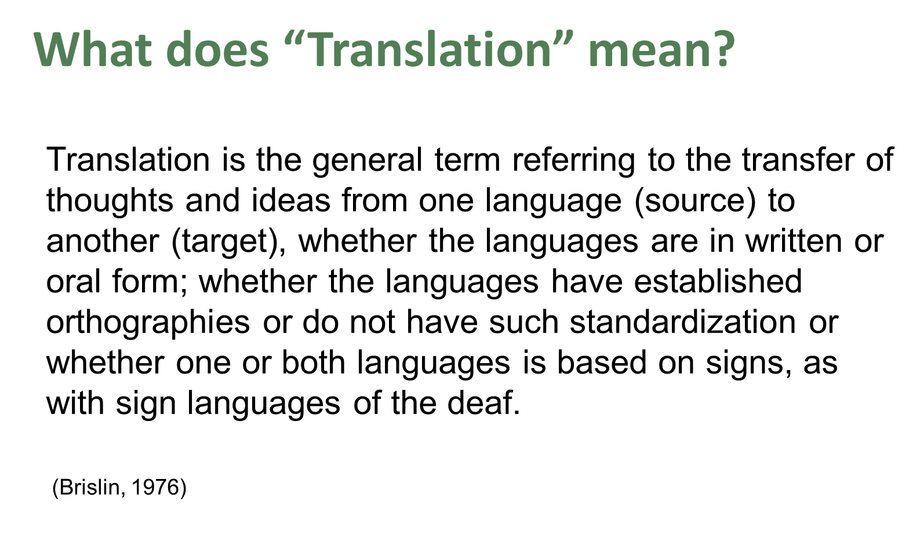

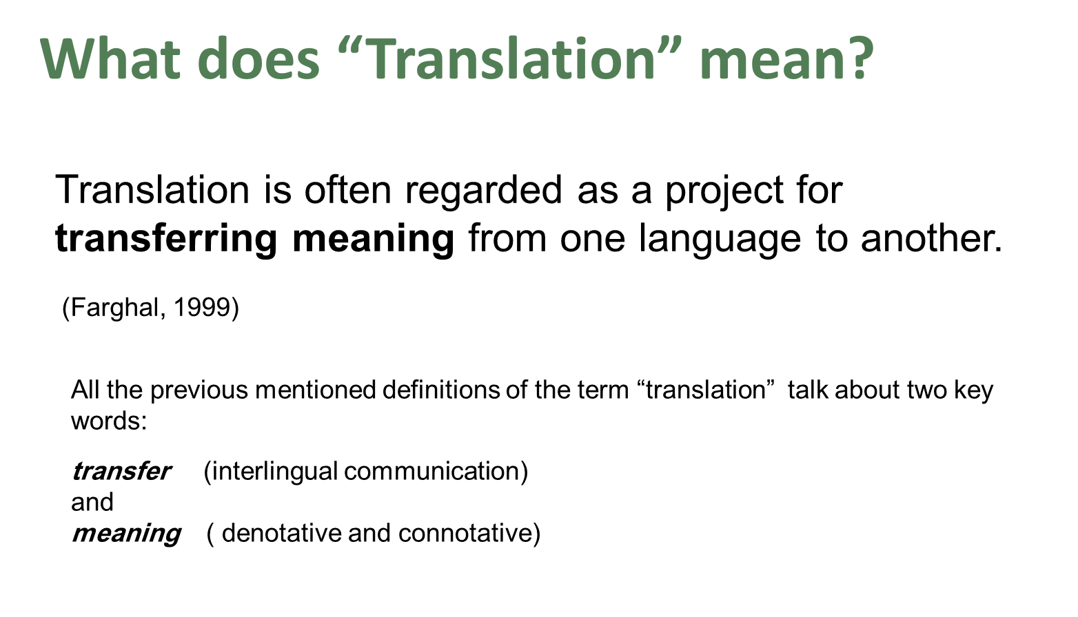

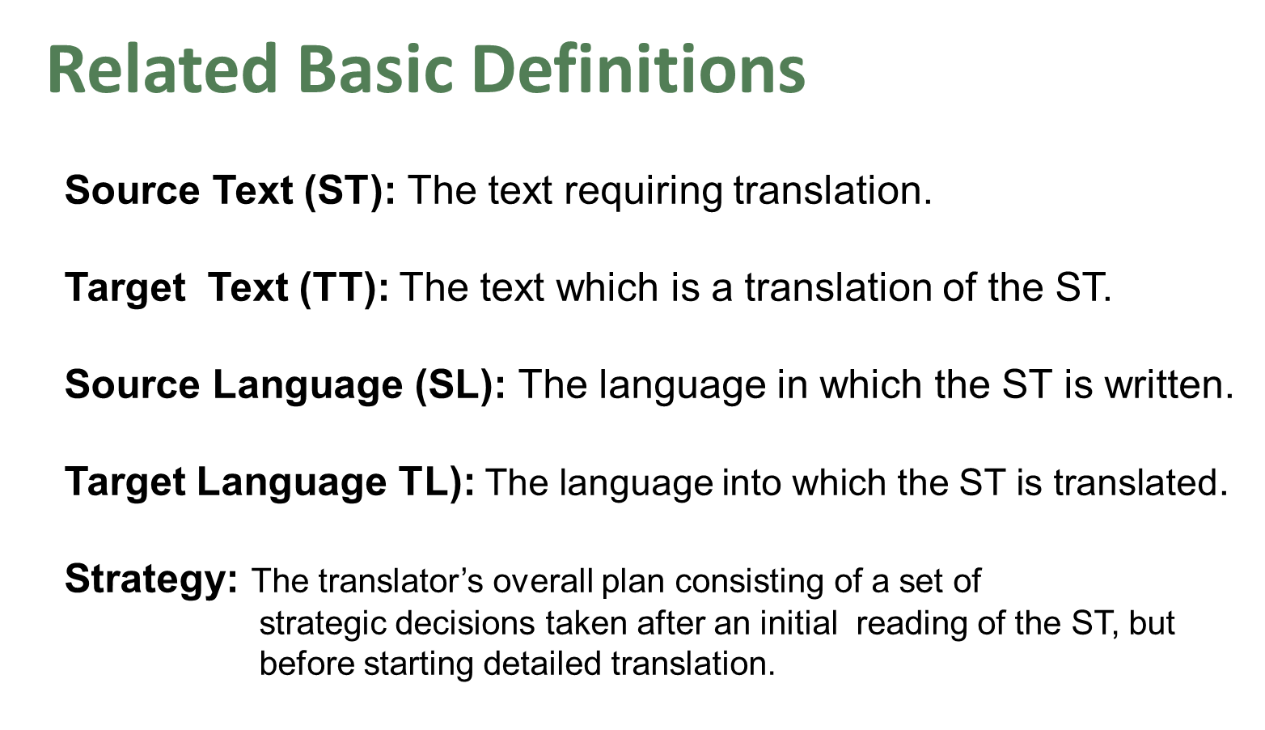

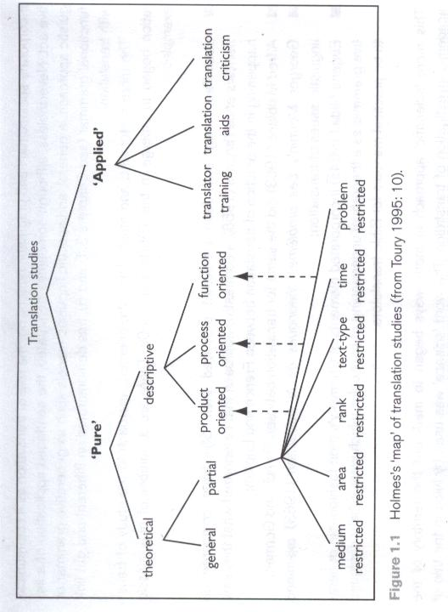
Translation Studies
James Holmes’s Map

Text Type
Are all those texts of the same text type?
Can you translate all of them following the same strategy?

"It is obvious that not all texts are the same type. We may distinguish between political texts, legal texts and medical texts; fairy tales, novels and short stories differ from newspaper reports, essays and scientific papers; food recipes, instructions booklets and advertisements may show similarities but they are not the same, expository texts differ from argumentative texts, etc. All these types of text differ in ways that are somewhat obvious, intuitively, but which nevertheless invite detailed analysis"
( Trosborg, 1998)

Katharina Reiss (1979/1989) views the text, rather than the word or sentence, as the level at which communication is achieved and at which equivalence must be sought.

Text Type Classifications
Hatim and Mason (1990) classified text types according to their rhetorical purposes:
argumentative, expositive and instruction-based.

They divide instructional texts into two types: instruction without option, and instruction with option. Instruction without option includes texts such as laws. One is required to follow the ‘instructions’
(law, for instance); otherwise there may be a punishment.

Newmark depends on Buhler’s functions of language to deal with text types. According to Buhler, there are three language functions:
Expressive: serious imaginative literature, authoritative statements,
autobiography, essays and personal correspondence

Informative: a textbook, a technical report, a scientific paper or agenda of
a meeting
Vocative: notices, publicity, propaganda, persuasive writing and
advertisements
" Few texts are purely expressive informative or vocative: most include all three functions, with an emphasis on one of the three" ( Newmark,1988: 42)

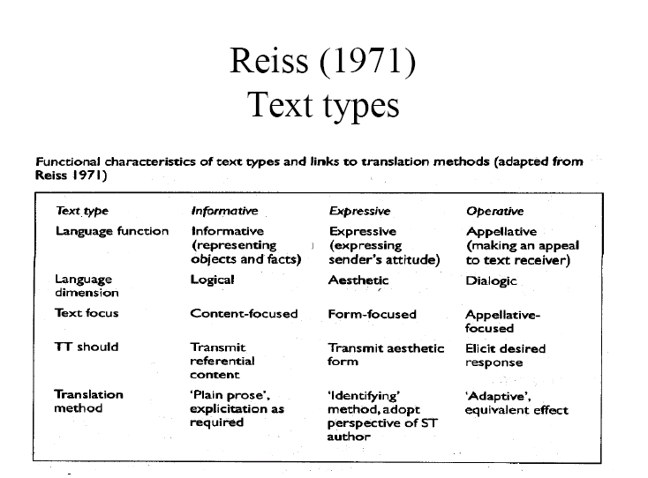

Text Type and Genre
The term “text type” is often used in a similar sense of “genre”.
Dickins, Hervey and Higgins opted for using the term “genre” instead of “text type”

Genre

Dickins, Hervey and Higgins distinguished five broad categories of “genre” :
Literary
Religious
Philosophical
Empirical
Persuasive

Before Beginning to Translate a Text

Before you begin translating any text, you need to ask yourself the following important questions:
- What is the message content of this particular ST?
- What are its salient linguistic features?
- What are its principal effects?
- What genre does it belong to and what audience is it aimed at?
- What are the functions and intended audience of my translation?

