Past Perfect Progressive

How do we Use this Tense?
PERFECT here means "complete, finished".
The Past Perfect Progressive is a form of the verb that shows the action started in the past and continued up until another time or action in the past.
It does not mean the action was "perfect" (100%). It means the action was finished.
Here are the different usages of this tense:

An action that started in the past, and continued up until another time or action in the past
*Note: The Past Perfect Progressive is often used together with the Simple Past.
For example: Sam had been driving all night before he reached home.
The action closest to the present is in the Simple Past, and the action that came before it is in the Past Perfect Progressive.

- He had been driving for hours before he arrived.
- He had been carrying that computer for an hour before he put it down.
- He had been fighting with that machine
for a long time until the mechanic arrived.
- He had been drawing for some hours before he got it right.
- He fell asleep because he had been working all night.

Examples of Typical Time Expressions
- For
- Since
- All morning
- All day

Positive Sentences
Who? | Form of verb | Examples
I | had + been + verb + ing | I had been waiting all day.
He/She/It | had + been + verb + ing | He had been waiting all day.  She had been waiting all day.  It had been waiting all day.
You | had + been + verb + ing | You had been waiting all day.
We | had + been + verb + ing | We had been waiting all day.
They | had + been + verb + ing | They had been waiting all day.
Negative Sentences
Who? | Form of verb | Examples
I | had + not + been + verb + ing  hadn't + been + verb + ing | I had not been waiting all day.  I hadn't been waiting all day.
He/She/It | had + not + been + verb + ing  hadn't + been + verb + ing | He had not been waiting all day.  He hadn't been waiting all day.  She had not been waiting all day.  She hadn't been waiting all day.  It had not been waiting all day.  It hadn't been waiting all day.
You | had + not + been + verb + ing  hadn't + been + verb + ing | You had not been waiting all day.  You hadn't been waiting all day.
We | had + not + been + verb + ing  hadn't + been + verb + ing | We had not been waiting all day.  We hadn't been waiting all day.
They | had + not + been + verb + ing  hadn't + been + verb + ing | They had not been waiting all day.  They hadn't been waiting all day.

Question Sentences
 | Who? | Form of verb | Examples
Had | I | been + verb + ing | Had I been waiting all day?
Had | he/she/it | been + verb + ing | Had he been waiting all day?  Had she been waiting all day?  Had it been waiting all day?
Had | you | been + verb + ing | Had you been waiting all day?
Had | we | been + verb + ing | Had we been waiting all day?
Had | they | been + verb + ing | Had they been waiting all day?

Who are they? What had they been doing?
Where had they been going?

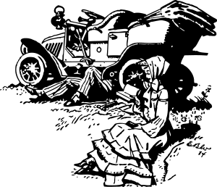
Donald and Elizabeth had been driving to church before they stopped. They had been driving down a dirt road when they heard a strange noise. Donald stopped the car. He got out of the car. Then, he helped Elizabeth out of the car. Elizabeth sat and waited for Donald.
Donald looked at the car. It had been going for an hour or so. He knew how to fix cars. He had been working as a mechanic for 5 years before he moved to the country. Donald got his tools. He looked under the hood. It seemed that the engine had been heating up. He crawled under the car.
Donald had been working on the car for a while when Jake parked beside him. Jake had been driving home when he saw Donald and Elizabeth on the side of the road. Jake helped Donald fix the car. Donald thanked Jake for his help. Elizabeth waved to Jake as they drove away. Thanks to Jake's help, they arrived at church on time.
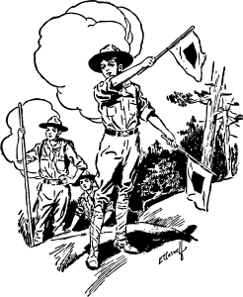
Where were they? What had they been doing?

Billy and the other scouts had been hiking on the mountain all morning when they realized they were lost. They looked each direction. They did not see the camp. They did not see the river.
The scouts were tired because they had been hiking for four hours. They were worried because they were lost. They sat down under a tree.
But Billy was not worried. Billy had been hiking these mountains with his dad his whole life. Billy's dad had been teaching him how to use a compass for three years. Billy climbed a tree and saw the river. He knew the camp was north of the river. Billy looked at his compass. He guided the scouts back to the camp.

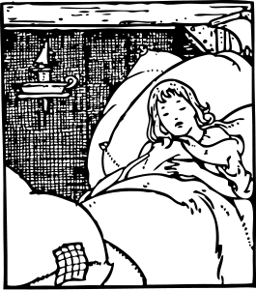
Where was she? What did she do? What had she been doing?
Lisa slept because she had been feeling very sick. In fact, Lisa had not been feeling well for three days. Her mother knew something was strange because Lisa had not been acting normal. She had not been finishing her meals for the past two days. She had not even been playing with her friends.
The doctor visited Lisa. He had been visiting many children since the sickness arrived. He examined Lisa. He gave Lisa medicine. He talked to Lisa's mother.
Lisa's mother had been praying for a week when Lisa woke up. Lisa looked much better. She did not feel sick anymore. Everyone was happy that Lisa was better!

Change the verb into the correct form :
1. They (chat) for over 2 hours.
2. I (wait) there for ages.
3. Brianna (sit) there for 20 minutes before the doctor (call) her name.
4. You (work) there for several years before you (quit) your job.
5. They (jog) for a while before they (get) tired.
6. I (wait) for the bus for 10 minutes when it (arrive).
7. She (want) to rest a bit because she (clean) the whole day.
8. They (decide) to break up because they (fight) for a long time.
9. Alex (play) golf for many years before he (retire).
10. Susan (be) hungry because she (fast) the whole day.
11. Peter (drink) too much, so he (have) to run to the bathroom a lot.
12. Anna (fail) the exam because she (skip) classes.
13. I (work) on my book for a year when I (publish) it.
14. You (pass) the test because you (study) very well.
15. We (buy) the house after we (save) for many years.

