المحــــآضره الثانيه عشر
Meanings | New words
Kinds of living things |  | Species ( N )
Way of acting |  | behavior ( N )
The small hard part of a plant |  | seeds (N)
Character / qualities and features of a person |  | personality ( N)
A building where old things are shown |  | museum ( N)
Sea or ocean beach/ shore |  | coast ( N)
Calculate or say 1, 2, 3……. |  | Count ( V )
Be impossible to see / stop existing |  | Disappear ( V )
Like |  | Prefer ( V )
To be happy in doing something |  | Enjoy ( V )
To move from a place to another |  | Travel ( V)
Feel uninterested |  | bored (Adj)
Very clever |  | Intelligent ( Adj)
Anxious or unhappy |  | Worried ( adj)
Comment in a joking way |  | Irony ( N )
With each other/ opposite of apart |  | together ( adv)
- امثله وتمارين..
1. The word” ___” is closest in meaning to the phrase “ a way of acting”.
A. difficulty B. behavior
C. entertainment D. character
2. Most of the students feel _______ because of the final tests.
A. worried B. thirsty
C. sleepy D. hungry
3. The word “ ____” is closest in meaning to the phrase “ very clever”.
A. interesting B. intelligent
C. easy D. enjoyable
4. Every one felt ______________ because of the bad movie.
A. bored B. happy
C. dangerous D. tall
5. “_____” is closest in meaning to the phrase“ kinds of living things”.
A. islands B. beaches
C. species D. insects
6. All children _________ watching cartoon movies.
A. dislike B. enjoy
C. are afraid of D. avoid
7. “ _________” is closest in meaning to the word “ like”.
A. hate B. attract
C. prefer D. avoid
8. When the sun rises, the fog ___________________ quickly .
A. disappears B. succeeds
C. returns D. fails
مراجعه لما اخذناه في المحاضره 11..
اذا كانت الصفه من مقطع واحد نضيف er لصفه التي تقارن بين اثنين est لصفه التي تقارن بين مجموعه
Superlative | Comparative | Adjective
The softest | Softer | Soft
The cheapest | Cheaper | Cheap
The sweetest | Sweeter | Sweet
The thinnest | Thinner | Thin
نقول عن حالات الصفه ذا مقطع واحد
عندما تنتهي بحرف ساكن وقبله حرف عله يجب مضاعفه الحرف ونضيف بعده er-est
وعندما يكون اخر حرف e نستبدلها بـٍ er –est
وعندما يكون اخر حرف y وقبلها حرف ساكن نستبدلها بـٍ I ونضيف er-est
نقول عن حالات الصفه ذات مقطعين .
عندما تنتهي بـٍ y نستبدلها بـٍ I ونضيف er-est مثل
Superlative | Comparative | Adjective
Luckiest the | Luckier | Lucky
Prettiest the | Prettier | Pretty
Tidiest the | Tidier | Tidy

وعندما تنتهي بـٍ ed –ing-ful-less نرجعها االى اصلها ونستخدم more لصفه التي تقارن بين اثنين و most لصفه التي تقارن بين مجموعه ..
Superlative | Comparative | Adjective
The most worried | More worried | Worried
The most boring | More boring | Boring
The most careful | More careful | Careful
The most useless | More useless | Useless
نقول عن حالات ذات 3 مقاطع او اكثر ..
نرجعه الي حاله الأصل ولانضيف er –est للصفه ونستخدم more لصفه التي تقارن بين اثنين
وmost لصفه التي تقارن بين مجموعه ..
Superlative | Comparative | Adjective
The most dangerous | More dangerous | Dangerous
The most difficult | More difficult | Difficult
بعض الصفات يضاف لها un في البدايه لعكس معناها فمثلا happy =unhappy
التي تنتهي بـٍ حرف y نضيف لها more –most /er-est ..
الحالات الشاذه التي لاينطبق عليهها قواعد..
Superlative | Comparative | Adjective
The best | Better | Good
The worst | Worse | Bad
The farthest/furthest | Farther/further | Far
USE OF COMPARATIVES المقارنه بين شيئين ..
نستطيع ان نستخدم then في المقارنه بين شيئين عندما تكون الصفه الأكثر تميزا في بدايه الجمله
John is taller than me
I think that she’s more intelligent than her sister
هناك بعض الكلمات لديها تعطي انطباعا في الجمله مثل ..
You should go by train, it would be much cheaper.
Could you be a bit quieter?
I’m feeling a lot better.
Do you have one that’s slightly bigger?
نستطيع استخدام the في الجمله مرتين وتكون كل واحده تبع صفه مثال
The smaller the gift, the easier it is to send.
The more stressed you are, the worse it is for your health
في المثال الأول ذكرنا ان الهديه الصغيره والصفه الثانيه لها انها تكون اسهل في الارسال
استخدمنا the لتعطي انطباعا ومعنى للجمله والمستمع ..
The sea was getting rougher and rougher
Her illness was becoming worse and worse.
He became more and more tired as the weeks went by
في الامثله السابقه نجد استخدام and عند تكرار الصفه مثل المثال الأول اخبرنا ان البحر اصبح وعرا ثم وضح لنا انه اصبح اكثر وعورا ..
USE OF SUPERLATIVES المقارنه بين مجموعه ..
عند مقارنه بين مجموعه نطبق مثل المقارنه بين اثنين
the most delicious chocolate cake I’ve ever eaten
Annabel was the youngest
This restaurant is the best
ولكن هنا فيه إضافات نستطيع وضعها مثل استخدام of –in فهي تحدد وجه المقارنه بشكل أوضح
Annabel was the youngest child
Annabel was the youngest of the children
This restaurant is the best in town.
وعندما تكون المقارنه بين صفات اقل من الأخرى نضع less لصفه التي تقارن بين اثنين the least لصفه التي تقارن بين مجموعه
This sofa is less comfortable
She was the least intelligent of the three sisters.
Similarity متشابه ..
من جهه أخرى من المقارنات ذكرنا المقارنه عندما تكون صفه اكبر من الأخرى وعندما تككون الصفه اقل من الأخرى
سنتكلم الان عن الصفه مشابه للاخرى او مساويه لها في مقدار ..
نضيف as قبل وبعد الصفه as + an adjective+ as مثل
Ahmed is as tall as Salim.
Ahmed is as famous as salim.
Ahmed is as good as Salim
نرى في المثال الأول وضعنا as قبل صفه tall وبعدها فنوضح للمستمع ان احمد يساوي او يشابه سليم في الطول
وفي الحال نعمل نفس عمل الصفه [ as + an adverb + as ] نضع as قبل وبعد الحال ..
Ahmed speaks English as fluently as Salim does.
Women work as hard as men do.
اما من ناحيه النفي فاننا نضع not قبل as حتى ننفي الجمله مثل..
Ahmed isn’t as tall as Salim
- امثله وتمارين ..
- People in Saudi Arabia are as _______ as people in Jordan .
A. more generous B. generous
C. most generous D. the most generous
- The weather in winter is _____________ than it is in summer.
  - Colder B. cold
  - Coldest D. the coldest
- I have ___________ money than you do.
  - much B. more
  - most D. least
- Abdullah is ______________ of all boys.
  - the fastest B. the most fastest
  - fast D. faster
هنا سنتكلم عن صياغ المقارنه ..
- .What is the comparative of "sad"?
- sader
- sadder
- sadier
- saddier
- .What is the comparative of "destructive"?
- destructiver
- more destructive
- destructivier
- more destructiver
- What is the superlative of "soft"?
- Softest
- softiest
- softtest
- most soft
- What is the comparative of "hot"?
- hoter
- hotter
- hotest
- hottest
- .What is the comparative of "heat"?
- Heater b. heater c. heatier d. hetter f. none of these
- .What is the superlative of "ugly"?
- Uglier b. ugliest c. ugliest d. ugliest
- .What is the superlative of "unpleasant"?
- Unpleasant b. most unpleasant c. more unpleasant d. unpleasantest
- .What is the superlative of "small"?
- Smallier b. smaller c. smalliest d. smallest
- .What is the comparative of "lively"?
- Livelier b. more livelier c. livelier d. more livelier
- What is the superlative of "deep"?
- Deeper b. deeper c. deepest d. deepest
هنا نقارن بصوره المقابله ونضع الإجابات
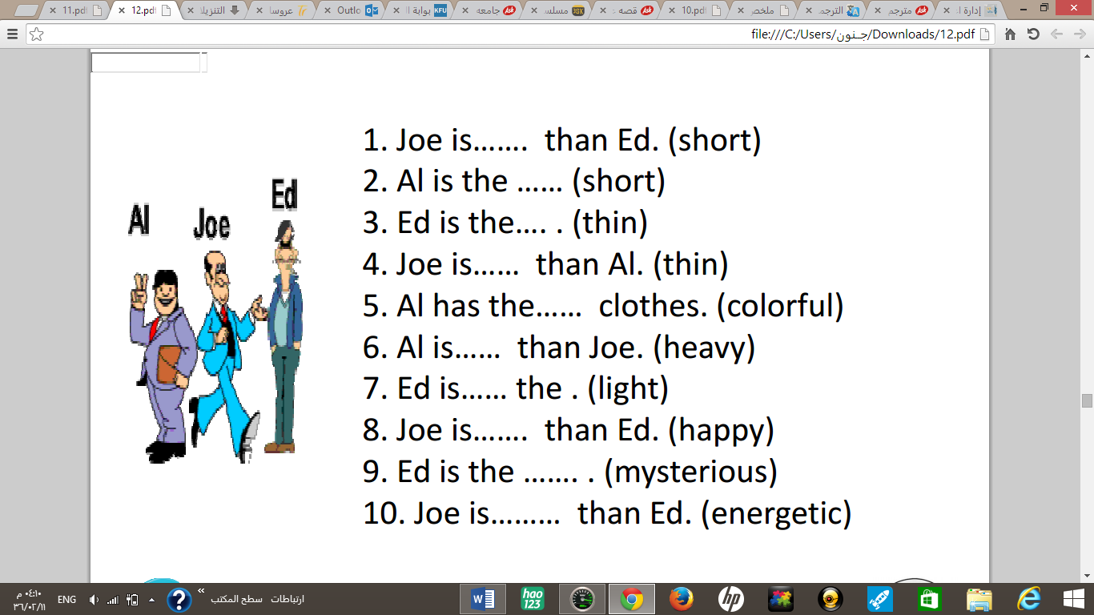
Joe is…shorter. than Ed. (short)
Al is the short est… (short)
Ed is the thinnest…. . (thin)
Joe is…thinner… than Al. (thin)
Al has the the most colorful .. clothes. (colorful)
Al is…haevier… than Joe. (heavy)
Ed is…the lightest… the . (light)
Joe is…happier…. than Ed. (happy)
Ed is the most mysterious …. . (mysterious)
Joe is…more energetic … than Ed. (energetic)
هنا ترتيب الكلمات حتى يتكون لدينا جمله ..
- Than , Vancouver , smaller, . much ,Victoria ,is
Vancouver is much smaller tane Victoria
- biggest ,. city ,Canada, Toronto, in, is, the
Toronto is the biggest city in Canada
- Uglytown ,is, beautiful ,more, Jasper, than
Jasper is more beautiful than uglytown
- In, province ,. Canada, BC, most, the, attractive, is
bc is the most attractive province in canada
superlative form | Irregular adjective
The best | Good
The worst | Bad
The most | Many
The most | Much
The least | little
John is _________________ of all.
• A. better b. best
• C. the better D. the best
. I think that’s _____ film I’ve ever seen
a) the funnier than b) the funny
c) the funniest d) the funnier
. Is football the _____ sport in Chile?
a) popular b) more popular
b) popularest d) most popular
.Vegetables are _____ last week
a) expensiver than b)more expensiver tham
b) more expensive than d) most expensive
. I think Vladimir is _____ intelligent person in the class
a) more than b) the most
c) most d) the more
. Don’t you think there are _____ things to do on hokidays than watching tv all day?
a) best b) bestest c) better d) better than
.Summer is _____ season in our country
a) the hottest b) hotter than c) the hot d) hot
. Groenland has the _____ weather of the world. It’s always raining and snowing
a) bad b) worse than c) worst d) worsest
. The Everest is _____ the Aconcagua
a) the highest b) highest than c) the higher than d) higher than
. Last week we had _____ day in Santiago, the temperature was –18ºC
a) the colder b) the coldest c) the cold d) colder than
. To fall from a motorcycle is _____ to fall from a bicycle.
a) more painful b) more painful than c) painfuller than
d) the painfullest
If you suffer asthma, don’t go to Mexico City. It is one of the _____ cities in the world
a) pollutest b) more polluted c) polluter than
d) most polluted
The _____ place from Chile is Australia. It’s on the other side of the world.
a) farther b) farthest c) farther than
d) farthest than
. I don’t think your bike is _____ mine.
a) fastest than b) faster c) fastest
d) faster than
. Michael was _____ basketball player in the world
a) taller b) tallest c) the taller d) the tallest
. Speaking Japanese is _____writing it.
a) the easiest b) easy c) easier than d) easyer than
هنا نحول الصفه ذات مقطع واحد الى صفه تقارن بين مجموعه
fast => the fastest
nice => the nicest
large =>the largest
tall => the tallest
old =>the oldest
long=>the longest
great=>the greatest
smart =>the smartest
friendly => the friendliest
funny => the funniest
silly => the silliest
hot => the hottest
big => the biggest
هنا نحول الصفه ذات 2 مقطعين او اكثر الى صفه تقارن بين مجموعه
popular => the most popular
exciting => the most exciting
successful => the most successful
اكمل الجمل بما يناسبها بصفه تقارن بين اثنين وبين مجموعه ..
• Clare is __older than_____ Mike. (old)
• Jane is __the healthiest ______ of the four. She eats very well and does a lot of sports, (healthy)
• The coach thinks that Peter is the __fastest______ player of the team, (fast)
• The Sahara desert is one of the ____the hottest____ deserts in the world. (hot)
• The climate in the North of Chile is ___drier than______ in the South, (dry)
• Asia is ________bigger than___________ Europe. (big)
• A Rolls-Royce is one of ___the most expensive__________ cars in the world. (expensive)
• ______the most violent___ hurricanes are developed over México, (violent)
• Diamonds are _the most precious____ jewels in the world. (precious)
• History classes are ___more interesting_____ chemistry classes. (interesting)

