CONSUMER EDUCATION

Consumer Education - is the preparation of an individual through skills, concepts and understanding that are required for everyday living to achieve maximum satisfaction and utilization of his resources.

FOOD LABELS

I. Ingredient label
- List of Chemical composition in food
- List of food in descending order by weight
- Does not specify how much-either by weight or percentage of an ingredient is in food

II. Nutrition facts label
Provides quantitative information on certain nutrients in the food and the calorie content of the food.

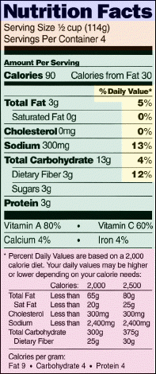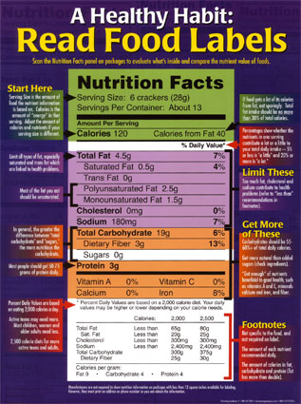

Common terms used in labelling…

1 . FREE- also with “no” and “zero”
a product contains no amount of, or only a trivial amount of, one of the following compounds: fat, saturated fat, cholesterol, sodium, sugars and calories.

2. LOW- also with “little”, “few” and “low source of”
foods that can be eaten frequently without exceeding dietary guidelines for one or more of these components: fat, saturated fat, cholesterol, sodium and calories.

3. High
This term can be used if the food contains 20 percent or more of the daily value for a particular nutrient per serving

4. Good Source
These terms mean that one serving of a food contains 10-19% of the daily value for a particular nutrient. Ex. Orange containers may say “good source of vitamin C.”

5. Less
This term means that a food, whether altered or not, contains 25% less of a nutrient or calories as compared as compared to the reference food. Ex. pretzels that have 25% less fat than potato chips.

6. Percent Fat-free
A product bearing this claim must be a low- fat or fat-free product. The claim must accurately represent the amount of fat present in 100 grams of the food. So, if the box of cookies you are picking up says 95% fat-free, it must contain 5 grams of fat per 100 grams.

Serving Sizes

The serving size remains the basis for reporting each food's nutrient content. However, unlike in the past, when the serving size was up to the discretion of the food manufacturer, serving sizes now are more uniform and reflect the amounts people actually eat. They also must be expressed in both common household and metric measures

Consumer Tips
- Planning - The Number One Key to Top Savings
- How Much Are You Spending?
- Analyze Your Spending
- Don't Shop on an Empty Stomach
- Avoid Darting Into Convenience Stores
- Don't Buy Toiletries at Grocery Stores
- Practice "Mixing It" Yourself
- Concentrated Juice Offers Big Savings
- Don't Be Shy About Shopping the Discount Basket
- Shop Store Brands and Generic Products
- Don't Leave Money on the Table

Food Purchasing Tips
- Do not shop when hungry
- Prepare a shopping list and do not deviate from it
- Buy only those foods that are low in Calories and high in nutrient value
- Buy natural foods as much as possible

Restaurant eating tips…
- When eating out, select low-Calorie items
- Request that items be prepared without fat.
- Have condiments like butter, mayonnaise and salad dressing served on the side.

Wise Food Choices
CHOOSE THIS FOOD | INSTEAD OF THIS FOOD
Baked Potatoes | French Fries
Boiled Egg Whites | Fried Eggs
100% Orange Juice | Sunny Delight
Steamed Brown Rice | Cocoa Puffs
Boiled Whole Wheat Spaghetti | Spaghetti-Os
Homemade Whole Wheat Brownies | Little Debbie Cakes
Homemade Food from Fresh Ingredients | Processed Foods
Fresh Fruit with its Skin | Canned Fruit
Water | Sodas
100% Stone Ground Whole Wheat Bread | White Bread
Broiled Skinless Chicken Breast | Fried Chicken
Bean Burrito with No Fat Cheese | Burrito Supreme
Fat Free Frozen Yogurt | Ice Cream
Shredded Wheat & Bran | Frosted Mini-Wheat
Broiled or Steamed Food | Breaded and Fried Food
Baked Potato Chips | Fried Potato Chips
Fresh Vegetables | Canned Vegetables
Whole Wheat Bagels | Donuts
Ground Lean Steak | Hamburger
Oatmeal | High Sugar Cereal
Skinless Chicken Breast | Chicken with Skin

