Handout #2
Health Education 2
EFFECTS OF EXERCISE IN THE RESPIRATORY SYSTEM

THE RESPIRATORY SYSTEM

-the system of the body that functions in the supply of oxygen in the blood and delivers it to all parts of the body.

-a system that includes a set of complex structures that enables air to move in and out of the body.

-an agent in extracting and releasing carbon dioxide.

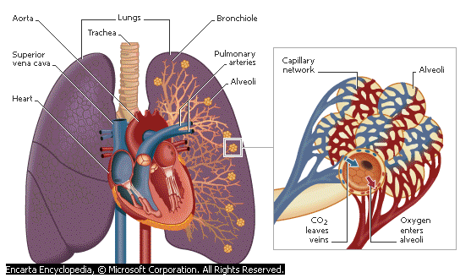

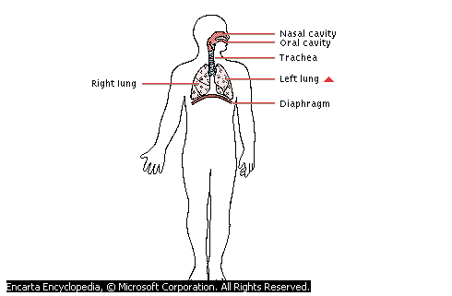

Parts of the Respiratory System:

- Nose (nasal cavity)
-passage of air going to and from the lungs.

- Mouth
-another air passage used by people. It is temporarily obstructed

- Throat (pharynx)
-collects incoming air from the nose and mouth and passes it downward to the trachea.
- Trachea
-section of the mammalian respiratory tract in the neck, extending between the larynx and the bronchi and lying in front of the esophagus. The trachea, commonly called windpipe, is made up of numerous cartilaginous half-rings, the open ends of which are adjacent to the esophagus.

- Lungs
-light, spongy, elastic, saclike respiratory organ in the chest used to remove carbon dioxide and provide oxygen in the blood.

- Alveoli
-pertains to the tiny air sacs of the lungs

- Diaphragm
-wall of muscles that separates the chest cavity from the abdominal cavity

- Bronchi
-the trachea that branched out as its reaches the lungs

Breathing/ Respiration
-mechanical process wherein air is drawn into and expelled from the lungs.

Phases in the Process of BREATHING

- Inhalation
- process during which air is inhaled.

-diaphragm muscles contract drawing the diaphragm downward; air moves into the lungs as it expands, filling the available spaces.

- Exhalation
-process during which air is exhaled.
occurs automatically when muscles causing inspiration are relaxed, although it can be assisted by contraction of the abdominal muscles.

-diaphragm relaxes and domes upward; size of the chest cavity decreases forcing the air out of the lungs

The Respiration Process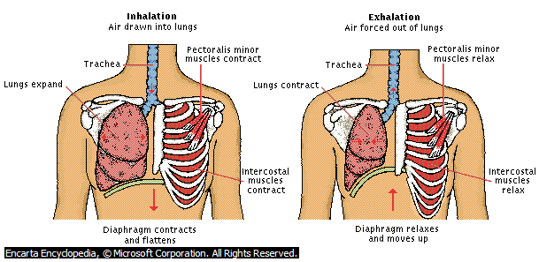

Volume of Air Stored in the Lungs
- Tidal Volume
-amount of air in the lungs while at rest.

- Expiratory Reserve Volume
-amount of air expired beyond tidal volume which is about 1000 ml.

- Inspiratory Reserve Volume
-amount of air inhaled beyond tidal volume which is about 2000-3000 ml.

- Vital Capacity
-the sum of the tidal volume, expiratory reserve volume and inspiratory reserve volume.

- Residual Volume
-the remaining air in the lungs even after a maximal expiration.

- Minute Volume
-amount of air taken in by the lungs during one minute.

Exercise
- set of physical activities designed to promote physical fitness
-series of actions, movements, or tasks performed repeatedly or regularly as a way of practicing and improving a skill or procedure.

Types of Exercise
- Moderate Exercise
-includes slow movement of the body or movements in lesser intensity. A good example is a walk every morning.

- Exercise of Varying Intensity
-regular set of physical activities that require greater work force. Examples of this are the following: swimming, racket sports, cleaning the house etc.

Effects of Exercise

Immediate Effects:

1. Increase in the rate and depth of breathing
-a normal response of the body to supply the greater amount of oxygen demanded by the working muscle and to eliminate the increased contribution of carbon dioxide.

2. Increase in minute volume
-during strenuous work or an exercise of varying intensity, the normal breathing of 16 times per minute or 8 liters of air breathed is increased by 107 liters.

3. Compensation of Oxygen Debt
-referred to as the deficit of oxygen in the performing muscles.
-while oxygen is being importuned during exercise, it is eventually repaid with greater amount during recovery time.

4. Oxygen Requirement
-exercise increases both the continuous supply of oxygen and he continuous removal of carbon dioxide.

5. Second Wind
-if the exercise is continued, the initial discomfort we feel is replaced with great relief

Long-Term Effects:

- The capacity of the lungs to allow more oxygen to be taken in is increased.
- Better lung ventilation.
- Recovery rate becomes quicker.
- Longer duration of effort before exhaustion.
- Greater mechanical efficiency.

Detrimental Effects of Exercise:

1. Impairment of Respiratory Cell
-during exercise a combination of high respiratory flow rates and a switch from nose to mouth breathing causes progressive cooling and drying of the respiratory mucosa and increased exposure of the bronchi to air contaminants; this results to the reducing of the clearance of microorganisms and toxic particles together with the impairment of the mucosal B cell, thereby reducing antibody secretion.

2. Increased in Susceptibility to Viruses
-susceptibility of viruses is increased after a marathon run but not after a 20-30-km run, which probably has an almost equal impact on physical barriers. It thus seems unlikely that damaging of physical defense mechanisms is a major caused of increased susceptibility to URTI in heavy exercises.

