تحيل الخطاب – محمود السلمان

الواجبات

الواجب الاول

الواجب الثاني
1-True
2-True
3-False
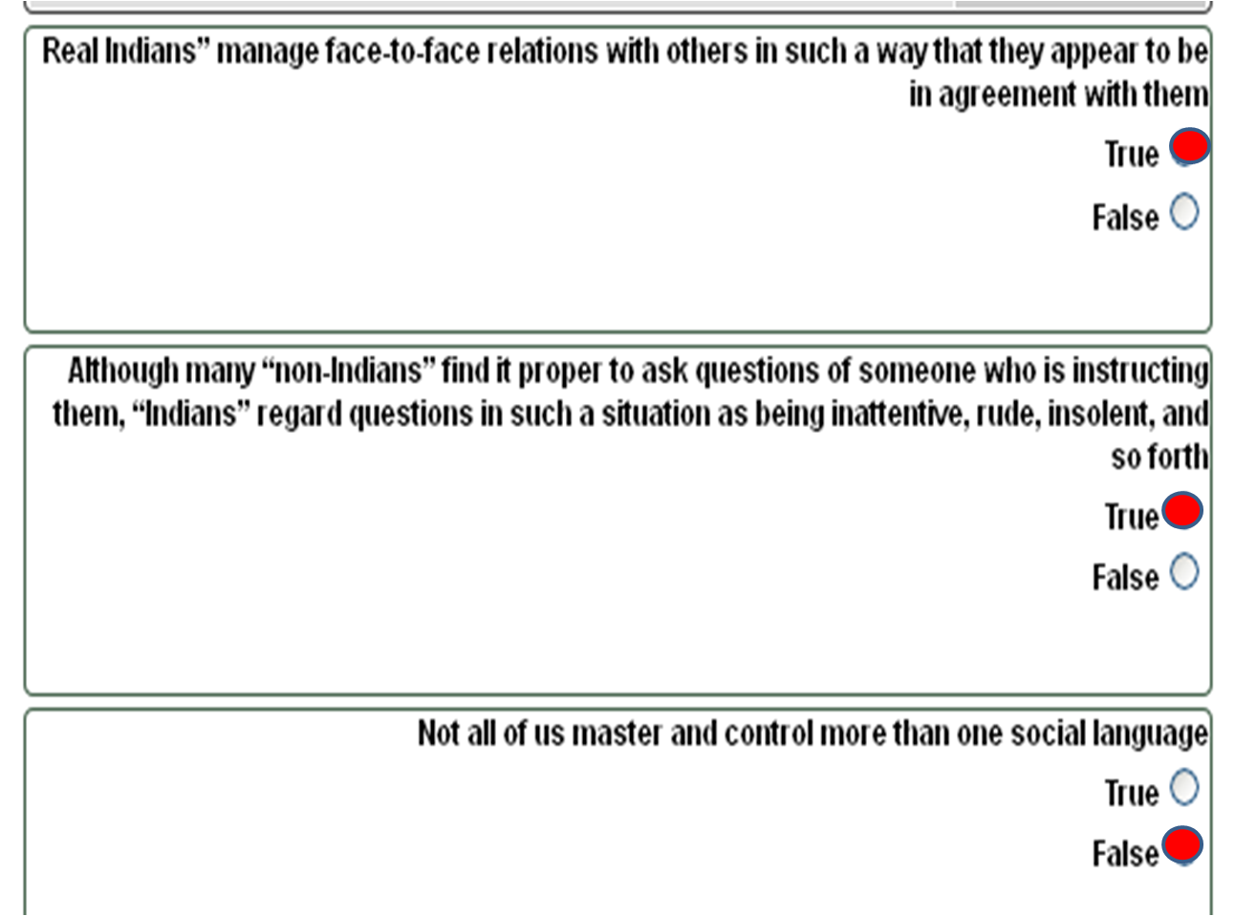

الواجب الثالث

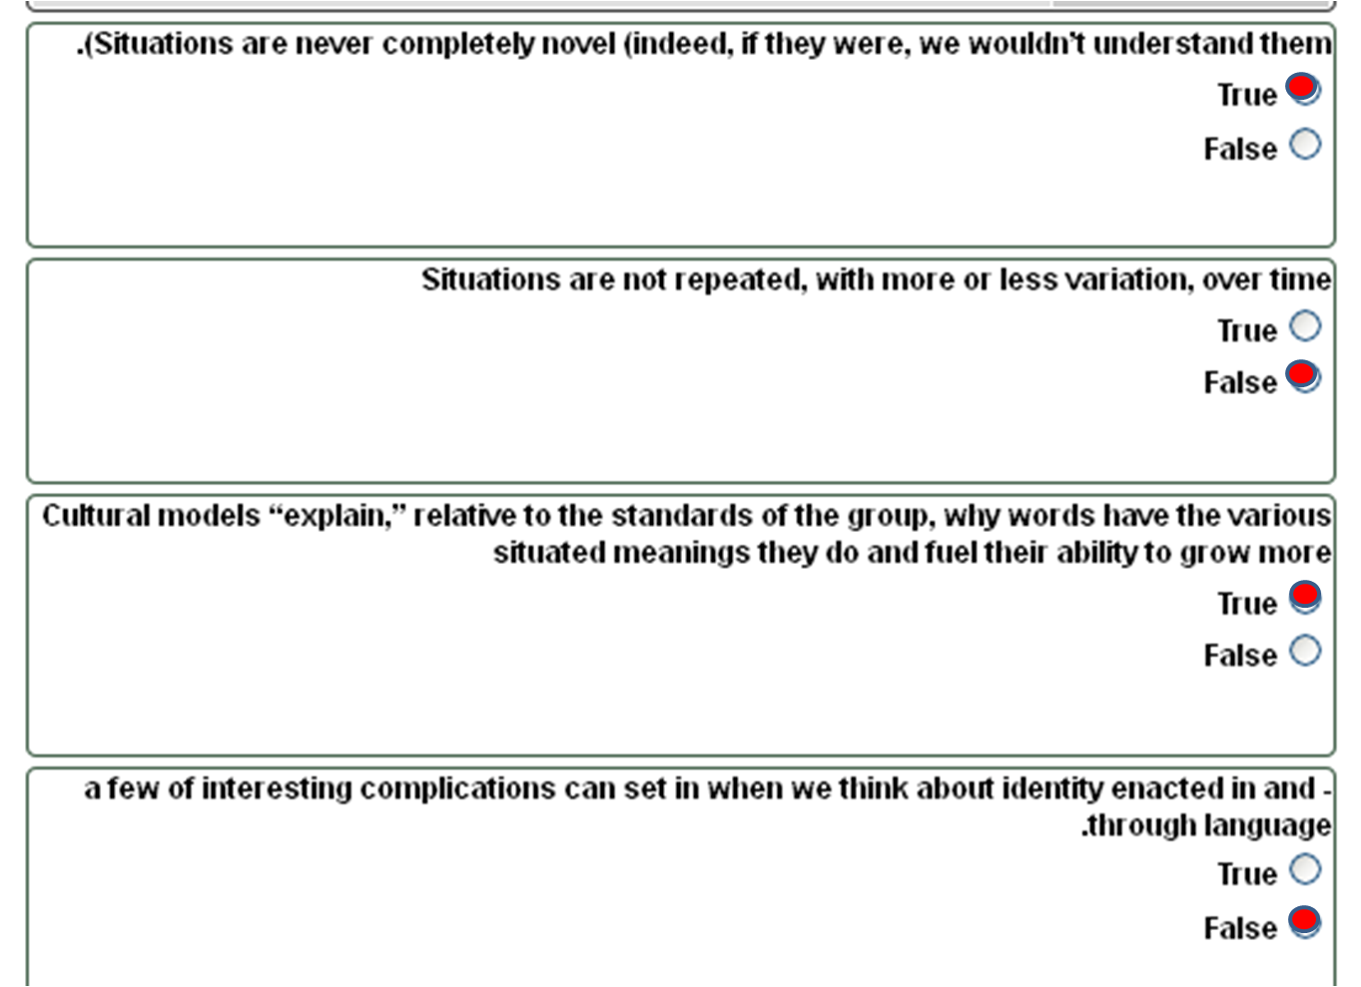

اسئلة اختبارات

اسئلة اختبارات 50 سؤال

حسبي الله لا اله الا هو عليه توكلت وهو رب العرش العظيم

تحليل الخطاب - اللغة الانجليزية - د.محمود سلمان
السؤال رقم: 1
1-Discourse analysis is meant to enable us to solve concrete problem by making us ask ……… and epistemological questions
a) Ontological l
b) Diglossical l
c) Undiglossia l
d) Biological l

السؤال رقم: 2
2- Analysis of discourse looks not only at the basic level of what is said, but takes into consideration the surrounding social and ………. Contexts
a) Geographical l
b) Political l
c) Historical l
d) Technological l

السؤال رقم: 3
3-In DA one term is looked upon a lot more favorably than the other, and this is what a Discourse Analyst would consider, as well as looking at the relationship of these terms with a…..
a) Wider world l
b) Wider society l
c) widely used term l
d) wider culture l

السؤال رقم: 4
- Language has a magical property: when we speak or write we craft what we have to say to ………. the situation or context in which we are communicating.
a) Fit l
b) Contradict l
c) Criticize l
d) Described l

السؤال رقم: 5
5-if institutions, committees, and committee meetings didn’t already exist, speaking and acting this way would be…………….
a) Nonsense l
b) Meaningful l
c) Logical l
d) Clear l

السؤال رقم: 6
6-"I enter a plain, square room" is an example of an area of reality which is reflect by speech the area which is reflected by this example is ………...
a) The meaning and value of aspects of the material world l
b) Activities l
c) Politics l
d) Semiotics l

السؤال رقم: 7
✓ 7- (what and how different symbol systems and different forms of knowledge “count) is an example of an area of reality which is reflect by speech the area which is reflected by this example is …………………..
a) The meaning and value of aspects of the material world l
b) Activities l
c) Politics l
d) Semiotics l

السؤال رقم: 8
8- “tools of inquiry” in DA means
a) ways of looking at the world of talk and interaction l
b) ways of writing l
c) ways of reading l
d) ways of constructing good sentences l

السؤال رقم: 9
✓ 9- When you speak or write anything, you use the resources of English to project yourself as a certain kind of……
a) object l
b) topic l
c) leader l
d) person l

السؤال رقم: 10
10- If I have no idea who you are and what you are doing…….
a) I cannot know where are you from l
b) I cannot make sense of what you have said, written, or done l
c) I find it easy to know what you have said, written, or done
d) I might find it difficult to understand what you have said, written, or done l

السؤال رقم: 11
11- Since different identities and activities are enacted in and through language, the study of language is integrally connected to matters of
a) inequity and injustice l
b) equity and injustice l
c) inequity and justice l
d) equity and justice l

السؤال رقم: 12
12-Who's …….. Multiple……. be people.
a) Cannot be /they need to l
b) can be/ they need not always l

السؤال رقم: 13
13-…………… , through the “anonymous” texts and products they circulate, can author or issue “utterances.” For example, we will see below that the warning on an aspirin bottle actually communicates multiple who's.
a) teachers l
b) Not just individuals, but also institutions l
c) Only institutions l
d) Only individuals l

السؤال رقم: 14
✓ 14- linguistic have focused on language, it is also important to see that making visible and recognizable who we are and what we are doing …….. requires more than language.
a) Sometimes l
b) Always l
c) Rarely l
d) Never l

السؤال رقم: 15
✓ 15- There are a multitude of ways one can do being-and-becoming-a-“real-Indian.” Some of these are “Real Indians” prefer to……
a) avoid conversation with strangers l
b) avoid mixing with strangers l
c) take to strangers l
d) take pictures with strangers l

السؤال رقم: 16
16- "Real Indians" manage face-to-face relations with others in such a way that they appear to be in ……
a) agreement with them l
b) disagreement with them l
c) quarrel with them l
d) conversation with them l

السؤال رقم: 17
17-…………..for who is a "real" feminist ,gang member ,patriot ,humanist ,culture scientist ,yuppie" or " regular" at the local bar .
a) there are something no once and for all the local tests l
b) there are rarely no once for all tests l
c) there are no once for all tests l

السؤال رقم: 18
✓ 18- The other – less studied of grammar that is considered distinctive grammar for social languages is ……
a) the “rules” by which grammatical units like nouns and verbs, phrases and clauses, l which signal characteristic whos-doing-whats-within- Discourses
b) the “rules” by which grammatical units like nouns and verbs, phrases and clauses, which do not signal characteristic whos-doing-whats-within- Discourses
c) the “rules” by which grammatical units like nouns and verbs, phrases and clauses, which signal characteristic only of whos-within- Discourses
d) the “rules” by which grammatical units like nouns and verbs, phrases and clauses, which signal characteristic whats -within- Discourses

السؤال رقم: 19
✓ 19- Some studies argue the physics experimental physicists “know” is, in large part, not in their ……..
a) names l
b) nationality l
c) books, apparatus, and books l
d) heads l

السؤال رقم: 20
20-“The coffee spilled, get a mop”; in this sentence ,triggered by the word " mop" in the context ,………
a) you create a situated meaning something like food we eat b) you create a situated l
meaning something like water c) you create a situated meaning something like "grains that we make our coffee from
b) you create a situated meaning something like water l
c) you create a situated meaning something like "grains that we make our coffee from
d) you create a situated meaning something like dark liquid we drink for coffee . l

السؤال رقم: 21
✓ 21-“cultural models are ……….. (like a mental movie). or information theories shared by people belonging to specific social or cultural groups.
a) Stereotypeline families with disconnected l
b) Storylines families of connected images l
c) Stereotype families with connected images l
d) Storylines families with disconnected realities l

السؤال رقم: 22
✓ 22-Any piece of language , oral or written, is composed of a set of ……… cuse or cluse that help listeners or readers to build six things.
a) Psychological l
b) Grammatical l
c) Social l
d) Historical l

السؤال رقم: 23
✓ 23-connection building , that is , using cues and clues to make assumptions about how the past and future of an interaction
a- Different l
b- Similar l
c- Equal l
d- Linked l

السؤال رقم: 24
✓ 24-the use of the following sort of pattern of grammatical features (such as " when I thought about it" , or the use of mitigators such as " I do not know") or complex subordinate clauses) by a young woman who is speaking to her parents , is indicative of a particular …….
a- Historical language l
b- Social language l
c- Academic language l
d- Regional language l

السؤال رقم: 25
✓ 25-conversation as it is used in discourse analysis can involve ……
a- Values l
b- Groups l
c- Controversy and Values l
d- Controversy l

السؤال رقم: 26
26- Discourse analysis will enable to reveal the hidden …………behind a text
a- Result l
b- Author l
c- Motivations l
d- Critic l

السؤال رقم: 27
27- Though critical thinking about the analysis of texts is as ancient as mankind, discourse analysis is perceived as the product of …………period
a- Modern l
b- Premodern l
c- Old l
d- Postmodern l

السؤال رقم: 28
28- the use of a term like ''colonization'' or a ''occupation'' is something that is………………….. important in DA.
a. Sometimes l
b. Always l
c. Rarely l
d. Seldom l

السؤال رقم: 29
29-Discourse Analysis (DA) is a modern discipline of the social sciences that covers a wide variety of different…………………… approaches.
a. Linguistic l
b. Psycholinguistic l
c. Syntactic l
d. Sociolinguistic l

السؤال رقم: 30
30- How we speak or write……………….. that very situation or context in which we are communicating.
a. Does not create l
b. Creates l
c. Avoids to describe l
d. Does not avoid to describe l

20 سؤال يتبع للـ 30ــ سؤال السابقة
ليكون المجوع 50 سؤال

السؤال رقم: 1
-All of us control many different social languages ………..in different context .
a) And switch between only two of them l
b) And switch among them l
c) But do not switch among them l
d) But they could not switch among them l

السؤال رقم: 2
…………..at play allow people to enact and recognize different discourse at world
a) psychological language and situated meanings l
b) situated meanings and cultural models l
c) Social meaning and cultural models l
d) Social language , situated meanings and cultural models l

السؤال رقم: 3
situations , when they involve communicative social interactions, always involve ………
a) emiotic aspect l
b) emetic aspect l
c) emotional aspect l
d) semiotic aspect l

السؤال رقم: 4
world building , that is, using cues or clues to assemble situated meaning about
a) what activity is going on l
b) what is here and now reality l
c) what is the heading l
d) the past and the future l

السؤال رقم: 5
The coffee spilled, get a broom”; in this sentence ,triggered by the word " broom" in the context ,………
a) you create a situated meaning something like food we eat l
b) you create a situated meaning something like water l
c) you create a situated meaning something like "grains that we make our coffee l
from
d) you create a situated meaning something like dark liquid we drink for coffee . l

السؤال رقم: 6
situated meaning is …………….“on the spot” as we communicate in a given context, based on our construal of that context and on our past experiences
a- a concept that we ignore l
b- a concept that we remember l
c- an image that we assemble l
d- an image that we forget l

السؤال رقم: 7
in the example of the upper-middle-class ,Anglo-American young woman named " Jane",took in our course , Jane
a- is making visible and recognizable two different versions of who, one is a daughter having dinner with her proud parents "and in the other case she is "a
girlfriend being intimate with her boyfriend."
b- is making visible and recognizable three different versions of who she is and what she is doing , In one case she is "a dutiful and intelligent daughter having
dinner with her proud parents "and in the other case she is "a girlfriend being intimate with her boyfriend." And in the third case she is a student
c- behaves similarly with her parents and with boyfriend
d- uses the same social language l

السؤال رقم: 8
Each social language has its own distinctive grammar. One of these is
the……………….
a. Modern set like accent l
b. ….ture set like unused words l
c. ……t set of units like verses of poetry l
d. the traditional set of units like nouns l

السؤال رقم: 9
when we think about how meaning is situated in actual contexts of use, we quickly face an important property of language, a property which is called…………..
a. reflexity l
b. reflex l
c. logicality l
d. reflexivity l

السؤال رقم: 10
….. which ''Indians'' call ''razzing'' each participant further establishes cultural competency in the eyes of the other
a. Only correctly responding to the sparring l
b. correctly engaging to the sparring l
c. correctly responding to the sparring and correctly engaging to the sparring l
d. avoiding engaging to the sparring l

السؤال رقم: 11
Whenever we speak or write we always and simultaneously construct or build …..… areas of ''reality''
a. Five l
b. Two l
c. Four l
d. Six l

السؤال رقم: 12
''I talk and act in such a way that a visibly angry male in a committee meeting (perhaps its me!) Is ''standing his ground on principle,'' but a visibly angry female is ''hysterical'' is an example of an area of reality which is reflect by speech. The area which is reflected by this example is…………………
a. The meaning and value of aspects of the material world l
b. Activities l
c. Politics l
d. Semiotics l

السؤال رقم: 13
Being a ''real Indian'' is not something one can simply be Rather. It is something that one becomes in and through, that is…………………
a. carrying out the actual performance of being a real Indian l
b. kinship only. l
c. Something that one can simply be without doing it l
d. carrying out the actual performance of being a real Indian and kinship l

السؤال رقم: 14
''Situated identities, ''means………………….
a. Different identities or social positions we enact and recognize in different settings l
b. Different styles of language that we use to enact and recognize different identities in different setting
c. Different ways in which we humans integrate language with non-language ''stuff''
d. Long- running and important themes or motifs that have been the focus of variety of different texts

السؤال رقم: 15
discourses ''with a capital ''D'' means
a. Different identities or social positions we enact and recognize in different settings l
b. Different styles of language that we use to enact and recognize different identities in different setting
c. Different ways in which we humans integrate language with non-language ''stuff'' l
d. Long- running and important themes or motifs that have been the focus of variety of different texts

السؤال رقم: 16
When you write or speak you try to project yourself as engaged in a certain kind of ………………………….
a. Society l
b. Activity l
c. World l
d. Class l

السؤال رقم: 17
it is better, in fact, to say that utterances communicate an (a)…………………., though often multiple or'' …………………..'' who- doing- what.
a. Integrated/ hetroglossic l
b. Integrated/ homoglossic l
c. disintegrated/ hetroglossic l
d. disintegrated/ homoglossic l

السؤال رقم: 18
You project a different identity at a formal dinner party than you do at the family dinner table. And, though these are both dinner
a. They are same kind of activities l
b. They are not activities l
c. They are different activities l
d. They are insignificant activities l

السؤال رقم: 19
- An oral or written ''utterance'' has meaning then, only if and when it communicates ……………………….
a. A who l
b. A what l
c. A who and a what l
d. A why l

السؤال رقم: 20
- An utterance ………A sort of overlapping …….. who
a. Can communicate/ but not compound l
b. Can communicate/ but compound l
c. Cannot communicate/ but not compound l
d. Cannot communicate/ but compound

اسئلة اختبار
42 سؤال
الاخ / غسان
اتمنى التوفیق لجمیع الطلبة والطالبات
الدكتور محمود محمد احمد السلمان
Sunday 11-2.30

ان اصبت فمن الله وان اخطأت فمن نفسي والشيطان
طبعا الاجوبة باللون الاحمر والأسئلة باللون المخالف وعدد اسئلة
الاختبار ٥٠ سؤال ولكن هنا ما اسعفتني به الذاكرة واعتذر عن
التقصير والخطأ
اتمنى ان تكون ذو فائدة للجميع

1. Discourse analysis will enable to reveal the hidden motivations behind a text or behind the choice of a particular method ofresearch to interpret that text.

2. Discourse analysis is meant to provide a higher awareness of the hidden motivations in others and in ourselves, and therefore, enable us to solve concrete problem by making us ask ontological and epistemological questions.

3. Though critical thinking about the analysis of texts is as ancient as mankind, discourse analysis is perceived as the product of postmodern period

4. Discourse Analysis (DA) is a modern discipline of the social sciences that covers a wide variety of different sociolinguistic approaches.

5. Analysis of discourse looks not only at the basic level of what is said, but takes into consideration the surrounding social and historical contexts

6. A Discourse Analyst would consider, as well as looking at the relationship of these terms with a widely used term.’

7. Language has a magical property: when we speak or write we craft what we have to say to fit the situation or context in which we are communicating .

8. How we speak or write creates that very situation or context .It seems, then ، that we fit our language to a situation or context that our language, in turn ،helped to create in the first place

9. After all, if we did not speak and act in certain ways ، committees could not exist; but then, if institutions, committees, and committee meetings didn’t already exist, speaking and acting this way would be nonsense .

10. Whenever we speak or write, we always and
simultaneously construct or build six things or six areas of “reality:”

11. The meaning and value of aspects of the material world :I enter a plain، square room, and speak and act in a certain way (e. g .like someone about to run a meeting), and, low and behold, where I sit becomes the “front” of the room .

12. Politics I talk and act in such a way that a visibly angry male in a committee meeting (perhaps it’s me!) is “standing his ground on principle,” but a visibly angry female is “hysterical ”.

13. Semiotics
(what and how different symbol systems and different forms of knowledge “count )”

14. there are several “tools of inquiry) ”ways of looking at the world of talk and interaction)

15. “ .Discourses ”with a capital “D,” that is, different ways in which we humans integrate language with non-language “stuff,”
16. You also project yourself as engaged in a certain kind of activity, a different kind in different circumstances. If I have no idea who you are and what you are doing, then I cannot make sense of what you have said, written, or done.

17. You project a different identity at a formal dinner party than you do at the family dinner table. And, though these are both dinner, they are none the less different activities.

18. the study of language is integrally connected to matters of equity and justice.

19. An oral or written “utterance” has meaning, then, only if and when it communicates a who and a what

20. Who's can be multiple and they need not always be people 21. The utterance communicates a sort of overlapping and compound who.

22. Not just individuals, but also institutions, through the “anonymous” texts and products they circulate, can author or issue “utterances.”

23. You are who you are partly through what you are doing and what you are doing is partly recognized for what it is by who is doing it. So it is better, in fact, to say that utterances communicate an integrated.

24. So it is better, in fact, to say that utterances though often multiple or “ heteroglossic,”

25. Though I have focused on language, it is important to see that making visible and recognizable who we are and what we are doing always requires more than language.

26. “Real Indians” prefer to avoid conversation with strangers

27. “real Indians” frequently engage in a distinctive form of verbal sparring. By correctly responding to and correctly engaging in this sparring,

28. Some studies argue the physics experimental physicists “know” is, in large part, not in their heads.

29. All languages, like English or French, are composed of many (a great many) different social languages.

30. Each social language has its own distinctive grammar.

31. One grammar is the traditional set of units like nouns, verbs, inflections, phrases and clauses.

32. This young woman is making visible and recognizable two different versions of who she is and what she is doing.

33. In one case she is “a dutiful and intelligent daughter having dinner with her proud parents”

34. And in the other case she is “a girl friend being intimate with her boyfriend.”

35. Conversations” with a “big C,” since they are better viewed as (historic) conversations between and among Discourses.

36. More than people, and more than language, are involved in Conversations.

37. A situated meaning is an image or pattern that we assemble “on the spot”

38. In the first case, triggered by the word “mop” in the context, you assemble a situated meaning something like “dark liquid we drink” for “coffee”;

39. in the second case, triggered by the word “broom” and
your experience of such matters, you assemble either a situated meaning something like “grains that we make our coffee from”

40. Cultural models are “storylines,” families of connected images.

41. When we think about how meaning is situated in actual contexts of use, we quickly face an important property of language, a property I will call “reflexivity”

42. Though discourse analysis usually focuses on the language (semiotic) aspect.

كل مايخص المستوى 8 ملخصات - واجبات - اسئلة مراجعة في هذا الرابط :
http://www.e1500.com/vb/t65048.html

