Lecture # 11
Types of Sentences: More about the Compound Sentence
Lecture Components
The compound sentence: Revision
Run-ons
Comma Splices
Conjunctive Adverbs
The Compound Sentence
A compound sentence is two simple sentences connected by a comma and a coordinating conjunction.

Simple sentence , simple sentence.
and
but
or
so

Coordinating conjunctions
comma
The Compound Sentence: Coordinating Conjunctions
And connects two sentences with similar ideas. The sentences can be positive or negative:
My friend is a teacher, and his sister is a doctor.
He doesn’t like music, and she doesn’t like art.
But connects two sentences with opposite ideas:
She likes art, but she doesn’t like music.
The Compound Sentence: Coordinating Conjunctions
Or connects two sentences that express alternatives or choices:
Every Friday, they go to a mall, or they visit some friends.
So connects a reason and a result:
My friend and his sister work a lot, so they don’t go out very often.
Run-ons
أخطاء العطف: جملتان متصلتان دون علامة ترقيم أو حرف عطف
A run-on is two simple sentences incorrectly joined with no coordinating conjunction and no comma.
Subject + verb + subject + verb
Example:
Francisco worked out Maria cleaned her room. X
The first test was difficult the second one was easy. X
Correcting run-ons
كيفية تصحيح الخطأ السابق
There are two ways to fix run-ons:
- With a period (.).
Francisco worked out. Maria cleaned her room.
The first test was difficult. The second one was easy.
2. With a comma and a coordinating conjunction.
Francisco worked out, and Maria cleaned her room.
The first test was difficult, but the second one was easy.
Practice
Which of the following is a run-on?
- Some people like cats others prefer dogs.
- Some people like cats, others prefer dogs.
- Some people like cats, and others prefer dogs.
- Some people like cats. Others prefer dogs.
Comma Splice
أخطاء العطف: استخدام فاصلة بين جملتين كاملتين
The comma splice is two simple sentences incorrectly joined with a comma alone.
Subject + verb + , + subject + verb
Examples:
Some people like cats, others prefer dogs. X
Francisco worked out, Maria cleaned her room. X
The first test was difficult, the second one was easy. X
Correcting Comma Splices
كيفية تصحيح الخطأ السابق
There are two ways to fix comma splices:
- With a period (.).
Some people like cats. Others prefer dogs.
Francisco worked out. Maria cleaned her room.
The first test was difficult. The second one was easy.
2. With a comma and a coordinating conjunction.
Some people like cats, and others prefer dogs.
Francisco worked out, and Maria cleaned her room.
The first test was difficult, but the second one was easy.
Practice
Which of the following is a comma splice?
- Some people like cats others prefer dogs.
- Some people like cats, others prefer dogs.
- Some people like cats, and others prefer dogs.
- Some people like cats. Others prefer dogs.
Which of the following is a comma splice?
- I don’t watch TV, but my children do.
- I don’t like garlic. I don’t like onions.
- I don’t like garlic, I don’t like onions.
- I don’t watch TV. My children do.
Identify the following sentence as either a comma splice, a run-on, or correct.
- We are going to have spaghetti for dinner, and we are going to have ice cream for dessert.
- Comma splice
- Run-on
- Correct
Identify the following sentence as either a comma splice, a run-on, or correct.
- Would you like to play tennis, would you like to go to the golf course?
- Comma splice
- Run-on
- Correct
Compound sentences with Conjunctive Adverbs
العطف باستخدام ظروف العطف
Study the following table:
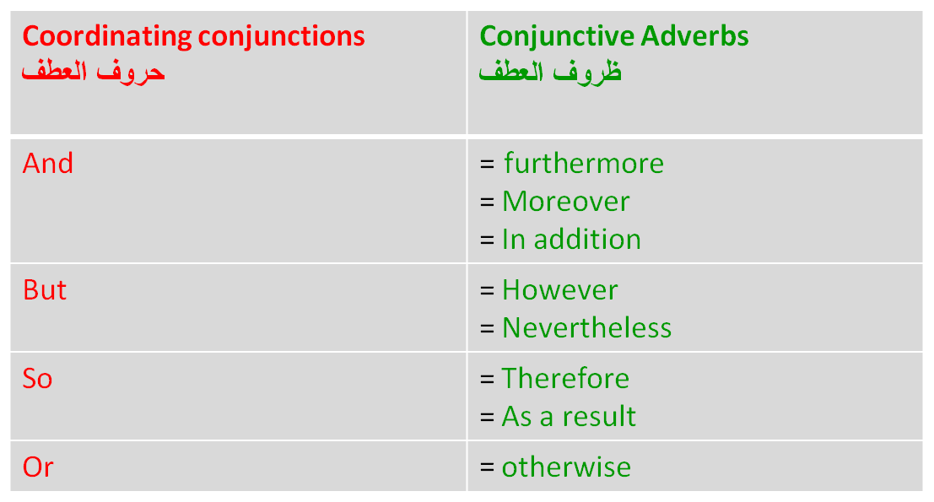

Compound sentences with Coordinating Conjunctions & Conjunctive Adverbs
It is raining, so she is wearing a raincoat.
It is raining; as a result, she is wearing a raincoat.
I’m hungry, but I don’t have time to eat.
I’m hungry; however, I don’t have time to eat.
We are going to have spaghetti for dinner, and we are going to have ice cream for dessert.
We are going to have spaghetti for dinner; in addition, we are going to have ice cream for dessert.
You need to work harder, or you will get fired.
You need to work harder; otherwise, you will get fired.
Practice
Which of the following sentences is punctuated correctly?
- Ali is tired, so, he would like to go to bed.
- Ali is tired so, he would like to go to bed.
- Ali is tired so he would like to go to bed.
- Ali is tired, so he would like to go to bed.
Which of the following sentences is punctuated correctly?
- My computer frustrates me however I couldn’t live without it.
- My computer frustrates me; however I couldn’t live without it.
- My computer frustrates me; however, I couldn’t live without it.
- My computer frustrates me however, I couldn’t live without it.

