Lecture # 10
Types of Sentences
المحاضرات 10، 11، 12، 13 هي مواد مساندة من خارج الكتاب لكنها مطلوبة في الاختبار ومهمة.
المحاضرة رقم 14 ستكون عبارة عن نماذج أسئلة للتدريب على الاختبار النهائي.
Lecture Components
The simple sentence
The compound sentence
Sentences with expressions of time
Types of sentences
There are three main types of sentence.
- A simple sentence.الجملة البسيطة
- A compound sentence.الجملة المركبة
- A complex sentence.الجملة المعقدة
- The Simple Sentence
- The simple sentence can be very short, consisting of a simple subject and a simple predicate.
- Examples from lecture 9:
- SUBJECTالمبتدأ
- PREDICATEالخبر
- My roommate lost his keys.
- My family lives in an apartment.
- I don’t like warm milk or cold coffee.
- We don’t have class on Tuesday.
- The simple sentence can have a compound subject and a compound predicate.
- Examples from lecture 9:
- My mother and my father speak and write English well.
- My brother, sister, and mother speak and write English well.
- Ahmad and his sister live and work in Jeddah.
- Ahmad and Ali watched TV and had dinner at home.
- The simple sentence can be declarative (تقريري)or interrogative (استفهامي):
- You can shop at the mall on weekends.
- Can you shop at the mall on weekends?
- Francisco cleaned his room for 2 hours.
- Did Francisco clean his room for 2 hours?

- A simple sentence can be an exclamation (صيغة التعجب)or an imperative (صيغة الأمر) :
- Help me.
- Please hold the box.
- This is a wonderful gift!
- How clever you are!
- A simple sentence can have a verb in any tense (past, present, or future):
- My friend shops at the mall on the weekend.
- My friend shopped at the mall last weekend.
- My friend will shop at the mall next weekend.
The Compound Sentence
الجملة المركّبة
A compound sentence is two simple sentences connected by a comma and a coordinating conjunction.

Simple sentence , simple sentence.
and
but
or
so

Coordinating conjunctions
حروف العطف
comma
The Compound Sentence: Coordinating Conjunctions
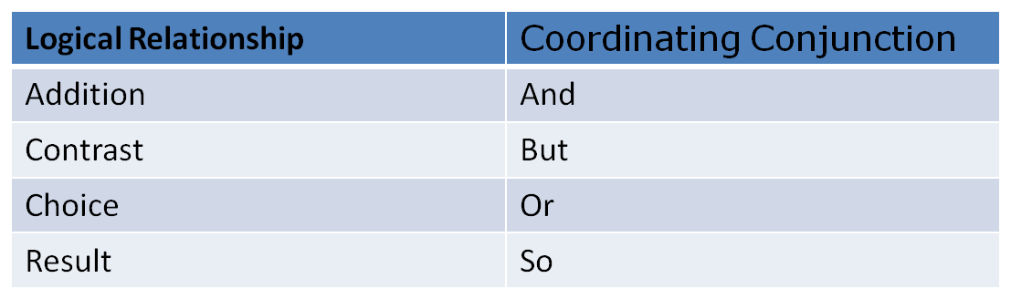

Ahmad is a scientist, and he travels often.
He works in Damman, but he lives in Al-Ahsa.
He didn’t study for the test, so he failed the exam.
Next year we will go to the beach, or we will stay at home.

The Compound Sentence: Coordinating Conjunctions
And connects two sentences with similar ideas. The sentences can be positive or negative:
My friend is a teacher, and his sister is a doctor.
He doesn’t like music, and she doesn’t like art.
But connects two sentences with opposite ideas:
She likes art, but she doesn’t like music.
Or connects two sentences that express alternatives or choices:
Every Friday, they go to a mall, or they visit some friends.
So connects a reason and a result:
My friend and his sister work a lot, so they don’t go out very often.

Insert the correct coordinating conjunction. Use and, or, but, or so.
1. We are going to have spaghetti for dinner, _______ we are going to have ice cream for dessert.
2. It is my birthday, _______ I have to go to work. I wish that I could stay home and relax.
3. Would you like to play tennis, ______ would you like to go to the golf course?
4. It is raining, ______ she is wearing a raincoat.

and
but
or
so
5. It is cold outside, ______ we can’t go swimming.
6. I’m hungry, _______ I don’t have time to eat.
7. I enjoy opera, _______ I like the ballet.
8. She’s a trustworthy friend, _______ I tell her my secrets.
9. I want to go to school, _______ I don’t have enough money.
10. We can go to the movies, _______ we can rent a video.
or
but
and
but
so
so
Practice
Which of the following sentences is punctuated correctly?
- They are running and jumping happily and their mother is watching them quietly.
- They are running and jumping happily, and, their mother is watching them quietly.
- They are running and jumping happily, and their mother is watching them quietly.
- They are running and jumping happily and, their mother is watching them quietly.
Which of the following sentences contains a compound subject?
- Francisco and Maria watch a movie every Saturday.
- Francisco watches a movie every Saturday.
- Maria watches a movie every Saturday.
- Francisco watches a movie and plays tennis every Saturday.
Sentences with expressions of time
Use the words and form meaningful statements. Always use the expression of time at the end of the sentence.
Example: goes / to school / every morning / Andy
Answer: Andy goes to school every morning.
) take / photos / they / every Monday
They take photos every Monday.
2) goes / every day / she / to school
She goes to school every day.
3) football / Eric / after school / plays
Eric plays football after school.
4) is making / he / at the moment / breakfast
He is making breakfast at the moment.
5) to the club / the girls / go / on Saturdays
The girls go to the club on Saturdays.
6) o'clock / school / at / 8 / starts
School starts at 8 o'clock.
7) Tuesday / the boys / their bikes / ride / every
The boys ride their bikes every Tuesday.
8) I / home / going / am / now
I am going home now.
9) Simon / on Fridays / the dishes / washes
Simon washes the dishes on Fridays.
10) are / questions / we / answering / the / now
We are answering the questions now.

