Lecture # 4 Describe a Favorite
Place
Lecture Components
Vocabulary:
Descriptive adjectives, location phrases, activities
Grammar:
Present Continuous, object pronouns
Reading (page66)
A Day in Oak Street Park
Francisco Garcia
There are many interesting places in my neighborhood. One place is Oak Street Park. I am at Oak Street Park right now. It’s my favorite place. It’s 1:00 on Saturday afternoon. I am sitting on a bench and writing in my journal. Today is a beautiful day. It’s really sunny and hot. The sky is clear and bright. The air smells fresh and sweet. (cont.)
The park is very crowded. Some people are young, and some people are old. Some people are tall, and some are short. Some people have long, straight hair. Some people have short, curly hair. One old man has no hair! He is sitting in front of the park gate. A tall woman is standing beside him. She has blonde hair and blue eyes. They are talking and laughing loudly. (cont.)
There are a lot of things happening around me. Many people are exercising. They’re walking quickly or riding their bikes. There is a food stand to the right of the entrance. A few people are eating lunch next to it. There is a handsome man to the left of the entrance. He is painting a picture very carefully. Across from me, a young girl is playing under a tree. Her brother is playing with her, too. They’re running and jumping happily. Their mother is sitting behind them. She is watching them quietly. Everyone is having fun.
Vocabulary – page 68 (Adjectives)
We use adjectives to describe people, places, things, etc.
1) Adjectives go before nouns:
The tall woman is in the park.

2) Adjectives go after the verb be (is, am, was, were ..)
The woman is tall.

adjective
noun
adjective
is
Adjectives
There are many interesting places in my neighborhood. One place is Oak Street Park. I am at Oak Street Park right now. It’s my favorite place. It’s 1:00 on Saturday afternoon. I am sitting on a bench and writing in my journal. Today is a beautiful day. It’s really sunny and hot. The sky is clear and bright. The air smells fresh and sweet.

The park is very crowded. Some people are young, and some people are old. Some people are tall, and some are short. Some people have long, straight hair. Some people have short, curly hair. One old man has no hair! He is sitting in front of the park gate. A tall woman is standing beside him. She has blonde hair and blue eyes. They are talking and laughing loudly.
Examples:
- There are many interesting places in my neighborhood.
- Today is a beautiful day.
- The sky is clear and bright.
- The park is very crowded.
- Some people are young, and some people are old.
- Some people have short, curly hair.

Vocabulary – page 68 (Adjectives)
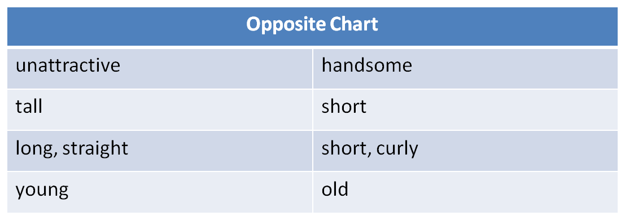

There is a handsome man to the left of the entrance.
Some people are tall, and some are short.
Some people have long, straight hair, and some have short, curly hair.
Some people are young, and some people are old.

Location phrases
Location phrases tell where something is located.
Examples:
I am in my favorite place.
I am at Oak Street park.
Ahmad is sitting next to Ali.
The bathroom is across from my room.
We are sitting under a tree.

Location phrases: Ex. B – page 68

Location phrases
There are many interesting places in my neighborhood. One place is Oak Street Park. I am at Oak Street Park right now. It’s my favorite place. It’s 1:00 on Saturday afternoon. I am sitting on a bench and writing in my journal. Today is a beautiful day. It’s really sunny and hot. The sky is clear and bright. The air smells fresh and sweet.
The park is very crowded. Some people are young, and some people are old. Some people are tall, and some are short. Some people have long, straight hair. Some people have short, curly hair. One old man has no hair! He is sitting in front of the park gate. A tall woman is standing beside him. She has blonde hair and blue eyes. They are talking and laughing loudly.
There are a lot of things happening around me. Many people are exercising. They’re walking quickly or riding their bikes. There is a food stand to the right of the entrance. A few people are eating lunch next to it. There is a handsome man to the left of the entrance. He is painting a picture very carefully. Across from me, a young girl is playing under a tree. Her brother is playing with her, too. They’re running and jumping happily. Their mother is sitting behind them. She is watching them quietly. Everyone is having fun.

Francisco is ____ a bench.
An old man is _________ the park gate.
A tall woman is _________him.
There is a food stand _____________the entrance.
A few people are __________the food stand.
A young girl is ___________Francisco.
The girl is __________ a tree.
The children’s mother is ________them.
on
in front of
beside
to the right of
next to
across from
under
behind
Simple Present: Adverbs of Frequency
Adverbs of frequency answer the question how often
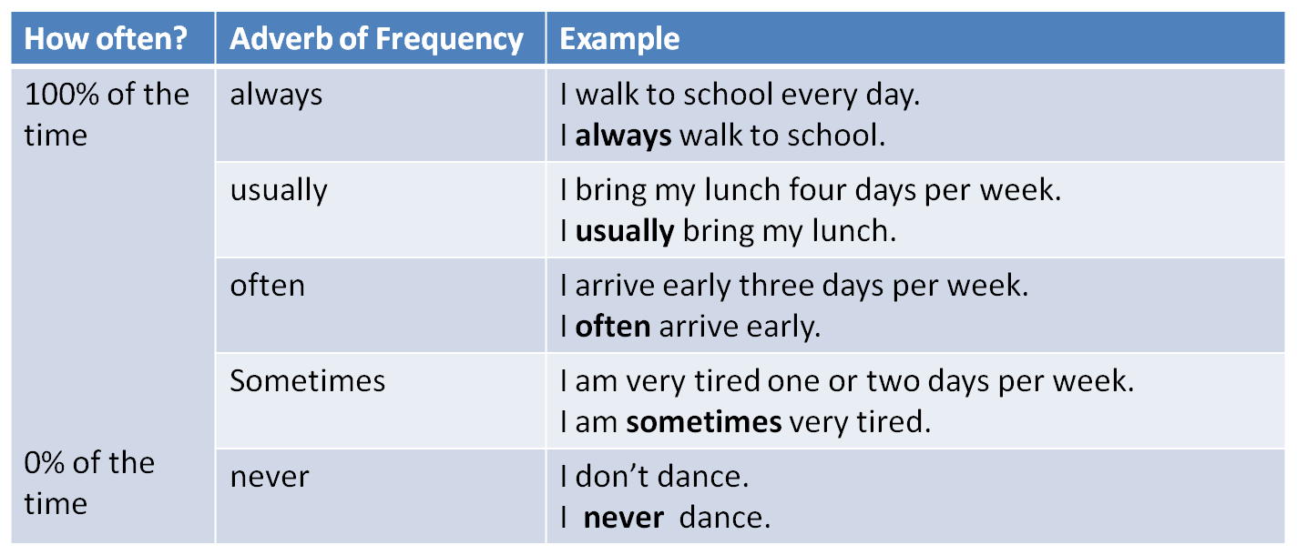
Simple Present: Ex. C – pages 68-9
Francisco usually _________ at the gym in the morning.
Mr. Garcia often __________ TV in the evening.
Sometimes he _____________ if a program is funny.
In her free time, Mrs. Garcia ____________beautiful pictures.
She often ___________ with her friends on the telephone, too.
Maria often _________ in the park for exercise. She’s really fast.
She also sometimes ____________ rope.
Francisco and Maria never ___________ their bikes to school. Their school is very close.
exercises
watches
laughs
paints
talks
runs
jumps
ride
Present Continuous Tense
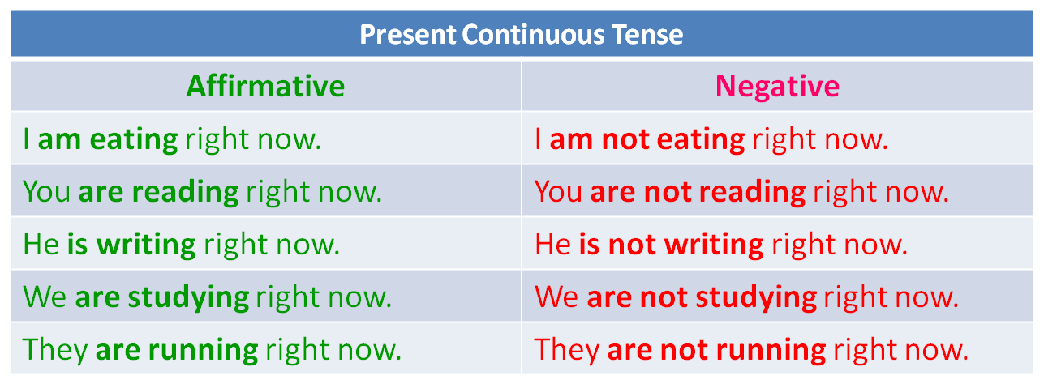
The present continuous tense tells what is happening right now.

Present Simple vs. Present Continuous
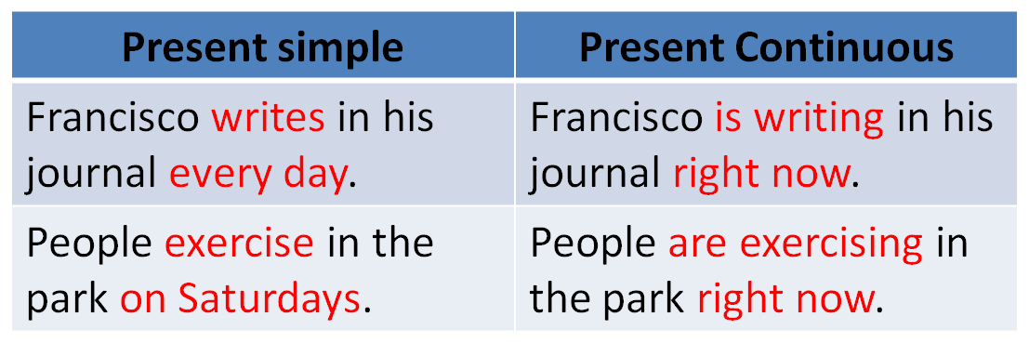
Present Continuous Tense
Exercise A – page 69
1. Maria and her friends play soccer every Saturday afternoon.
Maria and her friends _____________soccer ___________.
2. Mrs. Garcia eats lunch with her friends every Saturday afternoon.
Mrs. Garcia __________ lunch with her friends _________.
3. Francisco’s classmates exercise every Saturday afternoon.
Francisco’s classmates _____________ ______________.
4. Mr. and Mrs. Garcia watch a movie every Saturday afternoon.
Mr. and Mrs. Garcia ____________ a movie ___________.

are playing
right now
is eating
right now
right now
are exercising
right now
are watching
Object Pronouns
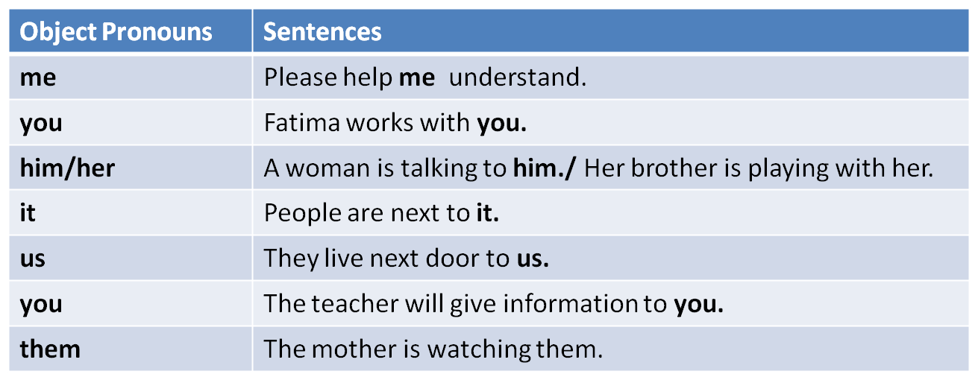
Object pronouns take the place of object nouns. They show to whom something happened or who got something. They come after a verb or a preposition.

Object Pronouns: Page 70
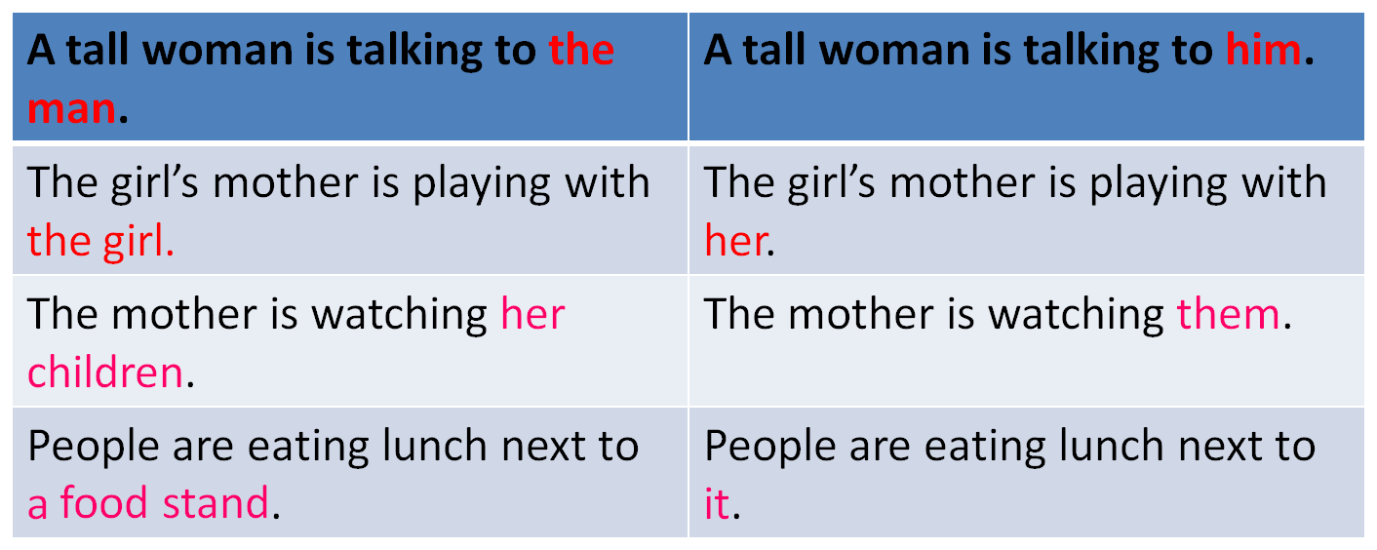
Object Pronouns: Ex. B – page 70
1. Francisco is writing in his journal.
Francisco is writing in ____.
2. There is a food stand to the right of the entrance.
There is a food stand to the right of ____.
3. The boy’s sister is playing with the boy.
The boy’s sister is playing with _____.

it
him
it
Object Pronouns: Ex. B – page 70
4. An old man is talking to a tall woman.
An old man is talking to ____.
5. Francisco is watching the brother and sister.
Francisco is watching _____.
6. The children are playing across from Francisco.
The children are playing across from _____.

her
them
him
Subject vs. Object Pronouns
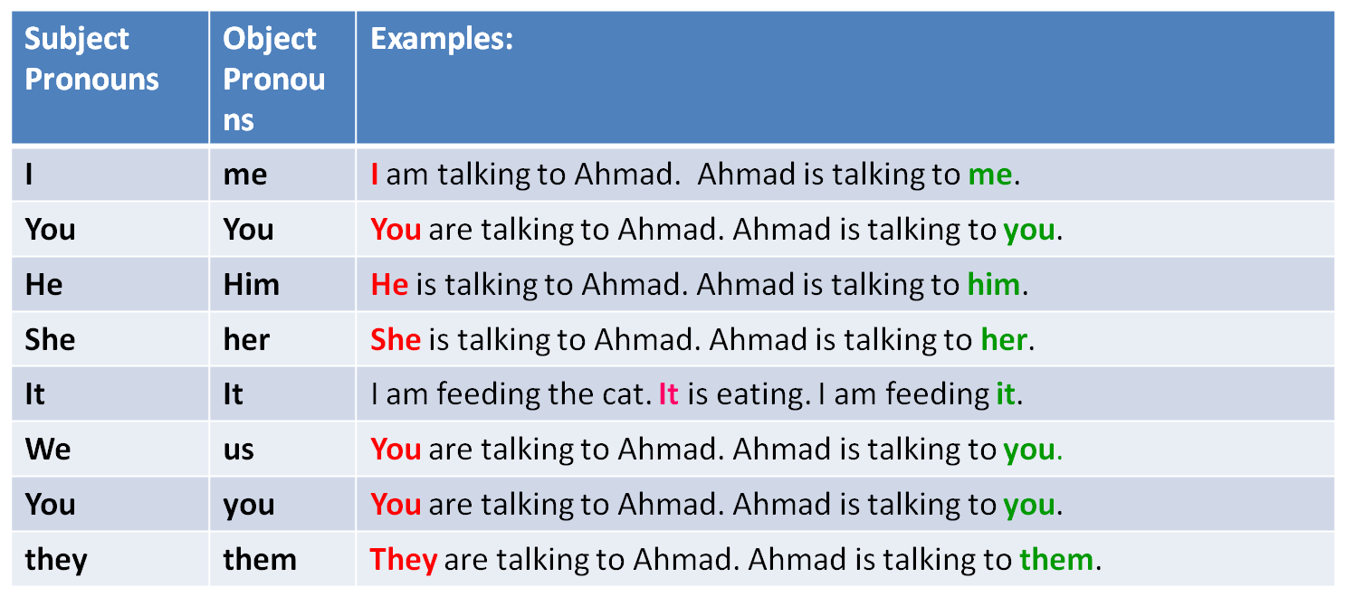
Practice
1. There ____ a tall, old woman in the park.
is B. hasC. haveD. are
2. A woman is standing _____me.
acrossB. rightC. behindD. next
3. Mary ______ right now.
A. is paint a pictureB. paints a picture
C. painting a pictureD. is painting a picture

√
√
√

فاطمه ... فهد

