Lecture # 2
Describe Your Family
and Home
Lecture Components
Vocabulary:
Home and family, singular and plural, adjectives
Grammar:
Simple Present Tense
Prepositions
Possessive adjectives
Strategies & Conventions:
Capitalization: Writing complete sentences

Introduction
This lecture starts with a reading text. The text is then analyzed for the major points included in the previous slide.
Most parts are followed by references to web pages. Students should refer to those web pages for further study.
Reading (page14)
Francisco has four people in his family. His parents’ names are Berta and Miguel. Francisco does not have a brother. He has a sister. Her name is Maria. Francisco’s father is very smart. He is a computer programmer. He works in a big office. Francisco’s mother works in a bookstore. She is very kind. She reads books in her free time. Francisco and Maria do not work. They go to Oak Street School. They are good students. They study every day. After school, Francisco plays baseball. Maria listens to music.
Reading (page14)
Francisco and his family live at 145 Oak Street in Los Angeles, California. They do not live in a house. They have a nice apartment. Their apartment has three bedrooms, a living room, a kitchen, and a bathroom. Mr. and Mrs. Garcia’s bedroom is next to the living room. Maria’s bedroom is next to their room. Francisco’s bedroom is across from Maria’s bedroom. The bathroom is between Francisco’s bedroom and Maria’s bedroom. They aren’t big bedrooms. They are small. They are clean and comfortable. The Garcia family is very happy in their home.

Ex. A - Page 14
1. I have three people in my family.
2. Their names are Ahamd,
Iman
Salwa
3. I live in a house / an apartment.
4. My house has threebedrooms
twobathrooms
two living rooms
onekitchen
5. My home is big / small
nice , clean, comfortable
Now try to write similar sentences.
Singular or Plural
(Add s to most singular nouns)
one bedroom two/ three bedrooms
one brothertwo/ three brothers
one classfour classes
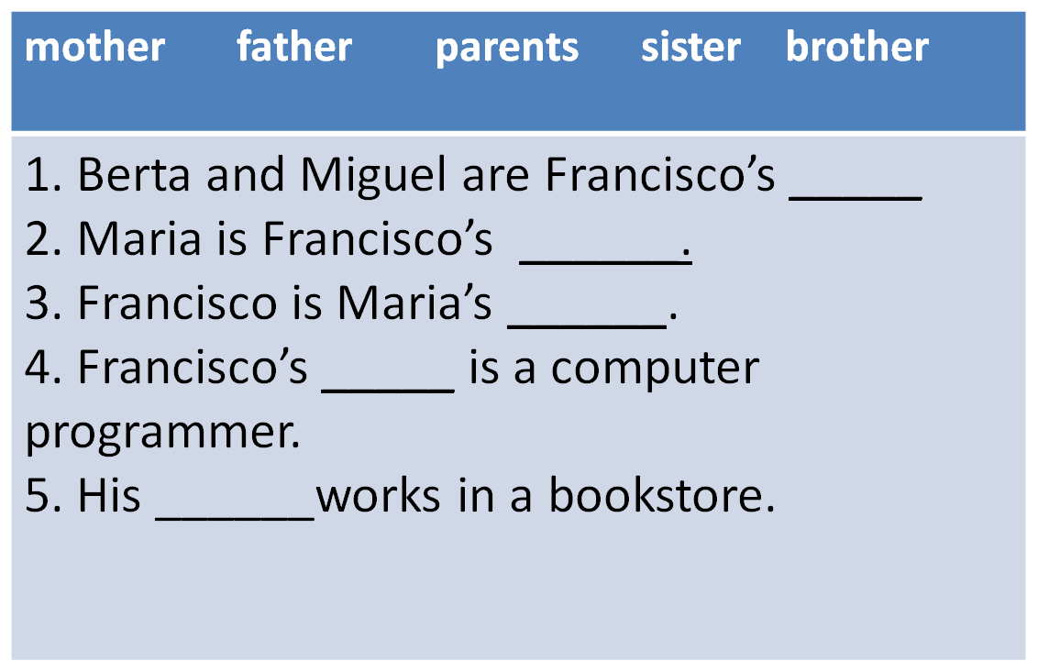
Vocabulary Exercise A / page 16
parents
sister
brother
father
mother
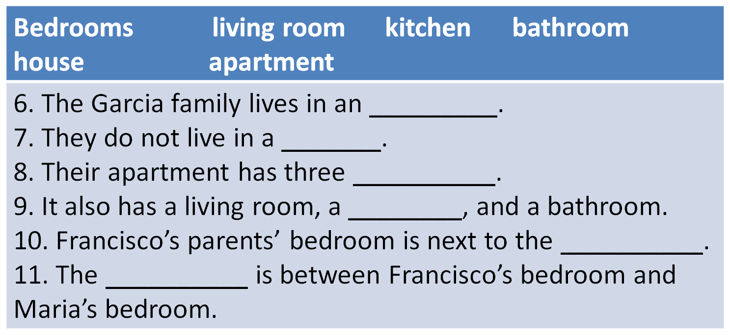
Vocabulary Exercise A / page 16
apartment
house
bedrooms
kitchen
Living room
bathroom
Adjectives / opposites
small______
silly______
good______
big
smart
bad
Exercise B/ page 16
Mr. Garcia is silly.
Mr. Garcia is smart.
2. Mr. Garcia works in a small office.
Mr. Garcia works in a big office.
3. Mrs. Garcia is very mean.
Mrs. Garcia is very kind.
4. Francisco and Garcia are bad students.
Francisco and Garcia are good students.

Exercise B/ page 16
5. The apartment has big bedrooms.
The apartment has small bedrooms.
6. The apartment is dirty.
The apartment is clean.
7. The Garcias are sad.
The Garcias are happy.
Simple present tense (page 17)
1. Ahmad lives on King Abdullah Street.
He does not live on King Abdul-Aziz Street.
2. Ahmad and his family live on King Abdullah Street.
They do not live on King Abdul-Aziz Street.
3. Ahmad has a small bedroom.
He does not have a big bedroom.
4. Ahmad and his family have a big house.
They do not have a small house.

Affirmative and Negative
Affirmative NegativeContractions
Livedo not livedon’t live
Livesdoes not livedoesn’t live
Havedo not havedon’t live
Hasdoes not havedoesn’t have

Exercise A / page 17
Francisco ( / have ) four people in his family.
2. Francisco ( /don’t have) a brother.
3. Mrs. Garcia ( / read) books in her free time.
4. Francisco and Maria (doesn’t work/ ).
5. They (goes/ ) to school.
6. They (studies / ) every day.

has
doesn’t have
reads
don’t work
go
study
Prepositions: Exercise B / page 18
Mr. and Mrs. Garcia’s bedroom
is _________the living room.
2. The kitchen is __________
their bedroom.
3. Maria’s bedroom is ______
her parents’ bedroom.

Living room
Francisco’s room
Maria’s room
bathroom
kitchen
Mr. & Mrs. Gracia’s room
next to
across from
next to
4. Francisco’s bedroom is _________
Maria’s bedroom.
5. The bathroom is _______
Francisco’s bedroom
and Maria’s bedroom.

Now makes similar sentences about the rooms in your house.

Living room
Francisco’s room
kitchen
bathroom
Mr. & Mrs. Gracia’s room
Maria’s room
across from
between
Possessive form
Francisco__ bedroom is across from Maria’s bedroom.
___bedroom is across from her bedroom.

Mr. and Mrs. Garcia__ bedroom is next to the living room.
_______bedroom is next to the living room.

’s
His
’s
Their
Possessive form: Exercise C / page 18
1. Mr. Garcia’s office is very big.
His office is very big.
2. Mrs. Garcia’s job is in a bookstore.
Her job is in a bookstore.
3. The school is close to Francisco and Maria’s apartment.
The school is close to their apartment.
Possessive form: Exercise C / page 18
4. Their bedroom is next to the living room.
Mr. and Mrs. Garcia’s bedroom room is next to the living room.
5. His bedroom is next to the kitchen.
Francisco’s bedroom is next to the kitchen.
6. His bedroom is across from her bedroom.
Francisco’s bedroom is across from Maria’s bedroom.

Subject and Verb
Francisco and his family live at 145 Oak Street.

Which is the subject and which is the verb? Page 19
Mr. Garcia works in a big office.
Francisco’s mother works in a bookstore.
Subject
verb
Subject and Verb (cont.)
3. She reads books in her free time.
4. Francisco and Maria go to Oak Street School.
5. They study every day.
6. Francisco plays baseball.
7. Maria listens to music.
Write about yourself (page 20)
1. My name is Mark Hanson.
My name ____ _______ _________.
2. I am fifteen years old.
I am _________ ______ _________.
3. I live in Houston, Texas.
I live ____ __________, _________.
Write about yourself (page 20)
4. My father works in a restaurant.
My father ______ ____ __ ___________.
5. His name is Mike.
His ______ ____ __________.
6. He listens to music in his free time.
He _______________ in his free time.

Write about yourself (page 20)
7. My mother’s name is Janet.
My ________ ______ ___ _________.
8. She’s a teacher.
She _ ___ _____________.
9. My brother’s name is Alex.
My ________ ______ ___ ______.
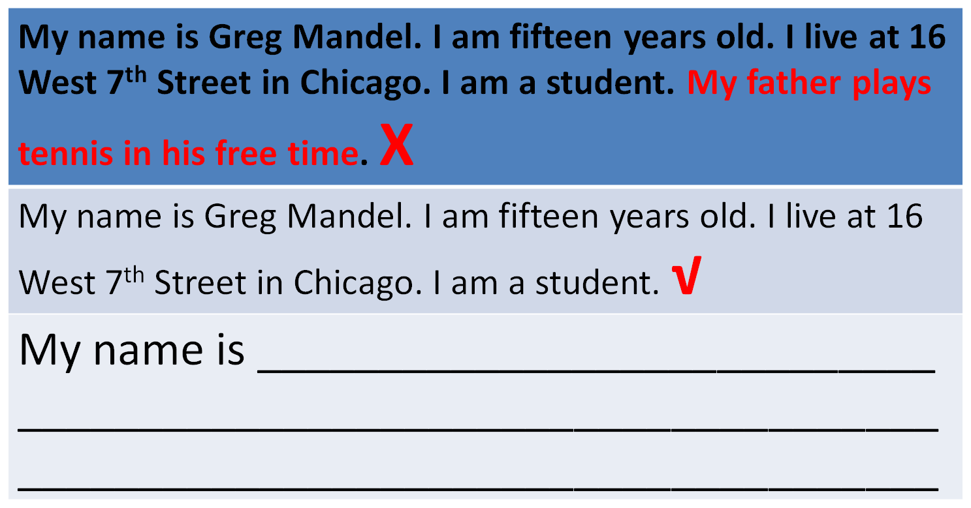
Write about yourself (page 20)
10. He plays soccer in his free time.
He __________________ in his free time.
11. Our family lives in a nice apartment.
Our _______ _____ ___ __ ________ house.
12. Our house has five rooms.
Our house ____ ______ rooms.

Irrelevant ideas
Find the irrelevant idea.
(1)Our house has a living room, a kitchen, a bathroom, and two bedrooms. (2)My bedroom is next to my parent’s room. (3) My mom is really funny. (4) The bathroom is across from my room.
1
2
3
4

√
Practice
Look at the following sentences. Choose the best substitute for the underlined words. If the sentence is correct, choose “Make no change.”
Mr. William work in a restaurant.
Mr. William is work
Mr. William works
Mr. William don’t work
Make no change
√
Practice
2. My house have a living room and two bedrooms.
My house don’t have
My house has
My house is have
Make no change
√
3. My bedroom is big. He is not clean.
- She is not clean.
- It is not clean.
- They are not clean
- Make no change
4. Faisal and Ahmad goes to King Fahd School.
- Faisal and Ahmad go
- Faisal and Ahmad not go
- Faisal and Ahmad doesn’t go
- Make no change
5. My sister is really mean. I like her a lot!
- uncomfortable
- sad
- Make no change
- nice
- الدمامة:
- مكتبة العبيكان، مكتبة جرير، مكتبة المتنبي، مكتبة المريخ
- الاحساء: مركز السعد(مقابل مدخل الطالبات، جامعة الملك فصيل)
- مكتبة العبيكان، مكتبة جرير

☆FF
فـهد وفـاطمه

