Phonemes (44)

Vowels (20)
Consonants (24)

Diphthongs(8)
Triphthongs (1)

Single vowels (12)
ʊə | əʊ | aʊ | I ə | eə | ɔɪ | eI | aI

Short vowels (7)
_week
Long vowels (5)
_strong

are combinations of three sounds-
English has 1 triphthong
(a diphthong + a schwa sound)

/ə/ | /ʊ/ | /o/ | /Λ/ | /æ/ | /e/ | / I / |  | / З: / | / u: / | / ᴐ: / | / ɑ: / | / i: /

Height _ Frontness _ Roundedness / ( rounded / spread / neutral )

examples | shape of lips | Frontness | Height | Single vowels
 | spread | front vowel | high vowel | / i: /
 | neutral | back vowel | low vowel | / ɑ: /
 | rounded | back vowel | mid vowel | / ᴐ: /
 | rounded | back vowel | high vowel | / u: /
 | neutral | central vowel | high vowel | / З: /
 | slightly spread | front vowel | high vowel | / I /
 |  | front vowel | mid vowel | /e/
 | spread wide open | front vowel | low vowel | /æ/
 | neutral | central vowel | mid vowel | /Λ/
 | rounded | back vowel | mid vowel | /o/
 | more rounded | back vowel | high vowel | /ʊ/
 | neutral | central vowel | mid vowel | /ə/

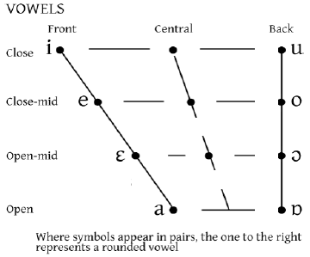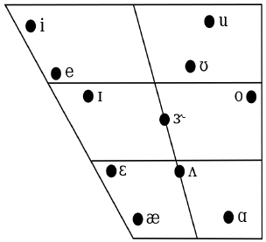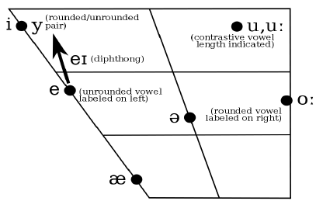

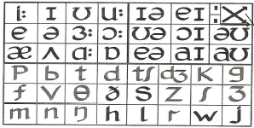

examples | Voiced / Voiceless | manner of articulation | place of articulation |  | consonants
examples | Voiced / Voiceless | manner of articulation | active | passive
 | Voiceless(-) | Stops | Bilabial |  | p | p
 | Voiced (+) | Stops | Bilabial |  | b | b
 | Voiceless(-) | Stops | alveolar |  | t | t
 | Voiced (+) | Stops | alveolar |  | d | d
 | Voiceless(-) | Affricates | palatal |  | tʃ | ch
 | Voiced (+) | Affricates | palatal |  | dʒ | j
 | Voiceless(-) | Stops | Velar |  | k | k
 | Voiced (+) | Stops | Velar |  | g | g
 | Voiceless(-) | Fricatives | labiodentals |  | f | f
 | Voiced (+) | Fricatives | labiodentals |  | v | v
 | Voiceless(-) | Fricatives | dental |  | θ | th
 | Voiced (+) | Fricatives | dental |  | ð | dh
 | Voiceless(-) | Fricatives | alveolar |  | s | s
 | Voiced (+) | Fricatives | alveolar |  | z | z
 | Voiceless(-) | Fricatives | palatal |  | ʃ | sh
 | Voiced (+) | Fricatives | palatal |  | ʒ | zh
 | Voiceless(-) | Nasals | Bilabial |  | m | m
 | Voiced (+) | Nasals | alveolar |  | n | n
 | Voiced (+) | Nasals | Velar |  | ŋ | ng
 | Voiceless(-) | Fricatives | glottal |  | h | h
 | Voiced (+) | lateral Approximant |  |  | L | l
 | Voiced (+) |  |  |  | r | r
 | Voiced (+) | Glides | Bilabial |  | w | w
 |  | Glides | palatal |  | j | y
Try to answer :
 | (2)  [s] |  | (1)  voiced velar nasal ?  voiceless post alveolar affricate?  voiced bilabial stop ?  voiceless velar stop ?  voiced alveolar fricative ?  voiced palatal glide?
 | [d]
 | [Z]
 | [T]
 | [m]
 | [w]

