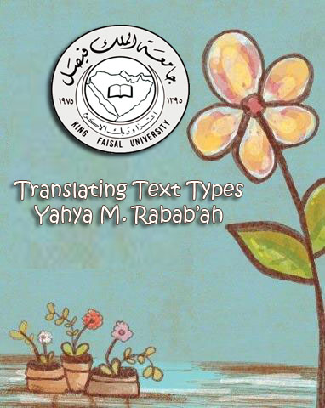
Introductory Lecture
Course Content:
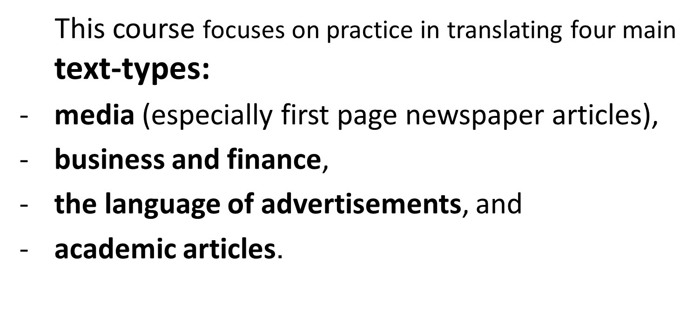

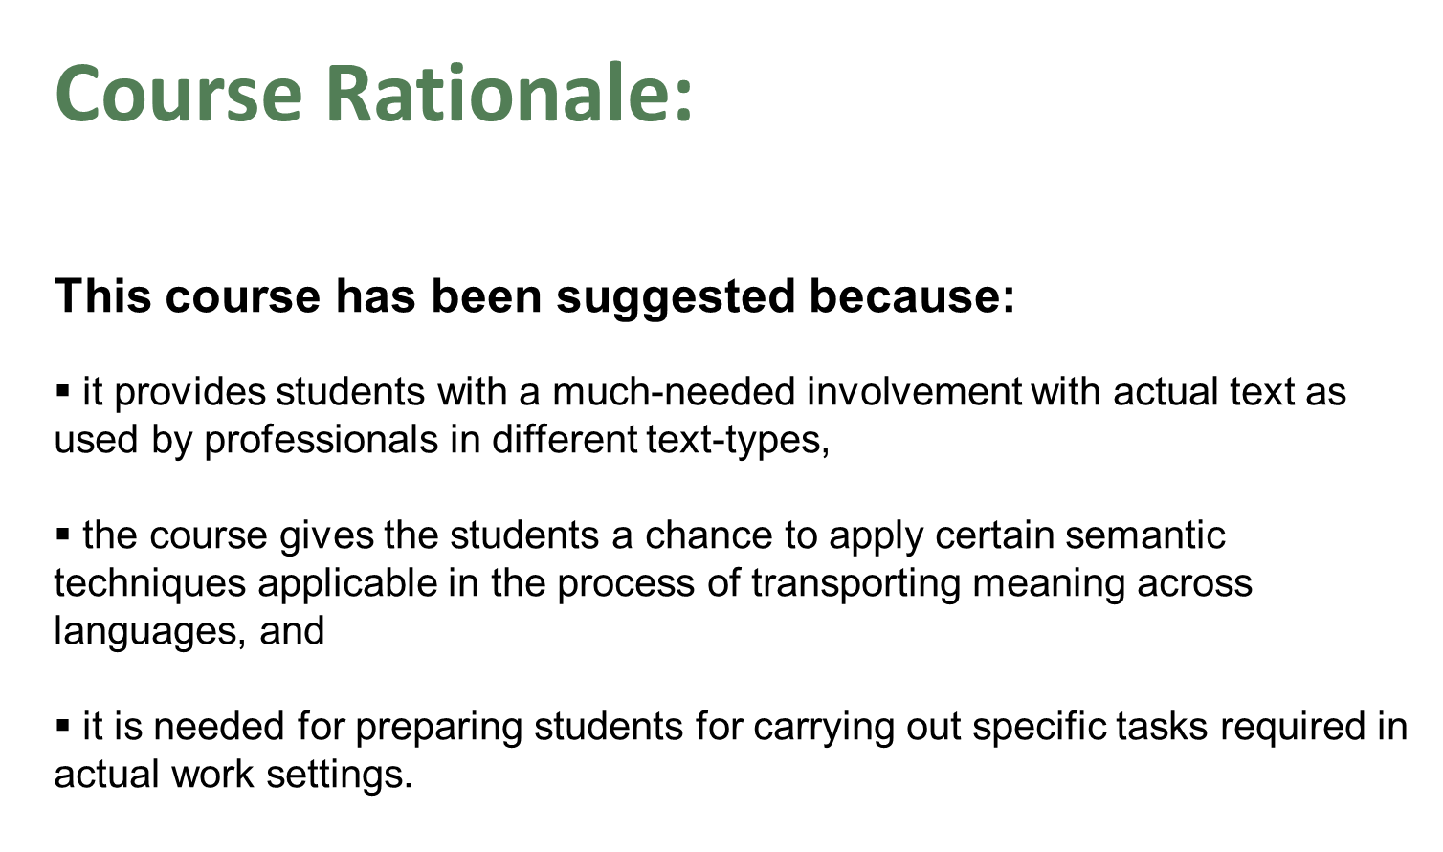

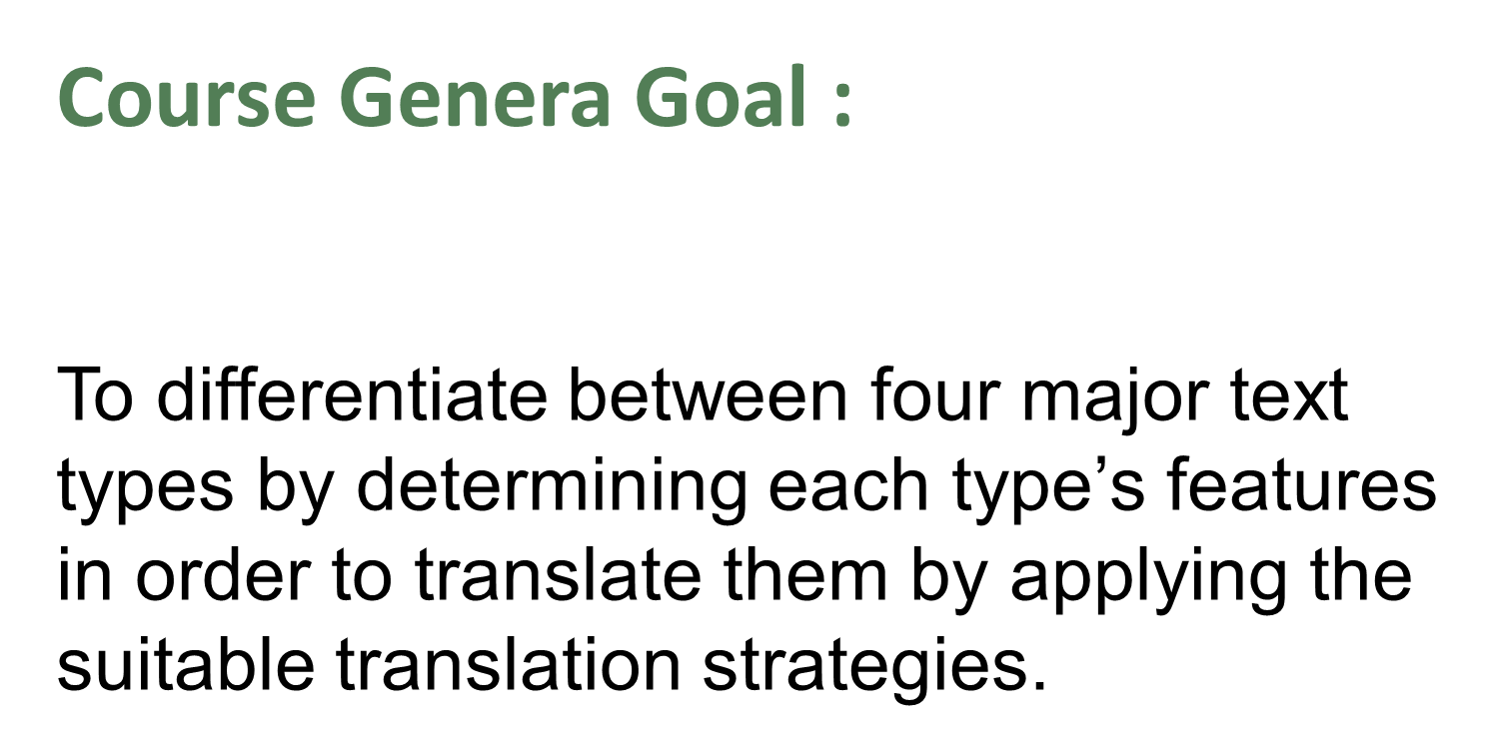

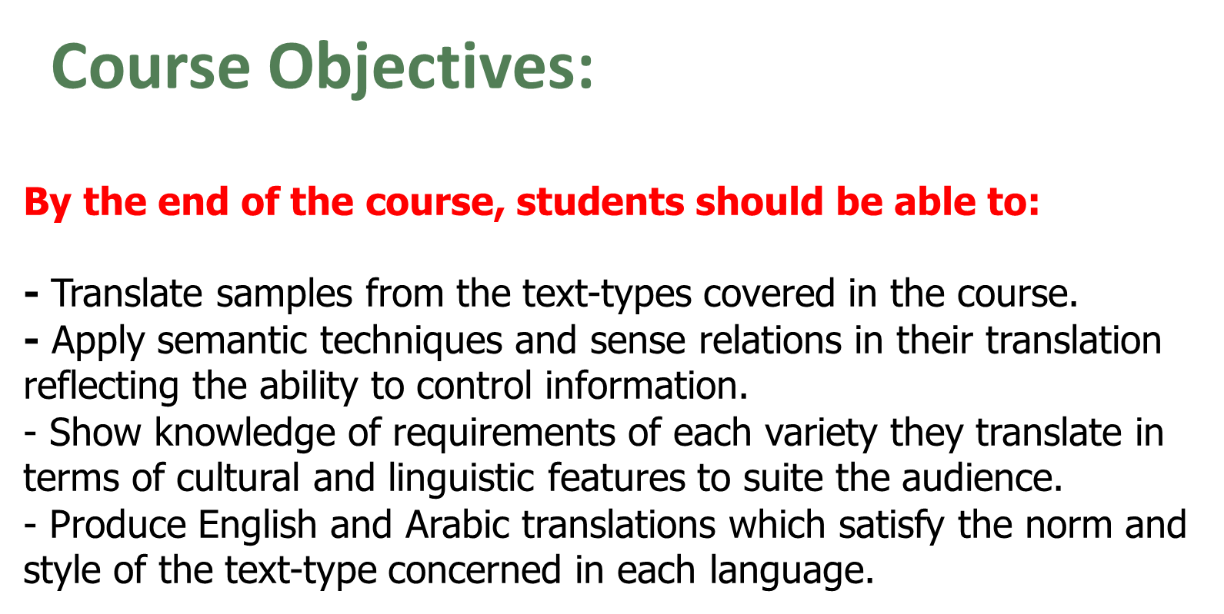

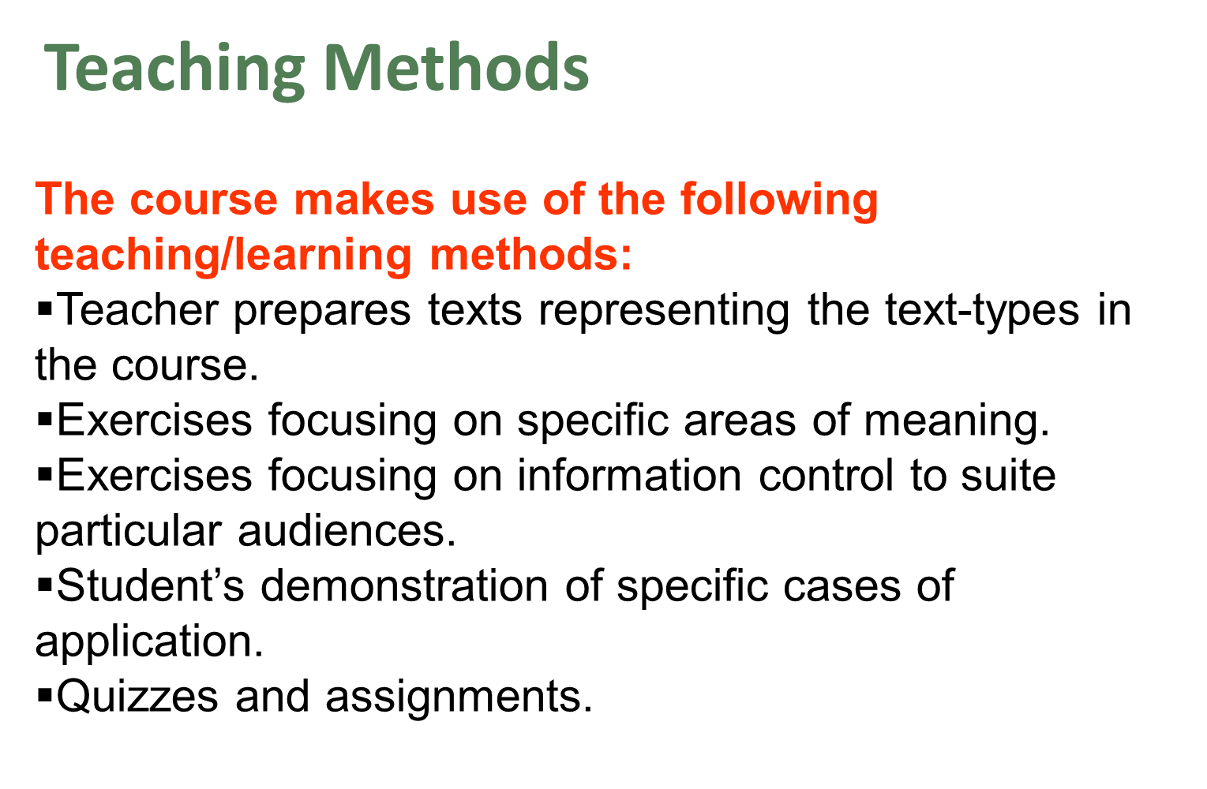

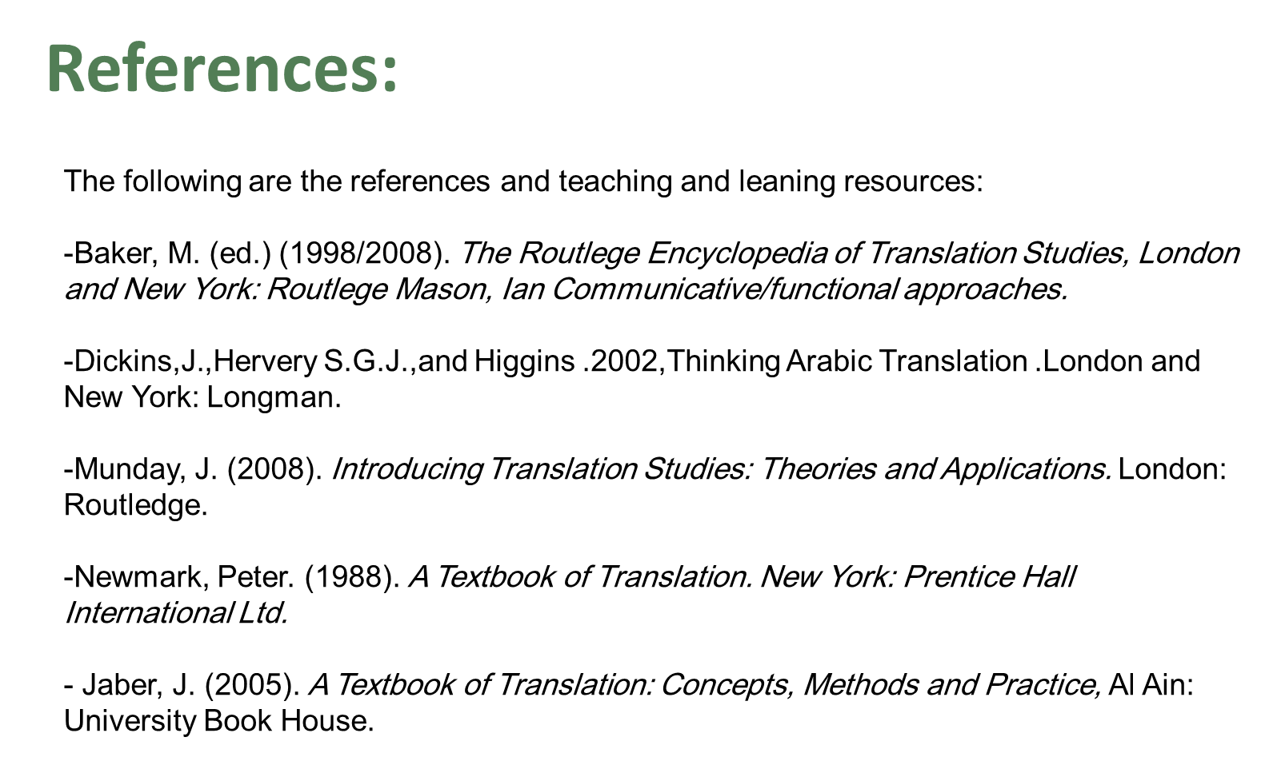

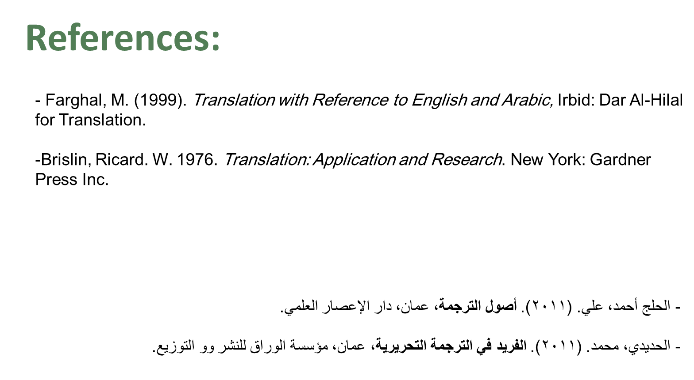

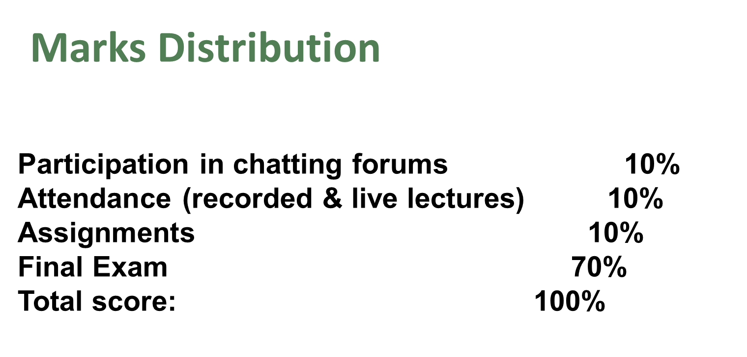

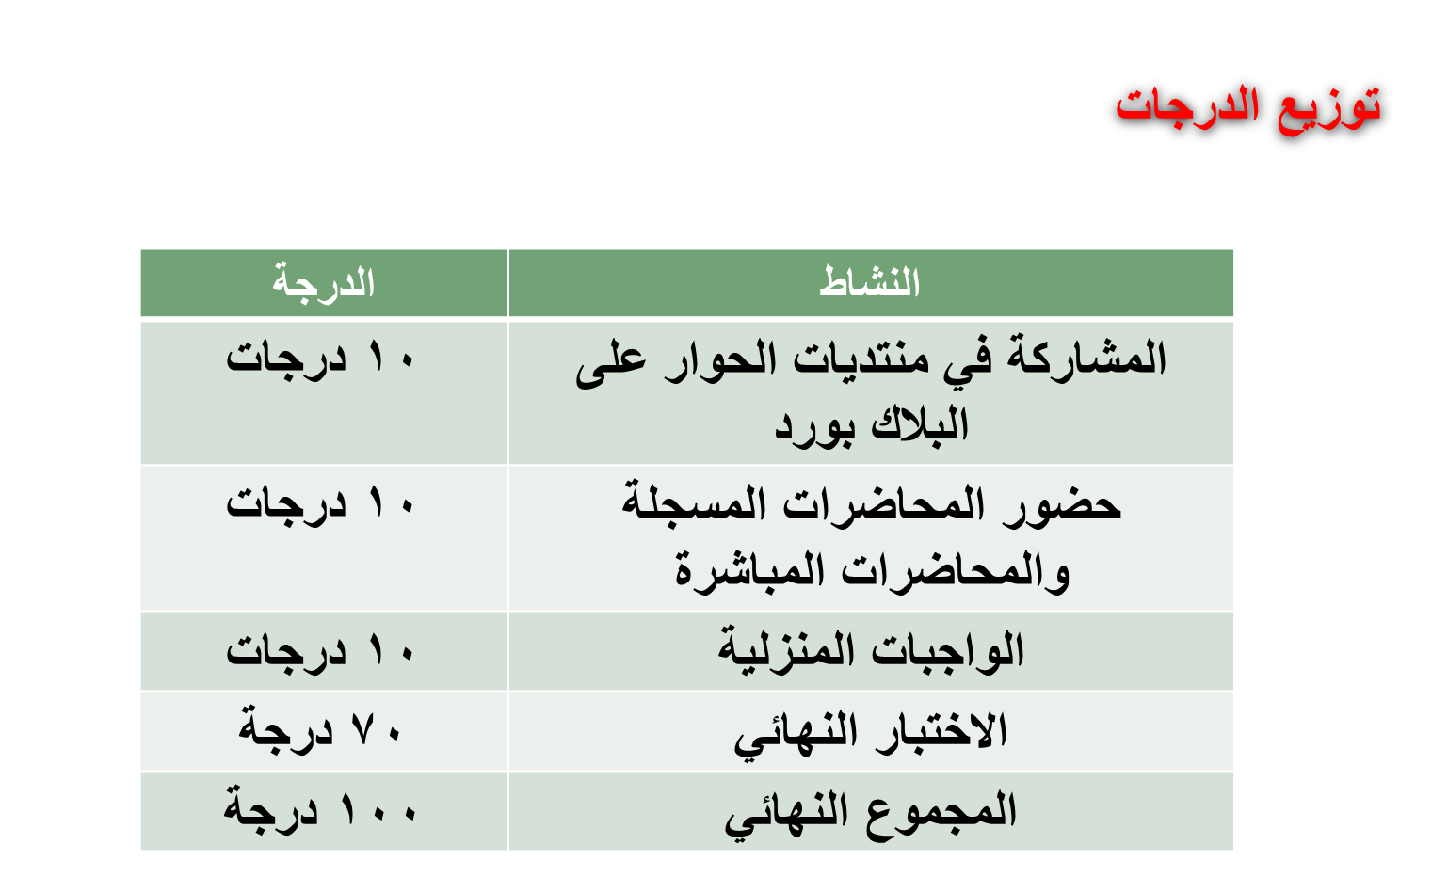

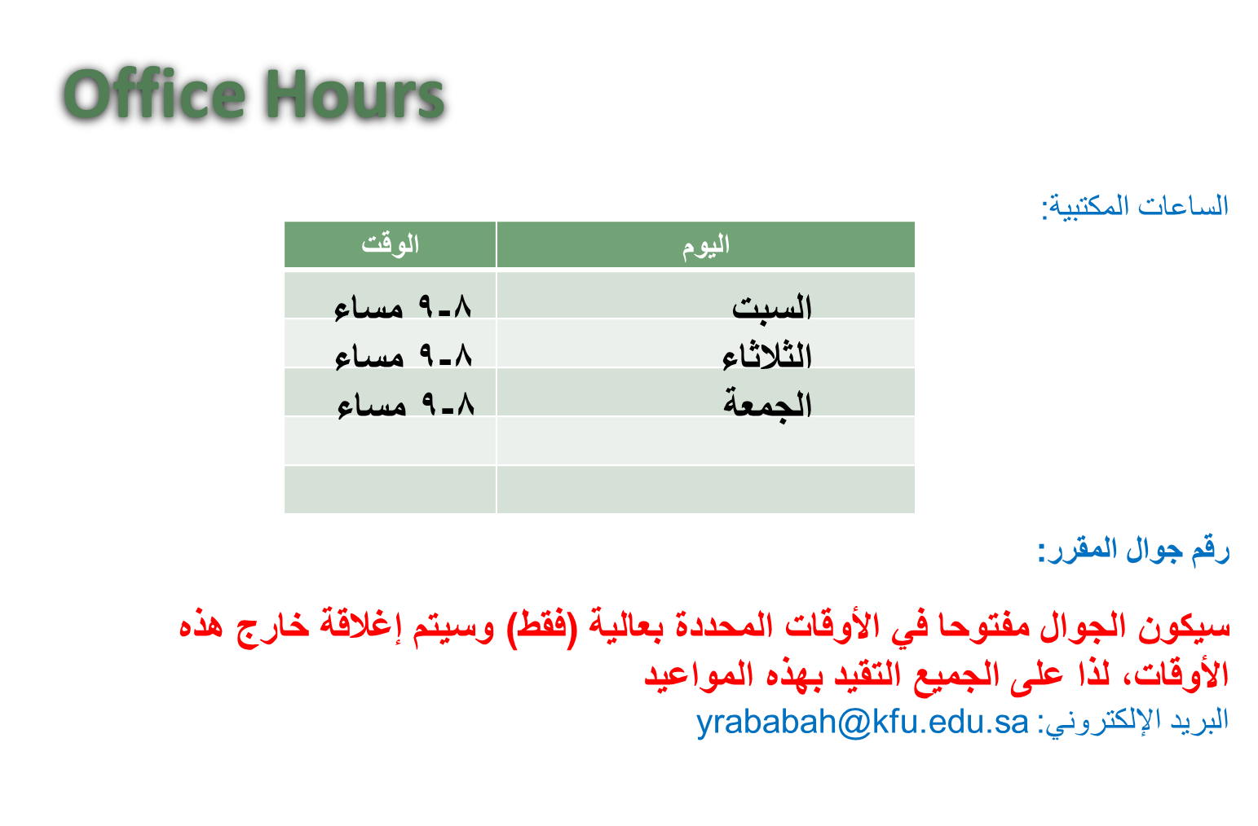

- Lecture 1
- translation
- Importance and Definition
Language, Communication and translation:
A certain language system has its own feature and norms that people use to communicate with each other.
An Arabic language speaker can understand what is spoken as he listens to somebody speaking Arabic and course; he can understand what is written as he reads an Arabic text.
This is obviously logical because the speakers of a certain language can communicate with each other and understand the spoken and written texts of this language.
But
What if two sides who are speakers of two different language needs to communicate with each other for a certain purpose?
- Example 1 : Company (A) speak only English
- Company (B) speak only Arabic
Both companies need services from other
- How can they communicate?
- How can they achieve their mutual goals?

- Example 2 : Suppose that you are in China. You need to buy one million SR goods.
The Chinese Company gave you a contract written in Chinese and asked you to sign it?
have a look at the contract , please ...
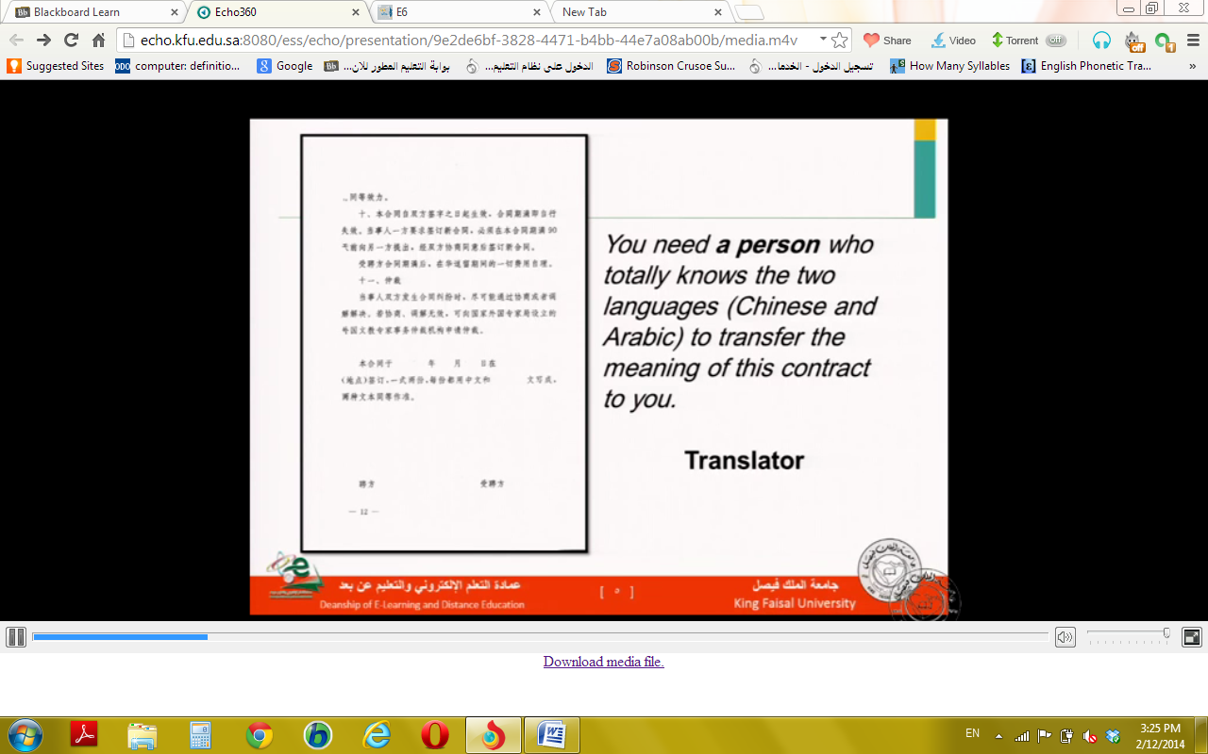
You need a person who totally Knows the two languages ( Chinese and Arabic ) to transfer the meaning of this contract to you .
translator

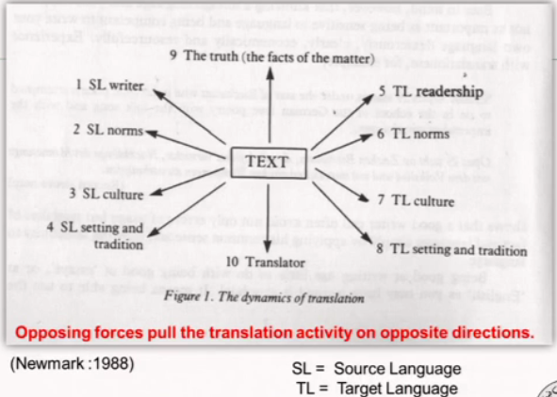
What does "translation " mean
- the term "translation" can refer to :
- the general subject field
- the product ( the text that gad been translation)
- the process ( the act of producing the translation)
(munday:2008)
Many authors tried to define "translation"
- "Rendering the meaning of text into another language in the way that the author intended the text".
- (Newmark:1988)
"author= the originator the text whether it is oral or written"

- translation is the general term referring to the transfer of thoughts and ideas from one language (source) to another (target), whether the languages are in written or oral from : whether the languages have established orthographies or do not have such standardization or whether one or both language is based on signs, as with sign languages of the deaf.
- (Brislin: 1976)

- Translation is often regarded as a project for transferring meaning from one language to another.
- (Farghal: 1999(

All the previous mentioned definitions of the term "translation" talk about two key words:
- Transfer(interlingual communication)
- meaning (denotative and connotative)

Related basic Definitions
- Text :
- Any given stretch of speech or writing assumed to make coherent whole.
- (Dickins: 2002)
so..
- a text maybe a single word like the sign: (قف)
- or thousands of pages like: (كتاب تاريخ الرسل والملوك )which consists of many volumes

- Source text (ST): the text requiring translation.

- Target text (TT): The text which is a translation of the ST.

- Source Language (SL): the language in which the ST is written.

- Target Language (TL): The language into which the ST is translated.

- Strategy: the translators overall plan consisting of a set of strategic decisions taken after an initial reading of the ST, But before starting detailed translation.

- Questions
- A certain language system has its own features and norms that people use to……………………… with each other.
- 2. You need a …………………… who totally knows both Chinese and Arabic languages to transfer to you the meaning of a certain contract written in Chinese language .
- According to Newmark, SL writer and TL readership are two components of the ………….……
- SL and TL stand for : …………………… and …………………………….
- “ Rendering the meaning of a text into another language in the way that the author intended the text.” This is the definition of "……………………….." according to Newmark.

- Lecture 2
- Translation Studies and Samples of Text Types
Translation Studies
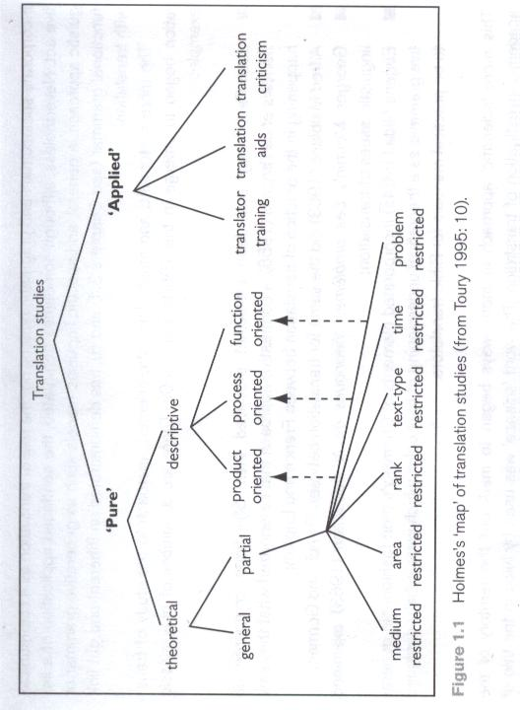
Translation studies is now understood to refer to the academic discipline concerned with the study of translation at large, including literary and non-literary translation, various forms of oral interpreting as well as dubbing and subtitling.
(Baker, M. (ed.) 1998/2008)
So, what is the relation between the Translation Studies and Text Types?
James Holmes’s Map

Text Type
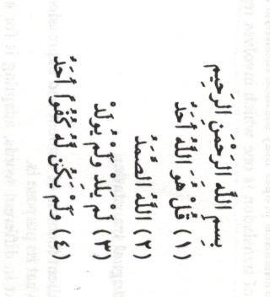
Let’s have a look at the following texts and try to see if they differ from each other!

TEXT 1:

TEXT 2 :
- Dear Valued Customer
In order to make your online banking experience more secure, we have improved the username and password rules. If you are facing difficulties logging into our internet and mobile banking, then perhaps your user name and password does not comply to the rules that we have applied. In such a case please contact the call center 920003344 to reset your Al Mubasher access. This would require you to register for online banking again by accessing the following linkhttps://www.almubasher.com.sa/registration/ and comply to the username and password rules that are mentioned below.
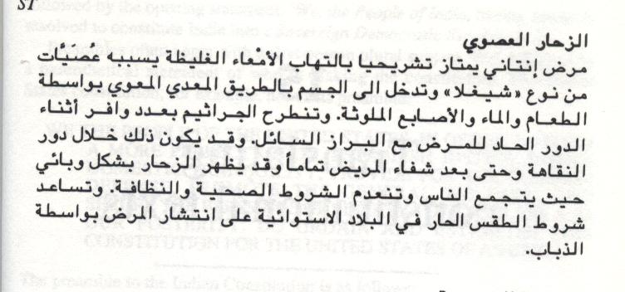
TEXT 3:

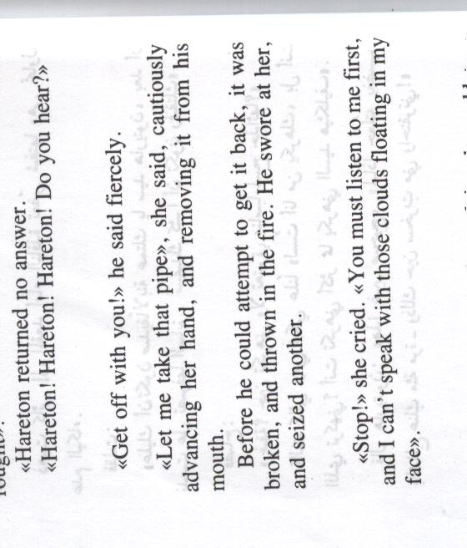

TEXT 4:

TEXT 5:
بسم الله الرحمن الرحيم
والصلاة والسلام على رسول الله الهادي الأمين وعلى آله وصحبه أجمعين .
أيها الإخوة الكرام في مشارق الأرض ومغاربها .
السلام عليكم ورحمة الله وبركاته :
أهنئكم بعيد الفطر المبارك وبصيام وقيام الشهر الفضيل، وأخاطبكم من رحاب البلد الحرام ومهد رسالة الإسلام، وقبلة المسلمين التي انطلق منها نور الهداية الربانية ليضيء للبشرية طريق الخير والسلام، لتشكل حضارته أهم روافد التحضر الإنساني والإبداع البشري، ولا غاية لهذا الخير الذي أجراه الله تعالى على يد مُعلم البشرية وهاديها نبينا محمد صلى الله عليه وسلم سوى إخراج العالم من غياهب الظلام والاستبداد والجهالة إلى نور الحق والمساواة والعدالة، مع رفع راية التسامح والتعايش والحكمة والرشد، والدعوة إلى كلمة سواء تخرج بها البشرية من ظلمات جهلها وشحنائها وتناحرها إلى نور ربها الهادي إلى سواء الصراط.
من خطاب لخادم الحرمين الشريفين الملك عبدالله بن عبدالعزيز آل سعود
She dwelt among the untrodden ways
Beside the springs of Dove,
A Maid whom there were none to praise
And very few to love:
A violet by a mossy stone
Half hidden from the eye!
—Fair as a star, when only one
Is shining in the sky.
She lived unknown, and few could know
When Lucy ceased to be;
But she is in her grave, and, oh,
The difference to me!

TEXT 6:

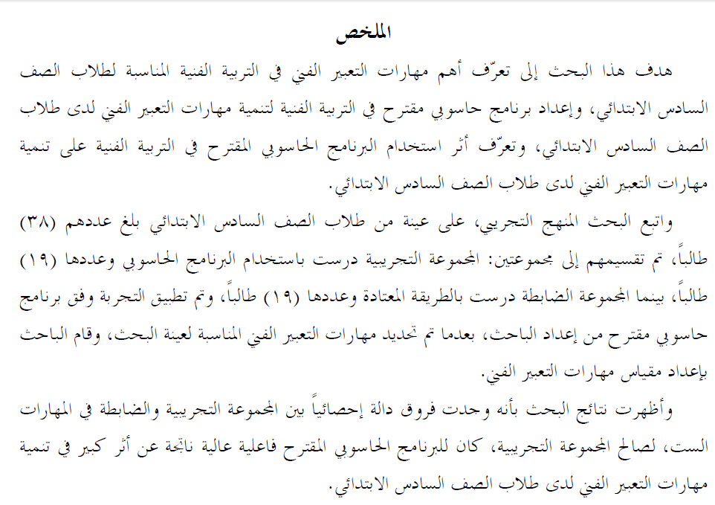
TEXT 7:

TEXT 8:
- Small Change
HOPES deferred rather than hopes dashed: that sums up the reaction of the transport lobby to the £1.8 billion in additional funding over the next three years that was announced this week. Representing a 25% increase in comparison with a 25% cut in the last parliament.
The concession is an important breakthrough, for which local authorities have long campaigned. London First, a business pressure group, estimated in a study, published last month, that a non-residential parking tax levied at an average of £750 per parking space in central and outer London could raise £300m per year, enough, for example, to bridge the investment backlog of London's Underground.
From The Economist Jul 16th 1998
- TEXT 9:
إن وادي رم ذو الجمال الطبيعي الفاتن يلخص رومانسية الصحراء بأوديتها القديمة الشبيهة بسطح القمر والتلال الرملية التي ترتفع فوق الأرض. وعلاوة على ذلك فوادي رم يعتبر مسكنا للعديد من القبائل البدوية التي تعيش في مخيمات متناثرة في المنطقة.
Are all those texts of the same text type?
Can you translate all of them following the same strategy?
TEXT 1 is a religious text taken from the Holy Quran.
TEXT 2 is a bank leaflet
TEXT 3 is a technical text describing a certain disease.
TEXT 4 is a literary text taken from the novel “Wuthering Heights” by Emily Bronte
TEXT 5 is an official speech by The Custodian of the Two Holy Mosques
TEXT 6 is a poem by the famous English poet William Wordsworth.
TEXT 7 is an academic text - thesis abstract
TEXT 8 is a financial text taken from The Economist Newspaper - 1998
TEXT 9 is taken from a tourist brochure

"It is obvious that not all texts are the same type. We may distinguish between political texts, legal texts and medical texts; fairy tales, novels and short stories differ from newspaper reports, essays and scientific papers; food recipes, instructions booklets and advertisements may show similarities but they are not the same, expository texts differ from argumentative texts, etc. All these types of text differ in ways that are somewhat obvious, intuitively, but which nevertheless invite detailed analysis"
( Trosborg, 1998)
Katharina Reiss (1979/1989) views the text, rather than the word or sentence, as the level at which communication is achieved and at which equivalence must be sought.

Questions
Choose the right answer:
- A short story is an example of a (religious / literary / technical ) text.
- A religious text is like a (Quran Surah/ poem / short story ).
- The Custodian of the Two Holy Mosques has addressed the nation with a speech which is considered as a ( technical / literary / religious) text.
- A certain text talking about a certain disease is considered as ( religious / literary / technical ) text.
- Katharina Reiss views the ( word / sentence / text ) as the level at which communication is achieved and at which equivalence must be sought.

- Lecture 3
- Text Types as Seen by Scholars
- Texts are not all the Same
"It is obvious that not all texts are the same type. We may distinguish between political texts, legal texts and medical texts; fairy tales, novels and short stories differ from newspaper reports, essays and scientific papers; food recipes, instructions booklets and advertisements may show similarities but they are not the same, expository texts differ from argumentative texts, etc.
( Trosborg, 1998)
Text not a word or a sentence
Katharina Reiss (1979/1989) views the text, rather than the word or sentence, as the level at which communication is achieved and at which equivalence must be sought.
Importance of Text Type
Both translators and those who write about translation have recognized the importance of the relationship between text type and translation process. The first and important step towards a suitable and considerable translation of any text is to identify the typology to which that text belongs. There are several classifications put by several scholars concerning text types.
A translator of any text necessarily needs to know which text type and what nature is that text, in order to be able to adequately produce a suitable target text.
Text Type Classifications
There are several classifications put by several scholars concerning text types.
Basil Hatim
&
Ian Mason
(1990)

- Hatim and Mason (1990) classified text types according to their rhetorical purposes:
- Argumentative , expositive and instruction-based.

They divide instructional texts into two types: instruction without option, and instruction with option. Instruction without option includes texts such as laws. One is required to follow the ‘instructions’
(law, for instance); otherwise there may be a punishment.
Peter Newmark
(1988)

Newmark depends on Buhler’s functions of language to deal with text types. According to Buhler, there are three language functions:
Expressive: serious imaginative literature, authoritative statements,
Originat or writer

autobiography, essays and personal correspondence
Informative: a textbook, a technical report, a scientific paper or agenda of
topic of knowledge

a meeting
Vocative: notices, publicity, propaganda, persuasive writing and
readership

advertisements
" Few texts are purely expressive informative or vocative: most include all three functions, with an emphasis on one of the three" ( Newmark,1988: 42)
Katharina Reiss
(1970s)

In the 1970s and depending on Buhler's typology, Katherina Reiss classified text types as follows:
- Informative
- Expressive
- Operative
- Audiomedial

Katharina Riess (1979/1989) views the text, rather than the word or sentence, as the level at which communication is achieved and at which equivalence must be sought.

- Questions
- Choose the right answer:
1. All texts are ( different / the same / argumentative).
2. We can distinguish between political and medical texts. (True/ False)
3. Advertisements and scientific papers (don't / always / usually ) show similarities.
4. The first step to suitably translate a text is to :
( determine the long and short sentences / identify the text type / recognize the title)
5. Hatim and Mason classified text types according to their ( rhetorical purposes / length of paragraphs / language functions)
6. Hatim and Mason classified text types into three major categories. One of them is:
( appellative / vocative / argumentative )
7. According to Newmark, serious imaginative literature is a text type which is:
( expressive / vocative / informative)
8. The core of an expressive text type is:( the topic / the readership / the writer )

Lecture 4
- Text Types as Seen by Scholars 2
- Texts are not all the Same
"It is obvious that not all texts are the same type. We may distinguish between political texts, legal texts and medical texts; fairy tales, novels and short stories differ from newspaper reports, essays and scientific papers; food recipes, instructions booklets and advertisements may show similarities but they are not the same, expository texts differ from argumentative texts, etc.
( Trosborg, 1998)

- Text Type Classifications
Katharina Reiss
(1970s)

In the 1970s and depending on Buhler's three-way categorization of the functions of language, Katharina Reiss links the three functions to their corresponding language dimensions and to the text types or communicative situations in which they are used:
- Informative
- Expressive
- Operative
- Audiomedial

- (1) Informative
- 'Plain communication of facts': information, knowledge, opinions, etc.
- The language dimension used to transmit the information is logical or referential, the content or 'topic' is the main focus of the communication, and the text type is informative.

- (2) Expressive
- 'Creative composition': the author uses the aesthetic dimension of language.
- The author or 'sender' is foregrounded, as well as the form of the message, and the text type is expressive.

- (3) Operative
- 'Inducing behavioral responses': the aim of the appellative function is to appeal to or persuade the reader or 'receiver' of the text to act in a certain way.
- The form of language is dialogic, the focus is appellative and Reiss calls this text type operative.

- (4) Audiomedial texts
such as films and visual and spoken advertisements which supplement the other three functions with visual images, music, etc.
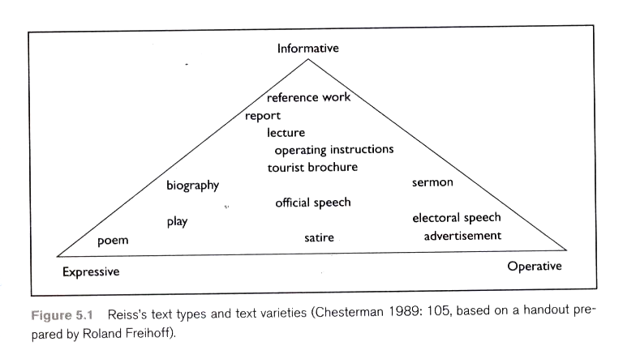

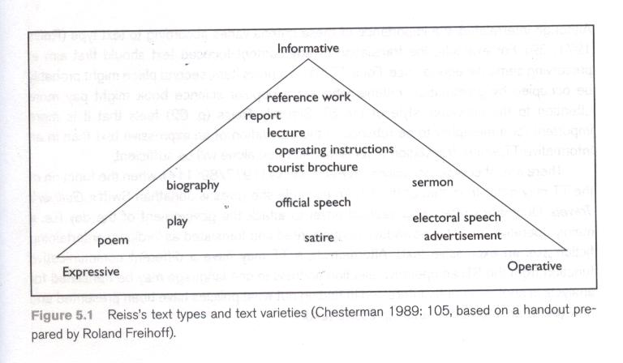
According to this diagram, the reference work is the text variety which is the most fully informative text type.

The poem is a highly expressive, form-focused type.

An advertisement the clearest operative text type.

Between those poles are positioned a host of hybrid of types.
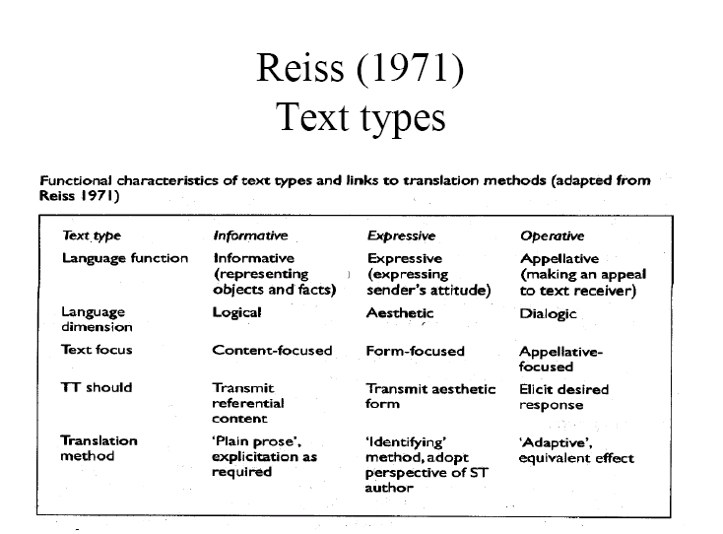
- Suitable Translation Methods
- The TT of an informative text should transmit the full referential or conceptual content of the ST. The translation should be in plain prose, without redundancy and with the use of explicitation when required.
- The TT of an expressive text should transmit the aesthetic and artistic form of the ST. The translation should use the identifying method, with the translator adopting the standpoint of the ST author.
- The TT of an operative text should produce the desired response in the target text receiver. The translation should employ the adaptive method creating an equivalent effect among TT readers.
- Audio-medial texts require what Reiss calls the supplementary method, supplementing written words with visual images and music.

Questions
- According to Reiss, in an informative text type the……………….is the main focus of the communication.
- dimension
- content
- communication
- text type
- According to Reiss, in an informative text type the language dimension used to transmit the information is …………………….
- logical
- theoretical
- communicative
- numerical

- Lecture 5
- Text Type and Genre
- James Dickins
- Sandor Hervey
- Ian Higgins
(2002)

- Text Type and Genre
The term “text type” is often used in a similar sense of “genre”.
Dickins, Hervey and Higgins opted for using the term “genre” instead of “text type”
- Genre
Dickins, Hervey and Higgins distinguished five broad categories of “genre” :
- Literary
- Religious
- Philosophical
- Empirical
- Persuasive

- Literary Genres:
poetry, fiction and drama
- Features of Texts in This Category:
- these texts concern a world autonomously but not controlled by the physical world outside
- they contain features of “expression” which create features of “content”.
- Religious Genres:
- Features of Texts in This Category:
- these texts imply the existence of a religious world that is not fictive, but has its own realities and truths. So the author is not free to create the world that animates the subject matter but to be merely instrumental in exploring it.
- Philosophical Genres:
- Features of Texts in This Category:
- These texts have a “world” of ideas.
- Pure mathematics is the best example of philosophical genres.
- Empirical Genres:
- Features of Texts in This Category:
- These texts purports to deal with the real world as it is experienced by observers.
- They are more or less informative, and it is understood to take an objective view of observable phenomena.
- Examples: scientific and technological
- Persuasive Genres:
- Features of Texts in This Category:
- These texts aim at getting listeners or readers to behave in prescribed or suggested ways, that is: getting an audience to take a certain course of action, and perhaps explaining how to take it.
- Examples: instruction manuals, laws, rules and regulations, propaganda leaflets, newspaper opinion columns and editorials, and advertisements.
Before Beginning to Translate a Text
Before you begin translating any text, you need to ask yourself the following important questions:
- What is the message content of this particular ST?
- What are its salient linguistic features?
- What are its principal effects?
- What genre does it belong to and what audience is it aimed at?
- What are the functions and intended audience of my translation?

- These questions are strategic decisions which are the first set of reasoned decisions taken by the translator before starting the translation in detail.

- Decisions of Detail:
- Reasoned decisions concerning the specific problems of grammar, vocabulary encountered in translating particular expressions in their
- particular context.

- Questions
- Poetry, fiction and drama are part of …………………genre.
- religious
- empirical
- literary
- persuasive
- With regard to religious genre, the author ……………… to create the world that animates the subject matter but to be merely instrumental in exploring it.
- totally free
- partially free
- not free
- all mentioned

