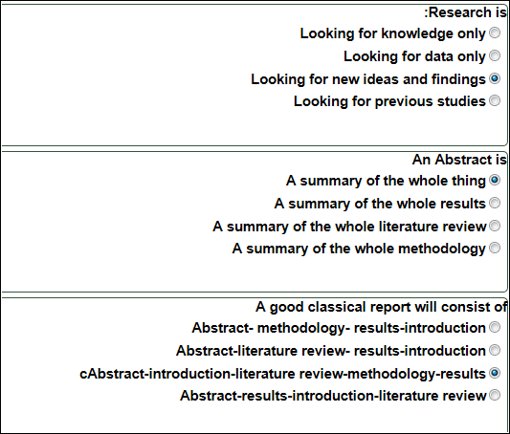
The dependent variable is
a-The variable that is affected by the independent variable
b- The variable that is dependent on the hypothesis
c- The variable that is affected by the abstract
d- The variable that is affected by the results
2-The significant difference has to be at the level of
a-P= 50
b- P=.05
c- P=.50
d- P=0.50
3-If you have one variable in your research, then it is
a- Multivariate
b- Univariate
c- Bivariate
d- factorial
4-We use questionnaires in research as a
a- tool to collect data
b- tool to analyse data
c- tool to generate results
d- tool to design research
In the introduction:
You introduce the results
You introduce the study and its significance
You introduce all previous studies and a critique for them
You introduce all the methods and instruments you used
In the literature review:
You talk about the results
You talk about the study and its significance
You talk about all previous studies and a critique for them
You talk about all the procedures used
Plagiarism is:
Representing other authors’ language and ideas as your own original work
Representing your own language and ideas as your own original work
Representing other authors’ language and ideas as their own original work
Representing other authors’ language and ideas as a plagiarised work

