Lecture 23
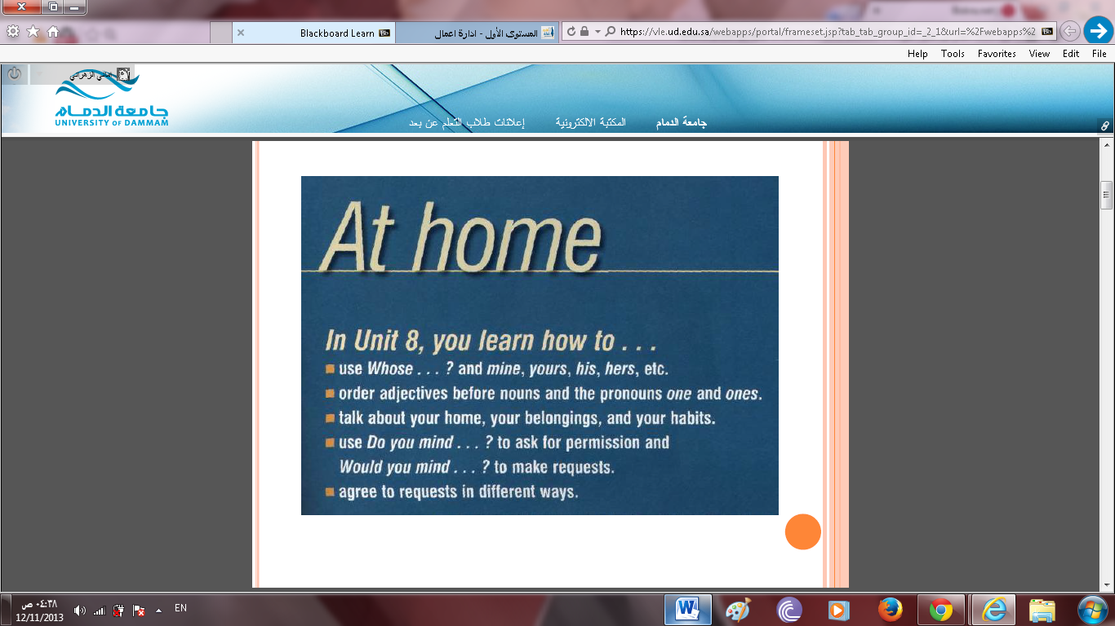
Unit 8
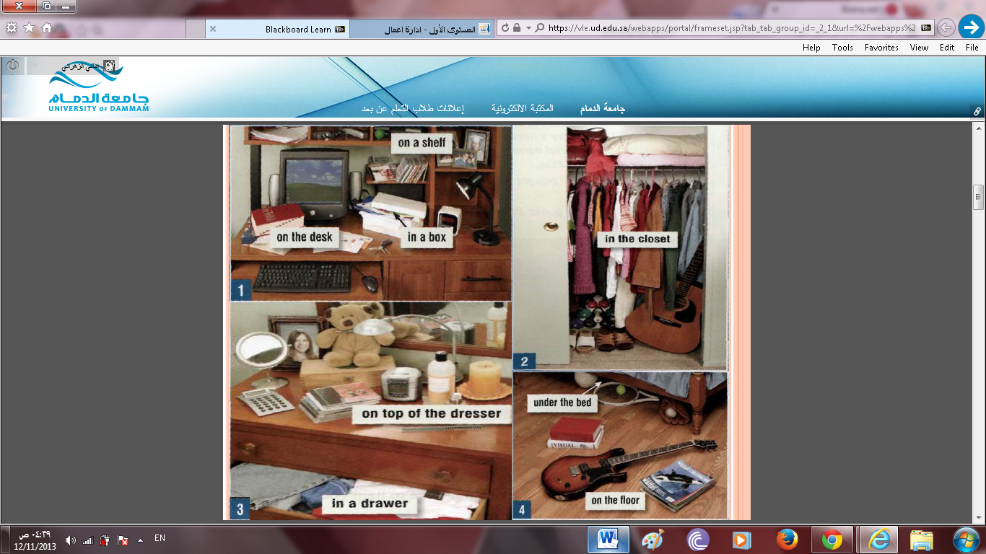

LESSON A: SPRING CLEANING
Possessive Forms
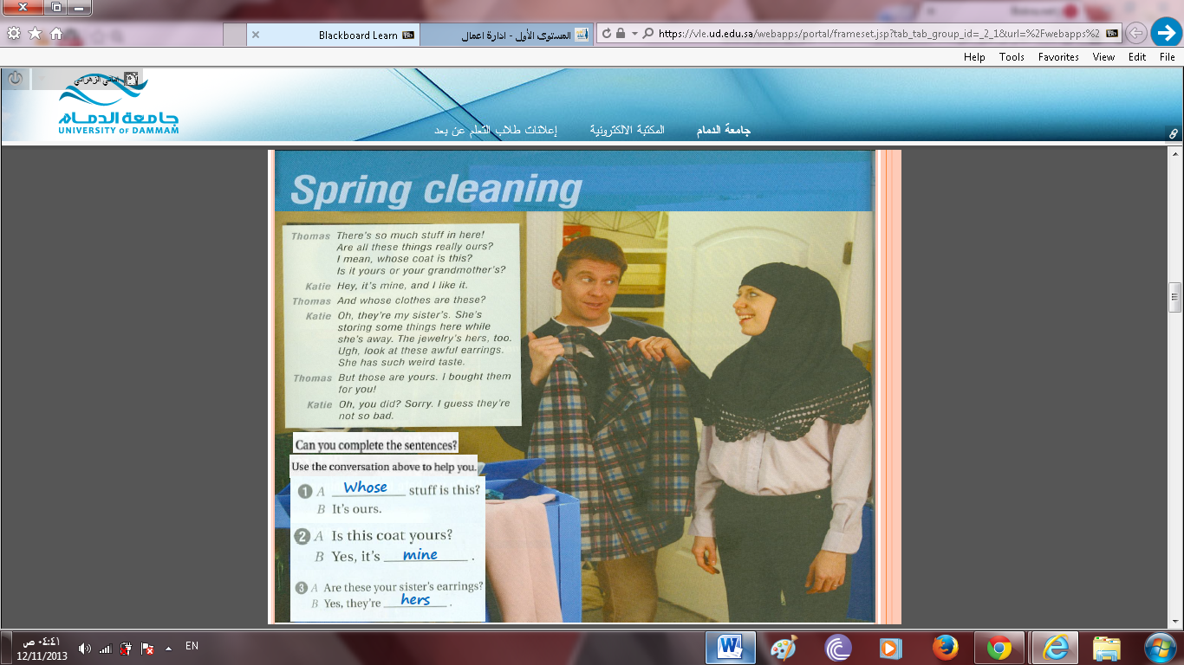

WHOSE . . . ?

Whose . . . ? = Who does this belong to?

Form

Whose + singular / plural noun + be + pronoun?
Whose coat is this?
Whose earrings are they?

Whose can be used in other patterns:
Whose jacket did you borrow?

POSSESSIVE ADJECTIVES

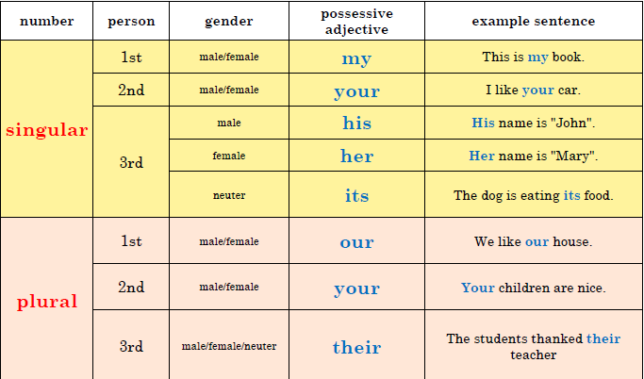
We use possessive adjectives to show who owns or "possesses" something. The possessive adjectives are:

POSSESSIVE ADJECTIVES EXERCISE

Complete the sentences with the right possessive adjective:
1.Two students didn't do _____________ mathematics homework.
2.I have a car. _____________ car is black.
3.We have a dog. _____________ name is Poncho.
4.Nancy is from England. _____________ husband is from Australia.
5.Sarah and Nadia go to a high school. _____________ little brother goes to primary school.
6.Mr. O'Brian has a van. _____________ van is very old.
7.We go to a high school. _____________ high school is fantastic.
8.I like swimming. _____________ brother swims with me.
9.Frank and Alan are French. _____________ family are from France.
10.Mary likes _____________ grandmother. She often visits her.

NOTES
Compare:

your = possessive adjective you're = you are
its = possessive adjective it's = it is OR it has
their = possessive adjective they're = they are there = adverb (I'm not going there / look over there / there is a car outside)
whose = possessive adjective who's = who is OR who has

POSSESSIVE PRONOUNS

We use possessive pronouns depending on:
number: singular (e.g.: mine) or plural (e.g.: ours)
person: 1st person (e.g.: mine), 2nd person (e.g.: yours) or 3rd person (e.g.: his)
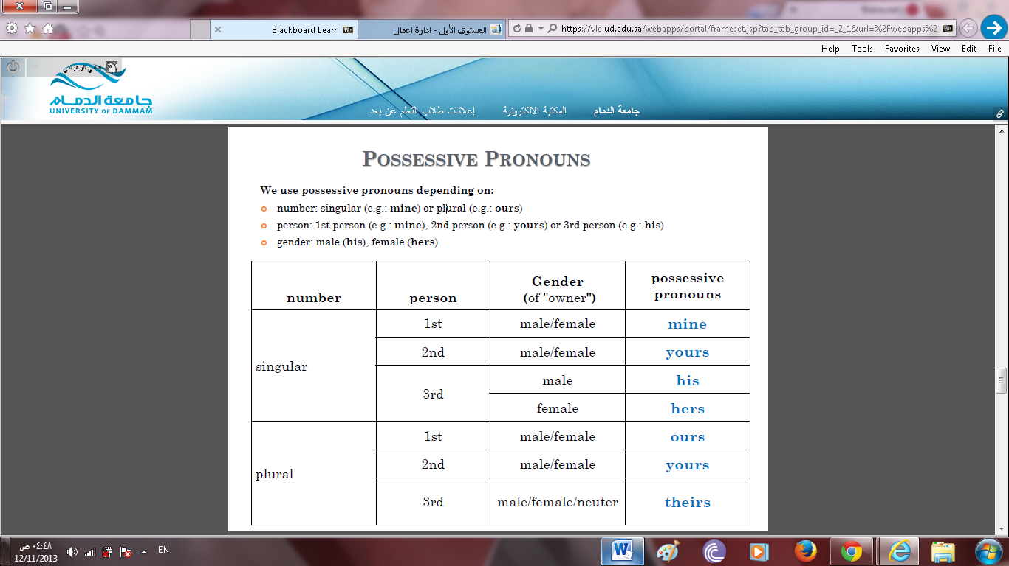
gender: male (his), female (hers)

EXAMPLES

Look at these cars. Mine is the white one. (subject = My car)
I like your pictures. Do you like mine? (object = my pictures)

I looked everywhere for your key. I found John's key but I couldn't find yours. (object = your key)
My flowers are dying. Yours are lovely. (subject = Your flowers)

All the essays were good but his was the best. (subject = his essay)
John found his passport but Mary couldn't find hers. (object = her passport)
John found his clothes but Mary couldn't find hers. (object = her clothes)

Here is your car. Ours is over there, where we left it. (subject = Our car)
Your photos are good. Ours are terrible. (subject = Our photos)

My shoes are Italian. Yours are Chinese. (subject = Your shoes)
I don't like this family's garden but I like yours. (subject = your garden)

These aren't John and Mary's children. Theirs have black hair. (subject = Their children)
John and Mary don't like your car. Do you like theirs? (object = their car)

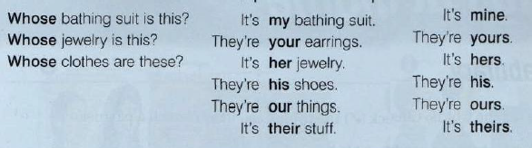
GRAMMAR

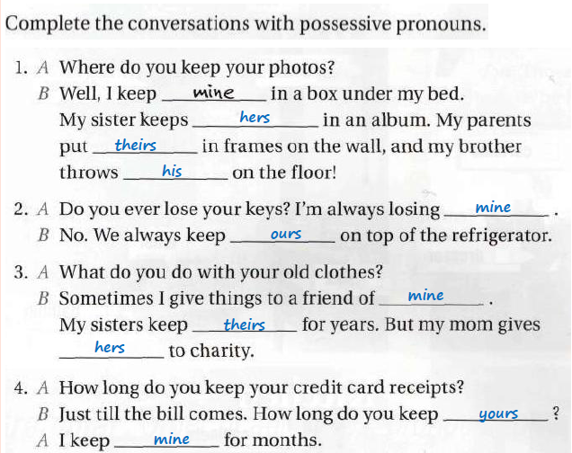

POSSESSIVE ‘S

When we want to show that something belongs to somebody or something, we usually add 's to a singular noun and an apostrophe ' to a plural noun, for example:

Ahmad’s car - Sami’s pen - Mary’s house - the boy’s ball

The friend of my father
My father’s friend

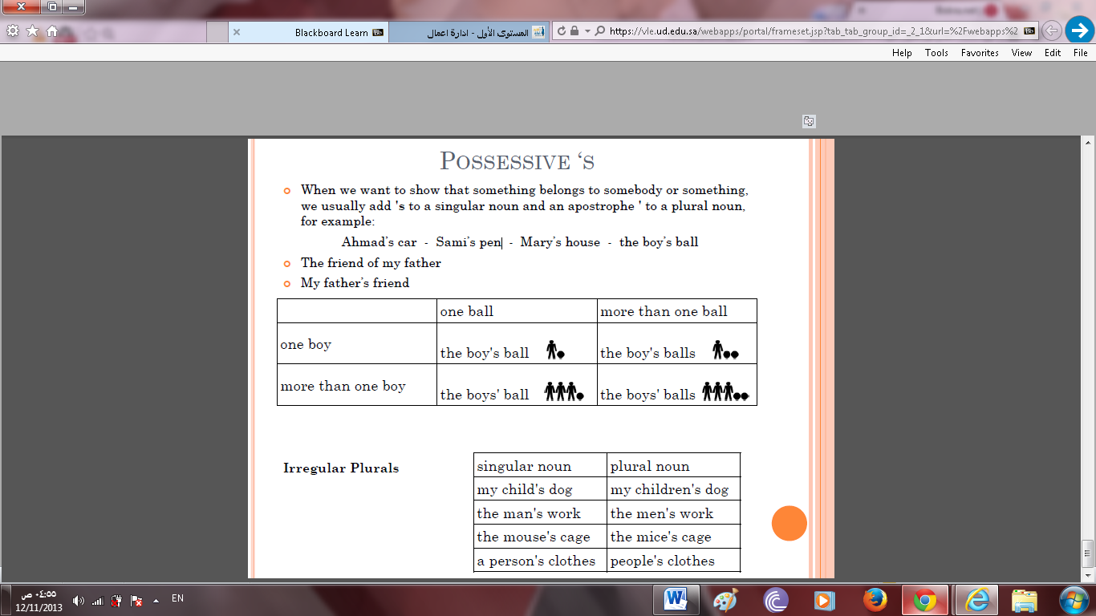

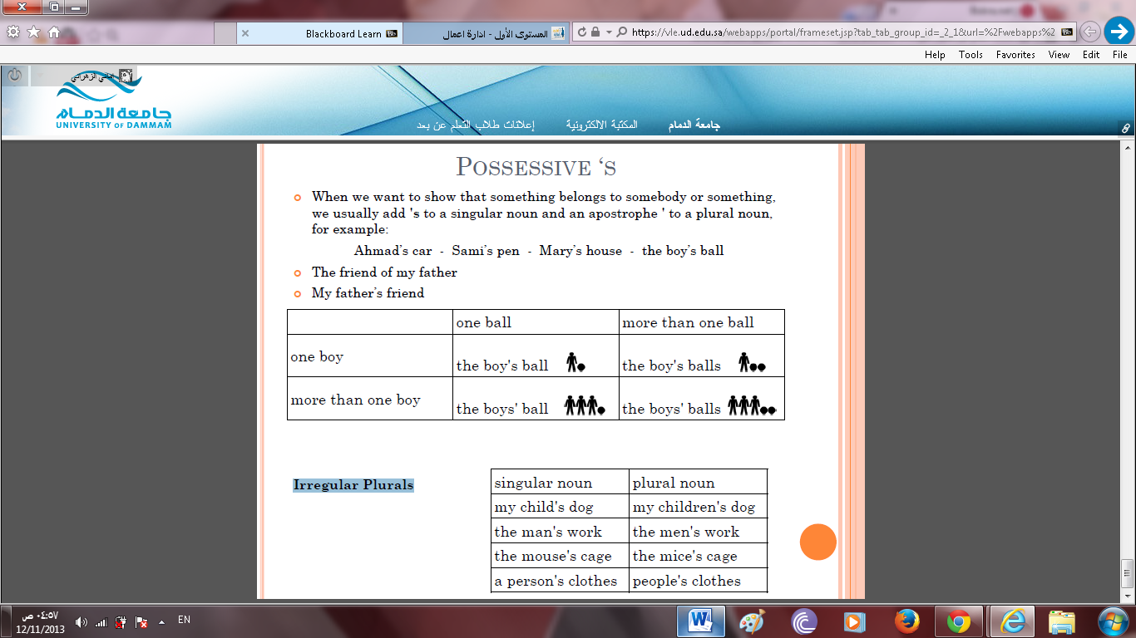

Irregular Plurals

