LECTURE 19 Unit 5 Growing up
Lesson C / well , actually
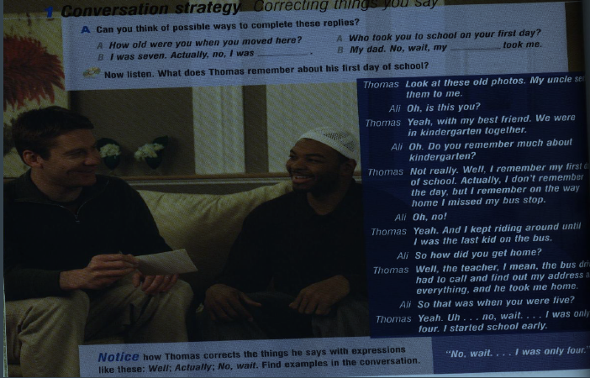
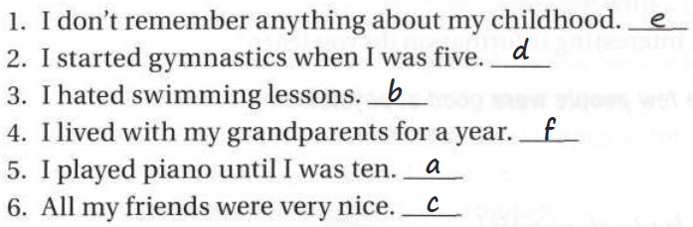
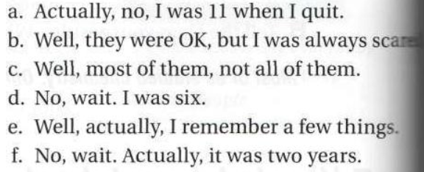
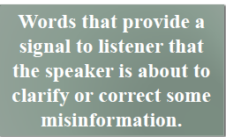
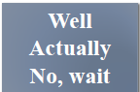
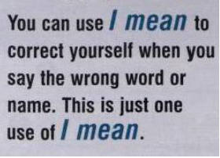
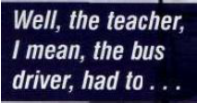
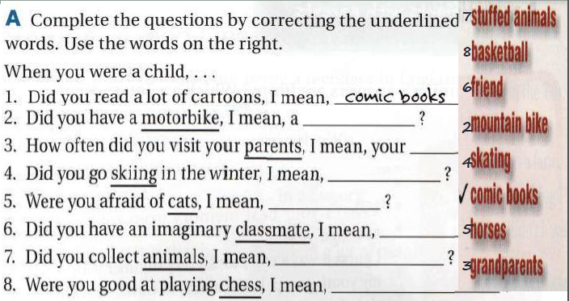

Linking Ideas
•Except (for) - apart from

We agreed on most things. We didn’t agree on soccer teams
We agreed on most things except for soccer teams.
We didn’t argue much. Still, we argued about soccer
We didn’t argue much apart from soccer.
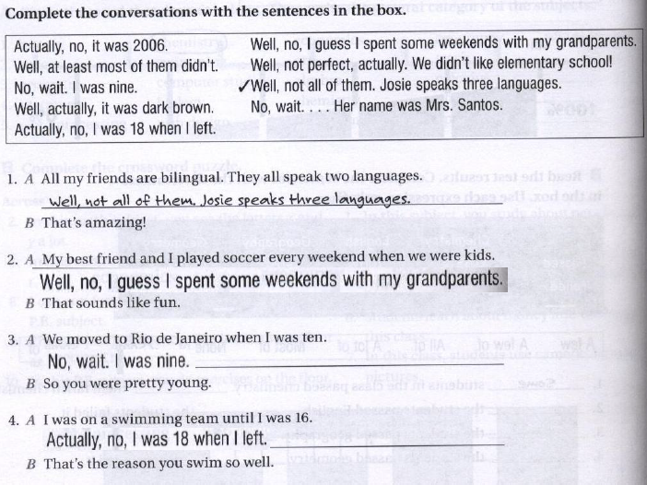
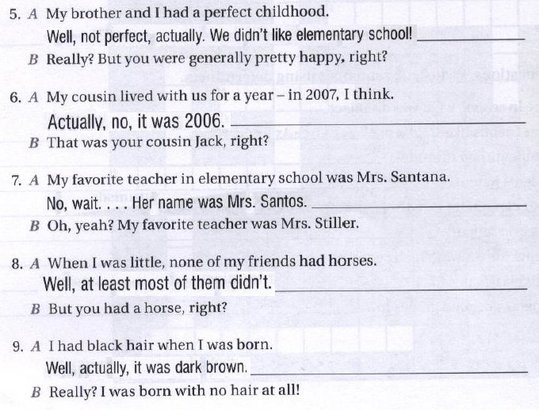
Simple Past: Past of be
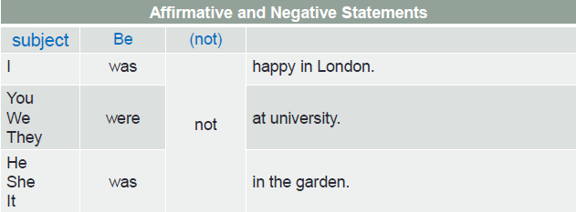

•You can contract negative statements:
was : wasn’t were : weren’t

Simple Past
•The simple past describes completed actions in the past.

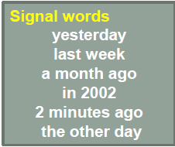
•Yesterday, I played basketball with my friends

•My father and I watched a match last weekend.

•The train stopped at the station.

•Ahmad took a Spanish class last week.

•Sarah stayed home and studied for the test.

Spelling of simple past verbs
•Add -ed after most verbs:
traveled – walked – talked – helped – answered

•Add -d after verbs that end in -e:
welcomed – improved – saved – liked – loved

If a one-syllable verb ends in vowel + consonant double the consonant and add -ed:
shop : shopped - plan : planned – stop : stopped

If the verb ends in a consonant + -y, change the y to i
and add -ed
study : studied – try : tried – hurry : hurried

If the verb ends in a vowel + y, add -ed:
play : played – stay : stayed

Simple Past :
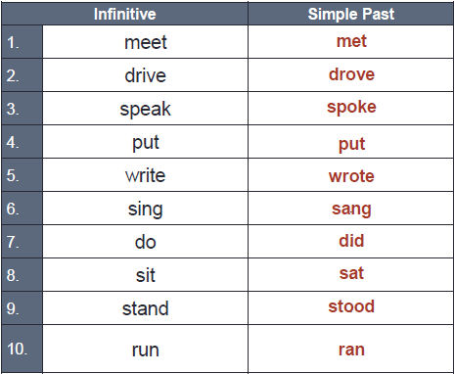
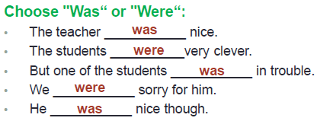

Write sentences in simple past.
•Janet / miss / the bus → Janet missed the bus.
•she / study/ her room → She studied in her room
•Nancy / watch / not / television→ Nancy didn’t watch television
•she / read / a book → She read a book
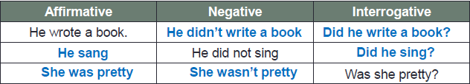
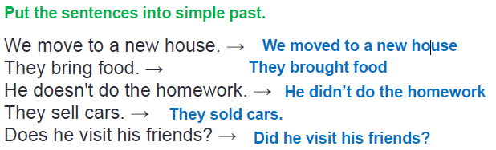
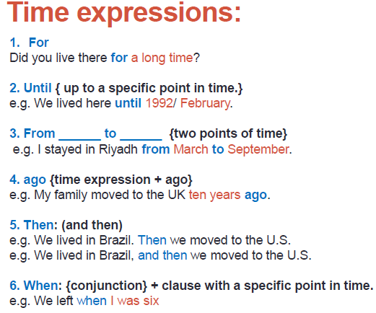
General Statement
.

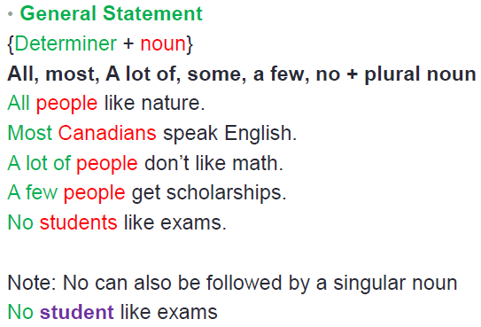

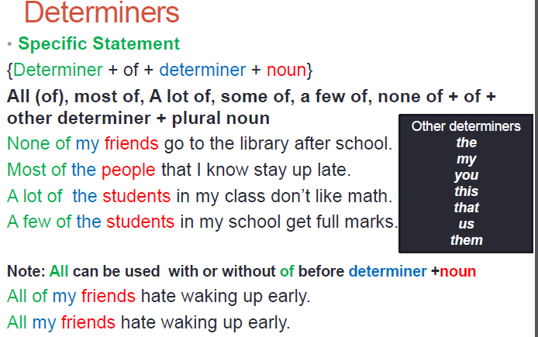

Building Vocabulary
