المسرحيه الحديثه

الواجب الاول
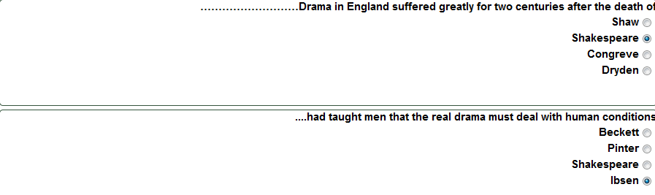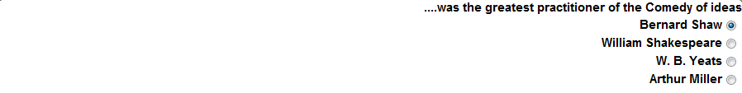
الواجب الثاني
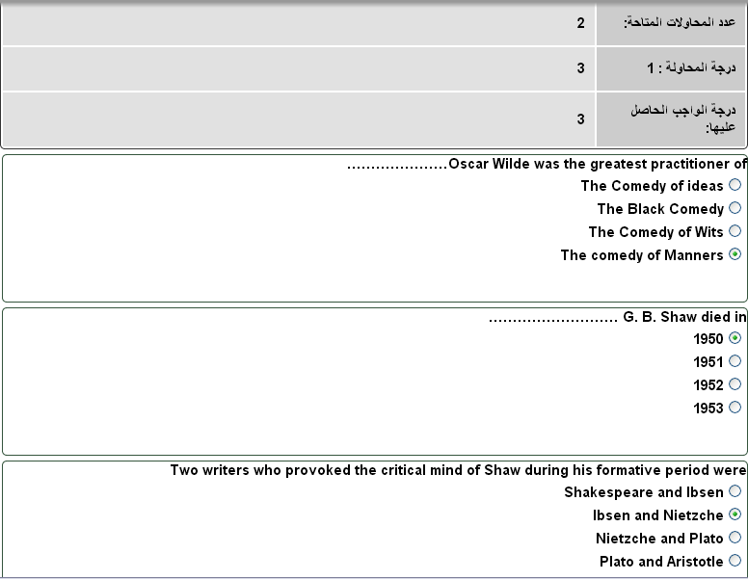

الواجب الثالث
1-It was only during the last …….. years of Wilde’s life that he turned his attention to writing for the stage
a- Four
b- Five
c- Six
d- Seven
2-Was written by Jhon Galsworthy......
a- Hamlet
b- A Doll’s House
c- The Dumb Waiter
d- The Silver Box
3-.....Before Ibsen tragedy had concerned itself with
a- Kings and queens
b- Animals
c- Ordinary people
d- Actors and actresses
4-is the man from whom Nora borrowed money eight years ago.
a- Dr Rank
b- Helmer
c- Krogstad
d- The porter

طرق البحث

الواجب الاول
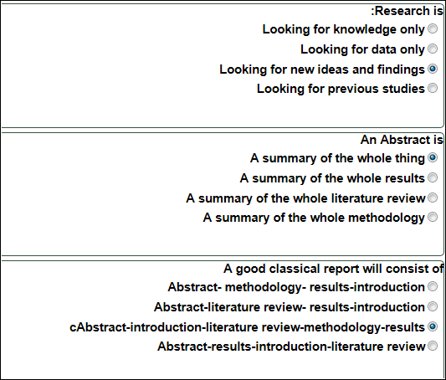

الواجب الثاني
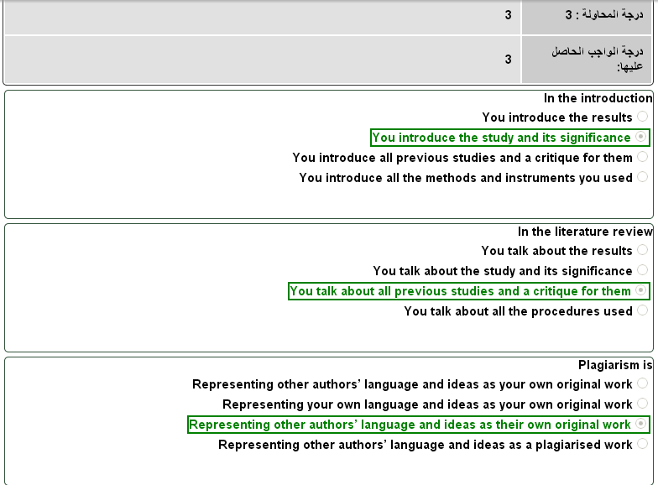
يوجد خطأ تقني في النظام الإفتراضي لمقرر طرق البحث وتصميم الأبحاث وهنا الشرح:
تلاحظون في الجواب الثالث من الفقرة الأخيرة معطينا صح (الأخضر) على:
Representing other author's language and ideas as your their original work
والصحيح هو الأول من الفقرة الأخيرة, وهو هذا :
Representing other author's language and ideas as your own original work
وحتى الدكتور في المحاضرة ال 14 حله مرة ثانية
لكن الواجب خطأ مع ذلك أعطانا علامة كاملة على أساس إنه صح
ولكن لو جاء في الامتحان النهائي لازم ننتبه بأن الحل ليس الذي في الواجب

^ مقتبسه من فضيل * يعني عدلو حله

الواجب الثالث
1-The dependent variable is
a-The variable that is affected by the independent variable
b- The variable that is dependent on the hypothesis
c- The variable that is affected by the abstract
d- The variable that is affected by the results
2-The significant difference has to be at the level of
a-P= 50
b- P=.05
c- P=.50
d- P=0.50
3-If you have one variable in your research, then it is
a- Multivariate
b- Univariate
c- Bivariate
d- factorial
4-We use questionnaires in research as a
a- tool to collect data
b- tool to analyse data
c- tool to generate results
d- tool to design research

ترجمة ابداعية
الواجب الاول
The dictionary definition of word ‘creative’ is
A. inventive and receptive
B. inventive and productive
C. inventive and communicative
D. inventive and imaginative
السؤال 2
Translation is considered as being creative when it is
a. novel and appropriate
b. new and relevant
c. fresh and imaginative
d. modern and productive
السؤال 3
The most appropriate translation of ‘"أَيُّهَا النَّاسُ، قَدْ فَرَضَ اللهُ عَلَيْكُم الحجَّ فَحُجُّوا
a. Oh people, Allah has made Hajj a must on you. So do it not."
b. Oh people, God has made Hajj obligatory on you. please do it."
c. Oh people, Allah has prescribed Hajj on you. So why you don’t do it."
d. Oh people, Allah has made performing Hajj obligatory on you. So do it

الواجب الثاني
Homework 2
1
One of the most appropriate approaches to translating poetry is

an aesthetic approach

a holistic approach

a communicative approach

a semantic approach

------------
2
The most appropriate Translation of ‘ كان يوماً ملتهباً كطفل نالت منه الحمى

It was a very hot afternoon as the child experienced the heat of a fever

It was a scorching summer afternoon. The heat was feverish

It was as hot as a child suffering from fever.

The day was as hot as a child with a fever

--------
3
The Translation of style in the context of literature is

awfully important

crucially unimportant

really unnecessary

significantly superfluous

الواجب الثالث
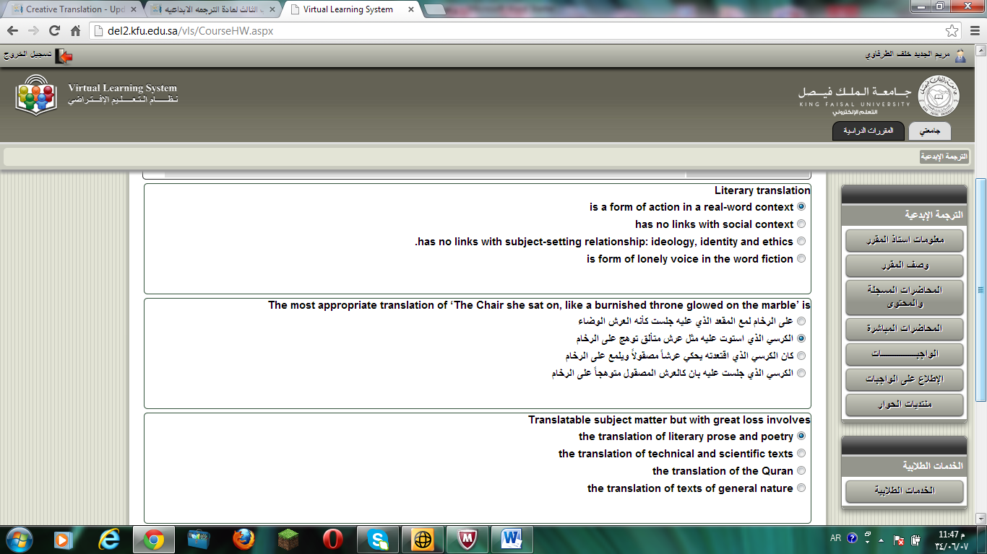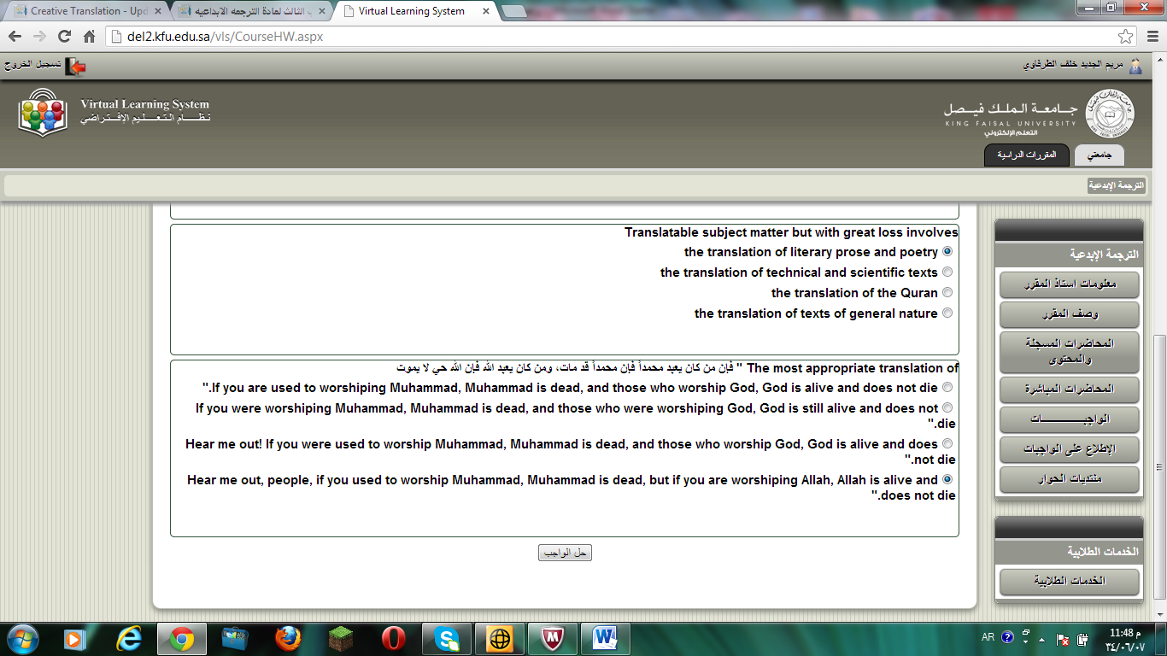

علم اللغه الاجتماعي
السؤال 1
When language is used …….. the speaker/writer can express his/her feelings or attitudes.
a. referentially
b. aesthetically
c. phatically
d. affectively
السؤال 2
is the actual use of language in both speech and writing........
إجابة a. Power
b. Langue
c. Parol
d. Bail
السؤال 3
According to The Sapir-Whorf Hypothesis, there is a .…….link between culture and language.
A. captive
B. active
C. causative
D. causal

الواجب الثاني
is the way that language can systematically vary according to the situation in which it is used
Registration
Registrar
Register
Resister
----
The prevailing way that a culture talks about or represents something is called
the domino discourse
the dominant discourse
the doming discourse
the committed discourse
---
terms refer to anything which deviates from the norm.
Marker
Maker
Marques
Marked
الواجب الثالث
- takes the difference in power between women and men as the main cause of discoursal variation .
a-Domineers Theory
b- Determination Theory
c- Dominance Theory
d- Difference Theory
2- Ethnic ….. members continue to participate in cultural, religious and linguistic practices which mark them as distinctive
a- minify
b-mortify
c- enormity
d- minority
3- Parents used ……… as a language-teaching tool.
a-Child Directed Language
b- Chilled Darted Lounge
c- Killed pierced linguist
d- Child-Directed jingoist
4- A Common …….. about women is that they talk more than men.
a-stereo tape
b- stereotype
c- steroids
d- steered shape

علم اللغه النفسي
و هذا الواجب الأول ..
Psycholinguistics studies:

A. how language is represented and processed in the mind
B. how language affects your psychological well being
C. how different languages can be learned
D. how words are organized in a dictionary

A (intended) You have wasted the whole term.
B (said) You have tasted the whole worm.
Sentence B is an example of:

A. a slip of a tongue
B. a syntactic error
C. a parsing problem
D. a priming effect

Lexical Decision is

A. a method used to understand how words are represented in the mind
B. a method used to organize words in a dictionary
C. a method used to analyze words using a computer
D. a method used to measure how many word are in the brain

الواجب الثاني :
Event-related potentials (ERPs) is an experiment that:
A. measures electrical activity in the brain
B. measures the potential to learn a language
C. measures the speed of someone's speech
D. measures the time of a learning event

Bottom-up processing is:
A. a phonetic analysis used to relate sounds to items in the mental lexicon
B. a morphological analysis used to relate sounds to items in the mental lexicon
C. a syntactic analysis used to relate sounds to items in the mental lexicon
D. a semantic analysis used to relate sounds to items in the mental lexicon

The psycholinguistic study of morphological processing:
A. seeks to understand how morphological principles play a role in the representation of words in themind
B. seeks to create a computer programs that work as word processors
C. seeks to analyze words and phrases in the sentences with speech errors
D. seeks to understand how computer word processors can be used to enhance language acquisition

أسئلة الواجب الثالث جات كلها

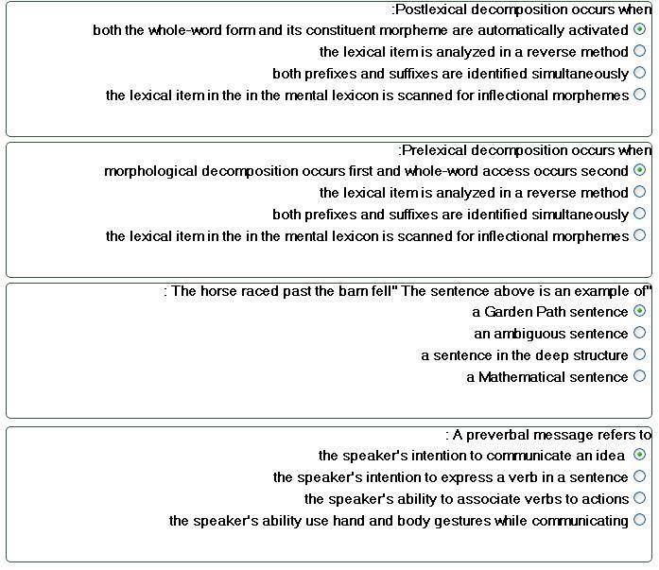

هنا اسئله مهمه لمادة علم اللغه النفسي وجات بالامتحان
A. Said: "I can't cook worth a cam".
B. Intended: "I can't cook worth a damn".

^^^
يقول هنآ المثآل يدل على ايش او مثال على ايش :

1-Plural attraction
2-Preservation error
3-Anticipation error
4-Segment exchange error

a. The time for fun and games are over.
b. The illiteracy level of our children are appalling

1-Plural attraction
2-Preservation error
3-Anticipation error
4-Segment exchange error

A. Said: "taddle tennis".
B. Intended: "paddle tennis".

1-Plural attraction
2-Preservation error
3-Anticipation error
4-Segment exchange error

A. Said: "hass or grash".
B. Intended: "hash or grass".
1-Plural attraction
2-Preservation error
3-Anticipation error
4-Segment exchange error

postlexicon decomposition:
Both the whole-word form and its constituent morpheme are automatically activated

prelexicon decomposition :
Morphological decomposition occurs first and whole-word access occurs second

تعاريف :
Cohort Model is :
consist of all the lexical items that share an initial sequence of phonemes

language is species specific is :
language is likely to be part of the genetic makeup of members of the species

universal Grammar is :
language of the world are are similar because all humans have the same language capacities

Neurolinguistic is :
the study of the representation of the language in the brain

aphasia is :
a language impairment linked to brain injury

non fluent aphasia known as :
Broca's Aphasia

fluent aphasia known as :
Wernicke's aphasia

language lateralized is :
language function is located in one of the two hemispheres

Contralateral is :
the left hemisphere controls the right side of the body and the right hemisphere controls the left side of the body

Dichotic listening experiment is :
given two different inputs to each ear at the same time

Barrowing is :
is incorporated into the lexicon of another language

unilingual mode is :
only one language
bilingual mode is :
Has two language

Grammatical encoding is :
the creation of sentence structure during sentence planning

Tip of the tongue Phoneme :
the speaker knows the word but cannot retrieve it

interlocutor is :
Participate in conversation

Orthorgraphy is :
writing system

سأل عن الـ Acquisition

جاب سؤال عن ثنائي اللغه
وعن الاكتساب ..
وو آلـ cohort ..

* هذه شرحها موجود في المحاضرات الأخيرة من المحتوى

Uni Langual Mode
Bilingual Mode

Code- Switching
Grammatical Eencoding
Plural Attraction
Preverbal Message

مثل:هذا جاء ايضا بالامتحان

Postlexical Decomposition
Prelexical Decomposition

أيضاً:

Garden Path sentence
Lexical Retrieval
Introlocutor
Laguage Transfer

رسمة الدماغ في المححاضره 7 ونفس الرسمه في الكتاب ص 83 :
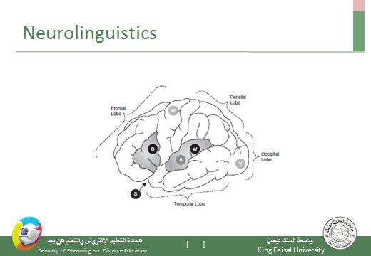
الدكتور ذكر الاجزاء الرئيسيه الاربعه بالمحاضره
1- frontal Lobe
2- parietal Lobe
3- occipital Lobe
4- temporal Lobe
وباقي الاجزاء :
5- M motor
6- A auditory
7- V visual
8- S sylvian fissure
9- W wernickc's area
10- B broca's area

بالاضافه الى رسمة النحو
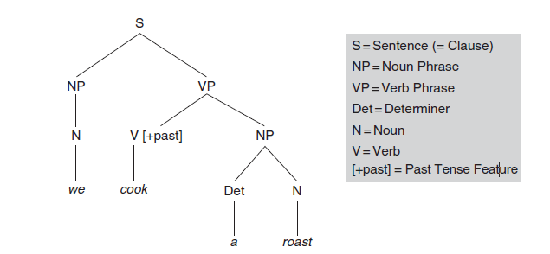

+رسمة اجزاء الفم في المحاضره 14

بالتوفيق :*بحّه ☺

