Lecture 12

Structural Processing (1)

Contents
The Psychological Reality of Syntactic Structure
The clause as a processing unit
Structural ambiguity
Building Structure
The parser and its properties
Gap vs. fillers
Pronominal referents

The Psychological Reality of Syntactic Structure

Syntactic units (e.g. subject NPs and predicate VPs)
are NOT labeled as such in the signal. Yet psycholinguists think that hearers systematically compute syntactic structure while processing sentences, as illustrated below:

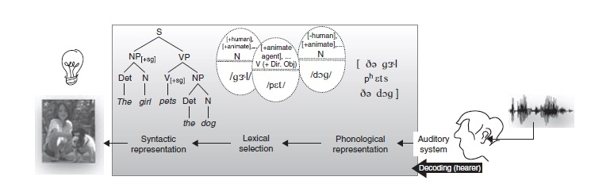

(The clause as a processing unit)
Clause boundary: the location where a new clause begins.
Compare these two sentences:
a. In her hope of marrying Anna was surely impractical.
b. Your hope of marrying Anna was surely impractical.

During listening, your mind “cuts” the received auditory input into clauses (segments). This process helps you understand auditory signal.

(Structural ambiguity)

Structural ambiguity: one sentence with more than one meaning.
For example:
The man saw the boy with the binoculars

(the boy is carrying binoculars) (the man saw the boy using binoculars)

Often, an ambiguous sentence can be disambiguated when put into context

Building Structure:

During the process of perception, the brain works like a parser (parsing is the mental process of building syntactic structure out of the linear set of words during listening to texts).
There are properties of the parser:
    - It prefers simple structures rather than complex structures
    - It computes relationships between words rapidly and efficiently
    - It breaks down complex sentences to simpler sentences
    - It responds differently to morpho-syntactic violations (e.g. syntactically wrong sentences)

(Gaps and fillers)

One function of the syntax is to move elements of a sentence
around. An element that has been moved is called a filler, and it has left a gap at its original position:
Mike drove the red car
Which car did Mike drive [ ]?

[filler] [gap]
In order to create structures that represent sentence meaning, when it encounters a filler, the parser must identify the location for its gap.

(pronominal referents)

Pronouns refer to noun phrases, the job of the parser is to locate which NPs these pronouns refer to:
The teacher saw the student and asked him to do an extra homework.

Exercise

The parser:

- Computes relations between words
- Prefers simple structures
- Responds to morpho-syntactic violations differently
- All of the previous items are correct

The answer is (D).

