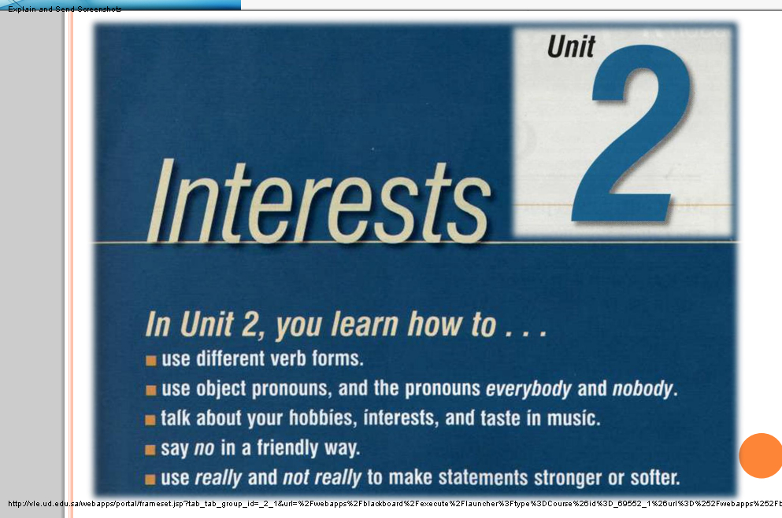
Lecture 7

LESSON A: LEISURE TIME

In this Lesson

You learn how to use different verb forms.

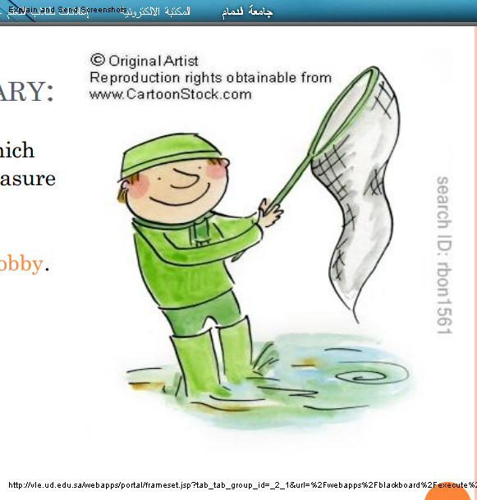
NEW VOCABULARY:

Hobby: an activity which

someone does for pleasure

when they are not

working.

e.g. I like to fish as a hobby.
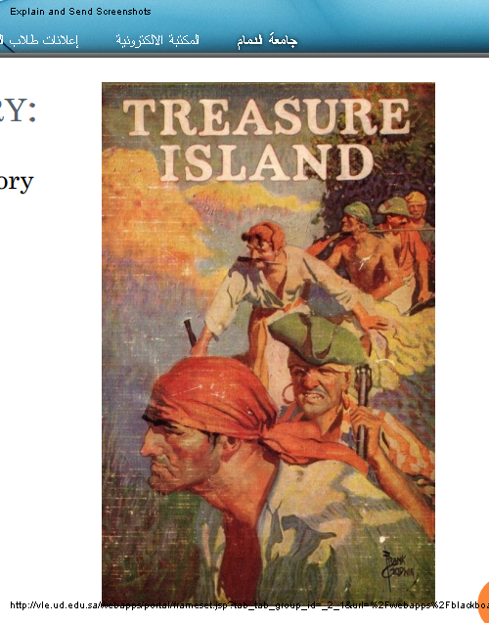

NEW VOCABULARY:

Novel: ﻿a long printed story

about imaginary

characters and events.

e.g. historical/romantic﻿

novels.

NEW VOCABULARY:

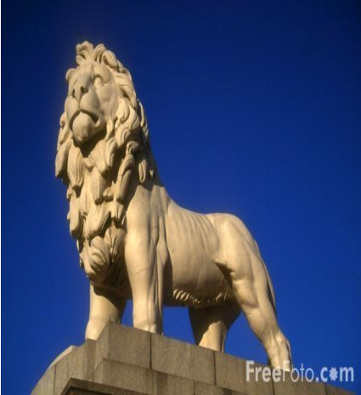
Sculpture: the art of

forming solid objects that

represent a thing, person,

idea, etc. out of a material

such as wood, clay, metal

or stone.

e.g. Tom teaches sculpture at

the local art school.

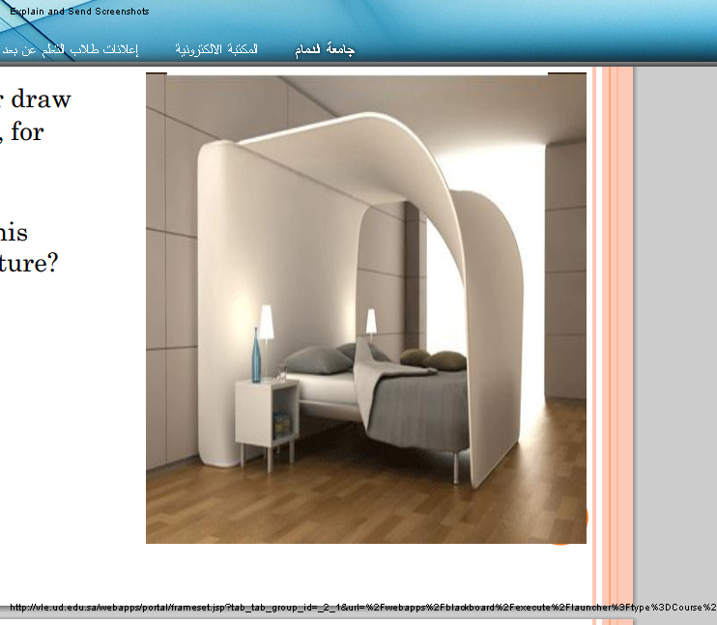
NEW VOCABULARY:

Design: to make or draw

plans for something, for

example clothes or

buildings.

e.g. Who designed this

building/dress/furniture?

NEW VOCABULARY:

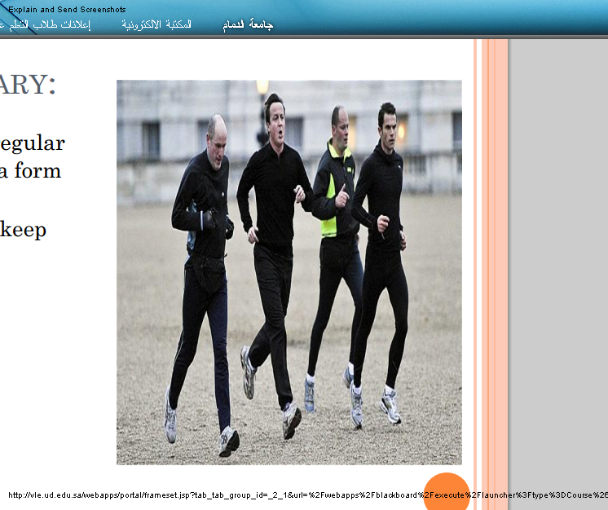
Jog: to run at a slow regular

speed, especially as a form

of exercise.

e.g. What do you do to keep

fit?" "I jog and go

swimming."

LESSON A: LEISURE TIME

Can you paint?

Are you good at sports?

Are you interested in

learning new things?

What else do you enjoy
doing in your free time?
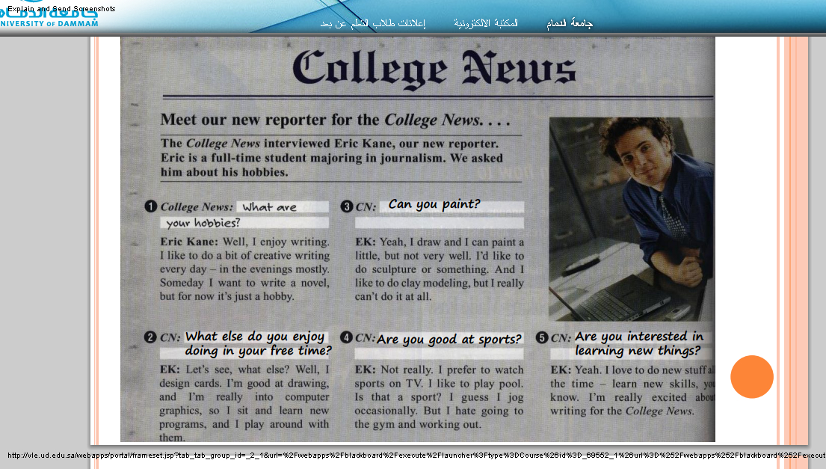

CAN YOU COMPLETE THESE SENTENCES WITH VERBS?

1- I can ___________ pool. (play)

2- I like ___________________ sports on TV. (watch)

3- I enjoy __________ books. (read)

4- I’m not good at ___________ new computer programs. (learn)

CAN

Can is an auxiliary verb, a modal auxiliary verb.

We use can to:

* talk about possibility and ability
* make requests

* ask for or give permission

Structure of Can

subject + can + main verb (base verb)
 | Main  Verb | Auxiliary  Verb | Subject
tennis | play | can | I | +
tennis | play | Cannot  can‘t | He | _
tennis? | play | you | Can | ?

The main verb is always the bare infinitive (infinitive without "to"). We cannot say:

I can to play tennis 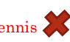

Use of Can

1-can: Possibility and Ability

He can drive a car.*

*John can speak Spanish.

*I cannot hear you. (I can't hear you).

Can you hear me?*

2- can: Requests and Orders

* Can you make a cup of coffee, please.

* Can you put the TV on.

* Can you come here a minute.

* Can you be quiet!

3- can: Permission

* Can I smoke in this room?

* You can't smoke here, but you can smoke in the garden.

GRAMMAR: VERB FORMS
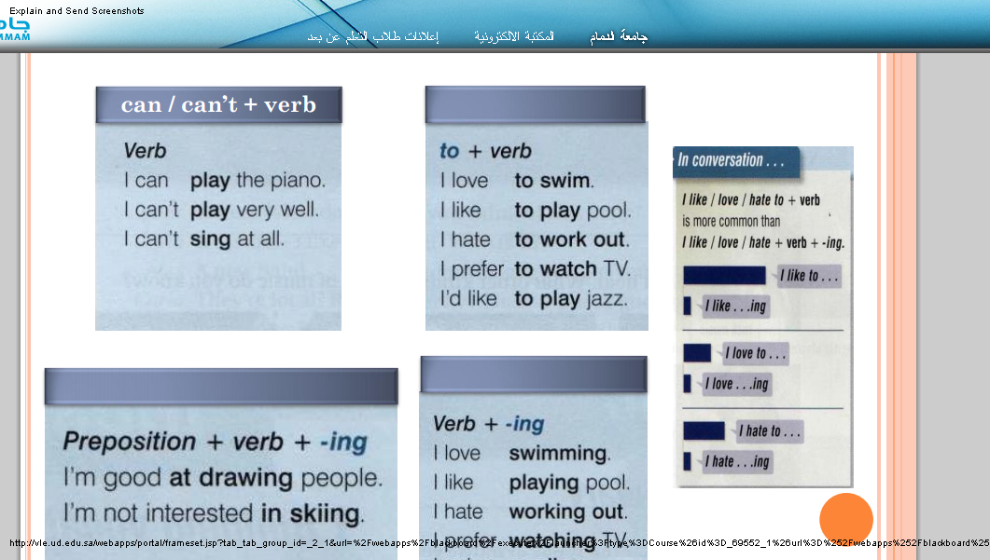

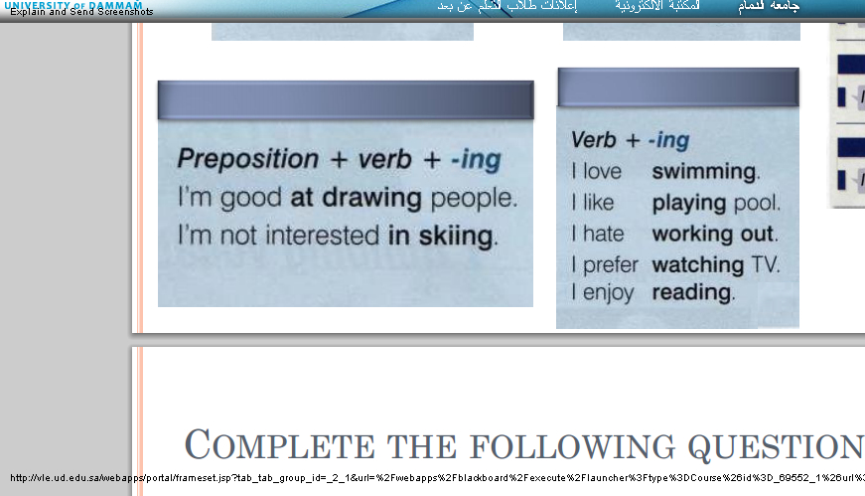

COMPLETE THE FOLLOWING QUESTIONS

1- Can you _______________________________ (speak) Spanish?

2- Do you enjoy _______________________________ (cook)?

3- Are you good at _______________________________ (skate)?

4- Do you like _______________________________ (play) table tennis?

5- Can you _______________________________ (swim)?

6- Are you interested in _______________________________ (join) am exercise class?

7- Do you prefer _______________________________ (exercise) alone or with friends?

8- Would you like _______________________________ (learn) a new sport?

100 0% of interest% of interest

I can’t stand | I don’t care | I like | I love

* I can’t stand washing dishes.

* I don’t care about music 0%

* I like to watch movies.

* I love going to the beach

100%

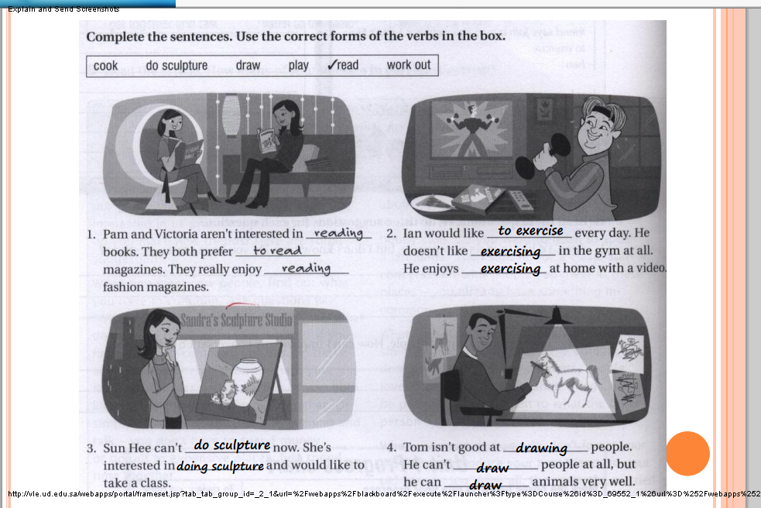
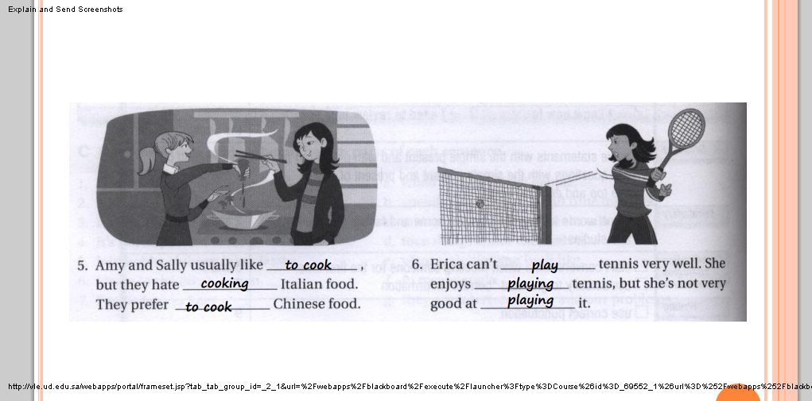

LESSON B: BOOKS

In this lesson,

You learn how to use object pronouns, and the

pronouns everybody and nobody.

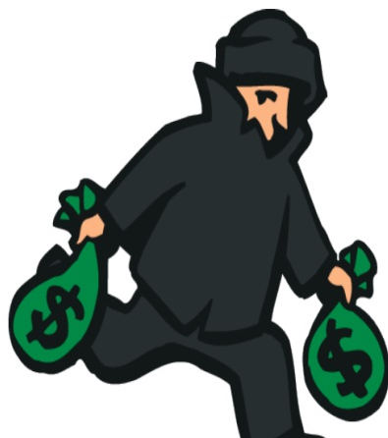
:NEW VOCABULARY

Crime: illegal activities.

e.g. He has admitted

committing﻿ several

crimes, including two

murders.

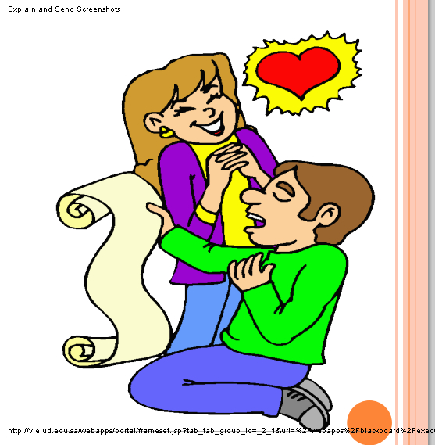

:NEW VOCABULARY

Poetry: ﻿poems in

general as a form of

literature.

e.g. She started writing

poetry at a young age.

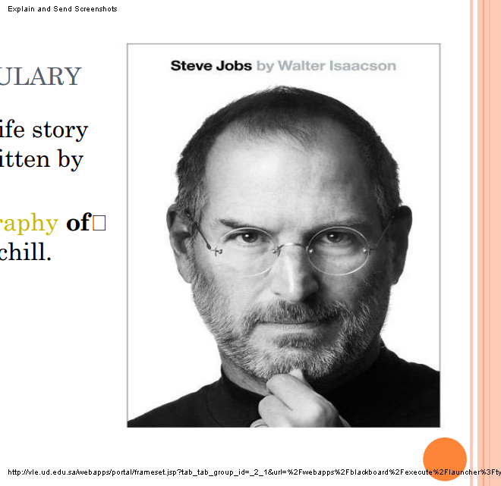
NEW VOCABULARY:

Biography: the life story

of a person written by

someone else.

He wrote a biography of﻿

Winston Churchill.

:NEW VOCABULARY

Mystery: a book, film or

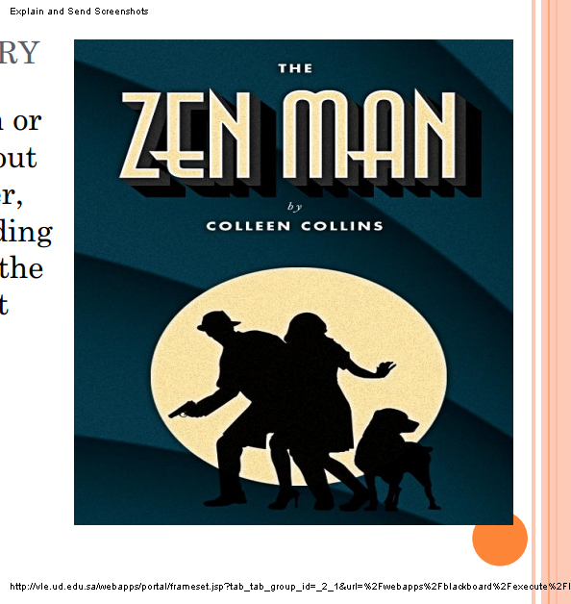
play, especially about

a crime or a murder,

with a surprise ending

which explains all the

strange events that

have happened.

e.g. I really enjoy

murder﻿ mysteries.

:NEW VOCABULARY

Science: ﻿(knowledge from)

the systematic﻿ study of

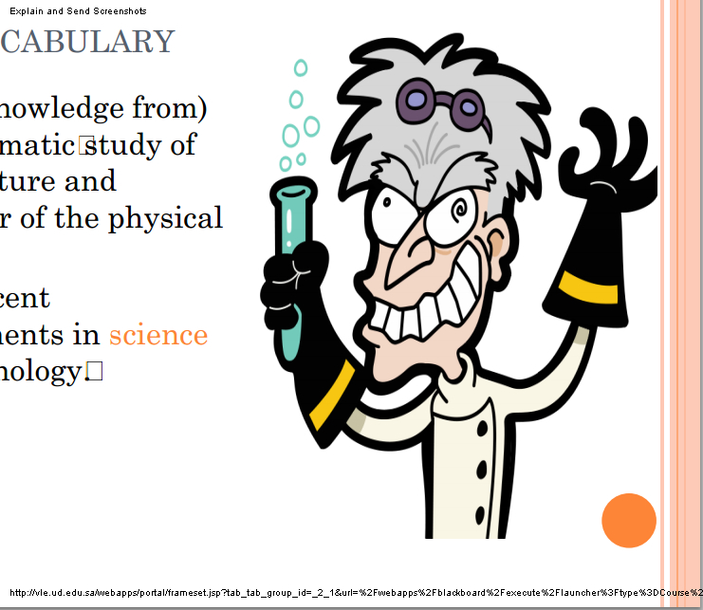
the structure and

behavior of the physical

world.

e.g. The recent

developments in science

and technology

﻿

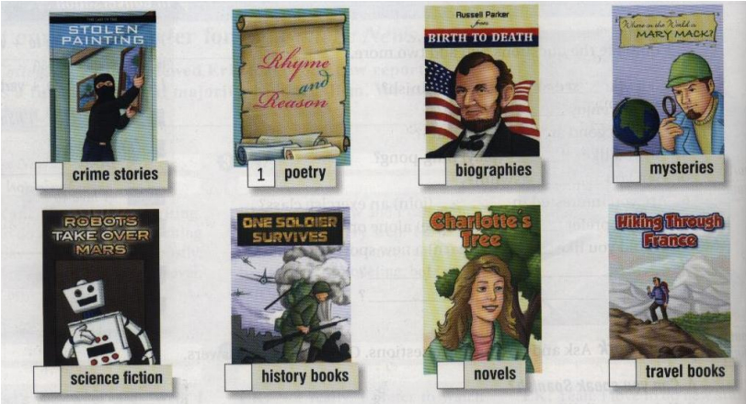
BOOKS
