Lecture 9:
Heart of Darkness: Background
The Modern Novel
Joseph Conrad: 1857-1924
- born Józef Teodor Conrad Korzeniowski in Russian occupied Ukraine
- 1874 joined French merchant marines, later the British
- 1886 became British citizen
- 1890 traveled to Congo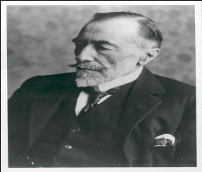
- Major works
- The Nigger of the Narcissus (1897)
- Lord Jim (1900)
- Nostromo (1904)
- The Secret Agent (1907)
- The Secret Sharer (1909)
- Heart of Darkness (1899, 1902)
- According to Conrad, it is based on real events–
- Conrad is "Marlow" in the novella.
- Conrad, born in Russia of Polish parents, did not learn to speak English until he was in his late 20s, yet he wrote Heart of Darkness in English and is considered to be a British novelist and one of the best prose writers in the English language.
- Heart of Darkness: background
- According to Conrad, it is based on real events–
- Conrad is "Marlow" in the novella.
- Conrad, born in Russia of Polish parents, did not learn to speak English until he was in his late 20s, yet he wrote Heart of Darkness in English and is considered to be a British novelist and one of the best prose writers in the English language.
- Heart of Darkness is set in the Congo at the time of the Belgian colonization
- Africa was the last continent to be overtaken by Europeans
- There was a big push to colonize by Britain, France, Germany, Netherlands, and Belgium.
- There was no regard for the native inhabitants. Millions of Africans were killed and maimed or worked to death.
- KING LEOPOLD II of Belgium
- 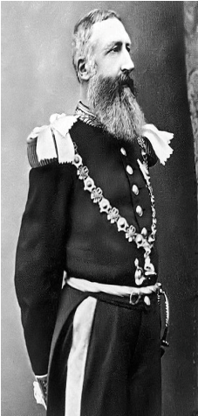
- Leopold II became king of Belgium in 1865
- He was greedy, inept, and unscrupulous.
- Leopold had an inferiority complex due to his small stature and because Belgium was small and weak.
- He wanted to acquire colonies and compete politically with the big powers like France and England
- The Colonization of the Congo
- In 1876 [Leopold] organized a private holding company disguised as an international scientific and philanthropic association.
- In 1879, under the auspices of the holding company, he hired the famous explorer Henry Morton Stanley to establish a colony in the Congo region”
- (http://www.reference.com/browse/wiki/ Leopold_II_of_Belgium)
- Leopold II financed exploration of the Congo area, laid claim to it, and made it his private colony.
- It belonged to the man, not to the country of Belgium. It was therefore called a "crown colony."
- Profits from the area went into his own pocket, not into the treasury of Belgium
- The Congo Free State
- Belgian Congo area was larger than Britain, France, Spain, Italy and Germany combined.
- Leopold called it the "Congo Free State."
- Later it became known as Zaire and is now called Democratic Republic of Congo
- 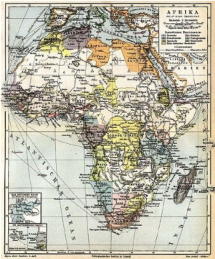
- Congo Free State is called by Adam Hochschild, author of the book King Leopold’s Ghost, "the world's only colony claimed by one man”
- The Belgian Congo under Leopold’s rule became an example of how terrible colonial rule can be.
- The native people were treated as commodities, and atrocities were committed against them
- Leopold hired the famous explorer Henry Morton Stanley to get control of the Congo.
- Stanley cut a deal with the chiefs of the native tribes and got economic control.
- Leopold realized that huge profits rely on forced labor, so it became illegal to pay an African for his work
- Rubber and Ivory
- Leopold declared a monopoly on rubber and ivory.
- His agents in the Congo were given the freedom to use as much force as necessary to get the rubber and ivory.
- Their profits were based on the total amount extracted, so it was to their advantage to work the natives mercilessly.
- Leopold set up a mercenary force called the Force Publique - 19,000 members, most of them Africans. They controlled Congo Free State for Leopold for 23 years between 1885 and 1908, and helped him extract rubber and ivory from the area
- Forced Labor
- The Force Publique took over native villages in areas where there was rubber or ivory to be harvested.
- They made the natives work for them but did not pay them--it was illegal to pay an African for his work. This is called “forced labor.”
- The only difference between forced labor and slavery is that the workers in forced labor situations are not actually owned by other people.
- Forced labor is even worse than slavery because in slavery, the “owner” is anxious to protect his “property” and has to feed them and clothe them. In Forced labor, the worker work for free and are responsible for their own food etc.
- Leon Rom and Kurtz
- The head of the Force Publique was Leon Rom, a ruthless and cruel man who decorated his yard with a fence featuring human skulls on posts and a garden with a rockery of human skulls of dead natives
- Rom kept a gallows permanently erected in his station to intimidate the workers
- The character Kurtz in the novella is based on Leon Rom.
- Leon Rom and Kurtz
- The Force Publique went into villages and captured the natives for forced labor.
- The women and children were separated from the men and held hostage until the men brought in their quota of rubber or ivory.
- If a worker didn't meet his quota, sometimes the Force Publique would motivate him by cutting off the hand or foot of one of his children
- 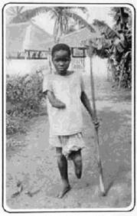
- Leon Rom and Kurtz
- The Men wore a numbered metal disk on a string around their necks. An accountant kept track of how much ivory or rubber each worker brought in.
- The Force Publique sold the women back to the natives when they were finished in the area.
- Leopold claimed that his goal was ultimately humanitarian-
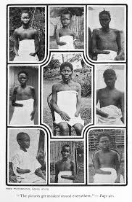
Heart of Darkness
- Conrad, author of Heart of Darkness, said that Heart of Darkness is a documentary--the things described in it really happened.
- Conrad actually did go to the Congo and was the captain of a steamboat on the Congo River. Heart of Darkness is a record of his experience.

- Marlow in the novella = Joseph Conrad
- Kurtz in the novella = Leon Rom, head of the Force Publique
- Further Reading
- To find out more, Read
- King Leopold's Ghost, by Adam Hochschild

