Lecture 5:
Early Novels and Novelists – Robinson Crusoe 2
The Modern Novel
Reception
- published on April 25, 1719
- Before the end of the year, this first volume had run through four editions.

- Within years, it had reached an audience as wide as any book ever written in English.
By the end of the 19th century, no book in the history of Western literature had had more editions, spin-offs and translations than Robinson Crusoe, with more than 700 such alternative versions, including children's versions with mainly pictures and no text
Version
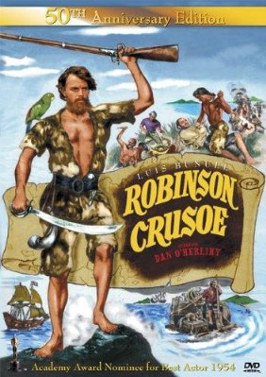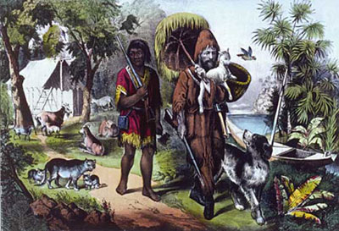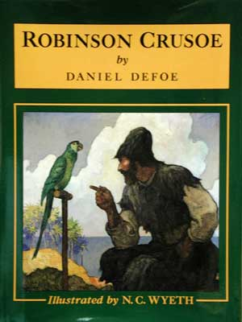

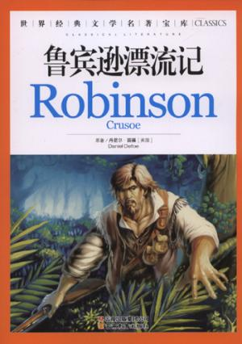
- The term "Robinsonade" was coined to describe the genre of stories similar to Robinson Crusoe.
- Defoe went on to write a lesser-known sequel, The Farther Adventures of Robinson Crusoe.
- It was intended to be the last part of his stories, according to the original title-page of its first edition but a third part, Serious Reflections of Robinson Crusoe was written; it is a mostly forgotten series of moral essays with Crusoe's name attached to give interest.
- Themes: colonialism

- Robinson Crusoe is the true symbol of the British conquest: The whole Anglo-Saxon spirit is in Crusoe.
- Crusoe attempts to replicate his own society on the island: application of European technology, agriculture, and even a rudimentary political hierarchy.
- The idealized master-servant relationship between Crusoe and Friday.
- Crusoe represents the “enlightened European.” Friday is the “savage” who can only be redeemed from his supposedly barbarous way of life through the assimilation into Crusoe's culture.
- Nevertheless, within the novel Defoe also takes the opportunity to criticize the historic Spanish conquest of South America.
- Themes: Religion
- Robinson is not a hero, but an everyman--a wanderer to become a pilgrim, building a promised land on a desolate island.
- Robinson becomes closer to God, not through listening to sermons in a church but through spending time alone amongst nature with only a Bible to read.
- Defoe's central concern is the Christian notion of Providence.

