المحاضرة التمهيدية
Orientation and introduction
Orientation and Introduction:
Course Objectives and aims.
Textbook and course contents.
Course objectives:
1- To familiarize the students with basic structures of English.
2- To introduce the English verb tenses.
Textbook and course contents:
Interactions 2 (Grammar).
The present simple.
The present progressive (continuous).
The past simple.
The past progressive (continuous).
The future.
The future progressive (continuous).


Lecture 1
The Present Simple
Lecture Summary:
Present Simple uses.
Structure.
Spelling Rules.
Practices.
Simple Present Tense: Uses:
Everyday activities: What do you do every day?
Routines, habits
General truths
What do these people do?
Bake answer telephone, type, file, take messages
cut / style hair sell
build serve, help customers
deliver teach
draw / design research, do experiments
drive wash dishes
fix / repair plumbing, appliances clean, wax
fly weld
garden
guard
manage / supervise
paint
use a computer / program
Third Person:
He / She / It
Singular subject (my friend, the boss, a co-worker)
Verb + s
Goes, works, talks, does, speaks
Spelling rules: Third person verbs in simple present tense:
- teach research wash push
Third Person Spelling Rules:
Pass fix wax
Rule 1: verbs ending in –ch, -sh, -ss, and –x + es
- fly dry try study
Rule 2: final consonant + y -> delete((- y ))+ ies
- do go have
Find and correct the mistakes:
- I’m work for a very good company, and I also student at MiraCosta College.
- The manager talkes with all employees once a week.
- The manager and I has a meeting today.
- The company’s profits looks good.
- The technician fixxes any computer problems we have.
- Everybody working hard every day, and company morale is high.
- The people in this company really likes working here.

Negatives in Simple Present Tense:
Change these to negative:
- I work.
- I like my job.
- They have benefits.
- We have a nice boss.
Change these to negative:
- She has a lot of experience.
- He drives to his work.
- The new employee comes early.
- My co-worker talks to me.
- I / you / we / they
Plural subject (the workers, the people)
+ do not (don’t) + verb
- He / she / it
Singular subject
+ does not (doesn’t) + verb (no –s)
Questions in Simple Present Tense:
Change these statements to questions:
- I work.
- I like my job.
- They have benefits.
- We have a nice boss.

Change these statements to questions:
- She has a lot of experience.
- He drives to his work.
- The new employee comes early.
- Your co-worker talks to you.
Questions in Simple Present Tense
- Do + I / you / we / they + verb + ?
- Does he / she / it + verb + ?


Lecture 2
The Present Simple
Lecture Summary:
Present Simple – summary.
Negative.
Questions.
Practices.
And again:
I / You / We / They + do not / don’t + verb1 + Rest of sentence
We don’t visit the moon
SNOB:
Don’t forget the snobs. He She It. They are very tricky. They also take the verb DO it becomes DOES
But the verb looses --< s
It snows in the winter.
It does not /doesn’t snows in the summer
LET’S PRACTISE:
Write in negative:
My cat has a swimsuit.
2) Dan and Dana catch frogs.
3) Robots eat hot dogs.
Write in negative:
My cat has a swimsuit.
My cat doesn’t have a swimsuit.

2) Dan and Dana catch frogs.
2) Dan and Dana don’t catch frogs
3) Robots eat hot dogs.
3) Robots don’t eat hot dogs.
Simple Present Tense- Negative:
Change these statements to questions:
- I work.
- I like my job.
- They have benefits.
- We have a nice boss.
Change these statements to questions:
- She has a lot of experience.
- He drives to his work.
- The new employee comes early.
- Your co-worker talks to you.
Yes/ No Questions in Simple Present Tense :
1. Do + (I – you – we – they) + verb + rest of sentence ?
2. Does (he- she- it) + verb + rest of sentence ?
3. IS (he-she-it)+ rest of sentence?
4. Are (you-we-they)+ rest of sentence?
5. AM (I) + rest of sentence?

Simple Present Tense- Questions :
Change these statements to questions and then answer them :
1. I work.
DO I work?
2. You like my job.
DO you like my Job?
3. He has cats.
Does he have cats.


Lecture 3
The Present Simple
Lecture Summary :
- Using the textbook to answer the exercises .


Lecture 4
The Present Progressive (Continuous)
Lecture Summary :
Present Progressive- Uses
Questions
Negative
Test-Taking strategies
Rule :
When you see verb to be you have to think of ing
Noun (pronoun) + Verb to be (is- am –are) + (verb) = verb ing
Majid is playing tennis
Sara is sleeping
Present Continuous : ((Afirmative))
I | am
You | are
He  She  It | is | Eating
We  You  They | are

Present Continuous : ((Interrogative))
Am | i
Are | you
Is | he  she  it | eating?
Are | we  you  they
Present Continuous : ((Negative))
I | am not
You | aren´t
He  She  It | isn´t | Eating
We  You  They | aren´t

Present Continuous- Signal words:
Now- right now
Look!
Listen!
At the moment
I am reading
What are they doing?
They are boxing He is weightlifting
He is cooking He´s playing rugby
He is doing judo He´s working on the computer
He is driving He´s windsurfing
He is falling down He´s surfing
He´s playing golf They are singing
They are playing hockey
He´s looking
He´s riding a bike
It is eating
They are shaking hands
He is skateboarding
Test-Taking Strategies :
1- The boys ____ to the gym everyday
a) going b) go c) goes
2- Sary is _____ to the radio right now.
a) listening b) listens c) listen
3- Mubarak and Huda usually ______ their parents
a) Visits b) visiting c) visit
4- Salim ____ a lexus car
a) drives b) driving c) drive
5- Reem _____ to a new house.
a) moving b) is moving c) move
6- Jamal ______ at 9.30pm
a) sleeping b) sleep c) sleeps
7- We____ a new house
a) buy b) are buying c) buys
8- Maha _____ as a manager.
a) working b) works c) work
9- I ______ drinking milkshakes.
a) Like b) liking c) likes


Lecture 5
The Simple Future
Lecture Summary:
Simple Future- Uses
Questions
Negative
Practices
Pre-Test (Affirmative Sentences) :
Select the best answer.
__ 1. The stores ____ at noon today.
(A) is going to close (B) are going to close (C) am going to close
__ 2. The secretary ___ the documents tomorrow morning.
(A) is going to fax (B) am going to fax (C) are going to fax
__ 3. Esteban ___ us at the Mall tonight at 8:30.
(A) am going to meet (B) are going to meet (C) is going to meet
__ 4. I ___ a health club next month.
(A) am going to join (B) is going to join (C) are going to join
__ 5. The meeting ___ in 15 minutes.
(A) are going to begin (B) is going to begin (C) am going to begin
__ 6. Mr. and Mrs. Cardona ____ their home near the beach.
(A) am not going to build (B) isn’t going to build (C) aren’t going to build
__ 7. Some friends ___ to our welcome party next Friday.
(A) isn’t going to come (B) aren’t going to come (C) am not going to come

__ 8. I ___ at any fast food restaurant this week.
(A) aren’t going to eat (B) isn’t going to eat (C) am not going to eat
__ 9. Elizabeth ___ cards to her friends this Christmas. She’s going to visit them.
(A) isn’t going to send (B) aren’t going to send (C) am not going to send
__10. Luis fractured his ankle. He ___ basketball this basketball season.
(A) aren’t going to play (B) am not going to play (C) isn’t going to play
__ 11. __ George ___ from California to Mexico next summer ?
(A) Is, going to drive (B) Am, going to drive (C) Are, going to drive
__ 12. __ you ___ casual clothes to the get together activity next Saturday ?
(A) Are, going to wear (B) Is, going to wear (C) Am, going to wear
__ 13. __ the students ___ their e-mails this afternoon ?
(A) Is, going to read (B) Am, going to read (C) Are, going to read
__ 14. __ the train ___ in twenty minutes ?
(A) Am, going to leave (B) Is, going to leave (C) Are, going to leave
__ 15. __ I ___ my reimbursement check next Friday ?
(A) Are, going to receive (B) Is, going to receive (C) Am, going to receive
__ 16. Where __ Anita ___ her job interview tomorrow morning ?
(A) am, going to have (B) is, going to have (C) are, going to have
__ 17. When __ Paul ___ the yard ?
(A) are, going to clean (B) is, going to clean (C) am, going to clean
__ 18. Who _______ Nancy to the airport next Sunday ?
(A) are going to take (B) am going to take (C) is going to take
__ 19. What __ you ___ next weekend ?
(A) are, going to do (B) is, going to do (C) am, going to do
__ 20. Why __ the manatees probably ___ in the future ?
(A) is, going to disappear (B) are, going to disappear (C) am, going to disappear
Pre-Test Answer Key :
1. B 11. A
2. A 12. A
3. C 13. C
4. A 14. B
5. B 15. C
6. C 16. B
7. B 17. B
8. C 18. C
9. A 19. A
10. C 20. B
Pre-Test Evaluation :
Total Correct Answers:
20 Excellent: Go to the Post Test.
19 Very Good: Review the incorrect answer and go to the
Post Test.
18-12 Good: Review the incorrect answers, study the rules
presented in this module, do the practice exercises
and then go to the Post Test.
11 or You Need More Practice: Study the module, review the
less rules carefully and do the practice exercises. When
you improve your score, you may go to the Post Test.
Simple Future Tense :
You use the Simple Future Tense when you talk about future events or plans.
You also use the Simple Future Tense when you want to make a prediction or make a promise.
There are two (2) ways to make the Simple Future Tense. In this module we will present Pattern # 1. In the module Simple Future Tense Part II, we will present Pattern # 2.
Pattern # 1:
SUBJECT + BE + GOING TO + VERB (BASE FORM)
Pattern # 2:
SUBJECT + WILL + VERB (BASE FORM)
Pattern # 1
Subject + BE (am, is, are) + going to + Verb (base form)…
Example:
I am going to graduate next May.

Future Time Expressions :
Tomorrow
tomorrow ► morning
► afternoon
► evening
► night
the day after tomorrow
next ► Monday
► week
► weekend
► month
► year
► semester
► summer
► Eid

Today
this ► afternoon
► Friday
► week
► month
► year
► Thanksgiving…
in ► ten minutes
► three days
► two weeks
► nine months
► a few years
► a little while…
Soon
Tonight
Affirmative Sentences :
 | Affirmative | Sentences
SUBJECT + BE | GOING TO | VERB (BASE FORM) | Time
I’m
you’re
he’s  she’s | going to | study | tomorrow.
we’re
you’re
they’re
it’s | going to | rain
Examples:
1. I’m going to watch a movie tonight.
2. You’re going to see the doctor tomorrow.
3. Miguel is going to fix his car later today.
4. Sarah and Daniel are going to buy a laptop next month.
5. The dog is going to eat its food soon.
6. We’re going to move to Florida next year.
7. The game is going to begin in 10 minutes.
8. Mrs. Medina is going to sign the house contract next Monday
 |  | Negative Sentences
SUBJECT + BE | NOT | GOING TO | VERB (BASE FORM) | TIME
I’m
You’re
He’s  She’s | not | going to | study | tomorrow
We’re
You’re
They’re
It’s | not | going to | rain
Examples:
1. I’m not going to watch a movie tonight.
2. You’re not going to see the doctor tomorrow.
3. Miguel is not going to fix his car later today.
4. Sarah and Daniel are not going to buy a laptop next month.
5. The dog is not going to eat its food soon.
6. We’re not going to move to Florida next year.
7. The game is not going to begin in 10 minutes.
8. Mrs. Medina is not going to sign the house contract next Monday.
Use of Contractions :
Contractions: A contraction is the combination of two words into
one. In contractions, letters are replaced with an apostrophe (’).
Examples:
I am not = I’m not you are not = you’re not / you aren’t
he is not = he’s not / he isn’t she is not = she’s not / she isn’t
it is not = it’s not / it isn’t we are not = we’re not / we aren’t
they are not = they’re not / they aren’t

Examples of Contractions in Negative Sentences :
- I am not going to watch a movie tonight.
- You’re not going to see the doctor tomorrow.
- We’re not going to move to Florida next year.
- The game is not going to begin in 10 minutes.
================================
- I’m not going to watch a movie tonight.
- You aren’t going to see the doctor tomorrow.
- We aren’t going to move to Florida next year.
- The game isn’t going to begin in 10 minutes.
Yes/No Questions and Short Answers :
 |  | YES/NO Questions
SUBJECT + BE | SUBJECT | GOING TO | VERB (BASE FORM) | TIME | ?
Am | I
Are | You
Is | he  she | going to | study | tomorrow | ?
Are | you  we  they
Is | it | going to | rain | tomorrow | ?

Yes/No Questions and Short Answers :
SHORT ANSWERS
AFFIRMATIVE | NEGATIVE
Yes, you are. | No, you’re not. / No, you aren’t.
Yes, I am. | No, I’m not.
Yes, he is.  Yes, she is. | No, he’s not. / No, he isn’t.  No, she’s not. / No, she isn’t.
Yes, you are.  Yes, we are.  Yes, they are. | No, you’re not. / No, you aren’t.  No, we’re not. / No, we aren’t.  No, they’re not. / No, they aren’t.
Yes, it is. | No, it’s not. / No, it isn’t.

Examples:
1. Are you going to watch a movie tonight?
Yes, I am. / No, I am not. / No, I’m not.
2. Are you going to see the doctor tomorrow?
Yes, I am. / No, I am not. / No, I’m not.
3. Is Mike going to fix his car later today?
Yes, he is. / No, he’s not. / No, he isn’t.
4. Are Sarah and Daniel going to buy a laptop next month?
Yes, they are. / No, they’re not. / No, they aren’t.
5. Is the dog going to eat its food soon?
Yes, it is. / No, it’s not. / No, it isn’t.
6. Are you going to move to Florida next year?
Yes, we are. / No, we’re not. / No, we aren’t.
7. Is the game going to begin in 10 minutes?
Yes, it is. / No, it’s not. / No, it isn’t.
8. Is Mrs. Medina going to sign the house contract next Monday?
Yes, she is. / No, she’s not. / No, she isn’t.
Wh-Questions (Information Questions) :
WH-QUESTIONS ABOUT THE SUBJECT :
WH-WORD | BE | GOING TO | VERB (Base Form) | TIME | ? | SHORT ANSWERS
Who | is | going to | come | tomorrow | ? | Robert and his family.
What |  |  | happen |  |  | There is going to be a cancer detection clinic.

OTHER WH-QUESTIONS
WH-WORD | BE | SUBJECT | GOING TO | VERB (BASE FORM) | TIME | ?
1. What | is | she |  | do
2. Where | is | the plane |  | land
3. When | are | you | going to | arrive | tomorrow | ?
4. Why | are | we |  | shop
5. Who | are | they |  | visit
6. How | am | I |  | finish

More Examples:
1. (Q) What are you going to watch tonight?
(A) A terror movie.
2. (Q) When are you going to take a test?
(A) Tomorrow at 9:30 am.
3. (Q) What is Mike going to fix today?
(A) His car.
4. (Q) Where are you going to move to next year?
(A) To Florida.
5.(Q) Who is going to sign the house contract next Monday?
(A) Mrs. Medina.
Practice Exercises (Affirmative Sentences):
Select the best answer.
__ 1. I ____ the laundry this afternoon.
(A) is going to do (B) am going to do (C) are going to do
__ 2. Eliezer ____ to a pool party next Saturday.
(A) is going to go (B) are going to go (C) am going to go
__ 3. We ____ at the new Italian restaurant tomorrow night.
(A) am going to eat (B) is going to eat (C) are going to eat
__ 4. The tutors ____ the students in the English class next week.
(A) is going to help (B) are going to help (C) am going to help
__ 5. Carolyn ____ her baby next month.
(A) is going to have (B) am going to have (C) are going to have
Practice Exercises (Negative Sentences) :
__ 6. My mother ____ dinner tonight.
(A) am not going to cook (B) isn’t going to cook (C) aren’t going to cook
__ 7. The temperature ____ in the 90s tomorrow.
(A) isn’t going to be (B) am not going to be (C) aren’t going to be
__ 8. Bob and his family ____ at the lake next weekend.
(A) aren’t going to fish (B) isn’t going to fish (C) am not going to fish
__ 9. I ____ new decorations for the house this Christmas.
(A) aren’t going to buy (B) am not going to buy (C) isn’t going to buy
__10. The meeting ____ at three o’clock. It’s going to end later.
(A) am not going to end (B) isn’t going to end (C) aren’t going to end
Practice Exercises (Yes/No Questions):
__ 11. __ you and your family __ your house before you sell it?
(A) Is, going to remodel (B) Am, going to remodel (C) Are, going to remodel
__ 12. __ Henry __ in the university next semester?
(A) Is, going to register (B) Am, going to register (C) Are, going to register
__ 13. __ your parents __ their wedding anniversary next July?
(A) Am, going to celebrate (B) Are, going to celebrate (C) Is, going to celebrate
__ 14. __ Julian and Carol __ a business next year?
(A) Is, going to own (B) Am, going to own (C) Are, going to own

__ 15. __ Wal-Mart __ until 10:00 pm next Sunday?
(A) Am, going to open (B) Are, going to open (C) Is, going to open
Practice Exercises (Information Questions) :
__ 16. Who ___ your sister ___ to her wedding?
(A) are, going to invite (B) is, going to invite (C) am going to bring
__ 17. When ___ the students ___ their science projects?
(A) are, going to finish (B) am, going to finish (C) is, going to finish
__18. What trick __ the dolphin __ next?
(A) am, going to do (B) is, going to do (C) are, going to do
__ 19. Why ___ Peter ___ his sports car next month?
(A) am, going to sell (B) are, going to sell (C) is, going to sell
__ 20. How ___ the engineers ___ houses in the future?
(A) are, going to design (B) am, going to design (C) is, going to design
Practice Exercise Answer Key :
- B 11. C
- A 12. A
- C 13. B
- B 14. C
- A 15. C
- B 16. B
- A 17. A
- A 18. B
- B 19. C
- B 20. A

Practice Exercise Evaluation :
Total Correct Answers:
20 Excellent: Go to the Post Test.
19 Very Good: Review the incorrect answer and go to the
Post Test.
18-12 Good: Review the incorrect answers, consult the module
again and then go to the Post Test.
11 or You Need More Practice: Study the module, review the
less rules carefully and do the practice exercises again.
When you understand the rules and improve your
score, you may go to the Post Test.

Post Test (Affirmative Sentences) :
Select the best answer.
__ 1. The stores ____ at noon today.
(A) is going to close (B) are going to close (C) am going to close
__ 2. The secretary ___ the documents tomorrow morning.
(A) is going to fax (B) am going to fax (C) are going to fax
__ 3. Esteban ___ us at the Mall tonight at 8:30.
(A) am going to meet (B) are going to meet (C) is going to meet
__ 4. I ___ a health club next month.
(A) am going to join (B) is going to join (C) are going to join
__ 5. The meeting ___ in 15 minutes.
(A) are going to begin (B) is going to begin (C) am going to begin

Post Test (Negative Sentences) :
__ 6. Mr. and Mrs. Cardona ____ their home near the beach.
(A) am not going to build (B) isn’t going to build (C) aren’t going to build
__ 7. Some friends ___ to our welcome party next Friday.
(A) isn’t going to come (B) aren’t going to come (C) am not going to come
__ 8. I ___ at any fast food restaurant this week.
(A) aren’t going to eat (B) isn’t going to eat (C) am not going to eat
__ 9. Elizabeth ___ cards to her friends this Christmas. She’s going to visit them.
(A) isn’t going to send (B) aren’t going to send (C) am not going to send
__10. Luis fractured his ankle. He ___ basketball this basketball season.
(A) aren’t going to play (B) am not going to play (C) isn’t going to play
Post Test (Yes/No Questions) :
__ 11. __ George ___ from California to Mexico next summer ?
(A) Is, going to drive (B) Am, going to drive (C) Are, going to drive
__ 12. __ you ___ casual clothes to the get together activity next Saturday ?
(A) Are, going to wear (B) Is, going to wear (C) Am, going to wear
__ 13. __ the students ___ their e-mails this afternoon ?
(A) Is, going to read (B) Am, going to read (C) Are, going to read
__ 14. __ the train ___ in twenty minutes ?
(A) Am, going to leave (B) Is, going to leave (C) Are, going to leave
__ 15. __ I ___ my reimbursement check next Friday ?
(A) Are, going to receive (B) Is, going to receive (C) Am, going to receive

Post Test (Information Questions) :
__ 16. Where __ Anita ___ a job interview tomorrow morning ?
(A) am, going to have (B) is, going to have (C) are, going to have
__ 17. When __ Paul ___ the yard ?
(A) are, going to clean (B) is, going to clean (C) am, going to clean
__ 18. Who _______ Nancy to the airport next Sunday ?
(A) are going to take (B) am going to take (C) is going to take
__ 19. What __ you ___ next weekend ?
(A) are, going to do (B) is, going to do (C) am, going to do
__ 20. Why __ the manatees probably ___ in the future ?
(A) is, going to disappear (B) are, going to disappear (C) am, going to disappear
Post Test Answer Key :
1. B 11. A
2. A 12. A
3. C 13. C
4. A 14. B
5. B 15. C
6. C 16. B
7. B 17. B
8. C 18. C
9. A 19. A
10. C 20. B

Post Test Evaluation :
Total Correct Answers:
20 Excellent: Congratulations! You have successfully
completed this module. You may work with a different
module if necessary.
19 Very Good: Review the incorrect answer. You may work
with a different module if necessary.
18-12 Good: Review the incorrect answers, review the areas of
difficulty and take the Post Test again.
11 or You Need More Practice: I recommend that you review
less the complete module and take the Post Test again.


Lecture 6
The Past
Lecture Summary :
Simple Past- Uses
Past Perfect
Present Perfect
Questions
Negative
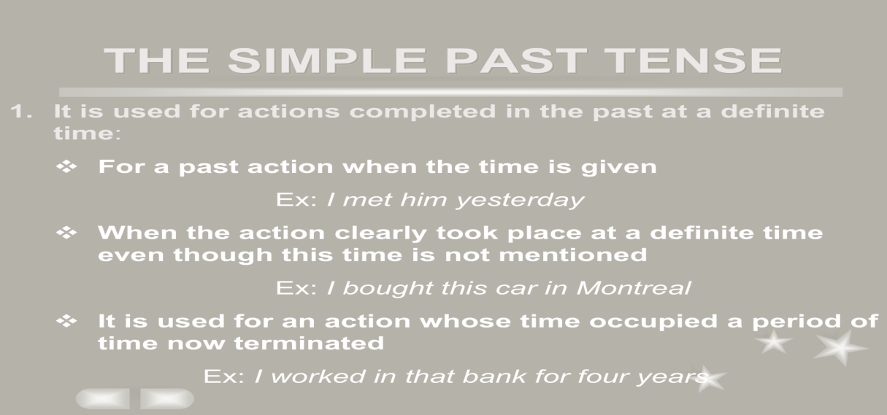
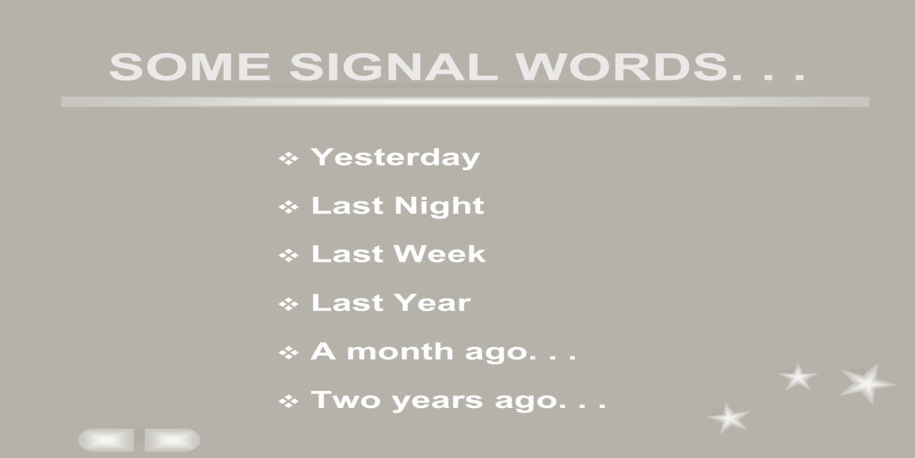

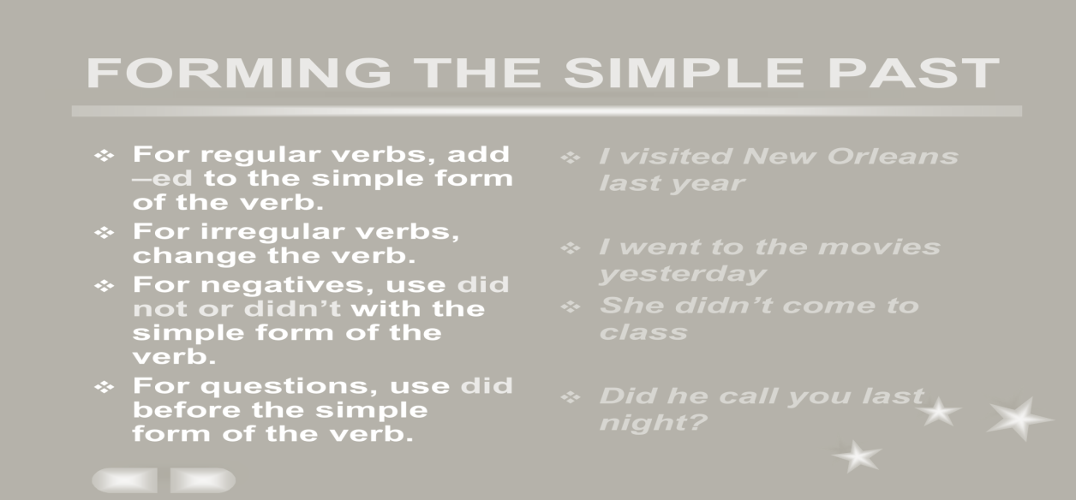
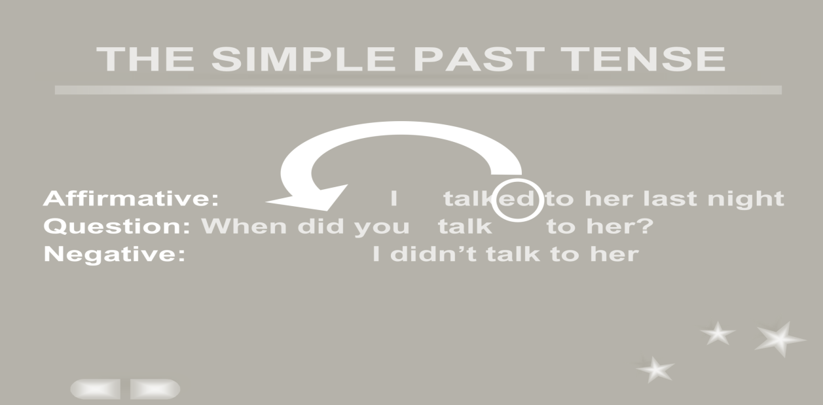
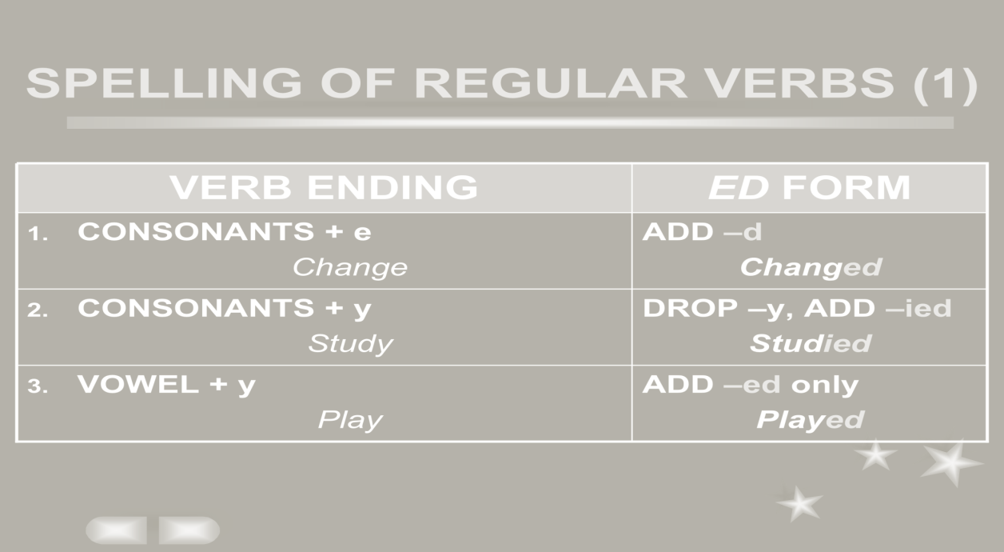
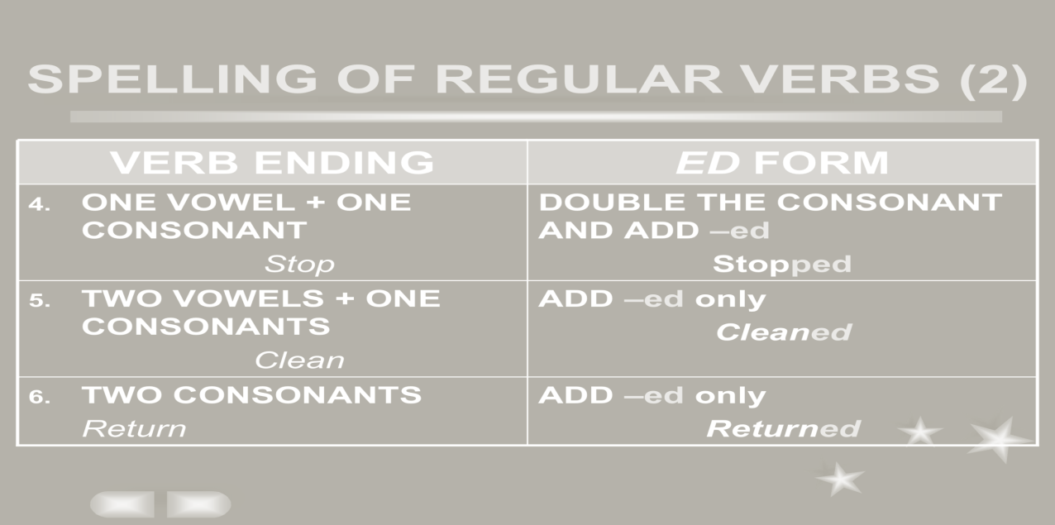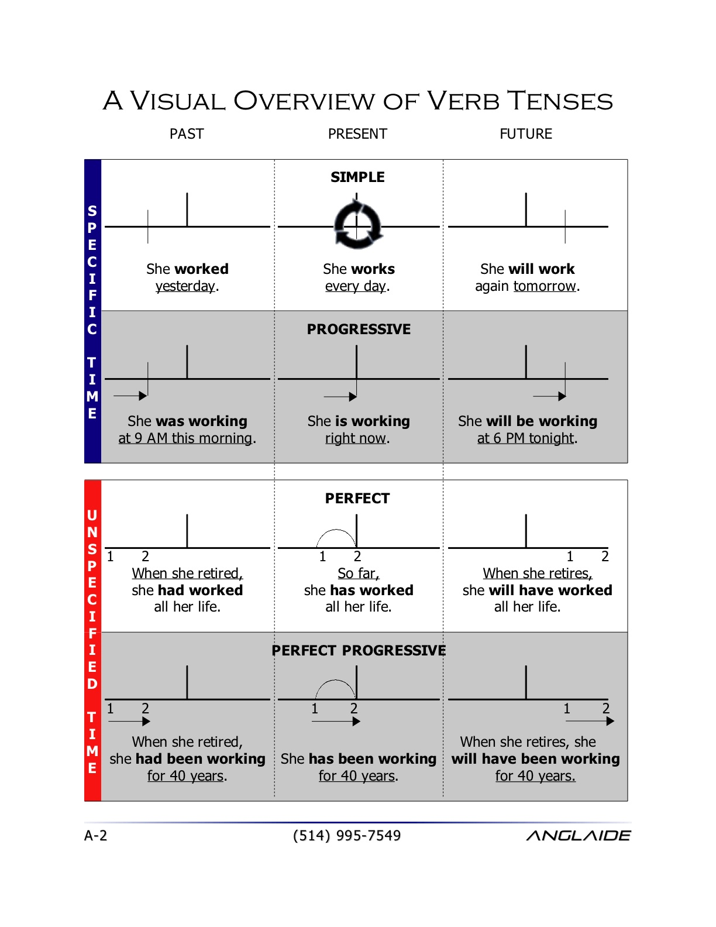


Lecture 7
Practices
Unit 1
Lecture Summary :
Referring to the book Unit 1
Pages 13-34

Lecture 8
Practices
Unit 1
Lecture Summary :
Referring to the book Unit 1
Pages 34-46

Lecture 9
Count and Noncount nouns
NONCOUNT NOUNS :
Whole groups or whole masses.
Furniture, coffee and sugar.
Abstract concepts.
Love, wisdom, spirituality.
Phenomenon of Nature
Sunshine, rain, snow.

SOME COMMON NONCOUNT NOUNS :
Whole groups made up of similar items .
Fluids .
Solids .
Gases .
Particles .
Abstractions .
Languages .
Fields of Study .
Recreation .
Activities .
Natural Phenomena .
Generic Nouns :
Articles are used to make generalizations.
A is used for singular nouns.
A banana is yellow.
An umbrella.
An egg.
0 is used for plural nouns and noncount nouns.
0 Bananas are yellow.
0 Fruit is good for you.

Indefinite Nouns :
Singular. | I ate a banana.
Plural count noun (two, a few, several). | I ate some bananas.
Noncount noun (a little, a lot of). | I ate some fruit.
Definite Nouns :
The banana I ate this morning was delicious. | Singular.
I got the apples from the tree. | Plural.
The fruit from that market is inexpensive. | Noncount.
Expressions of Quantity for Count nouns :
One Two ,three, etc. Many
Each A couple of Several
Every A few A number of
Expressions of quantity for noncount nouns :
A little
Much
A great deal of
Expressions of quantity for both count and noncount nouns :
No Plenty of
Some/any Most
A lot of/lots of all
Negative vs. Positive :
She has few friends. | She made a few friends.
I have little money. | I saved a little money.

Go to the book pp. 57
Page 96 important


Lecture 10
Modal Auxiliary
What do they mean?
Can- Could
will- Would
Shall- Should
Must- Have to – Ought to
May- Might
Modals Giving permission :
Would you please help me?
Could you help me
Can you help me?
Will you help me?
Would you please help me?
Could you help me
Can you help me?
Will you help me?
May I ….?
Modals Expressing ability :
I can speak English (present ability)
Last year I could speak English (past ability)
I am able to …. (present)
I was able to …. (past)
I will be able to ….. (future)

Modals Expressing expectation :
The train should arrive now.
Ought to seldom used! (negative or questions only!)
Should – ought to – had better (express advice)
You are sick. You should see a doctor!
You ‘d better not stay home.
Modals Expressing preferences :
I would like ……
I would rather to go to Costa rather than Blockbuster
Modals Expressing Need or obligation :
Must (You must have a driving license to drive)
Must not to ( you must not bother your parents)
Have to
You have to study for the exam.
Not have to
You do not have to come with us.
Modals Expressing possibility and impossibility :
May --- may not
Might …. Might not
Could … could not
…..have enough money
It can’t be five!
That couldn’t be my uncle!

Borrow & Lend :
Borrow = you take from some one
May I borrow your pen?
Borrowing a book from a library
Lend= you ask someone to give you something
Can you lend me your car?
Lending someone money
Modals Expressing preferences :
Go to the book pp. 135 (important)


Lecture 11
Phrasal Verbs
What do they mean?
Verb + preposition (particles)
separable- inseparable
Inseparable Phrasal Verbs :
agree with
belong to
talk to
wait for
look for
Remind – of
Ask ----- about
Inseparable verbs :
Check into (register)
Come across ( find/ met)
Drop by (visit)
Keep up with (stay on the same level)
Go over (review)
Go through (experience/ have)
Take care of (supervise)
Stay up ( remain awake)

Separable Phrasal verbs :
Bring up (raise)
Look over (review, read quickly)
Try out (test)
Work out (find a solution)
Separable phrasal verbs :
Academic:
Add up fill in
Finish up fill out
Write up hand in
Check in hand out
Check out hand back
Do over
Look over
Go to the book page 220


Lecture 12
Global Connections
What do they mean?
They connect two sentences .
And
But
Nor
Or
So
Adverb clauses (condition/ contrast/ reason/ time)
If after/before
Unless until
Although when/ since
Even though
So that
Because
Transitions :
For example
In addition/ furthermore
In fact/ as a mater of fact
However/ in contrast
Therefore/ as a result/ consequently
First/ second/ third etc..
Go to the book page 259..
Lecture 13
The Passive voice
Active sentence :
Noha made a cake.
Passive voice :
The cake was made by Noha.
Structure of the passive voice :
Present
Is/am/are + verb ed + by
Past
Was/ were + verb ed + by
**The cake was made of strawberry.
The cake was made for the guests.
Passive voice with it :
People believe that the Earth is round. (active present)
It is believed that the Earth is round. (passive present)
People thought that English was a difficult language (active past)
It was thought that English was a difficult language. (passive past)
Go to the book page 293..


Lecture 14
The Final exam
I bought _______________ pepper yesterday.
a) a few b) many
c) a little d) how much
_______________ people ar e there in the hall?
a) How many b) How much
c) How a few d) A few
Please give me _______________ stamps to send these two letters
a) much b) a little
c) how many d) a few
I eat _______________ chicken every day.
a) a little b) many
c) how much d) a few
_______________ wood do you need to make a chair?
a) How many b) How
c) A little d) How much
................ a business executive’s life stressful?
a. Are b. Is c. Am
The baby ..................at the moment.
a sleep b. are sleeping c. is sleeping d. is sleep
Fred is tired because ....................
a. she has failed her exams b. you haven’t` switched on c. he has worked all night

Yousef .....................a book after lunch every day.
a. read b. is reading c. reads d. are reading
......................go out last night?
a. Do you b. Did you c. Does he d. Does you
……….. that new film yet?
a. Did you see b. Have you seen c. Was you see
………… go out last night?
a. Have you b. Do you c. Did you
The baby ……………. at the moment
a. sleep b. are sleeping c. is sleeping
She saw the police car while she …………. to work.
a. was driving b. drove c. drive


