Lecture 1
Beginning Concepts
Content:
- Language vs. speech, thought and communication
- Signal and meaning
- Linguistic Creativity
- Prescriptive vs. descriptive grammar
- Linguistic competence vs. linguistic performance

Language, thought, and communication
Is the term language synonymous to the term speech?
No! Speech is one form of language. There are other forms such as writing and signals (i.e. sign language).
What about thought, is it synonymous to the term language?
No! There are individuals (e.g. infants) who can think but cannot produce language.
Similarly, we can ask: are the terms language and communication synonymous?
“Language is the primary communication system for human beings, but it is not the only way to communicate” (Fernandez and Cairns, 2010, p.6) 

Signal and meaning
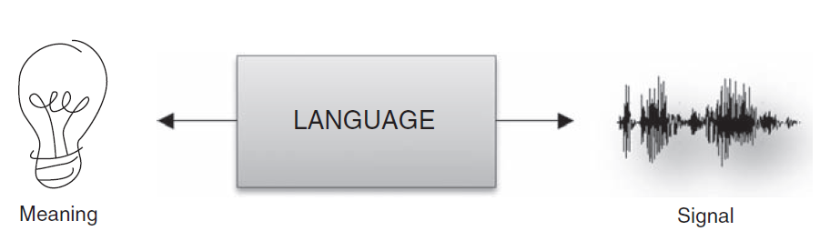
/hɔrs/ (horse) 
language

Linguistic Creativity
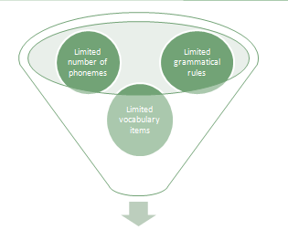
- Unlimited number of linguistic utterances

Prescriptive vs. descriptive grammar
Prescriptive grammar provides a “prescription” (i.e. how language should be used)
“People who teach language are interested
in teaching a standardized use of language, the form of a language that
is accepted in academic and business circles” (Fernandez and Cairns, 2010, p. 9)
Descriptive grammar describes how a certain language is actually used by its native speakers
For example: Me and Nasser went to Dammam
is accepted by a descriptive grammarian, but not by a prescriptive one.

Linguistic competence vs. linguistic performance
- Linguistic competence is the linguistic knowledge that provides a system for pairing sound and meaning (i.e. the ability of linking words with their meanings).
- Linguistic Performance is the use of such knowledge (i.e. linguistic competence) in the actual processing of sentences.
- Error vs. mistake

References
- Fernandez, E.M. & Smith Cairns, H. (2010) Fundamentals of Psycholinguistics. Wiley-Blackwell

