الباحثون الصوتيون يصنفون الأصوات الكلامية وفق معيارين أساسيين:
- طريقة النطق manner of articulation
- موضع النطق place of articulation
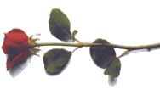

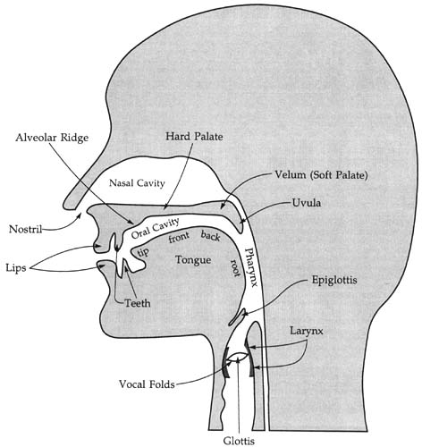

places of articulation

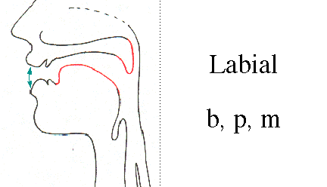
Bilabial = These are sounds formed using both upper and lower lips. The first sounds in the words pat, bat, and mat are all bilabials. They are represented by the symbols [p], which is voiceless, and [b] and [m], which are voiced.
نطق من خلال الشفتين فقط ( الشفة العليا + الشفة السفلى) هى الأصوات التالية
: b, p, m, w
...............................
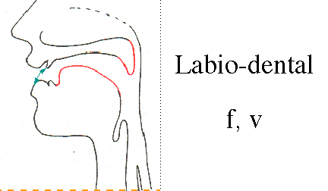

Labiodental = These are sounds formed with the upper teeth and the lower lip. The first sounds in of the words fat and vat and the final sounds in the words safe and save are labiodentals. They are represented by the symbols [f], which is voiceless, and [v], which is voiced. Cough and photo, are both pronounced as [f].
ينطق من خلال الشفاة و الأسنان (الأسنان العليا +الشفة السفلى ) و هى الأصوات التالية : v, f
...............................................
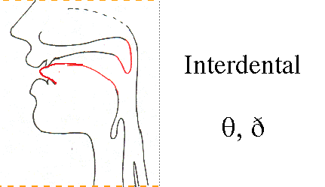

dental = These are sounds formed with the tongue tip behind the upper front teeth. The initial sound of thin and the final sound of bath are both voiceless dentals. The symbol used for this sound is [θ]. The voiced dental is represented by the symbol [ð] like the, there, then and thus.
صوت ينتج خلال الاسنان (أى خروج طرف اللسان بين الأسنان أثناء النطق ) و هى الأصوات التالية
: θ,&eth;
................................................................
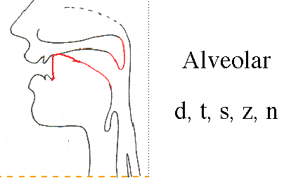
Alveolar = These are sounds formed with the front part of the tongue on the alveolar ridge. The initial sounds in top, dip, sit, zoo and nut are all alveolars. The symbols for these sounds are easy to remember [t], [d], [s], [z], [n]. Of these, [t] and [s] are voiceless whereas [d], [z] and [n] are voiced. Other alveolars are the [l] sound as in lap and [r] as in right.
وهويتشكل في الجزء الأمامي من اللسان على
الحافة الحويصلية، جزء محدّب مِنْ الفَمِّ، وراء الأسنانَ مباشرة) alveolar ridge (
: /d, t, z, s, I, n/
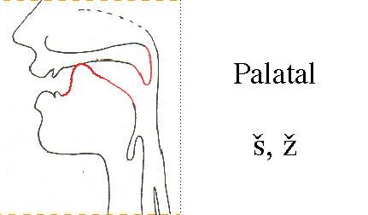
Palatal =These are sounds formed with the tongue and the hard palate. The initial sounds in the words shout and child, which are both voiceless. The “sh” sound is represented as [ʃ] and the “ch” sound is represented as [tʃ]. The word shoe-brush begins and ends with the voiceless palatal sound [ʃ] and the word church begins and ends with the other voiceless palatal sound [tʃ]. The sound [ʒ] such as treasure and pleasure which is voiced palatal. The other voiced palatal is [dʒ] as in joke and gem. The sound [j] is also voiced palatal as in yet
و هى الأصوات التى تنتج من خلال اللسان + الحنك الصلب + اللسان ) و هى

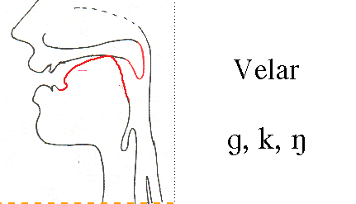
Velar = Sounds produced with the back of the tongue against the velum are called velars. . The sound [k] as in cook is voiceless. The sound [g] as in go. The voiced sound [ŋ] as in bang.
حلقي ( و هو الحنك الطرى وهو ما ندعوه باللسان المزمار و يوجد فى آخره وهذه
اللهاة+ اللسان) الأصوات هى
: k,g,ŋ
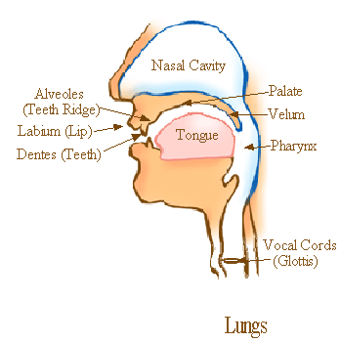
Glottal = There is one sound that is produced without the active use of the tongue and other parts of the mouth. It is the voiceless sound [h] as in horse .
هناك صوت واحد الذي يتم انتاجه دون الاستخدام الفعال لقطع اللسان وغيرها من الفم
هي اللاصوتيه
H

- Manner of articulation:

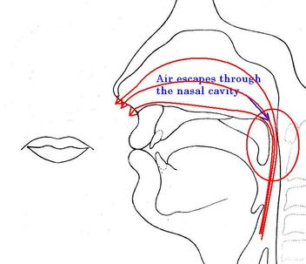

- Stops:
The set [p], [b], [t], [d], [k], [g] are all produced by some form of “stopping” of the air stream (very briefly) then letting it go abruptly. This type of consonant sound , resulting from a blocking or stopping effect on the air stream, is called a stop (or a “plosive”). Example: bed.
الانفجارية ) Plosives(
تسمى انفجاريه تراكم ضغط الهواء دخال الفم، و
. انطلاق الهواء مرة واحدة .
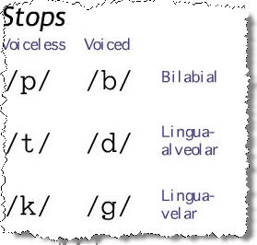
.............................................................................
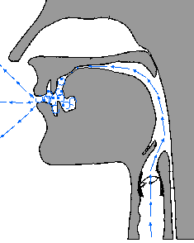

Fricatives:

The set of sounds [f], [v], [θ], [ð], [s], [z], [ʃ], [ʒ] involved almost blocking the air stream and having the air push through the very narrow opening. As the air is pushed through, a type of friction is produced and the resulting sounds are called fricatives. Example: fish, those.

أصوات احتكاكيةFricatives

الصوت الاحتكاكى هو صوت ساكن يتم انتاجه عندما يتم اجبار تيار

الهواء على المرور من خلال عائق تسببه أعضاء النطق (الكلام ) الموجودة فى المجرى الصوتى .
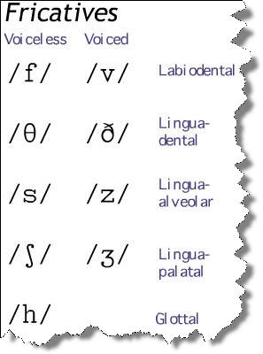
.....................................................................
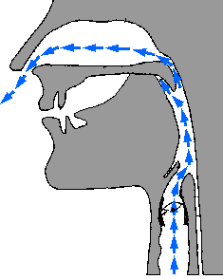

Nasals = When the velum is lowered and the air stream is allowed to flow out through the nose to produce [m], [n] and [n], the sounds are described as nasals Example: morning and name.

أصوات أنفية
الصوت الأنفى يشيرإلى صوت ساكن يتم نطقه من خلال سد كامل للمجرى الفمى بيحث تكون اللهاة منخفضة لكى تسمح لتيار الهواء بالمرور إلى المجرى الأنفى
و تتكون هذه المجموعة من ثلاثة أصوت و هى

:/m,n,ŋ /
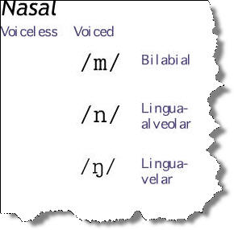
…………………………………………………………………….

- Affricates:
If you combine a brief stopping of the air stream with an obstructed release which causes some friction, you will be able to produce the sounds [tʃ] and [dʒ] these are called affricates . Example: cheap and jeep.
أصوات احتكاكية توقيفية
الصوت الاحتكاكى الوقفى هو صوت ساكن له خاصية كل من الاصوات الاحتكاكية Fricatives و الأصوات الوقفية Stops
و تتكون هذه المجموعة من صوتين و هما
://tʃ,dʒ/ /
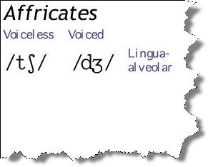

Glides:
The sounds [w] and [j] are described as glides. They are both voiced and occur at the beginning of we, you and yes. These sounds are typically produced with the tongue in motion )or “gliding”( to or from the position of a vowel and are sometimes called semi-vowels.
أصوات انزلاقية (أصوات نصف متحركة )Glides
الصوت الانزلاقى هوصوت ساكن يتميز بأنه دائم الانزلاق بواسطة حركة أحد أعضاء الكلام وخاصة الصوت المتحرك التالى لها
و تتكون هذه المجموعة من صوتين و هما:/w,j
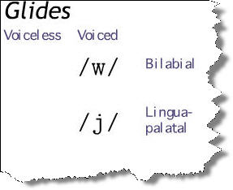
..............................................................
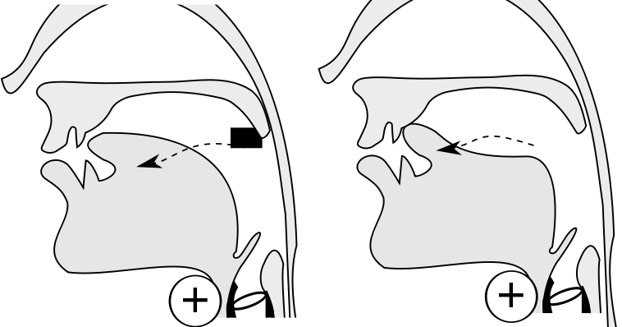
Liquids:
The initial sounds in led and red are described as liquids. They are both voiced. The [l] sound is called a lateral liquid and formed by letting the air stream flow around the sides of the tongue as the tip of the tongue makes contact with the middle of the alveolar ridge. The [r] sound at the beginning of red is formed with the tongue tip raised and curled back near the alveolar ridge.

أصوات سائلة
الصوت السائل هو تسمية عامة تستخدم لتصنيف صوتين
Consonant ساكنين
متقاربين
approsimant
و تتكون هذه المجموعة من صوتين و هما :/l,r /
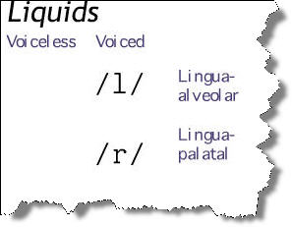
بعض المعلومات الإضافيه
التجويف الأنفى Nasal Cavity
التجويف الفمى Oral Cavity
و بها الأحبال الصوتية Vocal Folds أو Vocal Cords
الرئتين lungs
الحنك palate
الشفاه Lips
Hard palate سقف الفم
teeth ridge لحافة الأسنان
larynx الحنجره
البلعوم pharynx
…………………………………
Alveolar ridge, convex part of the mouth, immediately behind the teeth

الحافة الحويصلية، جزء محدّب مِنْ الفَمِّ، وراء الأسنانَ مباشرة
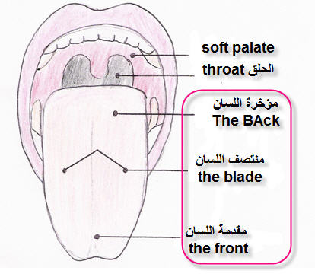
عليك أن تعرف أن ما أقصد به الحنك هنا هو ما خلف الفك العلوى و حتى اللهاة .
1- الحنك الملاصق للأسنان العلوية من الخلف مباشرة و يعرف بــ Alveolar ridge و هو للأسف غير موجود فى الرسم.
2- الحنك الصلب hard palate فى المنتصف.
3- الحنك الطرى soft palate وهو ما ندعوه باللسان المزمار و يوجد فى آخره Uvula اللهاة
By : Gucci .
م

