In The Name Of Allah Most Gracious Most Mercifvl

King Faisal University
Deanship of E-Learning and Distance Education



Graduation Project
Instructor : Fouzi Slisli and M. Al-Hilal
Level 8


By
Heart story

Lcourse introduction

Course Description:
The Graduation Project is a substantial piece of research that students are required to complete in order to graduate. Under the supervision of course instructors, students will make use of previous courses in terms of methodology and content, and put together a complete research proposal for their graduation. Throughout the process, students will benefit from the feedback and guidance of course instructors in three main fields (linguistics, translation and literature). The process gives students a hands-on experience in designing substantial projects and applying their analytical and problem-solving skills in a professional manner.

Course Content:
- Recorded lectures:
Three instructors will give 4 recorded lectures each
- Live sessions:
Each instructor will hold Live Sessions
- Students will submit drafts of their work in progress twice and
benefit from instructors' feedback

Assessment:
Projects will be assessed in terms of their:
- Validity of the topic
- Originality
- Presentation (includes the proper and professional use of English, of research material and citations and overall presentation of the project)
- Completeness of the project, which means that it should contain appropriate literature reviews, surveys and/or questionnaires when necessary.

Procedure
Week 5: Choice of a Research topic (instructor's approval is mandatory):
At this stage, students should submit a document (two pages maximum) containing
(1) a coherent thesis statement,
(2) a paragraph description of the project, and
(3) a description of the tools necessary for the completion of the project (research material, interviews, surveys, questionnaires, etc).

Procedures
Week 8: At this stage students should present a first draft of their complete research proposal presenting the final research proposal and supporting documents.
Week 13: Final drafts of the complete project should be submitted

Grading Formula:
- Live sessions: 10 pts.
- Attendance: 10 pts.
- Coursework and first drafts: 10 pts.
- Final draft: 70 pts.

Weekly Lectures:
Course Intro: Dr. Slisli
Week 1 & 2: Introduction and Conclusion
Week 3 & 4: Paragraph Unity, Coherence, Transitional Devices, Diction
Week 5 & 6: Citations, Choosing and Evaluating Sources, Integrating Research, etc.
Week 6 & 7: Feedback Lectures on Proposals
Week 10 & 11: Feedback Lectures on First Drafts
Week 13: Submissions of Final Drafts

Lesson 1

In this lecture, we will discuss the following:
- What is a research proposal?
- Where do research topics come from?
- Choosing a Research Topic
- Developing your Research topic
- Why should you present a research proposal?
- How to Develop the Research Proposal?
- Suggested Format for Research Proposal
Writing the The Abstract

What is a Research proposal?
Various terminologies are used to mean a research proposal depending on why the research is carried out?
- Research outline
- Plan of research
- Research/project proposal
- Thesis plan
It details how the study will be completed in order to achieve the aims and objectives and address the research questions or problems.

Where do research topics come from?
1- Individuals’ own experience of practical problems in certain fields.
2- Individuals’ Reading
3- Literature Review.
Books, internet, archives, journals, newspapers, etc.
4- Conducting interviews.
5- Examining records or reports.

Choosing a Research Topic
A Research topic should be:
1- Specific.
2- Measurable.
3- Achievable.
4- Time-specific.

Developing your Research topic
Ask yourself the questing:
WHY did you choose this topic?
- Significance.
Local
national
international
- Implications.
- Limitation.
- Aims

Why should you present a research proposal?
1- the research proposal is meant to convince your supervisor or department of the validity of your research project and that you have the ability and the work-plan to complete it.
2- Witting the research proposal gives you an opportunity to think through your project carefully, and define what you exactly want to investigate.
3- The research proposal can provide you with an outline that guides you through the research process.
4- Lets your supervisor and/or department know exactly what your research is going to be about and how you are going to do it.
5- The research projects helps the department to choose an appropriate supervisor based on the latter’s specialization.

How to Develop the Research Proposal?
- Choosing an appropriate research topic .
- Narrowing down and focussing your topic
- Determining research objectives
- formulating specific research questions for investigation .
- Outlining the main literature in the topic area
- Deciding on research methodology.
- Proposing an approach to data analysis
- Developing a timeline
- Developing a budget and resources you will need
- Developing a bibliography/list of references.

Suggested Format for Research Proposal
Title
Table of Contents
Abstract
- Introduction
- Literature review
- Significance of Research
- Research Question
- Research Methodology
- Ethical Consideration.
- Limitations of the study.
- Expected Results.
- References

The Abstract
The abstract includes:
- An outline of your proposal,
- What your research will involve,
- Research questions or hypothesis,
- Research methods and
- How you will analyse the data.

Lesson 2
How to write the introduction to your research proposal?

In this lecture, we will discuss the following:
- What is an Introduction?
B. Why is the introduction so important?
C. How to grab the Readers’ attention?
D. Common mistakes often made by young researchers.
E. Suggestions for starting your introduction

What is an Introduction?
The Introduction is the opening paragraph(s) of an essay or research paper. It gives a brief idea about the research question, the significance of the research, the methodology used and the main idea of the research. It should be designed in an attractive manner in order to grab the readers’ attention.

Why is the introduction so important?
- The purpose of an introduction is to prepare the reader for the body of writing that comes after it.
- The introduction catches the readers’ attention, making them want to read more.
- As a researcher, you know what you are writing about and why you are writing it. But unless you inform your readers of your topic in the introduction, they will feel lost and may judge your research to be an unclear.
- The introduction announces the subject matter and tone of your essay (humorous, satiric, serious, etc.)

How to grab the Readers’ attention?
The first sentence or sentences
in the introduction of your research proposal should be attractive enough to capture the readers’ attention. You can start an introduction with a quotation or thought provoking ideas about the subject. This raises the level of curiosity in the readers and they will continue reading your research.

Clarify the Central Idea of your research.
Introduction should be written in a way that it clearly depicts the central idea of the paper. After reading your introduction, readers should not have any doubt about the main idea of your research question or research topic.

Establish the Importance of the Topic
You should highlight the importance of the topic in the introduction. Constructing a successful introduction, you should tell the significance of the topic.

Common mistakes often made by young researchers
- An introduction should not introduce a detailed background of the topic. However, it should give a brief description of the research question, the importance of the study and the methodology used.
- The introduction should mention the significance of the topic in order to grab the attention of the readers.
Introductory paragraphs should not be too long. Half page paragraph or little more than that can be enough.
- Make sure your introduction introduces your thesis statement.
- Don’t begin with an apology or complaint. Such statements as “It’s difficult to find much information on this topic . . .” and “This controversy is hard to understand, but . . .”
- Don’t assume that your audience already knows your subject matter. Identify the research question even though you know your instructor/supervisor knows what you are writing about.
We should avoid standard dictionary definitions in the introductions.

Suggestions for starting your introduction.
- Statement of a problem or a popular misconception.
e.g. Some people believe that poetry is written only
by aging beatniks or solemn, mournful men and women…….

- A quotation.
e.g. “Translation is an art” Says John (1990).

- An arresting statistic or shocking statement
e.g. One of every nine women will develop breast cancer this year, according to a recent report prepared by the Health Information Service.

Lesson 3
How to Write the Conclusion to Your Research Proposal?

In this lecture, we will discuss the following:
- What is a conclusion?
B. Why the conclusion is so important?
C. How to start writing your conclusion?
Restating the thesis
Show whether the data supports the hypothesis.
Provide Actual Evidence.
Coming full Circle
D. Some guiding principles for strong and effective conclusions.

What is a conclusion?

- A conclusion is a summary of your research.
- The conclusion puts the hypothesis together with the data and comes with a conclusion based on research.
- It is the answer to the original research question.

Importance of the Conclusion?
The conclusion gives you a chance to:
- Remind your reader of your main idea or opinion.
- Give the essay a sense of completeness.
- leave a lasting impression with the reader

How to start writing your conclusion?
Restate your thesis statement.
In a conclusion, the topic sentence is the restatement of the problem/question.

Show whether the data supports the hypothesis.
Restate you hypothesis; what was predicted?
Does the data support the hypothesis?

Provide Actual Evidence.
Provide actual data in a sentence form that backs up your previous statement.
Actual data from the experiment
What did the data say?

Coming Full Circle
Finish your research project where it began.

Eg. If the research begins with a problem, then conclude it with a reference to the same problem.

Some guiding principles for strong and effective conclusions
Avoid a mechanical ending.
. One of the most frequent weaknesses in student essays is when the conclusion merely restates the thesis, word for word.

. Instead of recopying your thesis and essay map, try finding an original, emphatic way to conclude your essay.

Don’t introduce new points.

Treat the major points of your essay in separate body paragraphs rather than in your conclusion.

Don’t change your stance.
Sometimes writers who have been critical of something throughout their essays will soften their stance in their last paragraph.
Eg. Someone who is complaining about the poor quality of a particular college course might conclude with statements that declare the class wasn’t so bad after all.
This can undercut the thesis and confuse the reader who has taken the writer’s criticisms seriously.
Instead of contradicting themselves, writers should be consistent with their thesis.

Avoid trite expressions.
Don’t begin your conclusions by declaring,
“In conclusion,”
“In summary,”
“As you can see, this essay proves my thesis that . . . .”

End your essay so that the reader clearly senses completion; don’t merely announce that you’re finished.

Lesson 4

Paragraph Development

Paragraph Development
Possibly the most serious—and most common—weakness of all essays by novice writers is the lack of effectively developed body paragraphs. The information in each paragraph must adequately explain, exemplify, define, or in some other way support your topic sentence. Therefore, you must include enough supporting information or evidence in each paragraph to make your readers understand your topic sentence. Moreover, you must make the information in the paragraph clear and specific enough for the readers to accept your ideas.

Undeveloped Paragraph
“Although he was an outlaw, Jesse James was considered a Robin Hood figure in my hometown in Missouri. He used to be generous to the poor, and he did many good deeds, not just robberies. In my hometown people still talk about how lots of the things James did weren’t all bad.”

This paragraph is underdeveloped. Although the topic sentence promises a discussion of Jesse James as a Robin Hood figure, the paragraph does not provide enough specific supporting evidence (in this case, examples) to explain this unusual view of the gunfighter.

Rewritten, the paragraph might read as follows
“Although he was an outlaw, Jesse James was considered a Robin Hood figure in my hometown in Missouri. Jesse and his gang chose my hometown as a hiding place, and they set out immediately to make friends with the local people. Every Christmas for four years, the legend goes, he dumped bags of toys on the doorsteps of poor children. The parents knew the toys had been bought with money stolen from richer people, but they were grateful anyway. On three occasions, Jesse gave groceries to the dozen neediest families—he seemed to know when times were toughest—and once he supposedly held up a stage to pay for an old man’s operation. In my hometown, some people still sing the praises of Jesse James, the outlaw who wasn’t all bad.”

The topic sentence promises a discussion of James’s generosity and delivers just that by citing specific examples of his gifts to children, the poor, and the sick. The paragraph is, therefore, better developed.

The following paragraph offers supporting reasons but no specific examples or details to support those reasons:
Living with my ex-roommate was unbearable. First, she thought everything she owned was the best. Second, she possessed numerous filthy habits. Finally, she constantly exhibited immature behavior.

The writer might provide more evidence this way:
“Living with my ex-roommate was unbearable. First, she thought everything she owned, from clothes to cosmetics, was the best. If someone complimented my pants, she’d point out that her designer jeans looked better and would last longer because they were made of better material. If she borrowed my shampoo, she’d let me know that it didn’t get her hair as clean and shiny as hers did. My hand cream wasn’t as smooth; my suntan lotion wasn’t as protective; not even my wire clothes hangers were as good as her padded ones! But despite her pickiness about products, she had numerous filthy habits.

Her dirty dishes remained in the sink for ages before she got the incentive to wash them. Piles of the “best” brand of tissues were regularly discarded from her upper bunk and strewn about the floor. Her desk and closets overflowed with heaps of dirty clothes, books, cosmetics, and whatever else she owned, and she rarely brushed her teeth (when she did brush, she left oozes of toothpaste on the sink). Finally, she constantly acted immaturely by throwing tantrums when things didn’t go her way. A poor grade on an exam or paper, for example, meant books, shoes, or any other small object within her reach would hit the wall flying. Living with such a person taught me some valuable lessons about how not to win friends or keep roommates.”

By adding more supporting evidence—specific examples and details—to this paragraph, the writer has a better chance of convincing the reader of the roommate’s real character.

Where does evidence come from?
Where do writers find their supporting information? Evidence comes from many sources. Personal experiences, mem- ories, observations, hypothetical examples, reasoned arguments, facts, statistics, testimony from authorities, many kinds of studies and research—all these and more can help you make your points clear and persuasive. In the paragraph on Jesse James, for example, the writer relied on stories and memories from his hometown. The paragraph on the obnoxious roommate was supported by examples gained through the writer’s personal observation. The kind of supporting evidence you choose for your paragraphs depends on your purpose and your audience; as the writer, you must decide what will work best to make your readers understand and accept each important point in your discussion.

Having a well-developed paragraph is more than a matter of adding material or expanding length, however. The information in each paragraph must effectively explain or support your topic sentence. Vague generalities or repetitious ideas are not convincing.

Look, for example, at the following paragraph, in which the writer offers only generalities:

We ought to get rid of cellular telephones in cars. Some people who have them think they’re a really good idea but a lot of us don’t agree. A car phone can cause too many dangerous accidents to happen, and even if there’s no terrible accident, people using them have been known to do some really stupid things in traffic. Drivers using car phones are constantly causing problems for other drivers; pedestrians are in big trouble from these people too. I think car phones are getting to be a really dangerous nuisance and we ought to do something about them soon.

This paragraph is weak because it is composed of repetitious general statements using vague, unclear language. None of its general statements is supported with specific evidence. Why are car phones not a “good” idea? How do they cause accidents? What “stupid things” happened because of them? What are the “problems” and “trouble” the writer refers to? What exactly does “do something about them” mean? The writer obviously had some ideas in mind, but these ideas are not clear to the reader because they are not adequately developed with specific evidence and language. By adding supporting examples and details, the writer might revise the paragraph this way:

Although cellular telephones may be a time-saving convenience for busy executives or commuters, they are too distracting for use by drivers of moving vehicles, whose lack of full attention poses a serious threat to other drivers and to pedestrians. The simple act of dialing or answering a telephone, for example, may take a driver’s eyes away from traffic signals or other cars. Moreover, involvement in a complex or emotional conversation could slow down a driver’s response time just when fast action is needed to avoid an accident. Last week I drove behind a man using his car phone. As he drove and talked, I could see him gesturing wildly, obviously agitated with the other caller.

His speed repeatedly slowed and then picked up, slowed and increased, and his car drifted more than once, on a street frequently crossed by schoolchildren. Because the man was clearly not in full, conscious control of his driving, he was dangerous. My experience is not isolated; a recent study by the Foundation for Traffic Safety has discovered that using a cell phone is far more distracting to drivers than listening to the radio or talking to a rider. With additional studies in progress, voters should soon be able to demand legislation to restrict use of car telephones to passengers or to drivers when the vehicles are not in motion.

The reader now has a better idea why the writer feels cell phones are distracting and, consequently, dangerous to drivers. By using two hypothetical examples (looking away, slowed response time), one personal experience (observing the agitated man), and one reference to research (the safety study), the writer offers the reader three kinds of supporting evidence for the paragraph’s claim.

Joseph Conrad, the famous novelist, once remarked that a writer’s purpose was to use “the power of the written word to make you hear, to make you feel . . . before all, to make you see. That—and no more, and it is everything.” By using specific details instead of vague, general statements, you can write an interesting, convincing essay. Ask yourself as you revise your paragraphs, “Have I provided enough information, presented enough clear, precise details to make my readers see what I want them to?” In other words, a well-developed paragraph effectively makes its point with an appropriate amount of specific supporting evidence. (Remember that a hand- written paragraph in your rough draft will look much shorter when it is typed.

Therefore, if you can’t think of much to say about a particular idea, you should gather more information or consider dropping it as a major point in your essay.)

PARAGRAPH LENGTH
“How long is a good paragraph?” is a question novice writers often ask. Like a teacher’s lecture, paragraphs should be long enough to accomplish their purpose and short enough to be interesting. In truth, there is no set length, no prescribed number of lines or sentences, for any of your paragraphs. In a body paragraph, your topic sentence presents the main point, and the rest of the paragraph must give enough supporting evidence to convince the reader. Although too much unnecessary or repetitious detail is boring, too little discussion will leave the reader uninformed, unconvinced, or confused.

Although paragraph length varies, beginning writers should avoid the one- or two-sentence paragraphs frequently seen in newspapers or magazine articles. (Journalists have their own rules to follow; paragraphs are shorter in newspapers for one reason, because large masses of print in narrow columns are difficult to read quickly.) Essay writers do occasionally use the one-sentence paragraph, most often to produce some special effect, when the statement is especially dramatic or significant and needs to call attention to itself or when an emphatic transition is needed. For now, however, you should concentrate on writing well-developed body paragraphs.

One more note on paragraph length: sometimes you may discover that a particular point in your essay is so complex that your paragraph is growing far too long—well over a typed page, for instance. If this problem occurs, look for a logical place to divide your information and start a new paragraph. For example, you might see a convenient dividing point between a series of actions you’re describing or a break in the chronology of a narrative or between explanations of arguments or examples. Just make sure you begin your next paragraph with some sort of transition phrase or key words to let the reader know you are still discussing the same point as before (“Still another problem caused by the computer’s faulty memory circuit is . . .”).

Lesson 5
The Present Perfect Tense

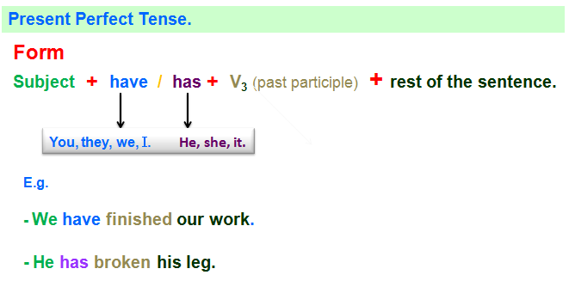

- Why the present perfect is not easy?
- It can describe present or past activities.
- There is no equivalent tense in Arabic.

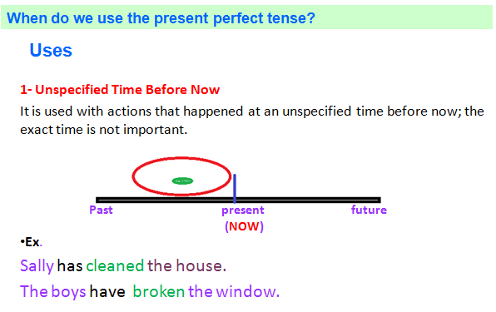

2- Experience we had in the past.
It is used to talk about an experience from the past.
Ex.
Sally has lived in Saudi Arabia. (She has the experience of living in Saudi Arabia).
We have been to England. (They have the experience of being in England).
We are not interested in when the experience took place. We are interested in whether we have the experience or not.

Uses of the Present Perfect Tense
3- Change or new information
- We use the present perfect to express a change that has happened over a period of time or to express new information
Ex.
They have become more interested in arts education.
Sally has bought a car.
The prices have gone up.
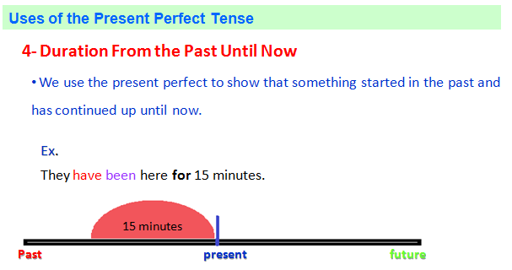
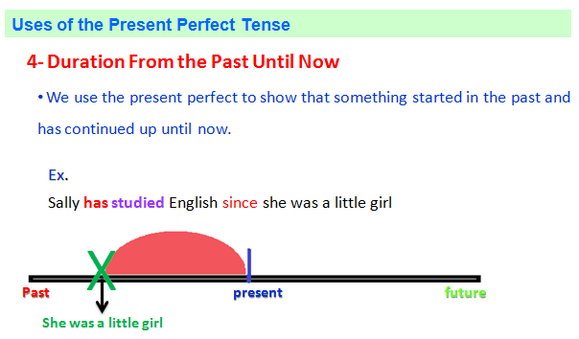

Uses of the Present Perfect Tense
4- Duration From the Past Until Now
- Since vs. For
Ex.
- They have been here for 15 minutes.
- Sally has studied English since she was a little girl.
- For is used to talk about a period of time.
- Since is used to talk about a point in the past.

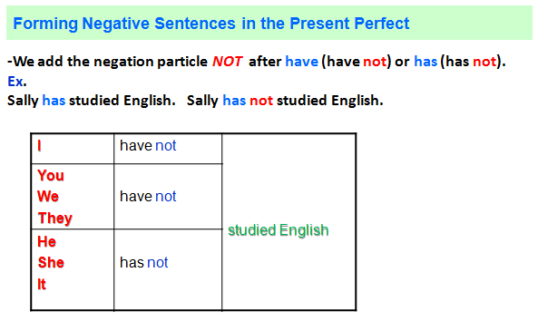
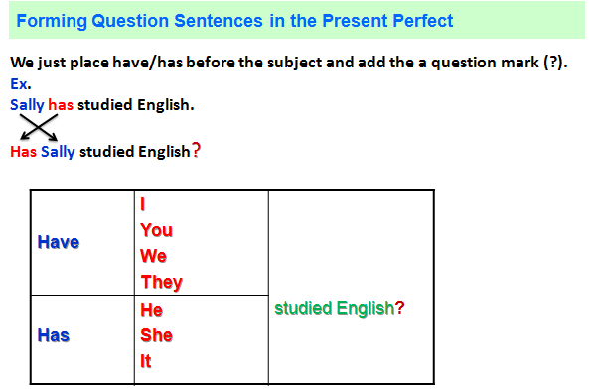


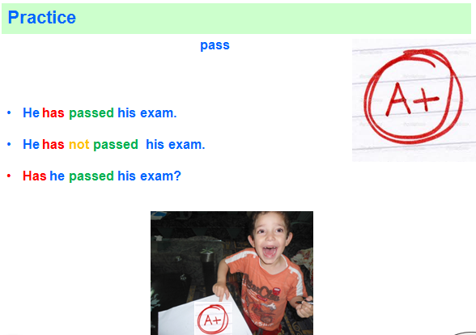

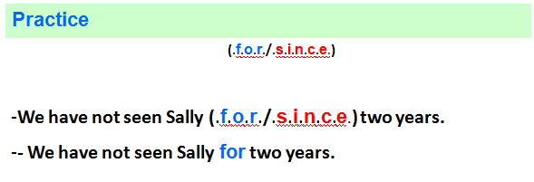

Lesson 6
Expressing the Future

The Future
Different ways to express the future.
- Will and shall
- Be going to
- The Simple Present Tense
- The Present Contiguous Tense
