English Language Speaking Skills
^{7th} Class
- Remember Giving advice. - Using Modals. -Understanding more reductions. -Participles.

Remember! Giving Advice
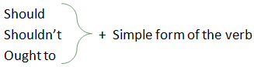
- These expressions are used to give advice and make suggestions. Other expressions to make suggestions are:
- It might be nice (good) if you…
- Why don’t you …
- If I were you I would …

- It’s more polite to use expressions for making suggestion than to use an imperative. Notice this contrast:
- Get out and take an art class. (less polite)
- You should get out and take an art class. (more polite)

- Let’s see more about Using of Modals… à à à à à

What are modals?
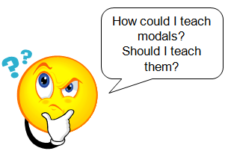
- Auxiliary verbs
  - Can
  - Could
  - Had better
  - a
  - Might
  - Must
  - Ought to
  - Shall
  - Should
  - Will
-- Would
Why do we use modals?
We use modals to talk about obligations, suggestions, advise and expectations!
There are two kinds of modals:
- Simple modals : for the present and future
- Perfect modals: to show necessity in the past tense.

Simple modals: Present and future
Modal + base form
Examples:
We should invite your friend to my party.
We could buy some soda if you have money.
You might want to call your mom and tell her you are at a friend’s house.

Perfect modals: past
Modal + have + past participle
Examples:
You should have called me last night.
Mary should have done her homework this week.
We should not have made a big mess here.

Showing strong necessity:
Must………I must go to sleep!
Have to……..I have to go to sleep!
Have got to…I have got to go to sleep!

Had better…for a warning!
Use “had better” to give a warning that something bad will happen if the advise is not followed.
You had better study tonight or you might fail the test.
He had better go home now or he will be in trouble!

Use Should to offer advise
Should means…it would be a good idea.
You should eat something you are hungry.
You should read a book and turn off the television.
They should stop being so loud.
We should have a party at the beach

Could or might are more gentle than should….
You could read a book.
They might like the movie.
We could buy some candy.
I might play basketball.
He could win your blue marble.

Practicing modals:
Do class surveys:
Who might want to play basketball at recess?
Who should be the student of the week?
When should we go to doctor?
Don’t forget to model the appropriate responses!

Sentence pairs:
He must be here | because I see his jacket on his chair.
I should buy a present | because it is Julie’s birthday.
You could call me tonight | since you will be at home.
They should come to my house | to play Nintendo.
He could win a prize | if he turns in his lottery ticket.

Conversation cards: Small group discussions
Why should the school day be shorter? | Name three things you should not do in class. | What could you do to be a good friend?
What would you do if you won a million dollars? | If you could meet one famous person, who would it be? | What might happen if pigs could fly?

The Sound of It: Understanding Reductions
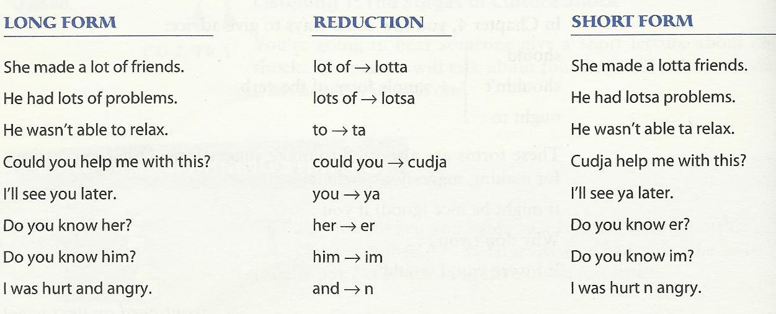

What are participles?
A participle is a form of a verb that functions as an adjective.

ing Participles + -ed Participles

Infinitive | past | Present  Participle | Past  Participle
bore | bored | boring | bored
interest | interested | interesting | interested

Participles used as adjectives
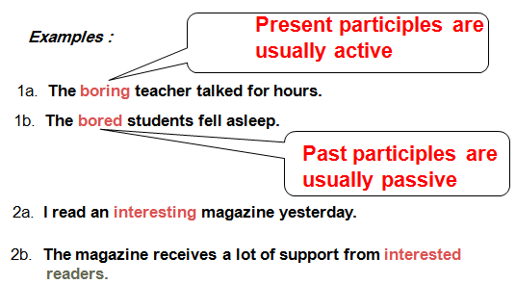

More examples:
3a. It was an exciting concert.
3b. The excited fans screamed during the concert.

4a. Many young people experience troubling situations.
4b. The Samaritan Befrienders Hong Kong receives calls from troubled young people.

DON’T CONFUSE PARTICIPLES AND VERBS!
Participles AREN’T preceded by helping verbs.
E.g.
The sputtering sedan wrenched down the boulevard. (participle)
The sedan was sputtering down the boulevard. (verb)

With my best regards
~Mrs.ENGLI$H~

^{8th} Class
- Review 1-5
نفس الشرايح ونفس الكلام فقلت أروح لتسعه أفضل وبإمكانكم العودة لنفس المحتوى والمحاضرة

9th Class
- Important Warming Up Activities - Culture Notes -Vocabulary Building -Getting Meaning from Context .

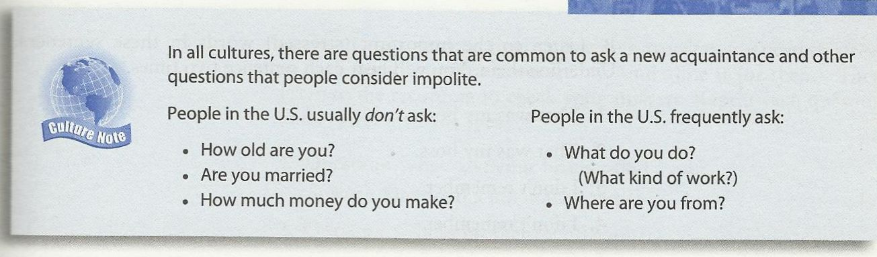
Culture Note:
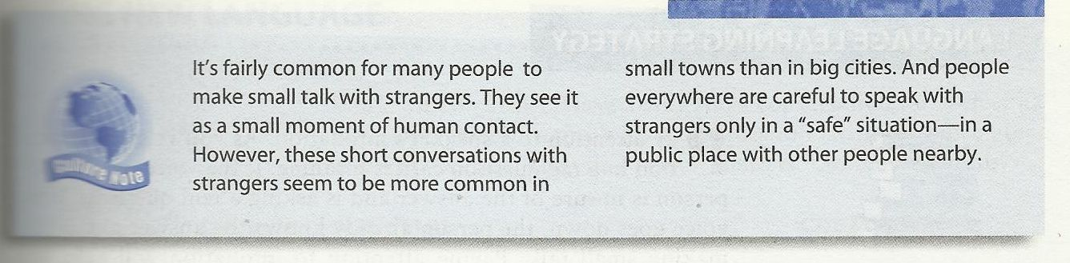
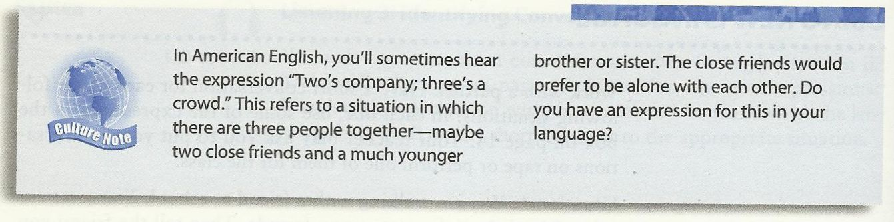

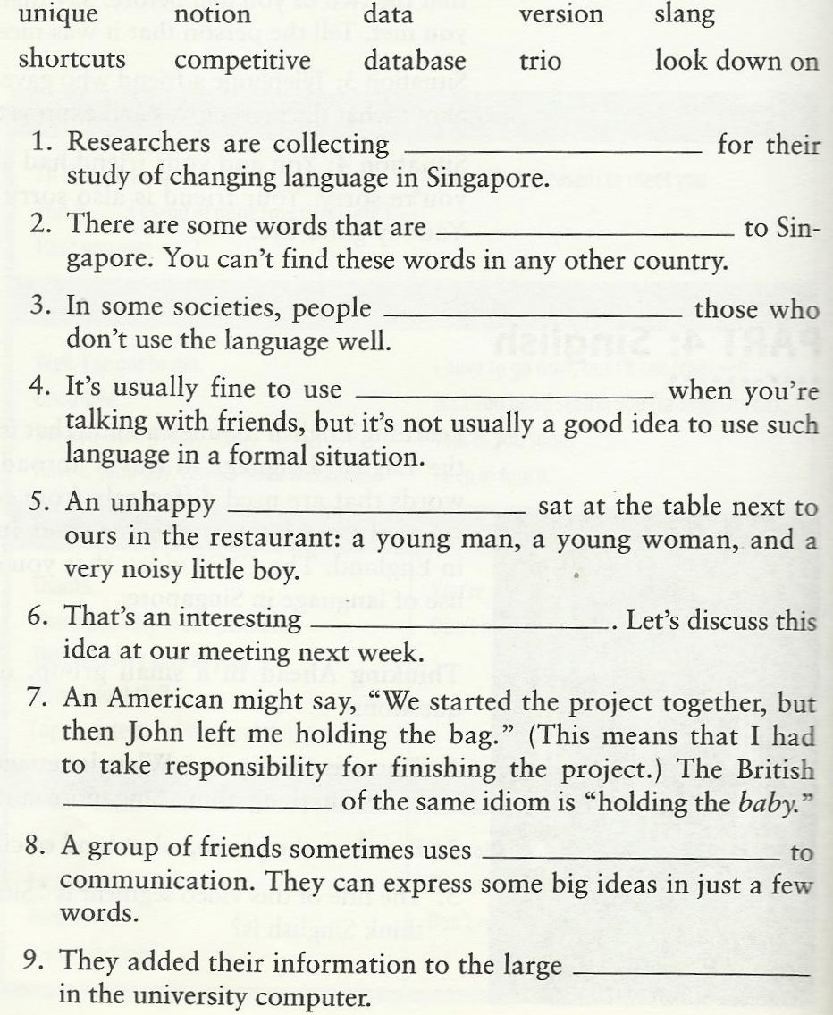
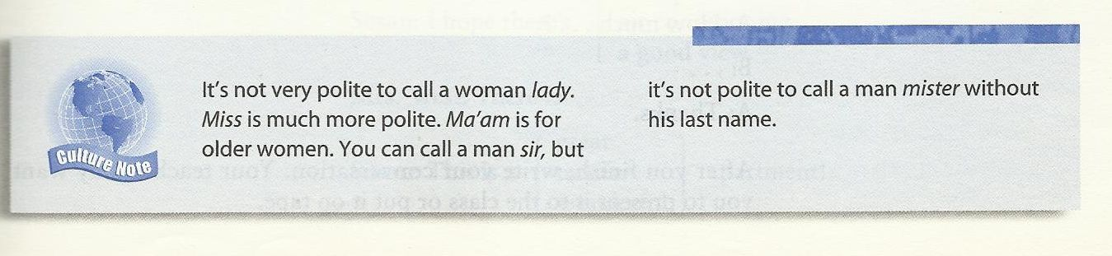

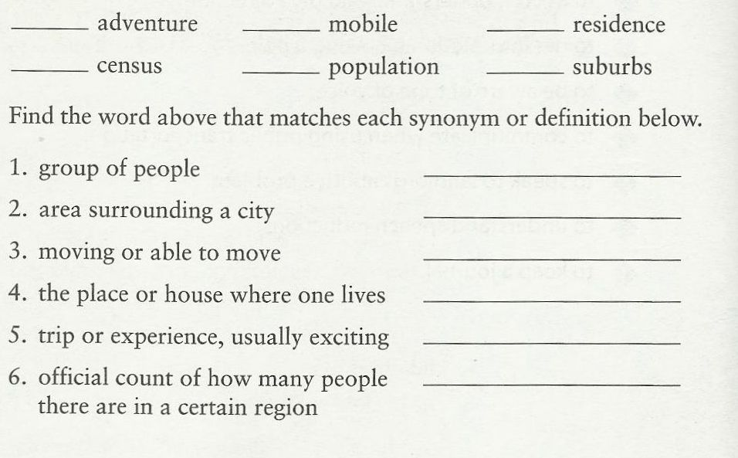
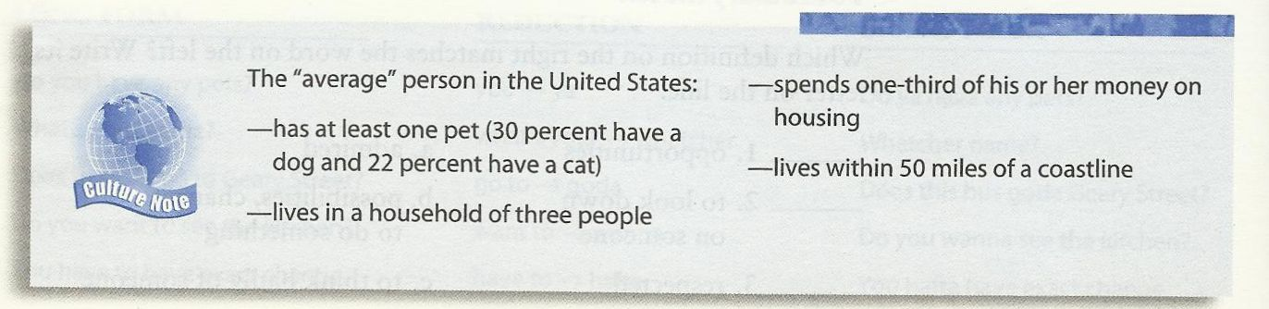
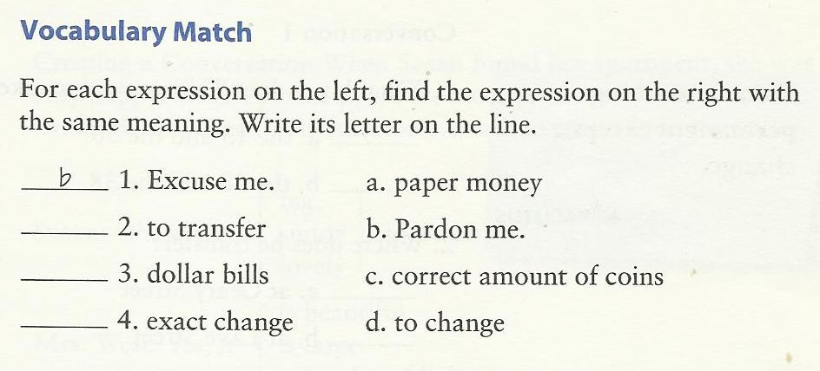
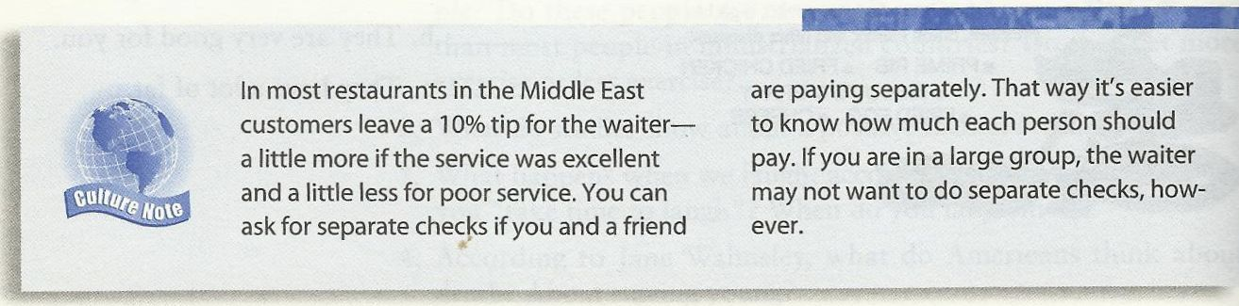

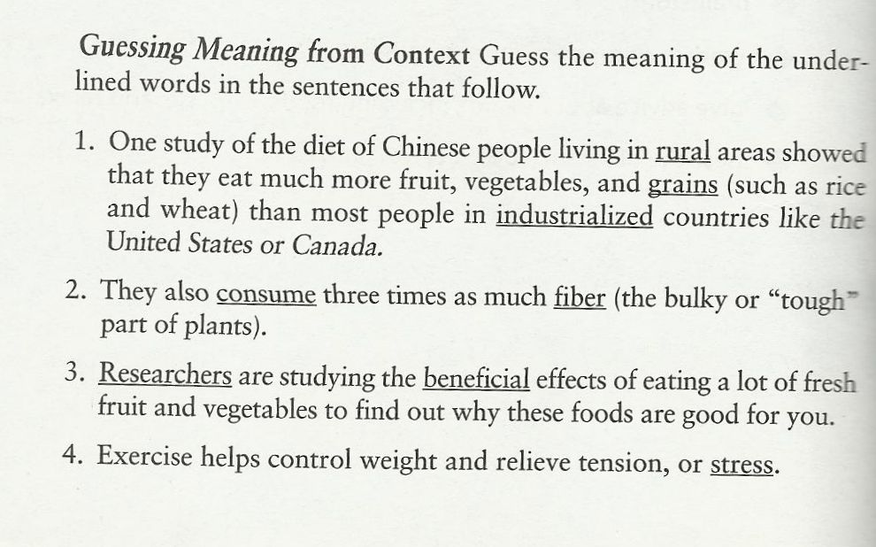
Getting Meaning from Context
1.Definition
A definition gives the meaning of words. The writer may use words, phrases, or statements to define something. The writer will use key words, or signal words to identify a definition so you need to look for them. See examples of key words below.
Key words is/are means/mean
is/are called what this means is
is/are known as consist of
is/are defined as refer to
is/are described as may be seen as
e.g.
Someone who explores and studies caves is known as a spelunker.
an unfamiliar word = spelunker
signal words = is known as
definition = someone who explores and studies caves

2.Restatement
The writer may use other words, phrases, or sentences to provide the meaning of difficult words. We call this restatement; the writer describes it again or in a different way. Signal words for restatement are in the “Key words box” below.

or
that is to say
in other words
i.e. or that is

e.g.
The surface of Africa consists mainly of plateaus, or large flat areas, although these occur at different levels.
an unfamiliar word = plateaus
signal word = or
meaning = large flat areas

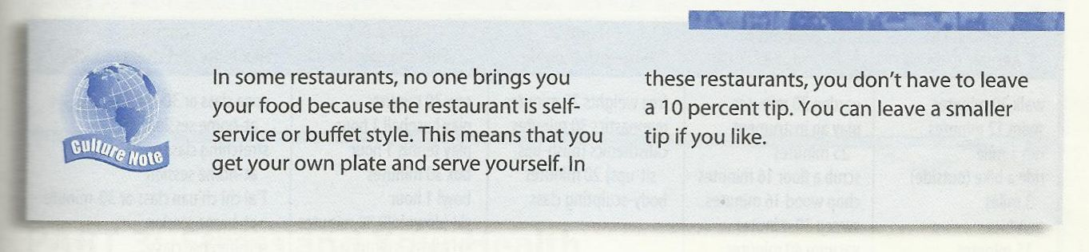
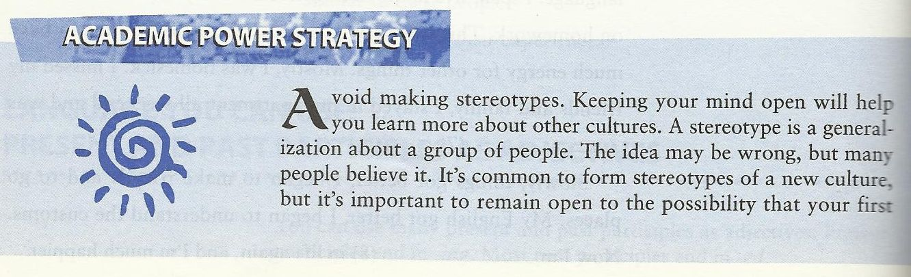
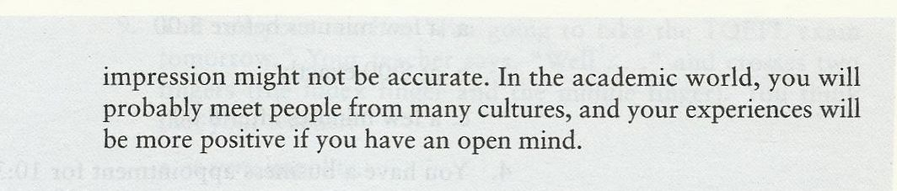
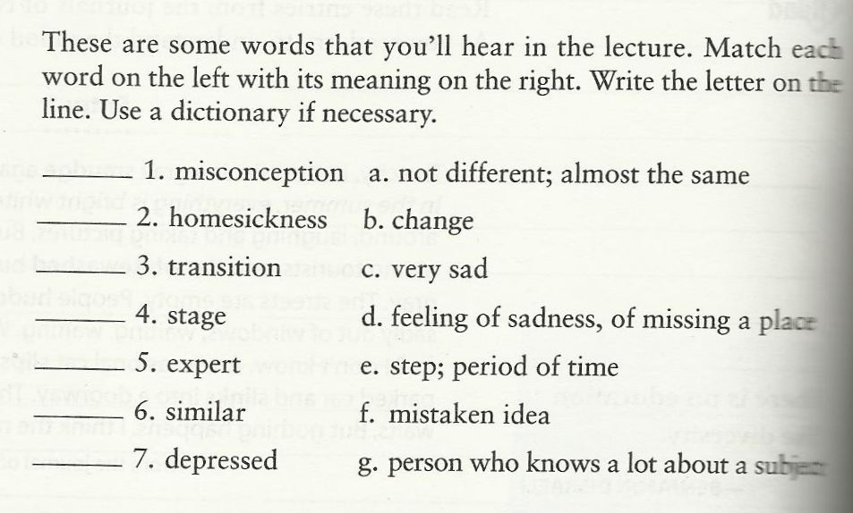

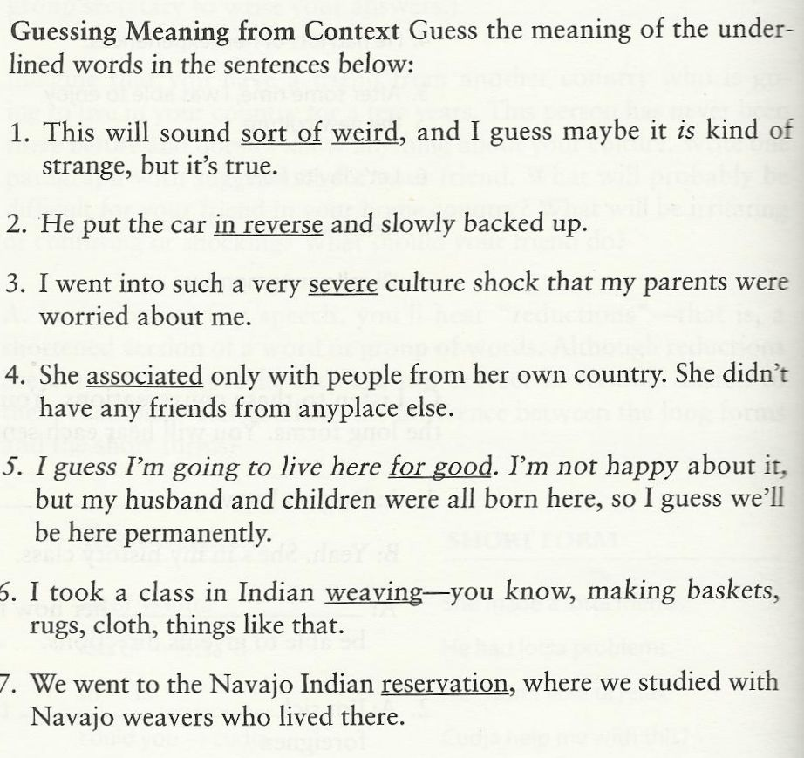
- 3. Punctuation marks
Punctuation is used to describe the meaning of unfamiliar words. The writer will write unfamiliar words and then use punctuation, words, phrases, or sentences to explain the meaning of the new words. Such punctuation is in the “Key words box” below.
, commas
, , appositive
( ) parentheses
? ? dashes
; semicolon
: colon
e.g. Full-color pictures are printed using only black and three colors: yellow, cyan (a light blue) and magenta (a light purple).
- an unfamiliar word = cyan and magenta
signal punctuation = ( )
- meaning : cyan = a light blue and magenta = a light purple

- The use of computers to handle text, or word processing, was foreseen in the 1950s.

an unfamiliar word = handle text
signal punctuation = , ,
meaning : handle text = word processing

4. Examples
help us to understand the meaning of new words. See key words or signal words used for
showing examples in the “Key words box”.

such as
like
for example, …
for instance
is / are

e.g. Use navigation buttons, such as, the “Next” button, the “Previous” button, the “Menu” button, and the “Exit” button, to go back and forth or jump to other topics while you are using your English software.

unfamiliar words = navigation buttons
signal word = such as
meaning = buttons on computer program that are used for turn on pages

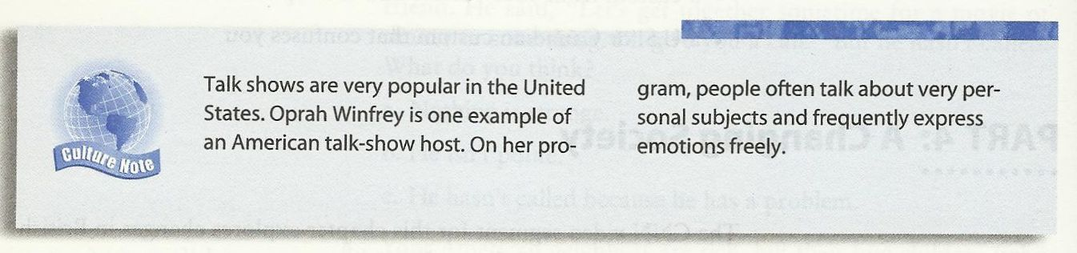

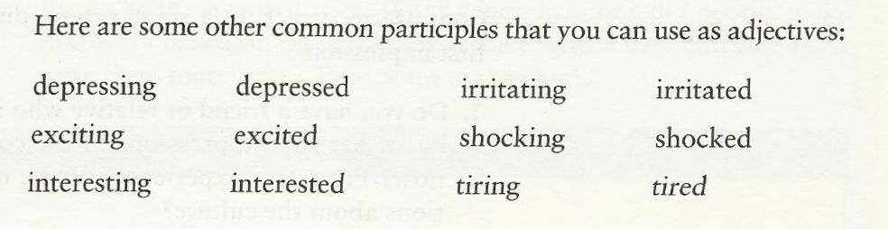

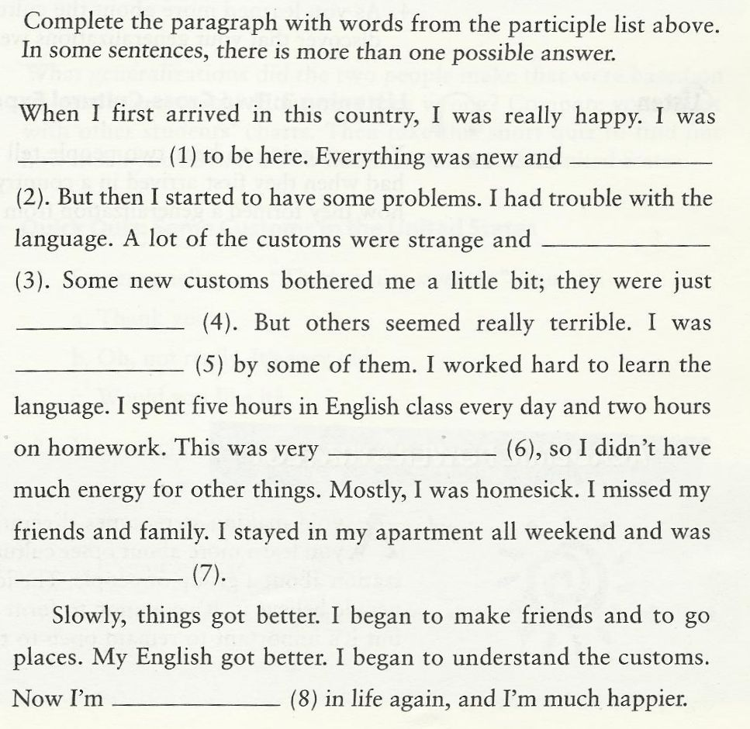

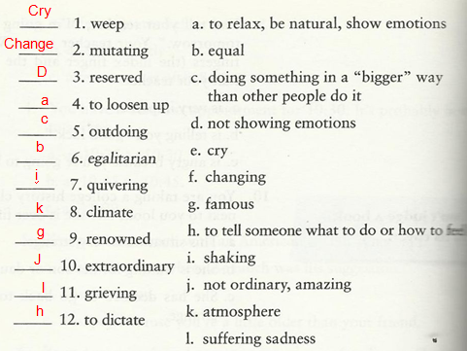

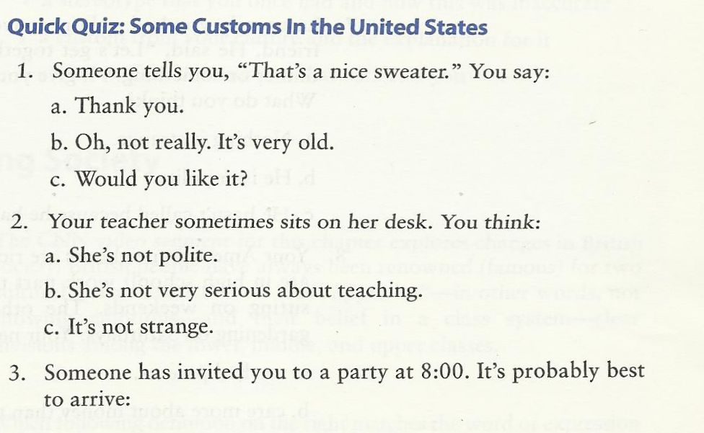

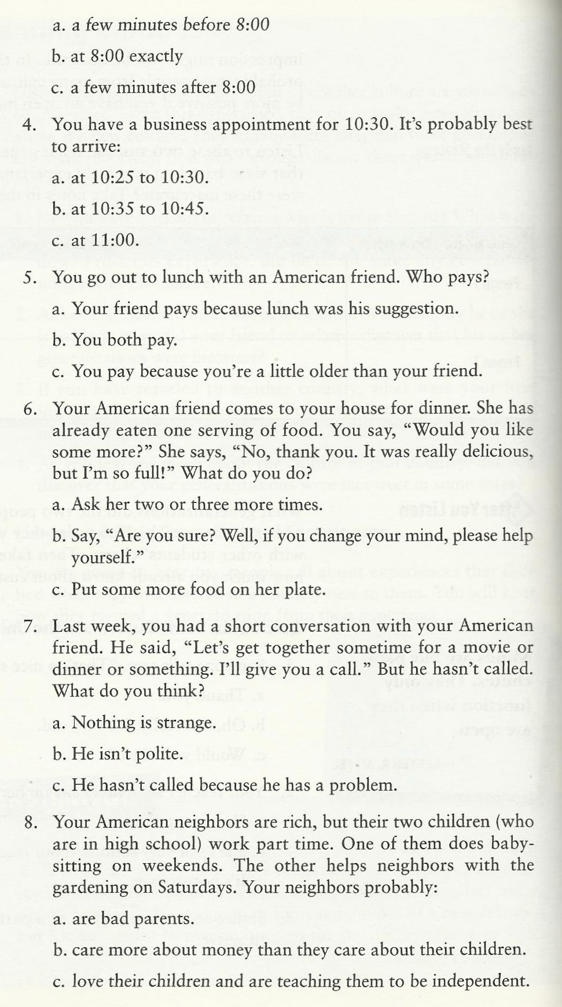

With my best regards
~Mrs.ENGLI$H~

10th Class

Elements of the Class
Vocabulary Previewing
- Academic Power Academy: Stereotypes –Reductions - Expressing Emotions
- People’s Intonation: happy or unhappy -Making an appointment
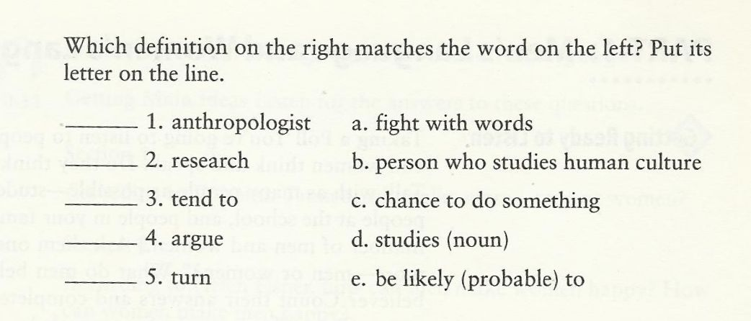
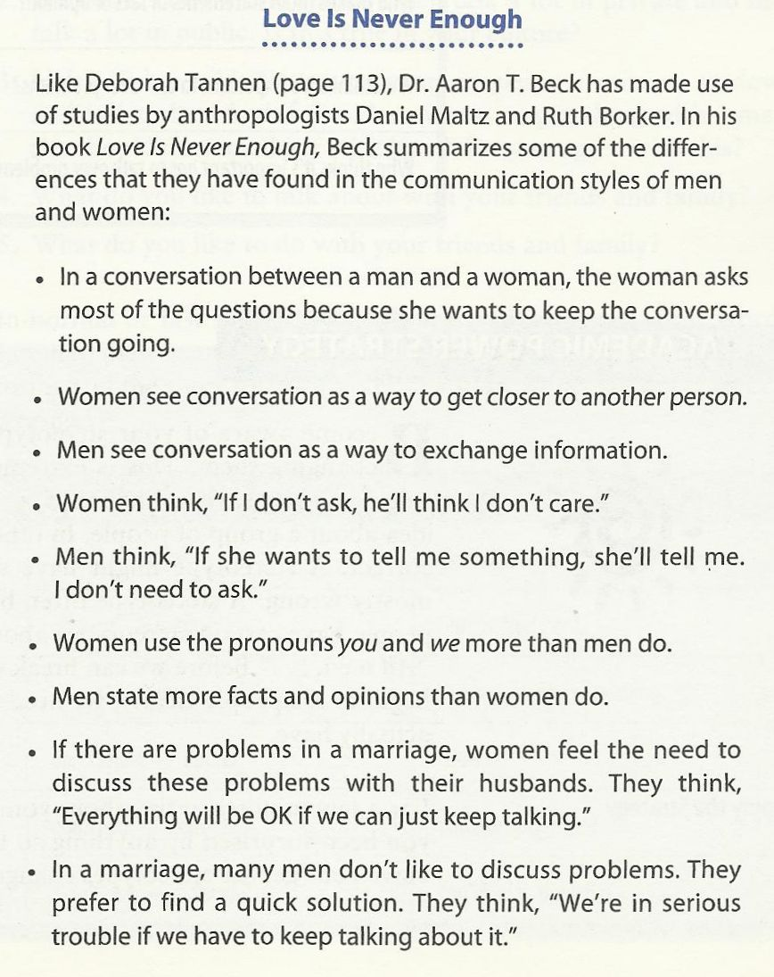

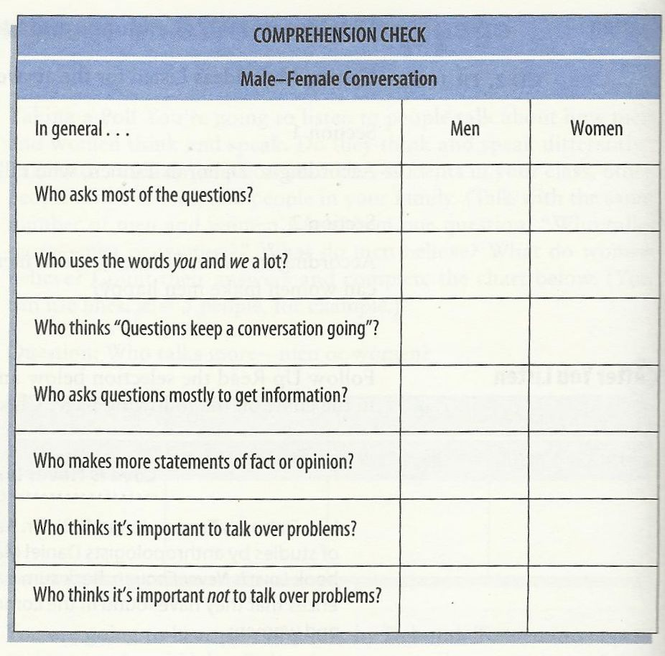
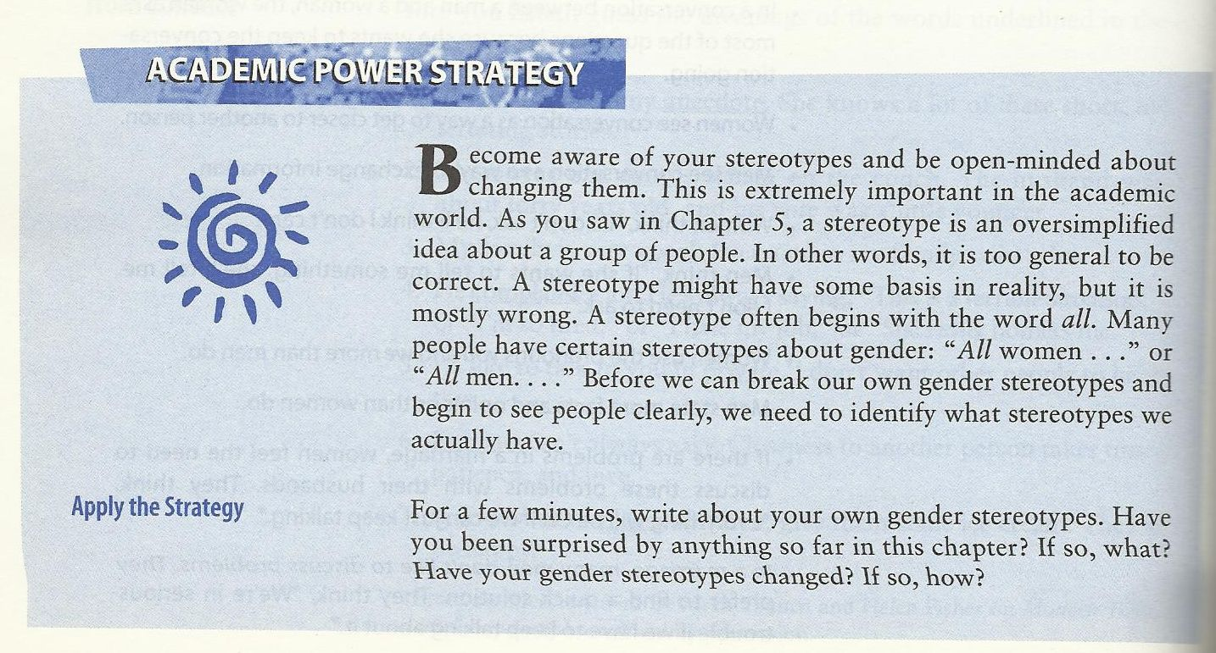

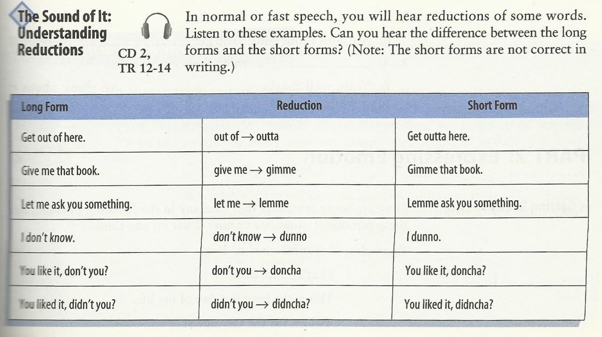
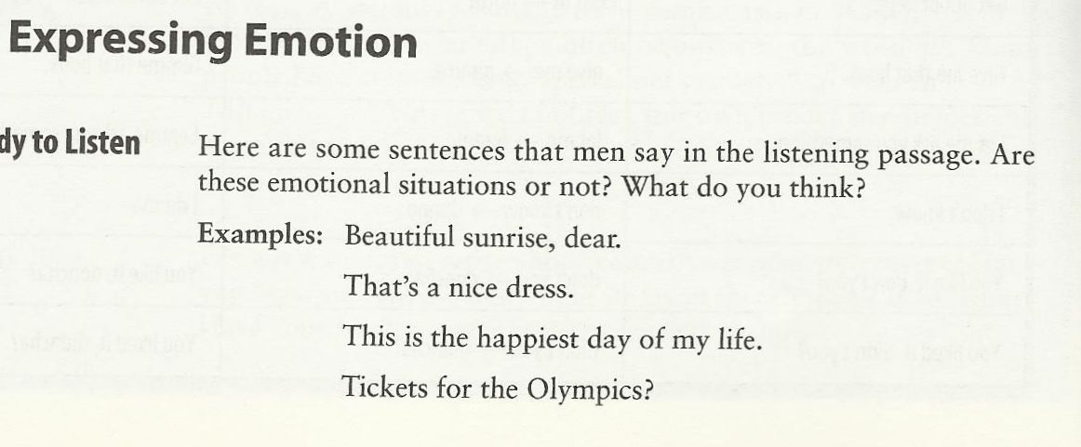
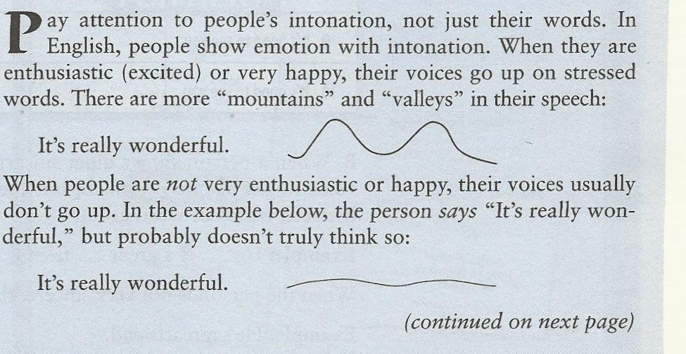

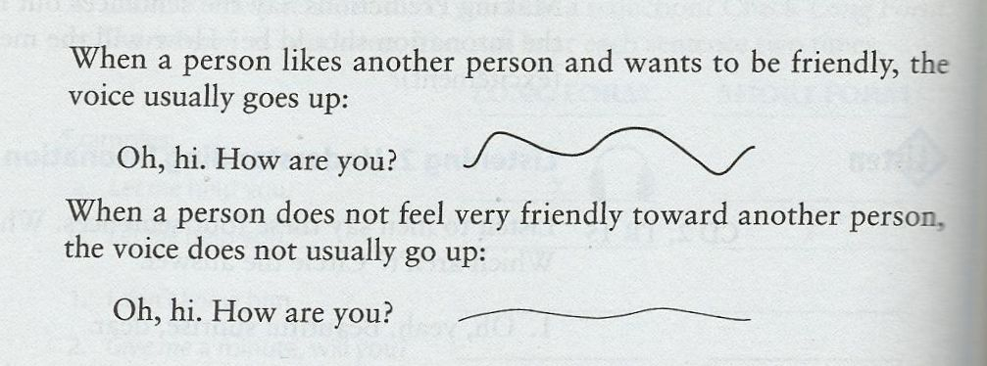
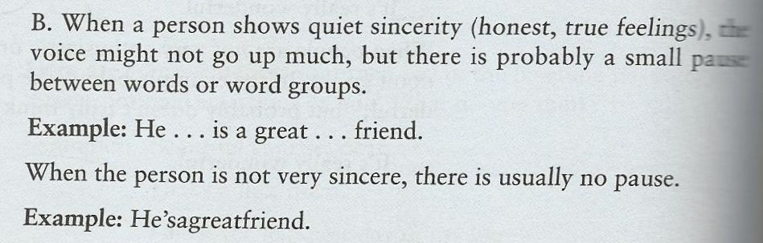
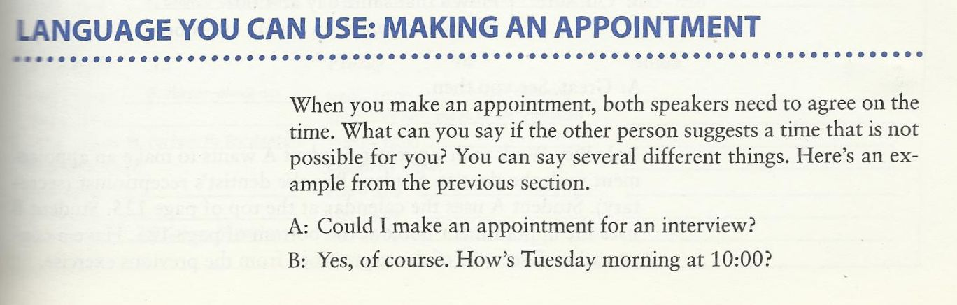

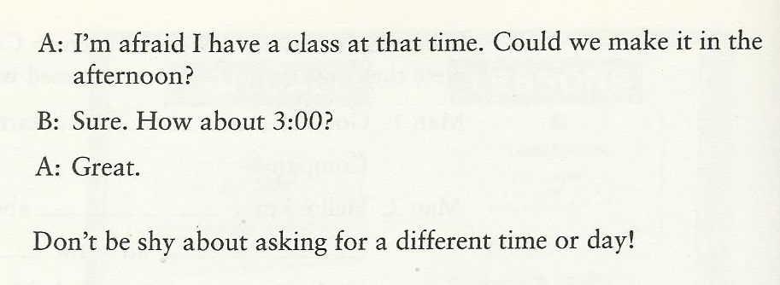

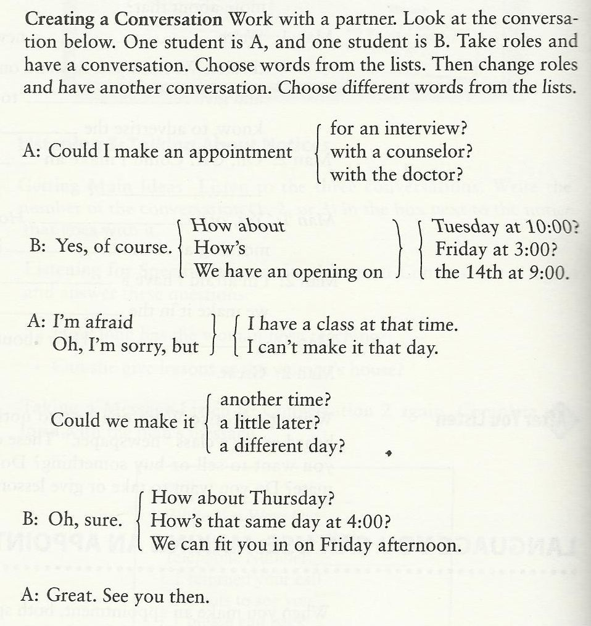

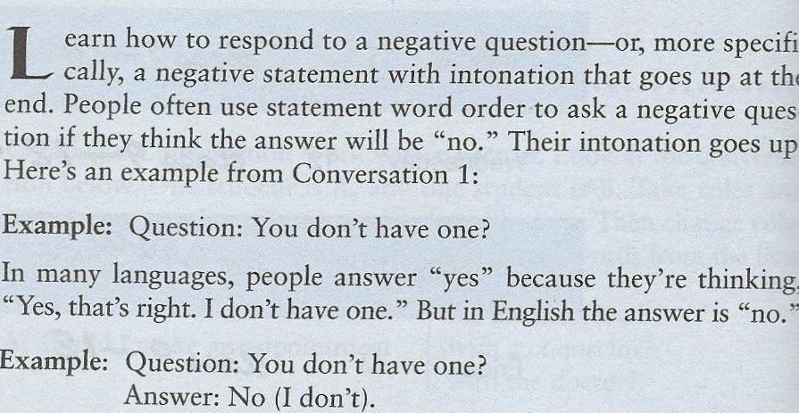
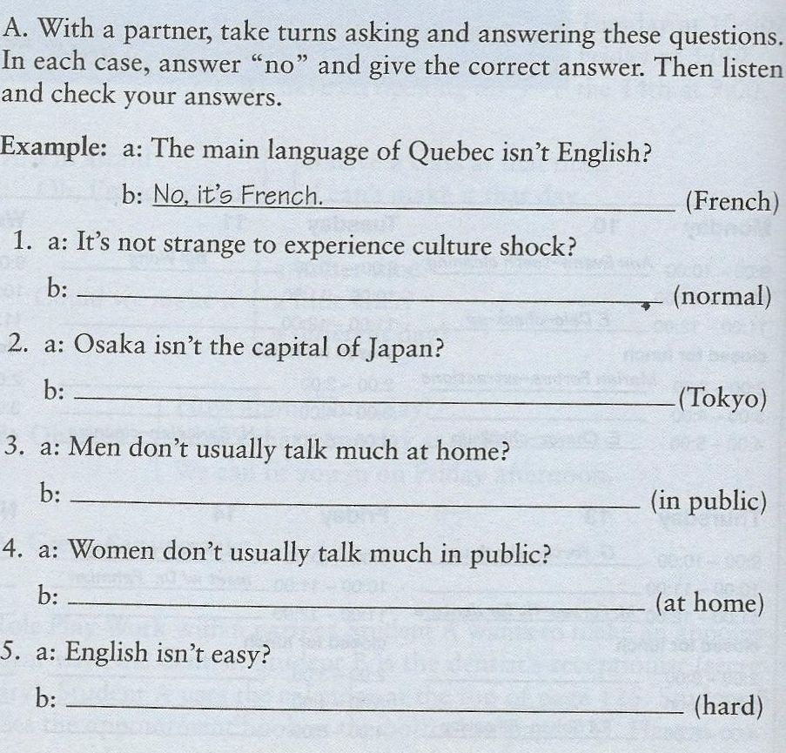

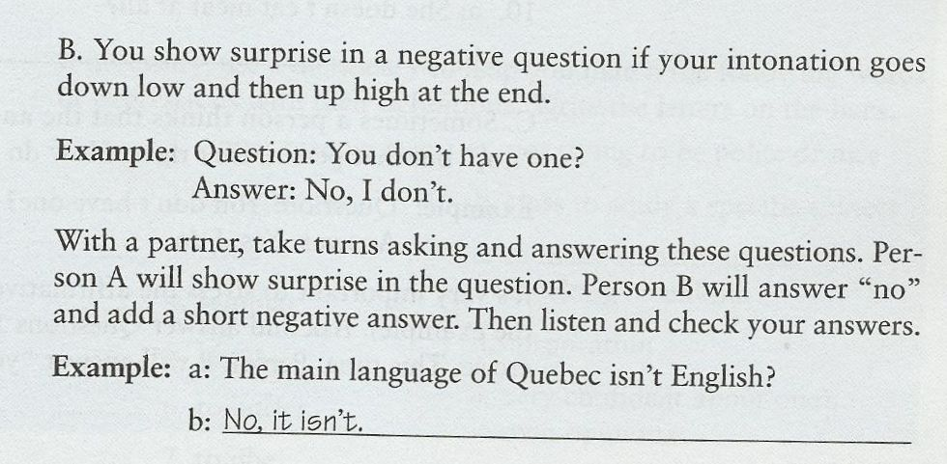
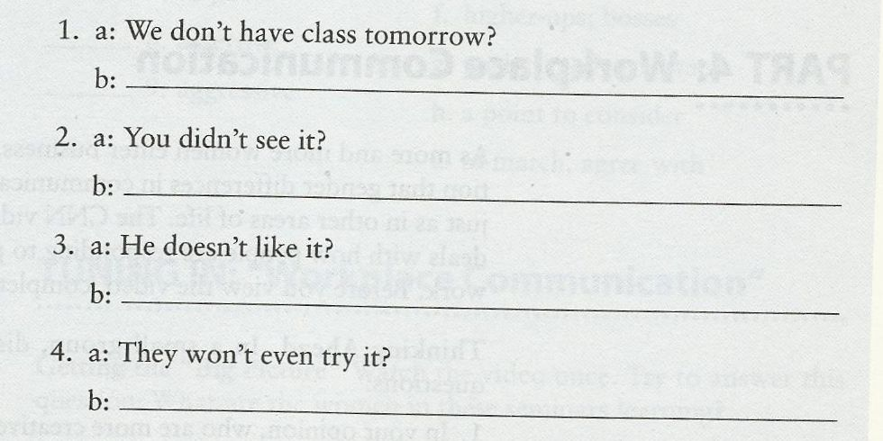
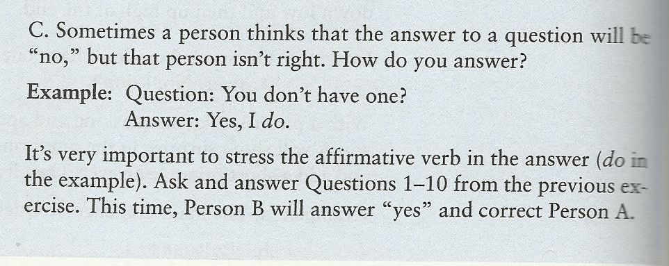

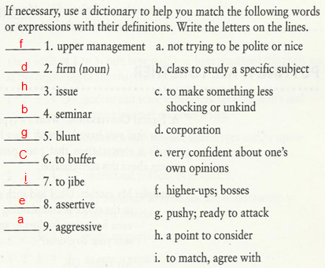

With my best regards
~Mrs.ENGLI$H~

11th Class`
Most Frequent Prefixes and Suffixes
Word Beginnings and Endings You Can Really Use

What Are Prefixes?
Prefixes are first syllables like “non-” and “re-” that have their own meaning.
Prefixes combine with words to create new meanings.
  - Pre + View = Preview (first look)
  - Super + Star = Superstar (top player)

Why Learn Prefixes?
- Prefixes add meaning to thousands of words.
- Learn a few prefixes, and you open up the meaning of thousands of words.
- The four most frequent prefixes are 97% of prefixed words!

Most Common Prefixes
- Anti = against : anti-war
- De = opposite : destroy
- Dis* = not, opposite of : disagree
- En(m) = cause to : encode, embrace
- Fore = before : forecast
- In(m) = in : intake, implant
- Inter = between : interact

Do you know common prefixes?
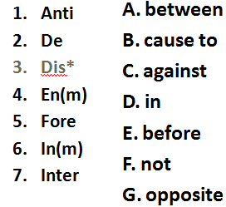

Most Common Prefixes
- Mid = Middle : Midway
- Mis = Wrongly : Mistake
- Non = Not : Nonsense
- Over = Over : Overlook
- Pre = Before : Preview
- Re* = Again : Return
- Semi = Half : Semicircle

Do you know common prefixes?
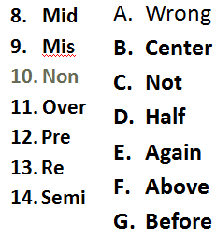

Most Common Prefixes
15. Sub = Under : Submarine
16. Super = Above: Superstar
17. Trans = Across : Transport
18. Un* = Not : Unfriendly
19. Under = Under : Undersea
20. In, Im, Il, Ir * = Not : Injustice,
Impossible, Illiterate, Irreligious.

Do you know common prefixes?
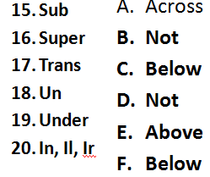

What Are Suffixes?
Suffixes are last syllables like “ed” and “ly” that have their own meaning.
Suffixes combine with words to create new meanings.
  - Turn + ed = Turned (in the past)
  - Quick + ly = Quickly (how it turned)

Why Learn Suffixes?
Suffixes add meaning to thousands of words.
Learn a few Suffixes, and you open up the meaning of thousands of words.
The four most frequent suffixes are 97% of suffixed words!

Most Common Suffixes
- -able, ible = can be done : doable
- -al, ial = has property of : personal
- -ed* = past verb : turned
- -en = made of : golden
- -er = comparative : higher
- -er = one who : doer, actor
- -est = superlative : best, biggest

Do you know common suffixes?
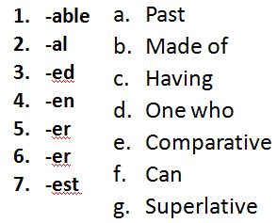

Most Common Suffixes
8. –ful = full of : careful, joyful
9. –ic = having property of : linguistic
10. –ing* = present participle : running
11. –(t)ion = act, process : action
12. –(i)ty = state of : infinity, sanity
13. –(t)ive = adjective : motive, votive
14. –less = without : fearless, careless

Do you know common suffixes?
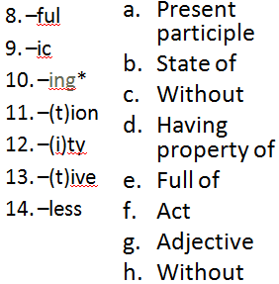

Most Common Suffixes
15. –ly* = having : quickly, quietly
16. –ment = action, process : enjoyment
17. –ness = state of : kindness
18. –ous = having : joyous, religious
19. –s* = more than one : books
20. –y = having : happy, windy
Use these suffixes correctly, and
you look and sound pretty smart.

Do you know common suffixes?
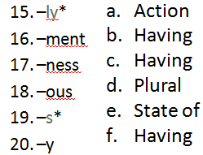

Can you use common affixes?
- I have a different idea; I __agree.
- That can’t be; it’s just __possible.
- Say that again; please __peat it.
- Aliens look bad; they are __friendly.
- Tina took the car since she want__ it.
- Now the car is run__ down the road.
- Tina is in a hurry; she’s driving quick__.
- Do you think that she has any ticket__?

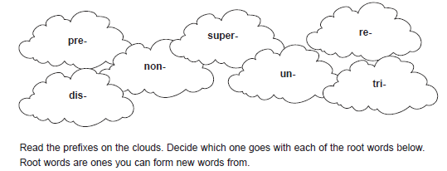

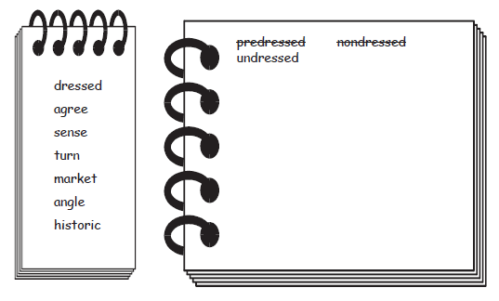

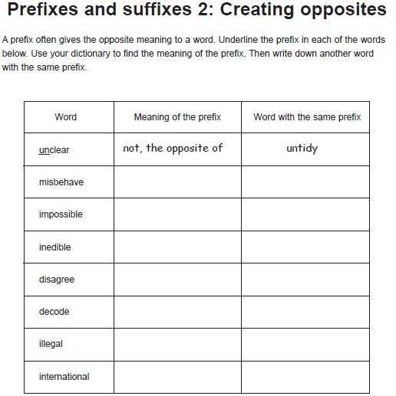

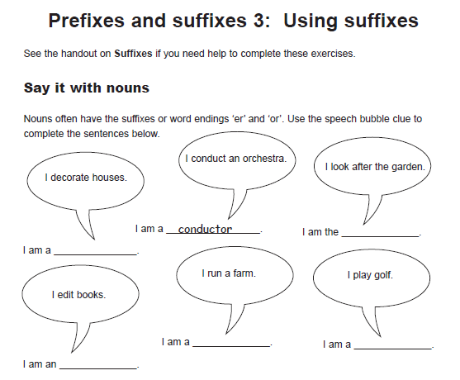

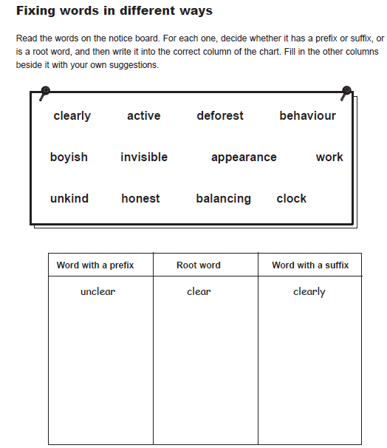

1. A programm …….. designs, writes, and tests programmes for perform …….. various tasks on a comput …..... .

2. A systems anal……. studies organization …….. systems and decides what act …….. needs to be taken to maxim…….. efficien…….. .

3. Laser print……… are prefer …….. to other types of print …….. devices because of their speed and quite…….. .

4. The microcomput ……… we have purchased does not have a FORTRAN compil …….. . It is programm ……… in BASIC only.

5. We have found that operat …….. s who have the freedom to take short breaks during the day great …….. improve their perform…….. .

6. The number of ship………. s will increase over the com ………months.

- We decided to computer………. the entire planet to give each divis …….. more independ………. .

B. Now decide for each word that has a suffix what part of speech the word is
(eg. noun (n), verb (v) , adverb (adv), adjective (adj) ). Insert the correct form - n, v, adv or adj into the spaces.
programmer (for) performing a computer
analyst organizational action
maximize efficiency printer preferable printing (device) quiteness microcomputer compiler programmable greatly shipment computerize division independence (a way of...)storing Spooling turning (...your office....) (big...) savings developer (...are) producing increasingly sophisticated application
a growing global ...(market)

C. Insert the right prefixes into the spaces:
1. Floppy disks are ……. expensive and …….. useable.
2. If a printer …… functions, you should check the……… face cable.
3. The…….. plexor was not working because someone had………. connected it by mistake.
4. …….. proper installation of the……… glare shield will make it ……….. possible to read what is on the screen.
5. After you ……… fer text using the 'cut and paste' feature, you may have to ………. format the text you have inserted.

12th Class
Comparatives & Superlatives

What is a noun?
Noun is a word which refers to a thing, person,activity, place etc.
What is an adjective?
Adjective is a word which describes a noun
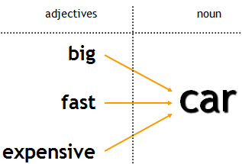

Examples - Adjectives
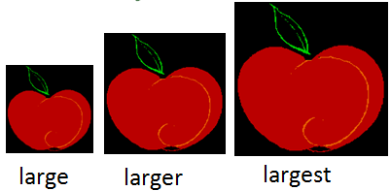
The first apple is large.
The second apple is larger than the first.
The third apple is the largest of the three.

What is a syllable?
Syllable is a part of a word containing vowel sound
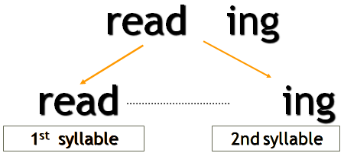

Syllables – examples
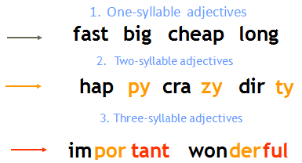

LET’S START J
Adjectives and adverbs are words the modify other words. The comparative form of an adjective or adverb compares two things. The superlative form of an adjective or adverb compares three of more things.

What is a “comparative form”?
Comaprative form expresses the idea of ‘more’
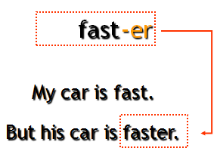

“Comparative form”?
How is a ‘comparative’ form built?
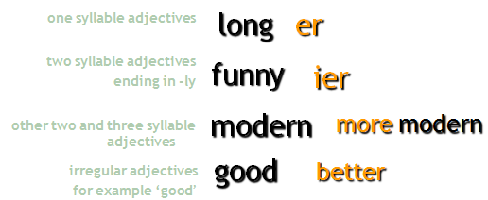

Change of ‘y’ into ‘i’
We want the comparative form of the adjective ‘funny’
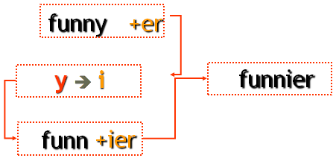

What is a “superlative form”?
Comaprative form expresses the idea of ‘most’
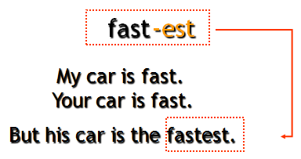

“Superlative form”?
How is a ‘superlative’ form built?
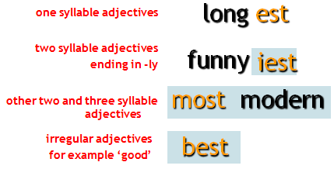

Summary comparison
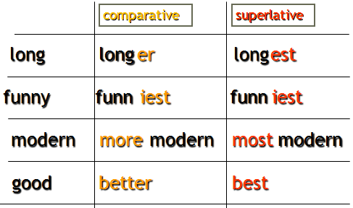

To make comparative and superlative forms of adjectives some rules must be followed.
Rule 1
To form the comparative or superlative of one syllable words with more than one vowel OR ending with more than one consonant at the add -er OR -est.
tall | taller | tallest
neat | neater | neatest
deep | deeper | deepest

Rule 2
To form the comparative or superlative of a one syllable word ending
in e add -r OR -st.
wide | wider | widest
fine | finer | finest
cute | cuter | cutest

Rule 3
To form the comparative or superlative of a one syllable word with one vowel and one consonant at the end double the consonant, and add -er OR -est.
sad | sadder | saddest
big | bigger | biggest
fat | fatter | fattest

Rule 4
To form the comparative or superlative of a two syllable word ending in y, change the y to i, then add -er OR -est.
happy | happier | happiest
jolly | jollier | jolliest
lazy | lazier | laziest

Rule 5
To form the comparative or superlative of a two syllable word ending a vowel-sound that is not stressed then add -er OR -est.
Adjectives ending in –le, -ow, er frequently take –er and –est.
yellow | yellower | yellowest
gentle | gentler | gentlest
simple | simpler | simplest

Rules at a Glance
Adjective form | Comparative | Superlative
Only one syllable, with more than one vowel or more than one consonant at the end. Examples:  light, neat, fast, tall, neat, deep | Add -er:  lighter, neater, faster, taller, neater, deeper | Add -est:  lightest, neatest, fastest, tallest. neatest, deepest
Only one syllable, ending in E. Examples:  wide, fine, cute | Add -r:  wider, finer, cuter | Add -st:  widest, finest, cutest
Only one syllable, with one vowel and one consonant at the end. Examples:  hot, big, fat, sad | Double the consonant, and add -er:  hotter, bigger, fatter, sadder | Double the consonant, and add -est:  hottest, biggest, fattest, saddest
Two syllables, ending in Y. Examples:  happy, silly, lonely, jolly | Change y to i, then add -er:  happier, sillier, lonelier, jollier | Change y to i, then add -est:  happiest, silliest, loneliest, jolliest
two syllable word ending a vowel-sound that is not stressed  yellow, simple | Add -er:  yellower, simpler | Add -est:  yellower, simpler
Two syllables or more, not ending in Y. Examples:  modern, interesting, beautiful, | Use more before the adjective:  more modern, more interesting, more beautiful | Use most before the adjective:  most modern, most interesting, most beautiful

NOTE: Like adjectives some adverbs can take comparative and superlative forms, with -er and -est:
Sally works hard.
Steve works harder than Sally
Kathy and Sue work the hardest of all.
The bird sings loudly.
The moose sang louder than the bird.
Pete sang the loudest of them all.

List of Adverbs in Which -er and -est May Be Added
Adverb | Comparative | Superlative
fast | faster | fastest
slow | slower | slowest
quick | quicker | quickest
early | earlier | earliest
bright | brighter | brightest
high | higher | highest

However, the majority of adverbs do not take these endings. Instead, they form the comparative using more and the superlative using most:
Adverb | Comparative | Superlative
recently | more recently | most recently
effectively | more effectively | most effectively
frequently | more frequently | most frequently
Irregular Comparative and Superlative Adjectives and Adverbs
Some comparative and superlative forms are irregular and do not follow any rules or patterns. These must be memorized.

USE OF COMPARATIVES
Comparatives are very commonly followed by than and a pronoun or noun group, in order to describe who the other person or thing involved in the comparison is, e.g.:
John is taller than me.
I think that she’s more intelligent than her siste

OTHER USES OF COMPARATIVES
- Comparatives are often qualified by using words and phrases such as much, a lot, far, a bit/little, slightly etc., e.g.:
You should go by train, it would be much cheaper.
Could you be a bit quieter?
I’m feeling a lot better.
Do you have one that’s slightly bigger?
- Two comparatives can be contrasted by placing the before them, indicating that a change in one quality is linked to a change in another, e.g.:
The smaller the gift, the easier it is to send.
The more stressed you are, the worse it is for your health.
- Two comparatives can also be linked with and to show a continuing increase in a particular quality, e.g.:
  - The sea was getting rougher and rougher.
  - Her illness was becoming worse and worse.
  - He became more and more tired as the weeks went by

USE OF SUPERLATIVES
- Like comparatives, superlatives can be placed before nouns in the attributive position, or occur after be and other link verbs, e.g.:
the most delicious chocolate cake I’ve ever eaten
Annabel was the youngest
This restaurant is the best
- As shown in the second two examples, superlatives are often used on their own if it is clear what or who is being compared. If you want to be specific about what you are comparing, you can do this with a noun, or a phrase beginning with in or of, e.g.:
Annabel was the youngest child
Annabel was the youngest of the children
This restaurant is the best in town.

THE OPPOSITES OF COMPARATIVE AND SUPERLATIVES
We use the forms less (the opposite of comparative more), and the least (the opposite of superlative the most).

Less is used to indicate that something or someone does not have as much of a particular quality as someone or something else, e.g.:
This sofa is less comfortable.
I’ve always been less patient than my sister.

The least is used to indicate that something or someone has less of a quality than any other person or thing of its kind, e.g.:
It’s the least expensive way to travel.
She was the least intelligent of the three sisters.

Irregular Adverbs
Word | Comparative | Superlative
badly | worse | worst
much | more | most
little | less | least
much | more | most
well | better | best

Irregular Adjectives

Word | Comparative | Superlative
good | better | best
bad | worse | worst
much | more | most
little | less | least
far | farther | farthest
old | older  elder | oldest  eldest

Example:
Nathan made good stew.
Molly's stew was better than Nathan's.
Ezra made the best stew of all.

Let’s Start Exercising
1. The weather in winter is _____________ than it is in summer.
A. colder B. cold
C. coldest D. the coldest
2. I have ___________ money than you do.
A. much B. more
C. most D. least
3. Abdullah is ______________ of all boys.
A. the fastest B. the most fastest
C. fast D. faster

Do More Exercises
- What is the comparative of "sad"?
  - sader
  - sadder
  - sadier
  - saddier
- What is the comparative of "destructive"?
  - destructiver
  - more destructive
  - destructivier
  - more destructiver
- What is the superlative of "soft"?
  - softest
  - softiest
  - softtest
  - most soft
- What is the comparative of "hot"?
  - hoter
  - hotter
  - hotest
  - hottest
- What is the comparative of "heat"?
  - heater
  - heatter
  - heatier
  - hetter
  - none of these
- What is the superlative of "ugly"?
  - uglier
  - uggliest
  - uglyest
  - Ugliest

- What is the superlative of "unpleasant"?
  - unpleasant
  - most unpleasant
  - more unpleasant
  - unpleasantest

10. To fall from a motorcycle is _____ to fall from a bicycle.
- more painful b) more painful than c) painfuller than d) the painfullest

11. If you suffer asthma, don’t go to Mexico City. It is one of the _____ cities in the world
- pollutest b) more polluted c) polluter than d) most polluted

12. The _____ place from Chile is Australia. It’s on the other side of the world.
- farther b) farthest c) farther than d) farthest than

13. I don’t think your bike is _____ mine.
- fastest than b) faster c) fastest d) faster than

14. Michael was _____ basketball player in the world
- taller b) tallest c) the taller d) the tallest

15. Speaking Japanese is _____writing it.
a) the easiest b) easy c) easier than d) easyer than

Write the following sentences using the correct form of the adjective (comparative or superlative)
- Clare is __________________________________________________ Mike. (old)
- Jane is ________ of the four. She eats very well and does a lot of sports, (healthy)
- The coach thinks that Peter is the __________________ player of the team, (fast)
- The Sahara desert is one of the ___________________deserts in the world. (hot)
- The climate in the North of Chile is _______________________ in the South, (dry)
- Asia is _________________________________________________ Europe. (big)
- A Rolls-Royce is one of _______________________ cars in the world. (expensive)
- ____________________________ hurricanes are developed over México, (violent)
- Diamonds are ______________________________ jewels in the world. (precious)
- History classes are _________________________ chemistry classes. (interesting)

With my best regards
~Mrs.ENGLI$H~

