English Language Speaking Skills

First Class
How to practice with Native Speakers
When you listen to a teacher’s lecture, pay special attention whenever the teacher emphasizes or repeats points. There are probably the main ideas or important details.
In the following lecture, you will hear a teacher talk about how to learn English more quickly. Listen one to each section. Pay Special attention if the teacher emphasizes or repeats a point. After you listen to the section, stop and answer the question about it. Then listen to the next section.

Section 1 CD, TR 1
Who is the best teacher, according to the speaker?
______1. a strict teacher who gives a lot of homework and does all the talking.
______2. a friendly teacher who lets the students talk a lot.
______ 3. you, the learner

Section 2 CD TR 2
The teacher gives a lot of examples of where to practice English outside of class. What examples does this she give? Listen once and check the answers.
______ supermarket _____ bus stop
______ movie theater _____ library
______ hospital _____ school

Section 3 CD TR 3
The teacher talks about her friend Sara. What four things did Sara do to learn English? Listen once and check the answer.
_____ talked with people everywhere
_____ took a class in English as a second language. ]
_____ asked friends for help
_____ listen carefully
_____ wrote idioms in a notebook

Section 4 CD TR 4
The teacher talks about her own experience. With whom did she practice a lot of Greek. Listen once and check the best answer.
______ her Greek teacher
______ taxi drivers
______ friends
______ neighbors

Beginning a conversation and making small talk
Seek out native speakers as conversations partners and make small talk with them. This is one good way to practice your English. In many countries, there are certain situation in which it is possible to have a very conversation with a stranger – in other words, to make small talk. This is usually as short as two or three sentences and is usually about something unimportant, like the weather.

How to begin a conversation?
How do people politely begin a conversation with a stranger? Does it depend on their culture? How acceptable is it in you country to begin conversations with the sentences in the chart on the following slide?

Put (Y) for sentence that people say are polite. Put (X) for sentences that are impolite
Situation First Sentence in Yes/ No
a conversation with stranger
at the bus stop? | It’s hot today, isn’t it?
At the post office | This line is really slow, isn’t it?
At a wedding | It’s nice to have a chance to celebrate, isn’t it?
In a supermarket | These tomatoes look terrible, don’t they?
On a bus | What country are you from?
Anywhere | Can you lend me some money?
In a museum | This is a wonderful painting, isn’t it?

Work with a partner. Pretend you are in the situation below. Make polite small talk.

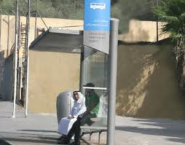

The Sound of it: Understanding Intonation in Tag Questions
We often a conversation with a sentence that includes a tag question. We add a “tag” to a sentence, and it becomes a question. Our voices goes up on the tag if we aren’t sure about the answers; it becomes a real question. Our voices goes down on the tag if we already know the answer and are making small talk.
Examples:
You will do it quickly ,won't you?

John and Mark aren't English ,are they?

Listen and Repeat CD 1 TR 6
Unsure of the Answer (Real Questions)
- The food is awful, isn’t it?
- You don’t see any fresh fruit, do you?
- There isn’t any yogurt, is there?
- There’s lots of sugar, isn’t there?
- You haven’t seen a good health food place, have you?

Sure of the Answer (small talk)
- The food is awful, isn’t it?
- You don’t see any fresh fruit, do you?
- There isn’t any yogurt, is there?
- There’s lots of sugar, isn’t there?
- You haven’t seen a good health food place, have you?

Pay attention to a speaker’s intonation.
As you’ve seen, intonation in a tag question carries meaning. If the voice goes up, the person is unsure of the answer and is asking a real question. If the voice goes down, the person already knows the answer and is just making small talk.
Paying attention to intonation will help you better understand a speaker’s meaning.

Asking Tag Questions
Notice the grammar in tag questions: if the verb in the main clause is affirmative, the verb in the “tag” (last two words) is negative.
Example:
It’s warm today, isn’t it?

If the verb in the main clause is negative, the verb in the “tag” (last two words) is affirmative.
Example:
It isn’t very windy today, is it?

Work with a partner. Have a very short conversation for each situation. One person begins with a tag question (with the voice going down at the end). The other person answers. Use the cue words.
Example:

Situation: Two people are at a bus stop. Cue Words: A: bus/ late again , B: yes

Student A: The bus is late again, isn’t it?
Student B: Yes, it is.

Common Expressions in Conversation
Introducing Someone | Responses
- I’d like you to meet…  - This is… a friend of mine (my brother, sister, etc.)  - Have you met..? | Nice (Glad, Pleased) to meet you.
Ending a Conversation
Well, I’ve got to run.  Good-bye.  See you later (Friday, etc.).  Have a good day. Have a good weekend | I have to go now, but I’ll see (call) you …  It’s been good seeing you (talking to you).  Talk to you soon.  Keep in touch.
Expressing Thanks | Responses
Thanks.  Thank you very much (so much)  That was very kind of you,  How thoughtful!  I appreciate it. I’m very grateful. | You’re welcome.  Don’t mention it.
Giving an Apology | Responses
I’m very sorry.  Excuse me.  Forgive me.  It was my fault. | No problem.,  That’s ok. That’s all right.  Don’t worry about it. a

Making prediction
Situations
_____ by mistake, you just stepped on someone’s foot.
_____ you are introducing a friend to your parents.
____ you’re talking with a friend at school, but you need to leave because you have a class.

What you can say
- ______________________
- ______________________
- ______________________

Homework! Tapestry
- Chapter 1: CD 1, TR 6,B.Listen and repeat. page11
- Chapter 1: CD, TR 7, Apply Strategy, page 12
- Chapter 1: Situations and Cue words. Page 13
- Chapter 1: part3: Getting ready to listen. Page 13
- Chapter 1: CD 1, TR 8, page 14

Second Class
Part 1: Asking for, Understanding and Giving Directions
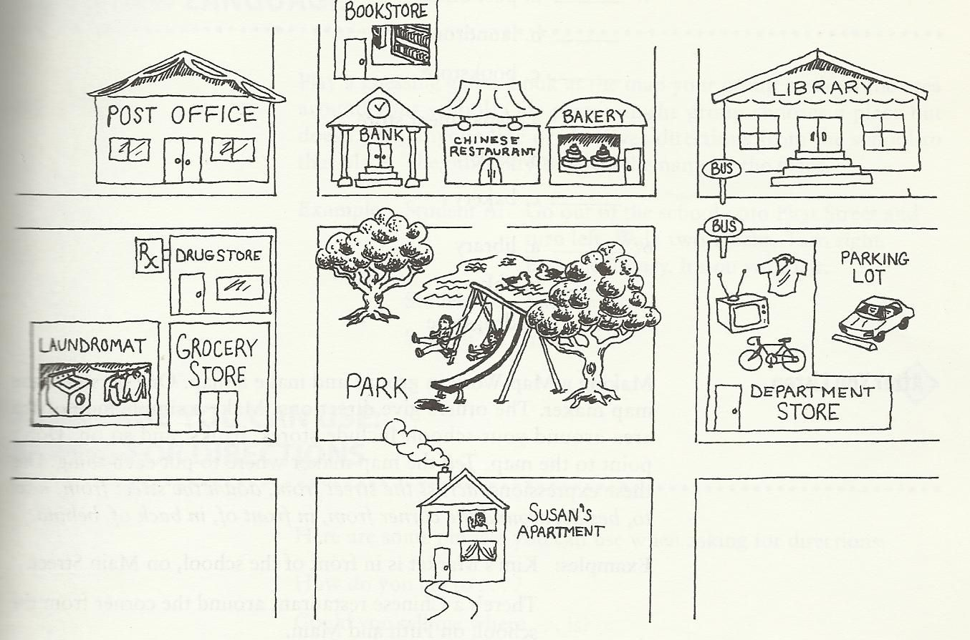

- The post office is across the street from the bank.
- The bakery is down the street from the post office.
- The launderomat is next to (beside) the grocery store.
- The drugstore is around the corner from the laundromat.
- There’s a bus stop in front of the library.
- There’s a parking lot behind (in back of) the department store.

Language You Can Use: Giving Directions
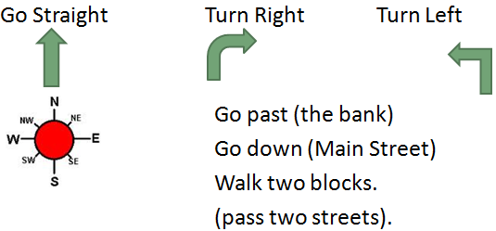

Language You Can Use: Asking For Directions
- How do you get to … ?
- Could you tell me where …. Is?
- Is …… far from here?
- I’m looking for …
- I’m trying to find…
- In what direction is …?

Getting Ready to listen: Vocabulary Match
For each expression on the left, find the expression on the right with the same meaning. Write its letter on the line.
_______ 1. Excuse me. a. paper money
_______2. to transfer b. pardon me.
_______3. dollar bills c. correct amount of coins
_______4. exact change d. to change

Listening 2: Understanding Tone of Voice (CD 1, TR 10)
Be aware of tone of voice. Tone of voice refers to how a voice sounds, not just the words a person uses. Understanding tone of voice can help you better understand what people mean. For instance, the tone of a message may be friendly even if the words are not friendly. It’s helpful to listen to people’s tone of voice because sometimes their voices tell more than their words.

CD 1, TR 10
Conversation 1
1. ______ friendly driver?
______ unfriendly driver?

2. what does William need to take to Seventh and Lake Streets?
_____ a. the 13 and the 30
_____ b. the 30 and the 38

3. where does he transfer?
_____ a. at Geary Street
_____ b. at Lake Street

Conversation 2, CD 1, TR 10
- The driver is
_______ friendly
_______ unfriendly
- How much does it cost to take the bus?
______ a. 85 cents
______b. one dollar and 85 cents
3. What does William need?
_______ a. exact change
_______ b. a dollar bill

Creating a Conversation
Work with a partner. Student A wants to take the bus. Student B is a bus driver. Have a conversation. Follow this model.

A: Excuse me. Does this bus go to …?
B: No, … you need bus number …..
A: where do I get ….?
B:…..
A: How much …..?
B:…..
A: Thanks.
B:……

Talking to Landlords or Apartment Managers; Making Complaints

Susan: Oh, what a (big, sunny, lovely) apartment!
Mrs. West: yes. It (is beautiful, is large, gets a lot of light.
Susan: what a nice, clean kitchen! The (oven, stove, refrigerator) looks new.
Mrs. West: Right! And there’s also a (lot of storage space, garbage disposal, dishwasher).
Susan: is there a (garage, swimming pool, security guard?
Mrs. West: Yes, there’s a (tennis court, a recreation area, cable television) too.
Susan: is there a (school, library, park) nearby?
Mrs. West: of course, and there’s a (bus stop. Grocery store, hospital) right down the street.
Susan: I hope there’s ( a fireplace, air conditioning, a good view),
Mrs. West: There is!!
Susan : this is a (great, terrific, wonderful) apartment.

Listening 3: Reporting Problems CD 1, TR 11
Identifying problems
Situation: After a few months, Susan has some trouble with her new apartment. She calls Mrs. West to complain. Listen to the conversation and check the problems she reports.
_______ 1. The garbage disposal is broken.
_______ 2. The roof is leaking.
_______ 3. The neighbors are too noisy.
_______ 4. There is no hot water.
_______ 5. The food in the freezer is melting.
_______ 6. it’s very hot, and the air conditioning does not seem to work.

The sound of it: Understanding Reductions
In a normal or fast speech, you will hear “reductions” of some words. For instance, want to may sound like wanna. Learning to understand reductions will help you become a better listener.
Listen to the following examples of reductions form the conversations in this chapter. à

CD 1, TR 12- 13 (A)
Can you hear the difference between the long forms and the short forms? Note: The short forms are not correct in writing.

LONG FORM | REDUCTION | SHORT FORM
Do you have any pets? | You à ya | Do ya have any pets?
What’s your name? | What’s you à watcher | Watcher name?
Does this bus go to Geary Street? | Go to à goda | Does this bus goda Geary Street?
Do you want to see the kitchen? | Want to à wanna | Do you wanna see the kitchen?
You have to have exact change. | Have to à hafta | You hafta have exact change

CD 1, TR 12- 13 (B)
B. Listen to these sentences. Do you hear a reduction? Check Long Form or Short Form as you listen. You will hear each sentence two times.

Examples | LONG FORM | SHORT FORM
a. You need bus number 3.
b. You need bus number 3.
1. Are you Susan Evans?
2. You can’t use dollar bills.
3. What’s your address?
4. I need to go to the store.
5. Do you go to Parkwood Avenue?
6. Does he want to pay that much?
7. I don’t want to walk?
8. I don’t want to walk?
9. Do you have to go?
I have to buy some furniture?

Vocabulary Match
Which definition on the right matches the word on the left? Write its letter on the line.
_____ 1. opportunities a. admired
_____ 2. to look down on someone b. possibilities, chances, to do something
_____ 3. respected c. to think badly of someone

Listening 4: getting main idea CD 1 TR 14
You are going to hear an opinion about the American lifestyle and the mobility of Americans. Pilar Hernandez, an immigrant to California and a former teacher for an American school in her country.
Listen and then tell whether these sentences are true or false:
_____ 1. Pilar worries because her mother is alone and lonely.
_____ 2. Pilar is not planning to go back to her country.
______ 3. In Pilar’s country, it is easy for an average person to become rich and successful.

Homework! Tapestry
Listen & Practice
- CD 1, TR 9 page 25,
- CD 1, TR 10, Page 31 + 32
- CD1, TR 11, page 34
- CD1, TR 12-13 page 34
- Directions page pages ; 24 +28 + 29
- Vocabulary Match pages: 31 + 35

Third Class
Elements of Chapter 3…
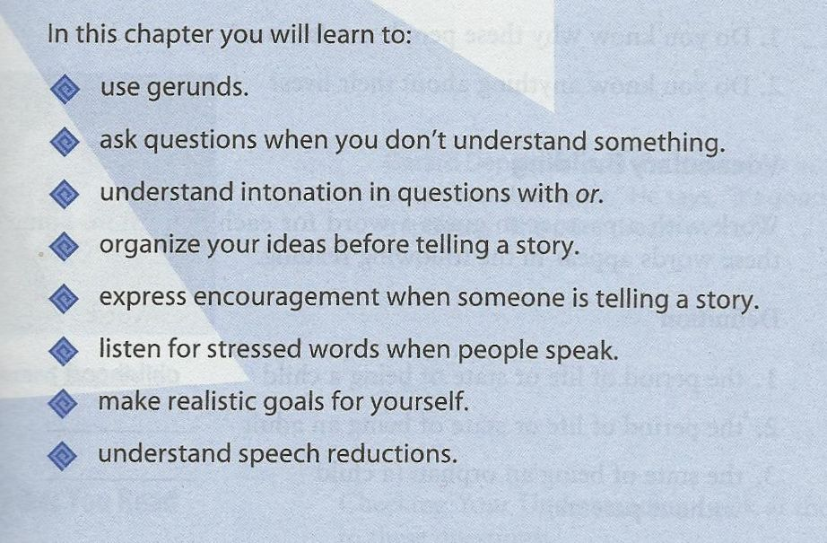
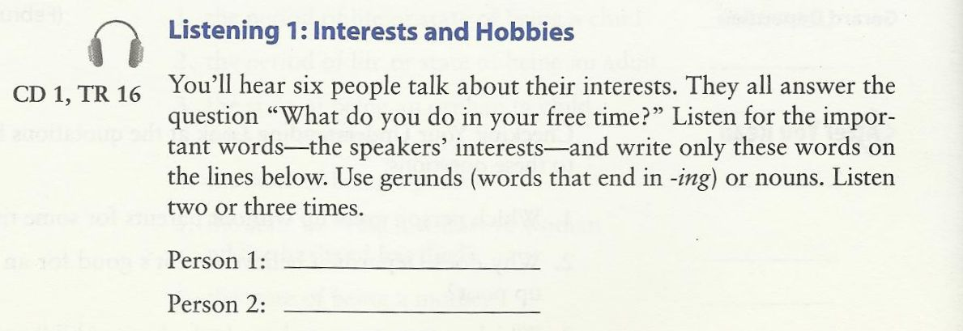

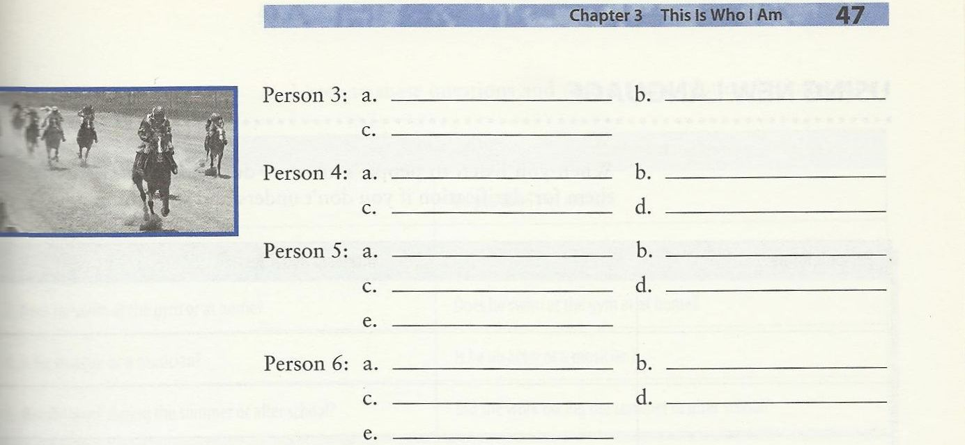
Do it by Yourself J
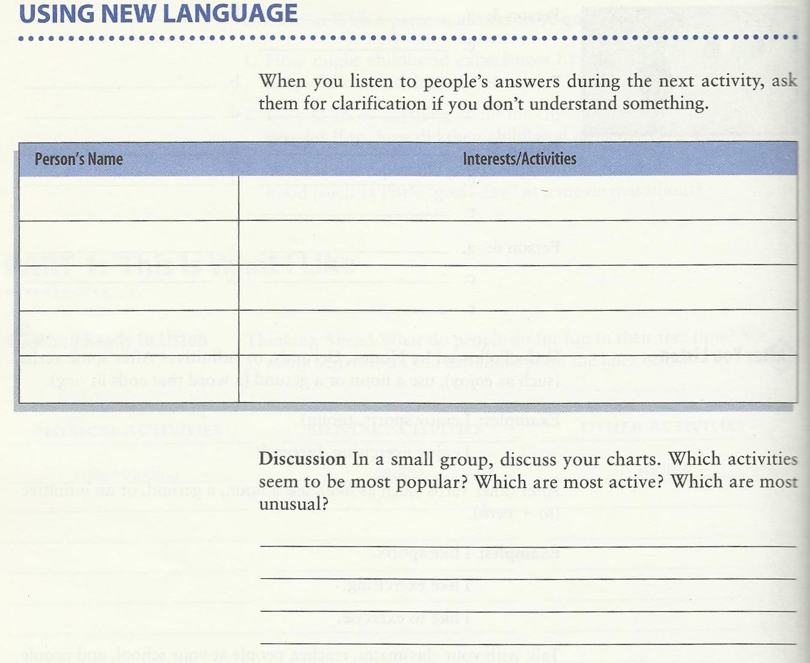

Gerund Form

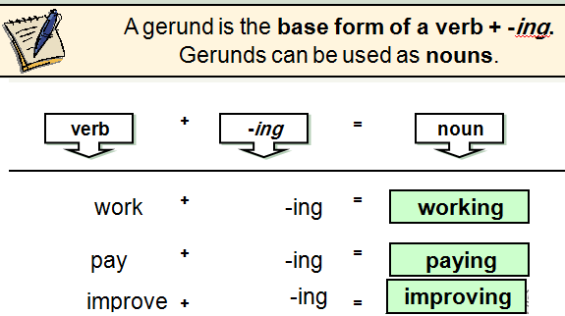

Gerunds as Subjects
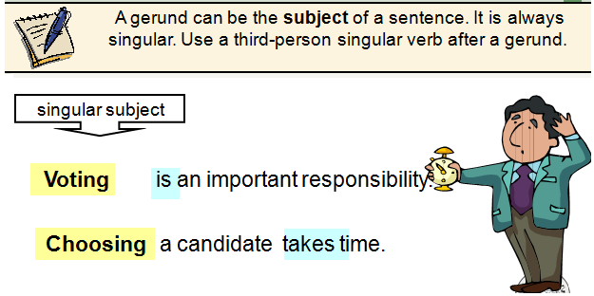

Be Careful!
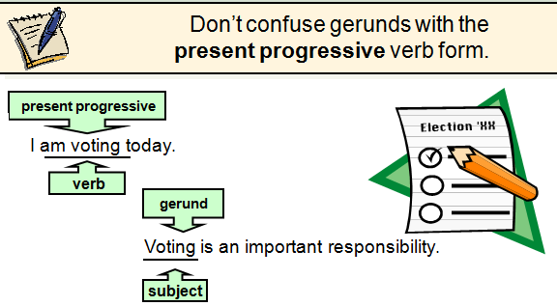

Gerunds as Objects
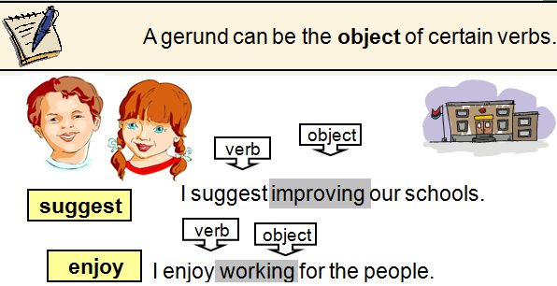
Gerunds with Go
We often use go + gerund to describe activities.
Our family goes bowling every Saturday.
John went jogging with his dog.

Practice 1: Ask a partner how often he or she does these activities.
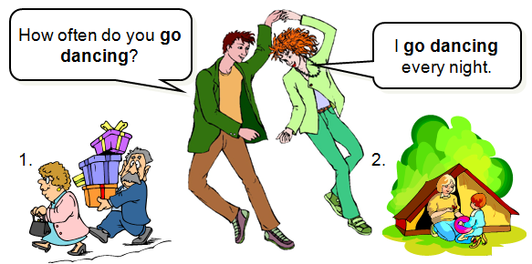

Practice 2 : Complete the sentences with gerunds.
Example: a__ _wind surfing__ is very exciting.
- __________ makes me laugh.
- __________ gives me a headache.
- __________ isn’t polite.
- __________ is popular in my country.
- __________ destroys the environment.
- Not __________ can be dangerous.

Practice 4: Ask a partner how often he or she does these activities.

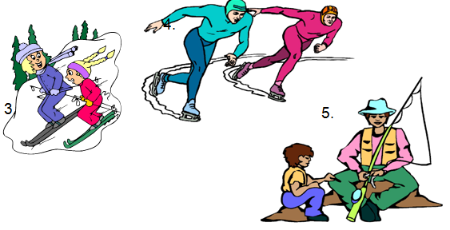

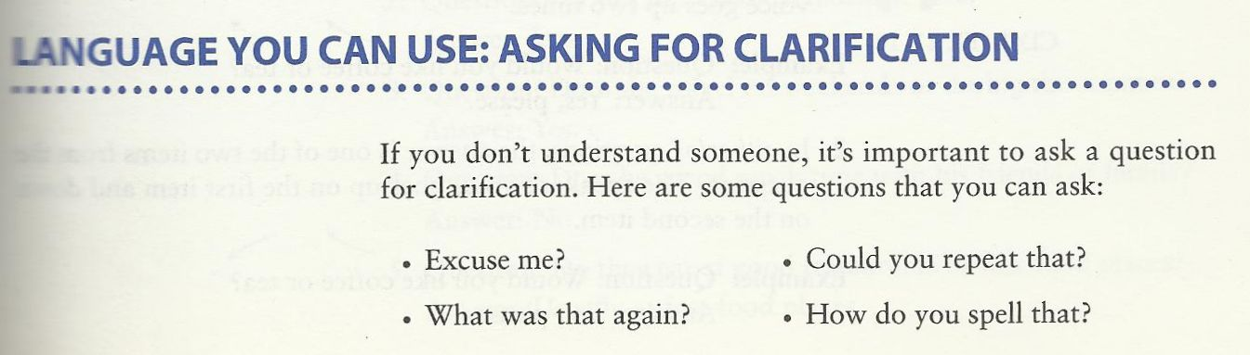
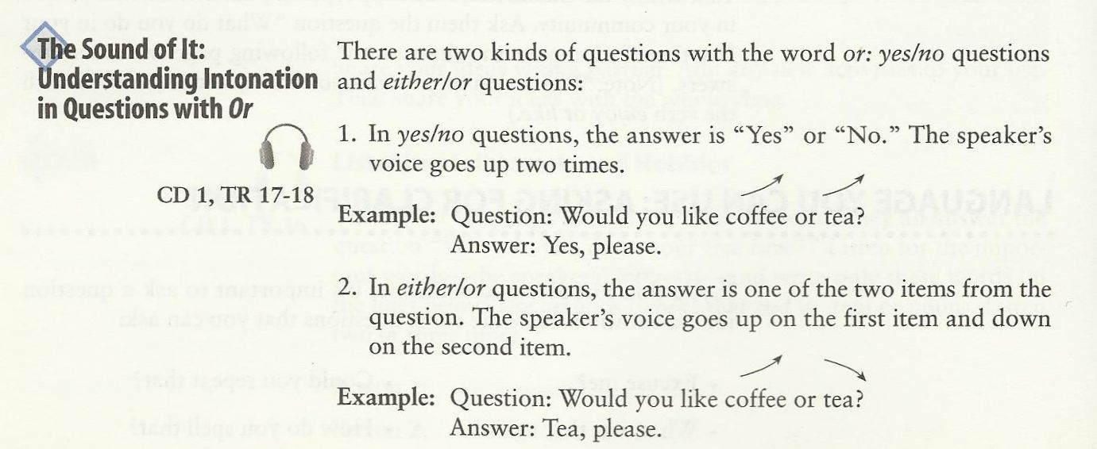

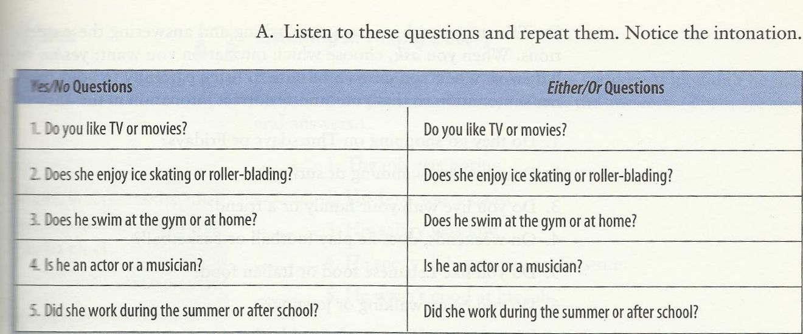
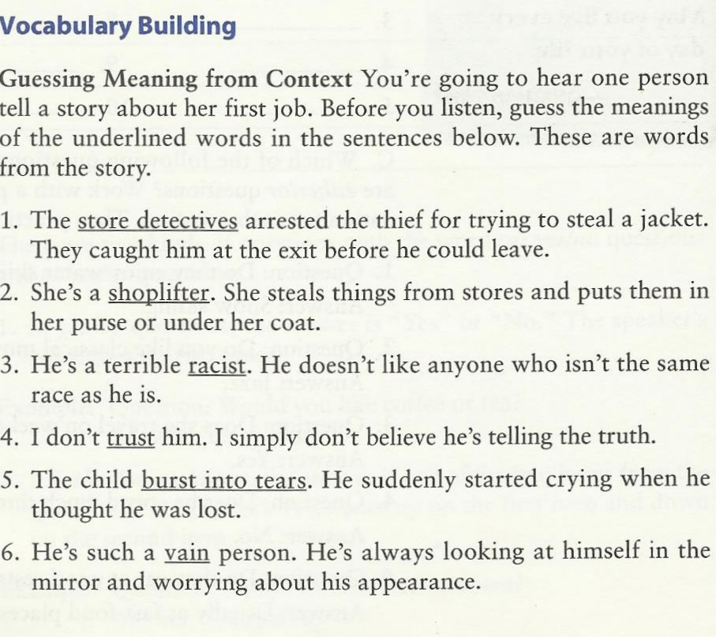

CD 1, TR 19
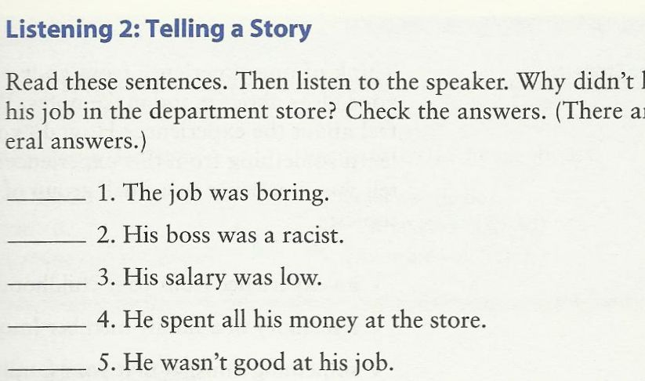
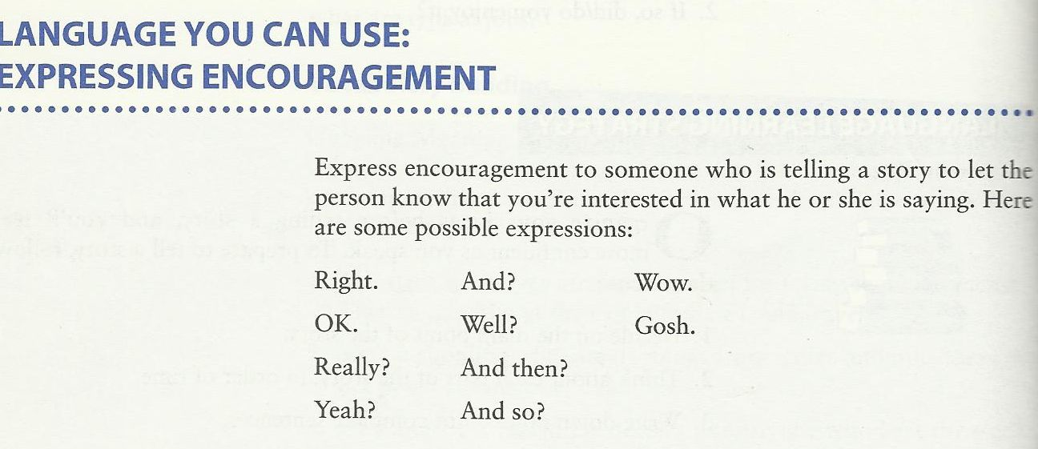
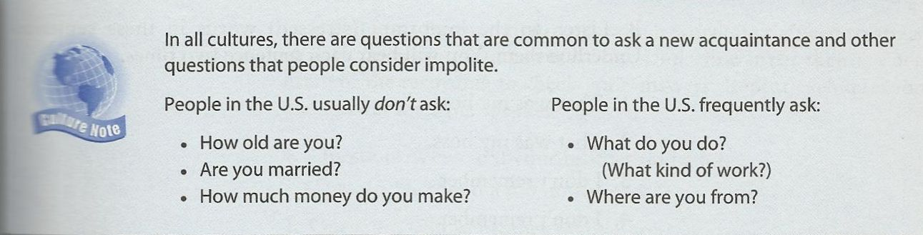

CD 1, TR 20-23
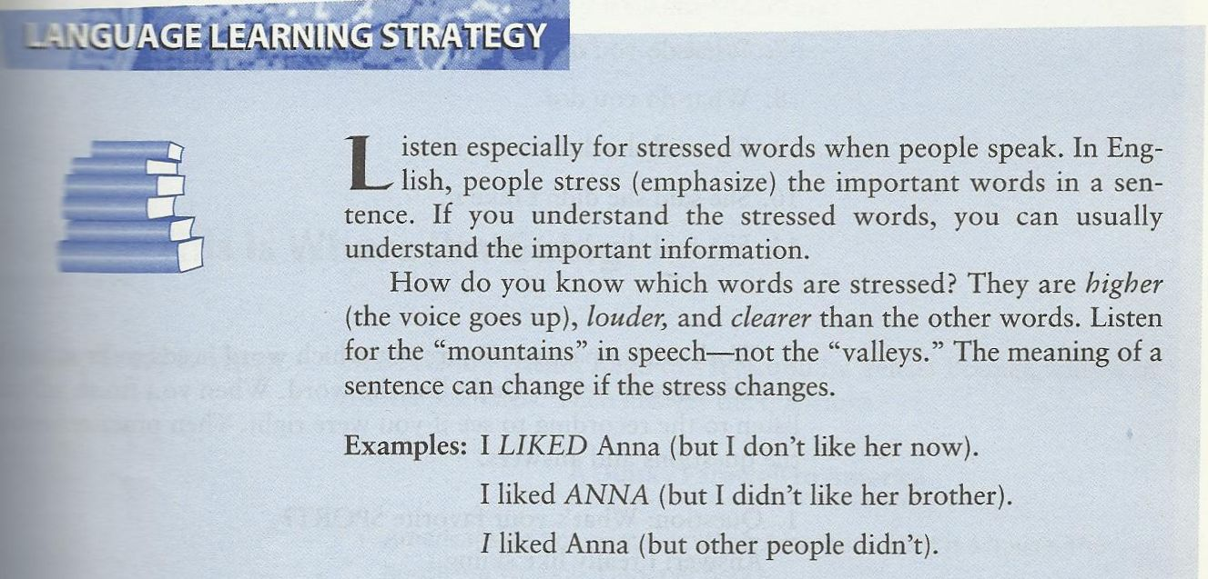

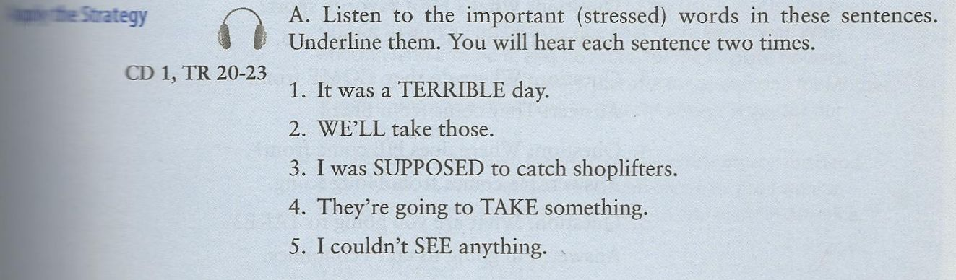

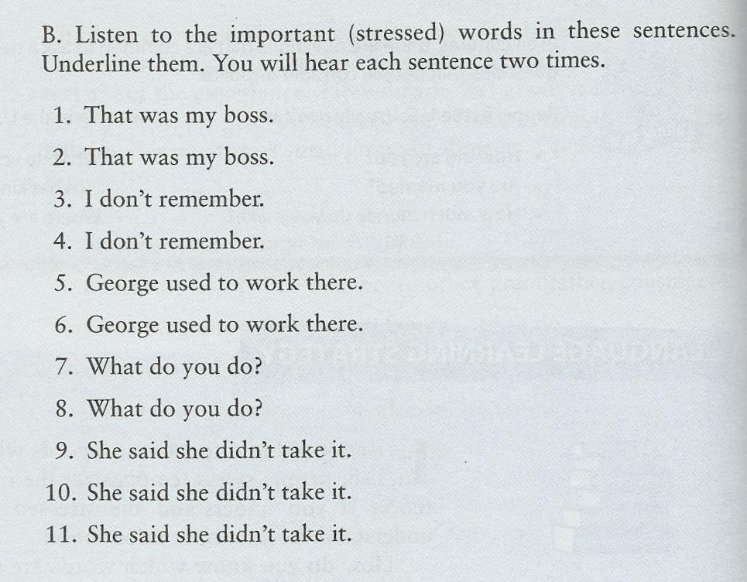

Do it by Yourself J

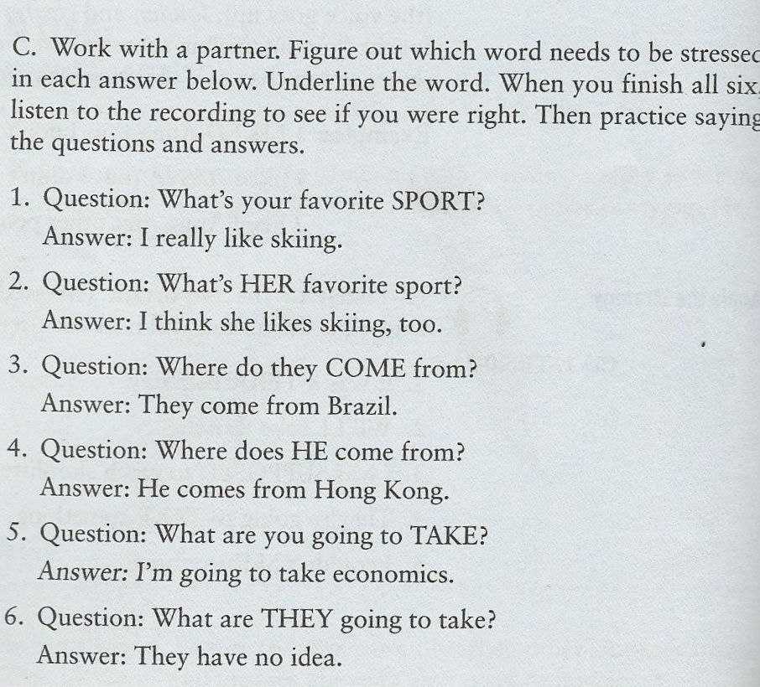

Fourth Class
CD1 TR 24-27
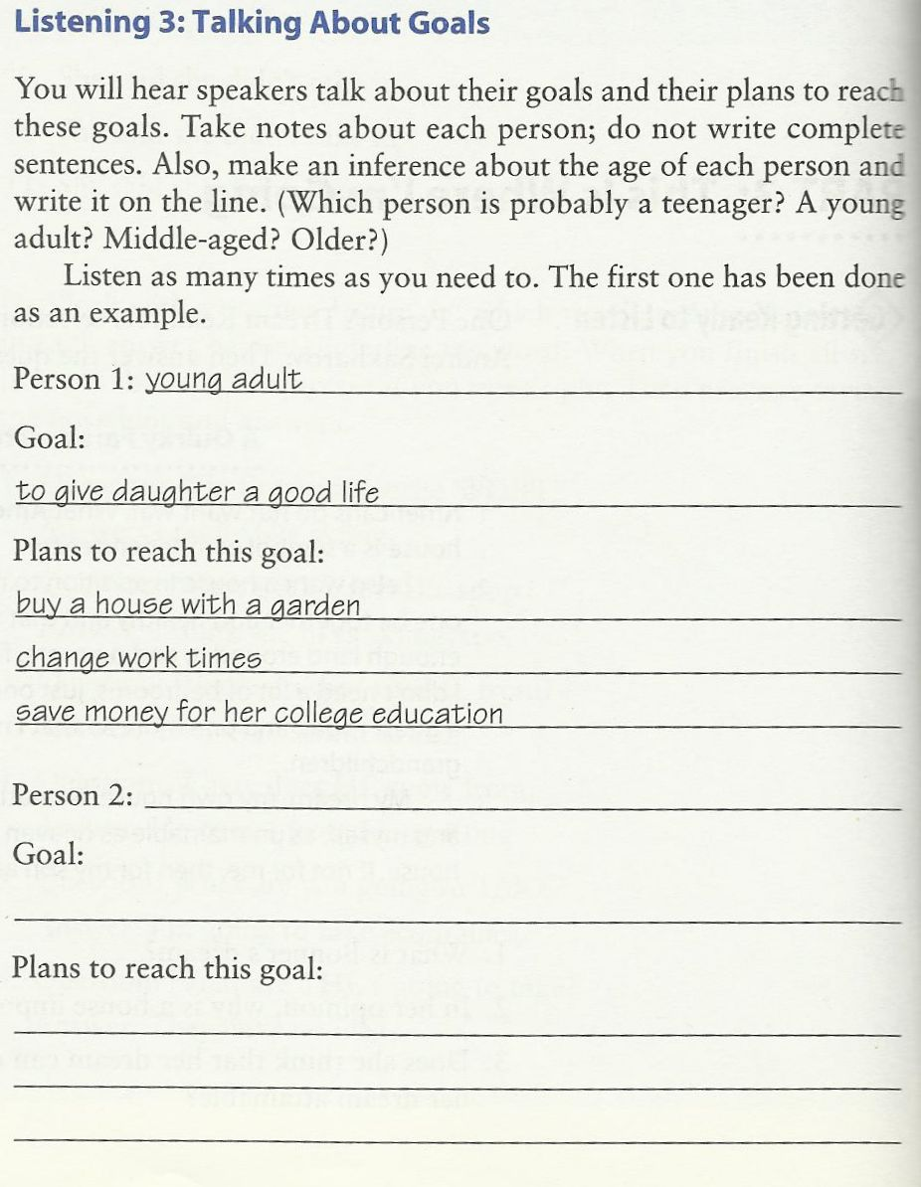

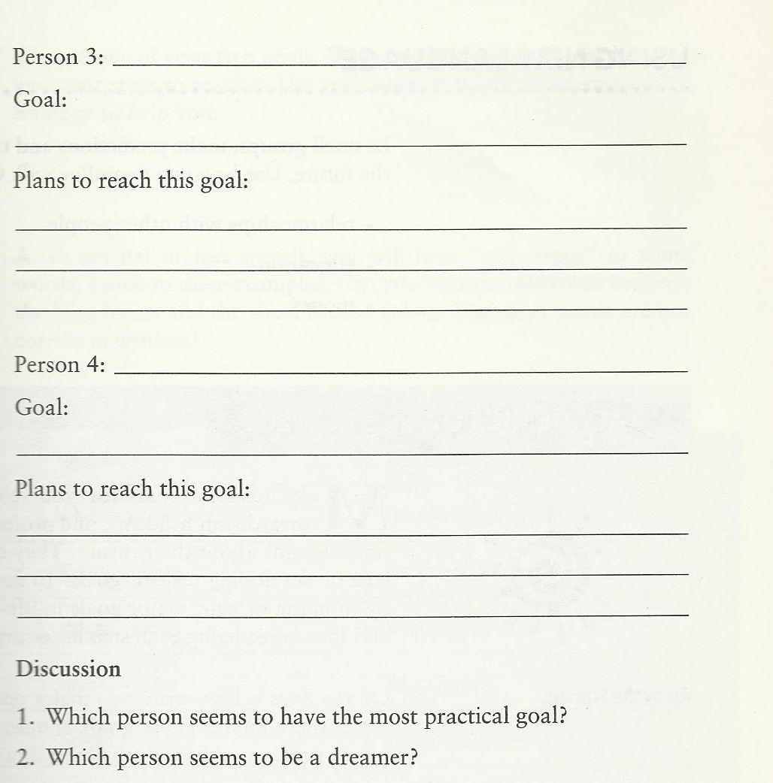

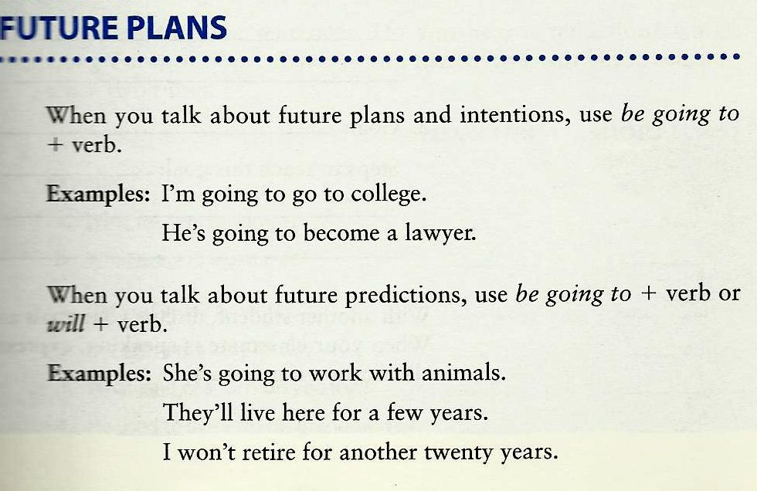

‘will’ ‘going to’

Kate: ‘Anna’s in hospital.’
Ben. ‘Is she?
I’ll visit her tomorrow.’

Kate: ‘Anna’s in hospital.’
Ben: ‘I know.
I’m going to visit her tomorrow.’

- I’ll visit her tomorrow.
- I’m going to visit her tomorrow.

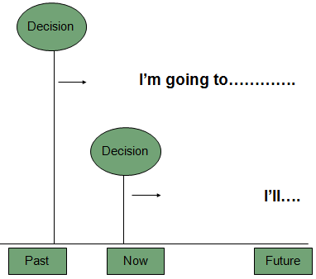

‘going to’ ‘will’

We use ‘going to’ when we have a plan.
We have decided to do something.

- We use ‘will’ when decide to do something now --- at the time of speaking.

- ‘My bag is so heavy.’ ‘I’ll carry / I’m going to carry it for you.’
- I bought some warm boot because I’ll go / I’m going skiing.
- ‘Tony’s back from holiday.’
’Is he? I’ll give / I’m going to give him a ring.’
- ‘What are you doing tonight?’
‘We’ll see / We’re going to see a play at the theatre.’
- You can tell me your secret. I won’t tell / I’m not going to tell anyone.
- Congratulations! I hear you’ll get married / you’re going to get married.
- ‘I need to post these letters.’
‘I’ll go/ I’m going shopping soon. I’ll post / I’m going to post them for you.’

‘will’ ‘going to’
- A Why are you turning on the television?
B _____I am going to watch___ the news. (I/watch)
- A Why are you filling that bucket with water?
B __I am going to wash_____ the car. (I/wash)
- A What would you like to eat?
B _I'll have__ a sandwich, please. (I/ have)
- A Hello. Can I speak to Jim, please?
B Just a minute. _I'll get__ him. (I / get)
- A I don’t know how to use this camera.
B It’s easy. _I'll show____ you (I / show)
Do it by Yourself J : Share it with us on Blackboard Forums
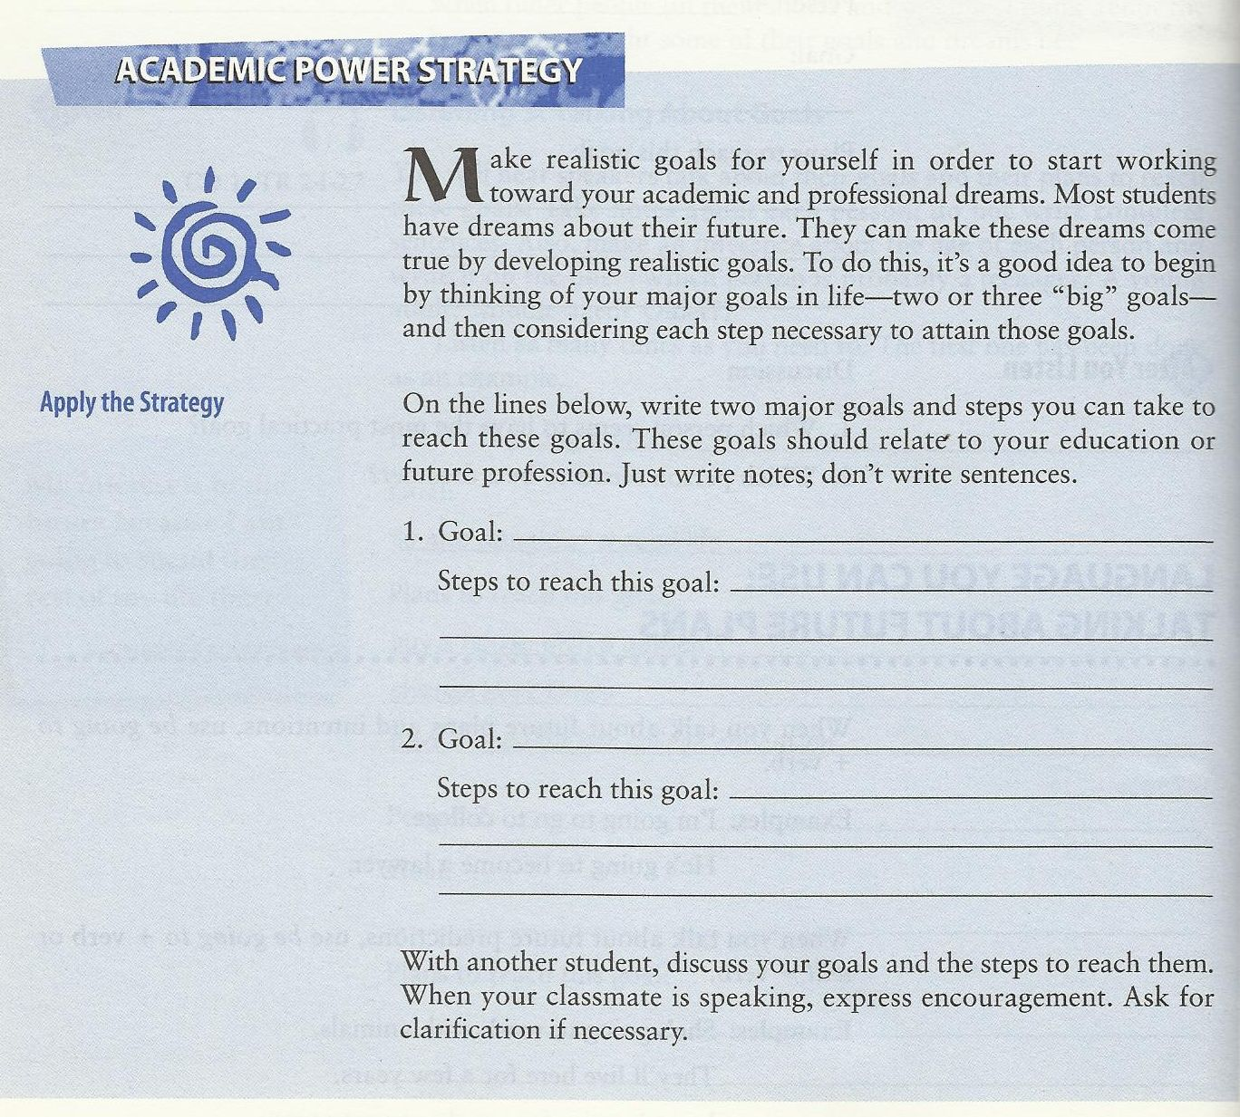

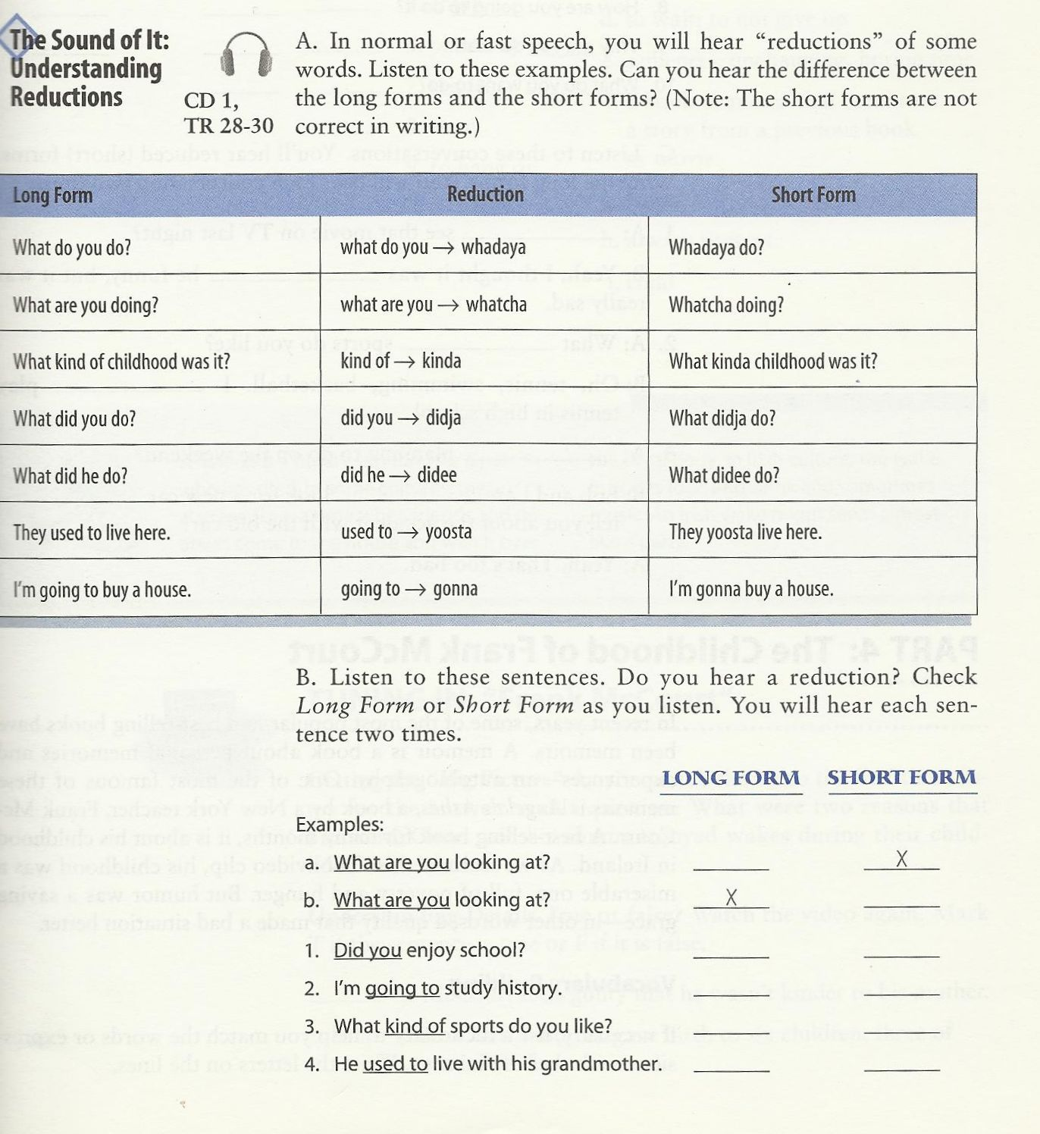

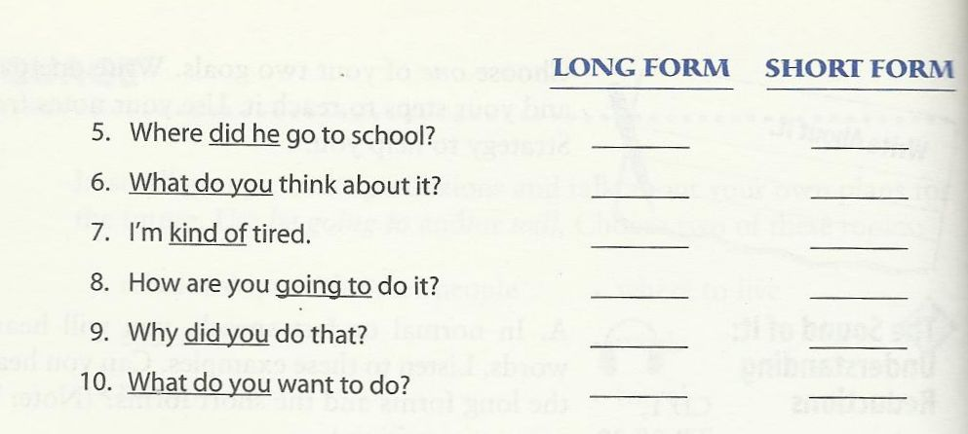
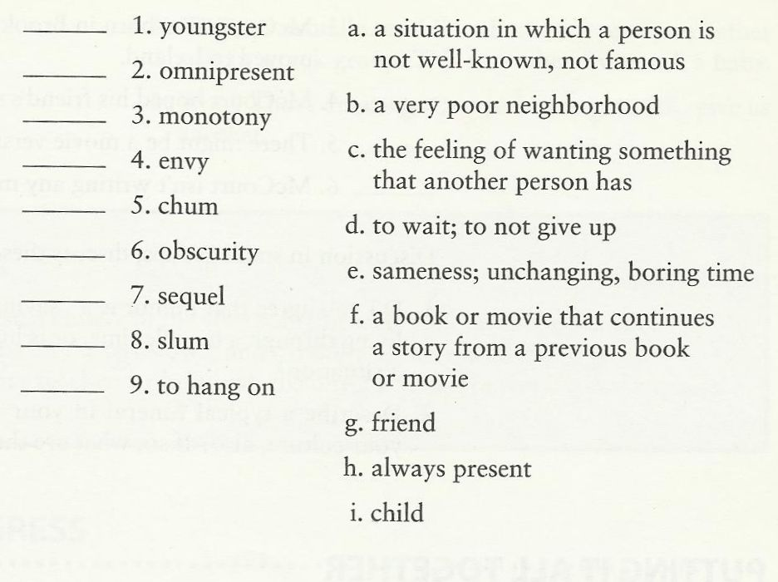

5th Class

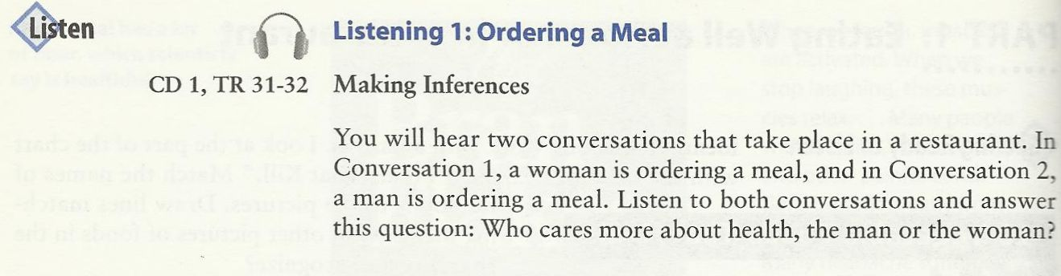
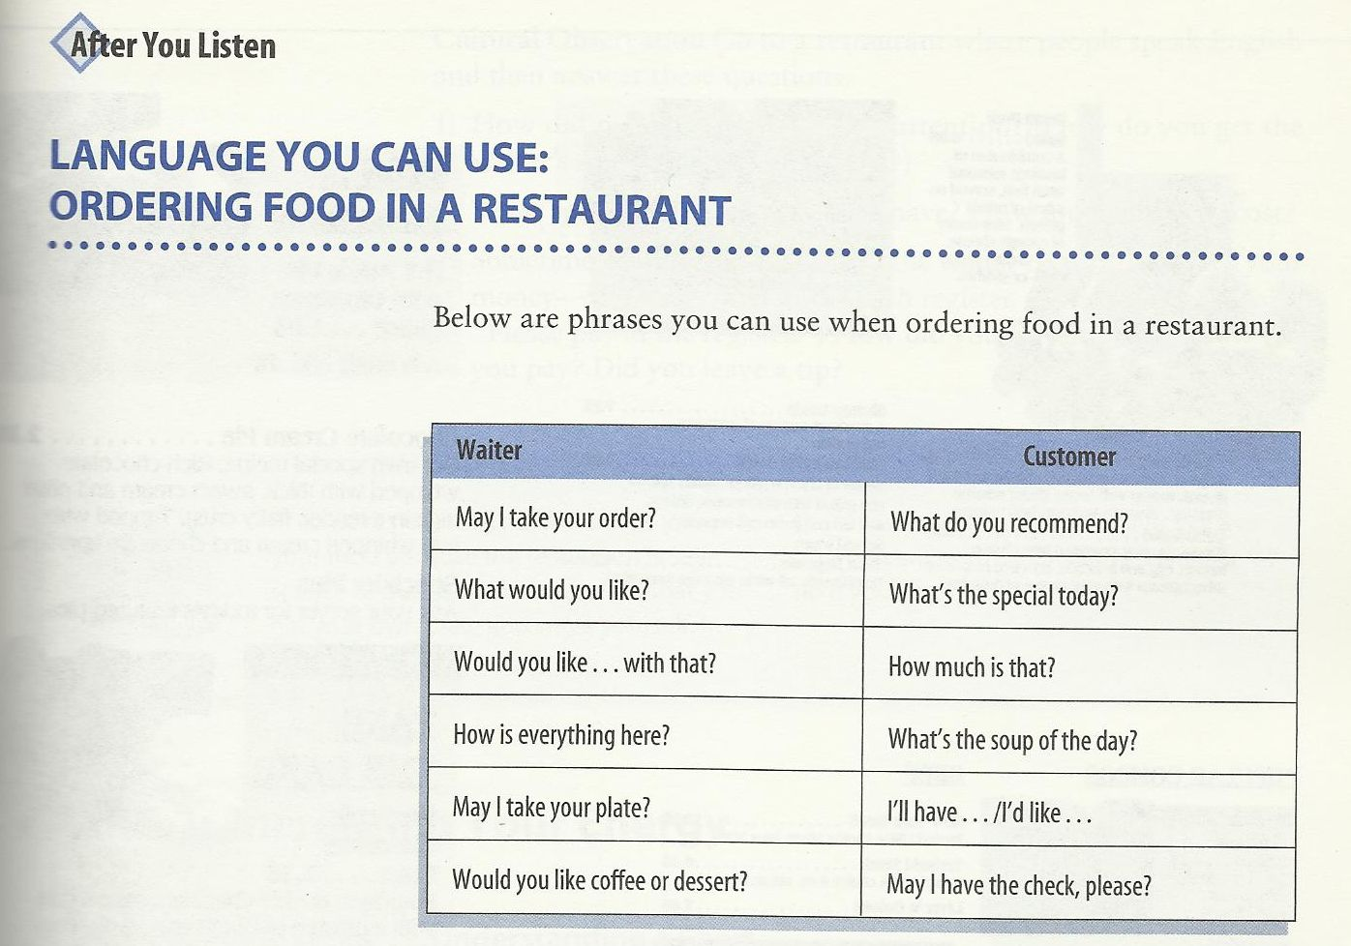

Dialogue:

C. May we see the menu, please?
W. Sure, here it is.
W. Can I take your order?
C. Yes, I'd like a hamburger and a milkshake.
W. How about you?
C. I'd like a ham sandwich.
W. (Would you like) anything to drink?
C. No, thank you. Just water.

Practice 1: Vocabulary Expansion
May we see the menu, please?
have more coffee?
have the check?

Practice 2: Vocabulary Expansion
I'd like a hamburger.
ham sandwich.
taco.
milk shake.
I'd like(a glass of) milk.
(a cup of) hot chocolate.
(a piece of) pie.
(a bowl of) soup.

Practice 3: Vocabulary Expansion
Would you like anything to drink?
to eat?
for desert?
else?

Practice 4: Role Play
Teacher :Can I take your order?
Student :Yes, I'd like __________.
Teacher :Thank you. How about you?
Student :I'd like __________.
Teacher :Would you like anything t drink?
Student :Yes. I'd like __________.

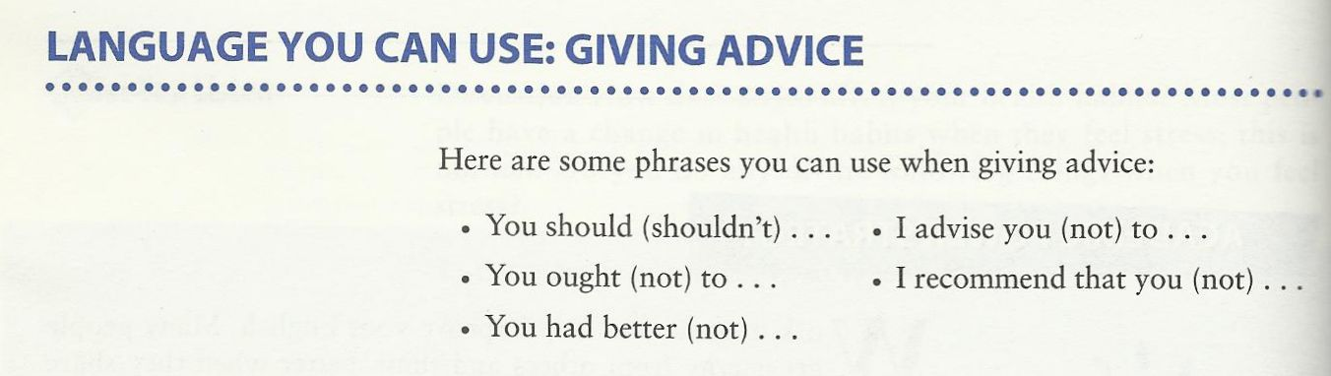
We should wash our hands with liquid soap.
We should prevent disease.
We shouldn't litter.
We should see a doctor promptly if we feel unwell.

Let’s do some exercises

You __________ eat too many sweets. They are not good for you.
You __________ sleep early.
We _______ be friendly to our friends.
Lily’s dress is dirty. She __________ clean it.
You _________ play on the road.
Your brother is weak in Maths. You ______help him.

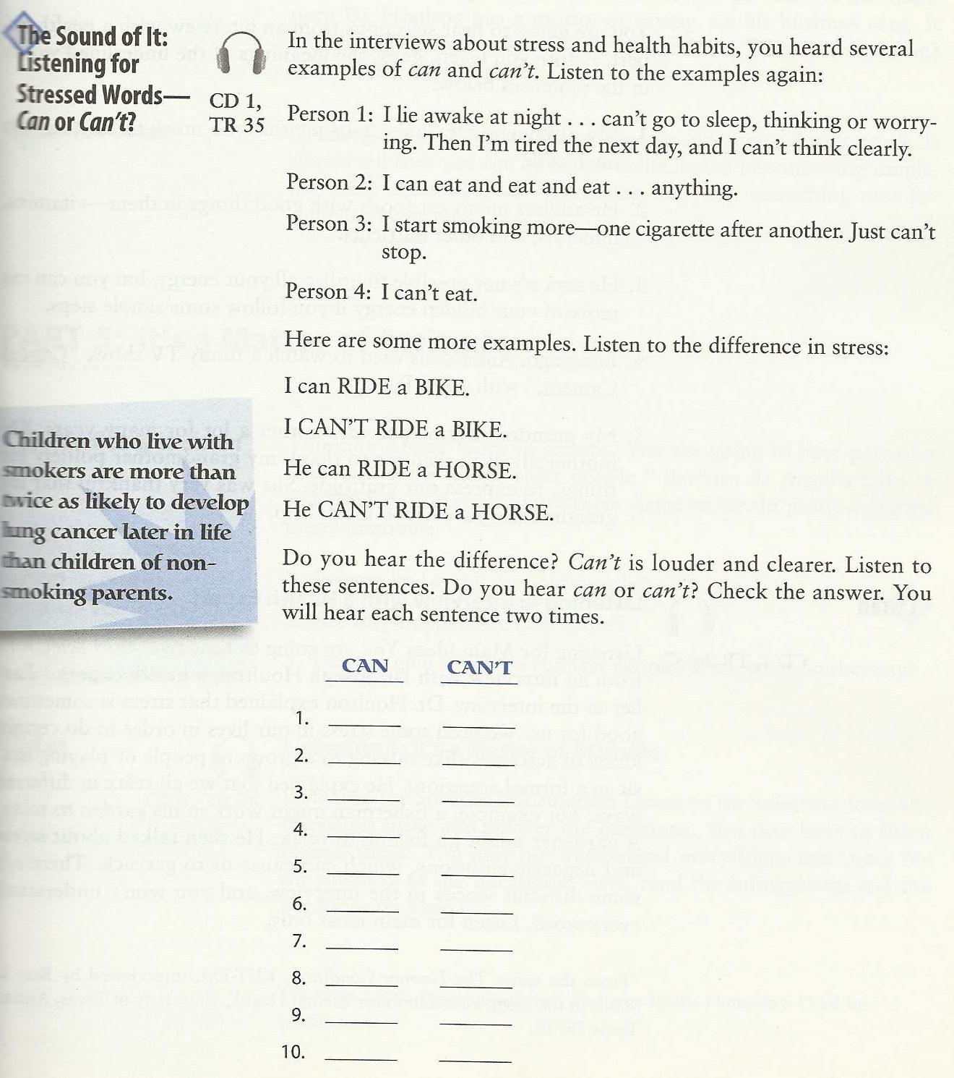

Write a Role Play . J
“What do you do to get exercise?”

^{6th} Class
Reviewing the Main Speaking Skills

Exercise : Start Short Conversation With Strangers.
- at the bus stop?
- At the post office
- At a wedding
- In a supermarket
- On a bus
- Anywhere
- In a museum

- It’s hot today, isn’t it?
- This line is really slow, isn’t it?
- It’s nice to have a chance to celebrate, isn’t it?
- These tomatoes look terrible, don’t they?
- What country are you from?
- Can you lend me some money?
- This is a wonderful painting, isn’t it?

Say the Following Correctly.

Unsure of the Answer (Real Questions)
- The food is awful, isn’t it?
- You don’t see any fresh fruit, do you?
- There isn’t any yogurt, is there?

Sure of the Answer (small talk)
- The food is awful, isn’t it?
- You don’t see any fresh fruit, do you?
- There isn’t any yogurt, is there?

Introduce Someone
- -I’d like you to meet…
- This is… a friend of mine (my brother, sister, etc.)
- Have you met..?

Response
- Nice (Glad, Pleased) to meet you

End a Conversation now.
- Well, I’ve got to run.
- Good-bye.
- See you later (Friday, etc.).
- Have a good day. Have a good weekend

Expressing Thanks
- Thanks.
- Thank you very much (so much)
- That was very kind of you,
- How thoughtful!
- I appreciate it. I’m very grateful.

Response
- You’re welcome.
- Don’t mention it.

Giving an Apology
- I’m very sorry.
- Excuse me.
- Forgive me.
- It was my fault.

Responses
- No problem.,
- That’s ok. That’s all right.
- Don’t worry about it. a

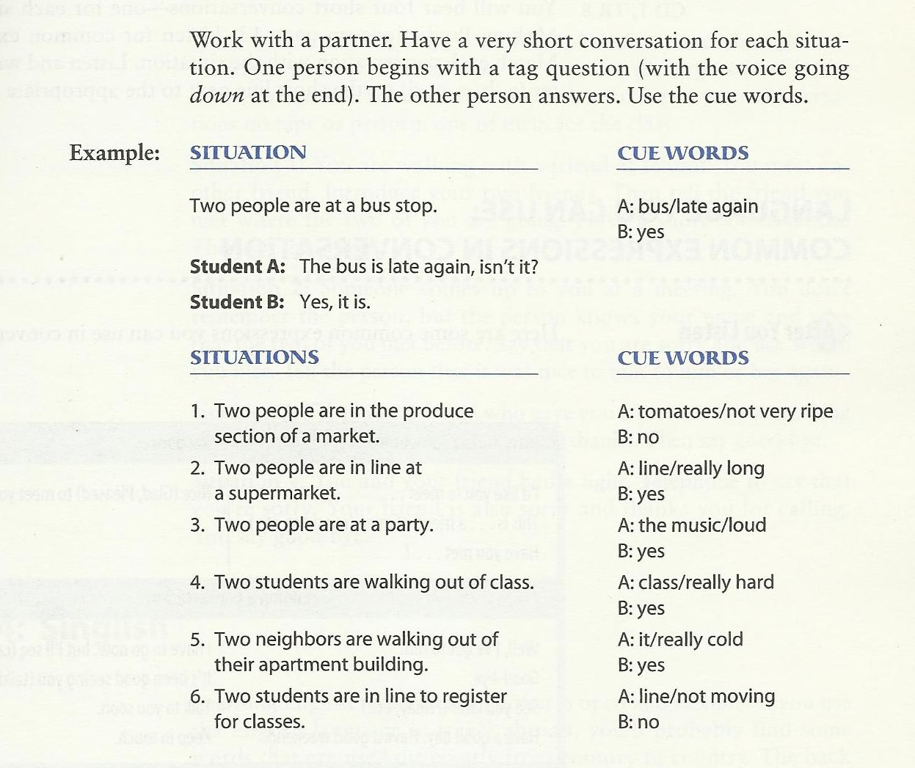

How can I get to
Could you tell me where … is?
Is….. Far from here?
I’m looking for ….
In what direction is …?

- The post office is across the street from the bank.
- The bakery is down the street from the post office.
- The Laundromat is next to (beside) the grocery store.
- The drugstore is around the corner from the laundermat

Creating a Conversation
Work with a partner. Student A wants to take the bus. Student B is a bus driver. Have a conversation. Follow this model.

A: Excuse me. Does this bus go to …?
B: No, … you need bus number …..
A: where do I get ….?
B: …..
A: How much …..?
B: …..
A: Thanks.
B: ……

Reduction
Long Form
- Do you have any pets?
- What’s your name?
- Does this bus go to Geary Street?
- Do you want to see the kitchen?
- You have to have exact change.

SHORT FORM
- You à ya
Do ya have any pets?
- What’s you à watcher
Watcher name?
- Go to à goda
Does this bus goda Geary Street?
- Want to à wanna
Do you wanna see the kitchen?
- Have to à hafta
You hafta have exact change

Study this situation J
Situation : your class colleague is talking about a topic that you are unfamiliar with. You want to ask him or her for clarification. What should you say?

Excuse me, What was that again?
Or
Could you repeat that?
Or
How do you spell that?

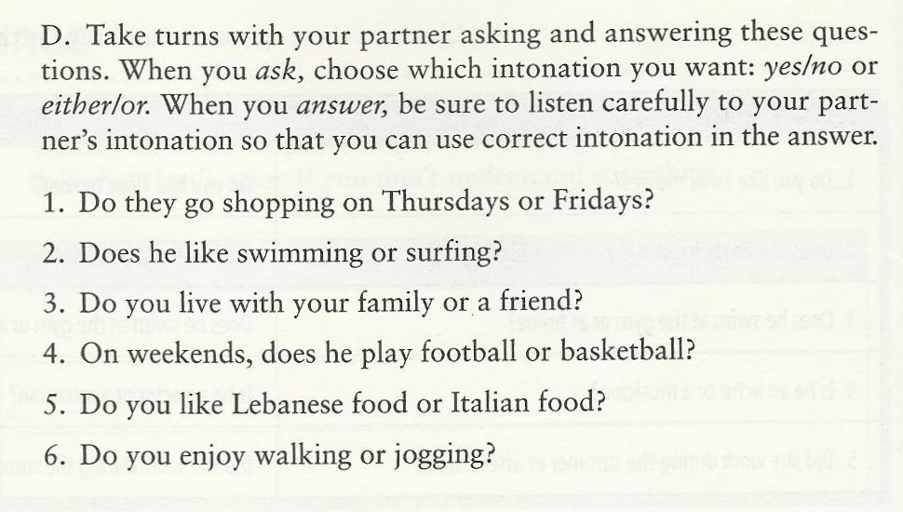
Remember: In yes, No questions, the answer is “yes” or “no” The speaker’s voice goes up two times.
Also Remember: in either/or questions, the answer is one of the two items from the question. The speaker’s voice goes up on the first item and down on the second item.

Study this situation
Situation: one of your colleagues has got average grade in his/her first exam. However, he/she is looking for a higher grade. Your role is to encourage him/her. What should you say.

Long Form
- What do you do?
- What are you doing?
- What kind of childhood was it?
- What did you do?
- What did he do?
- They used to live here.
- I’m going to buy a house.

Short Form, Reduction
- What do you do – whadaya
whadaya do?
- What are you – whatcha
whatcha doing?
- Kind of – kinda
What kinda childhood was it?
- Did you – didja
what didja do?
- Did he- didee
what didee do?
- Used to –yoosta
They Yoosta live here.
- Going to – gonna
I’m gonna buy a house

Study this Situation
- Situation: your professor is asking you a question about your future plans. “What’s your future plane?” he is saying. What should you say?

- I am going to go to Georgetown University. I have already got an admission.
- I will pursue my higher education. But I don’t know where yet.

We should wash our hands with liquid soap.
We should prevent disease.
We shouldn't litter.
We should see a doctor promptly if we feel unwell.

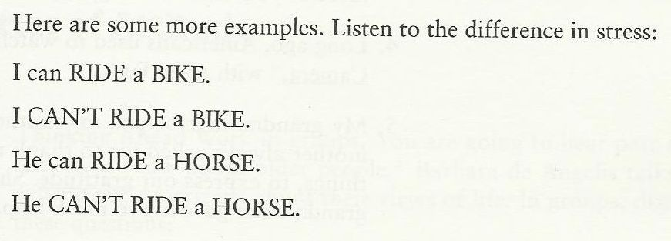

ــــــــــــــــــــــــــــــــــــــــــــــــــــــــــــــــــــــــــــــــــــــــــــــــــــــــــــــــــــــــــــــــــــــــــــــــــــــــــــــــــــــــــــــــــــــــــــــــــــ

With my best regards
~Mrs.ENGLI$H~

