علم اللغه النفسي
و هذا الواجب الأول ..
Psycholinguistics studies:

A. how language is represented and processed in the mind
B. how language affects your psychological well being
C. how different languages can be learned
D. how words are organized in a dictionary

A (intended) You have wasted the whole term.
B (said) You have tasted the whole worm.
Sentence B is an example of:

A. a slip of a tongue
B. a syntactic error
C. a parsing problem
D. a priming effect

Lexical Decision is

A. a method used to understand how words are represented in the mind
B. a method used to organize words in a dictionary
C. a method used to analyze words using a computer
D. a method used to measure how many word are in the brain

الواجب الثاني :
Event-related potentials (ERPs) is an experiment that:
A. measures electrical activity in the brain
B. measures the potential to learn a language
C. measures the speed of someone's speech
D. measures the time of a learning event

Bottom-up processing is:
A. a phonetic analysis used to relate sounds to items in the mental lexicon
B. a morphological analysis used to relate sounds to items in the mental lexicon
C. a syntactic analysis used to relate sounds to items in the mental lexicon
D. a semantic analysis used to relate sounds to items in the mental lexicon

The psycholinguistic study of morphological processing:
A. seeks to understand how morphological principles play a role in the representation of words in themind
B. seeks to create a computer programs that work as word processors
C. seeks to analyze words and phrases in the sentences with speech errors
D. seeks to understand how computer word processors can be used to enhance language acquisition

أسئلة الواجب الثالث جات كلها

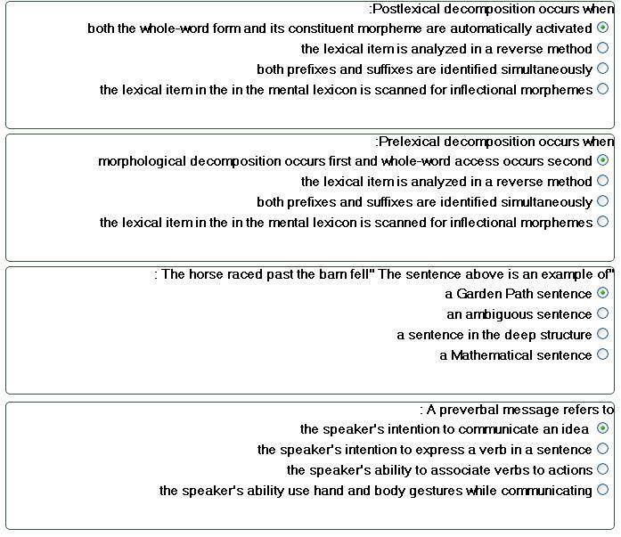

هنا اسئله مهمه لمادة علم اللغه النفسي وجات بالامتحان
A. Said: "I can't cook worth a cam".
B. Intended: "I can't cook worth a damn".

^^^
يقول هنآ المثآل يدل على ايش او مثال على ايش :

1-Plural attraction
2-Preservation error
3-Anticipation error
4-Segment exchange error

a. The time for fun and games are over.
b. The illiteracy level of our children are appalling

1-Plural attraction
2-Preservation error
3-Anticipation error
4-Segment exchange error

A. Said: "taddle tennis".
B. Intended: "paddle tennis".

1-Plural attraction
2-Preservation error
3-Anticipation error
4-Segment exchange error

A. Said: "hass or grash".
B. Intended: "hash or grass".
1-Plural attraction
2-Preservation error
3-Anticipation error
4-Segment exchange error

postlexicon decomposition:
Both the whole-word form and its constituent morpheme are automatically activated

prelexicon decomposition :
Morphological decomposition occurs first and whole-word access occurs second

تعاريف :
Cohort Model is :
consist of all the lexical items that share an initial sequence of phonemes

language is species specific is :
language is likely to be part of the genetic makeup of members of the species

universal Grammar is :
language of the world are are similar because all humans have the same language capacities

Neurolinguistic is :
the study of the representation of the language in the brain

aphasia is :
a language impairment linked to brain injury

non fluent aphasia known as :
Broca's Aphasia

fluent aphasia known as :
Wernicke's aphasia

language lateralized is :
language function is located in one of the two hemispheres

Contralateral is :
the left hemisphere controls the right side of the body and the right hemisphere controls the left side of the body

Dichotic listening experiment is :
given two different inputs to each ear at the same time

Barrowing is :
is incorporated into the lexicon of another language

unilingual mode is :
only one language
bilingual mode is :
Has two language

Grammatical encoding is :
the creation of sentence structure during sentence planning

Tip of the tongue Phoneme :
the speaker knows the word but cannot retrieve it

interlocutor is :
Participate in conversation

Orthorgraphy is :
writing system

سأل عن الـ Acquisition

جاب سؤال عن ثنائي اللغه
وعن الاكتساب ..
وو آلـ cohort ..

* هذه شرحها موجود في المحاضرات الأخيرة من المحتوى

Uni Langual Mode
Bilingual Mode

Code- Switching
Grammatical Eencoding
Plural Attraction
Preverbal Message

مثل:هذا جاء ايضا بالامتحان

Postlexical Decomposition
Prelexical Decomposition

أيضاً:

Garden Path sentence
Lexical Retrieval
Introlocutor
Laguage Transfer

رسمة الدماغ في المححاضره 7 ونفس الرسمه في الكتاب ص 83 :
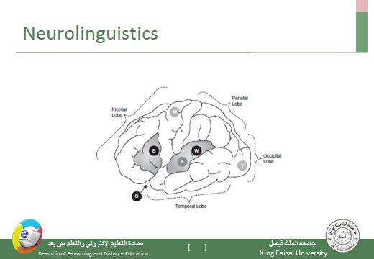
الدكتور ذكر الاجزاء الرئيسيه الاربعه بالمحاضره
1- frontal Lobe
2- parietal Lobe
3- occipital Lobe
4- temporal Lobe
وباقي الاجزاء :
5- M motor
6- A auditory
7- V visual
8- S sylvian fissure
9- W wernickc's area
10- B broca's area

بالاضافه الى رسمة النحو
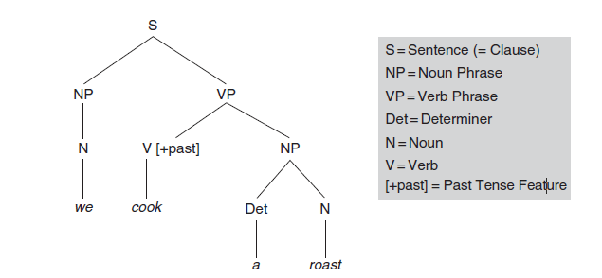

+رسمة اجزاء الفم في المحاضره 14

بالتوفيق :*بحّه ☺

