رسمة الدماغ

THE BIOLOGICAL BASIS OF LANGUAGE 83

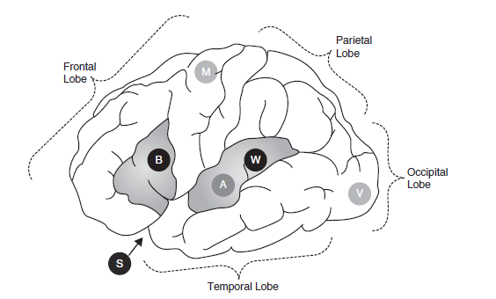

Figure

3.1 Diagram of the left hemisphere of the human cerebral cortex (side view). The diagram indicates the location of the primary language areas (Broca’s and Wernicke’s areas, ‘B’ and ‘W’, and the Sylvian fissure ‘S’), as well as the approximate areas recruited for motor (M), auditory (A), and visual (V) processing.

رسمة اجزاء الفم

